Supplementary Material

TropD-detector a CRISPR/LbCas12a-Based system for rapid screening of Trypanosoma cruzi in Chagas vectors and reservoirs

Luis A. Ortiz-Rodríguez¹, Rafael Cabanzo², Jeiczon Jaimes-Dueñez³, Stelia C. Mendez-Sanchez⁴ , Jonny E Duque^{1*}.

- Centro de Investigaciones en Enfermedades Tropicales - Cintrop. Escuela de Medicina, Departamento de Ciencias Básicas. Universidad Industrial de Santander, Parque Tecnológico y de Investigaciones Guatiguará Km 2 El Refugio, Santander, Colombia. Piedecuesta, Colombia. Telephone: +57 (7) 634 4000 Ext 3503.
- Laboratorio de Espectroscopía Atómica y Molecular (LEAM), COL0012909. Escuela de Física, Facultad de Ciencias, Universidad Industrial de Santander.
- Grupo de Investigación en Ciencias Animales GRICA, Facultad de Medicina Veterinaria y Zootecnia, Universidad Cooperativa de Colombia UCC, Bucaramanga, Colombia.
- Grupo de Investigación en Bioquímica y Microbiología GIBIM. Escuela de Química, Facultad de Ciencias, Universidad Industrial de Santander.

*Corresponding author: jonedulu@uis.edu.co

Annex table 1
 | Analysis of species in BLAST with Cytb primers
 | Forward |  |  | Reverse
 | 5’ GACAGGATTGAGAAGCGAGAGAG ‘3 |  |  | 5’ CAAACCTATCACAAAAAGCATCTG 3’
Specie | % Coverage | % Identity | Number of shared bp | % Coverage | % Identity | Number of shared bp
Trypanosoma theileri | 100 | 100 | 23 | 100 | 100 | 24
Leishmania infantum | 100 | 100 | 23 | 100 | 94 | 24
Rhodnius pallescens | 69 | 100 | 9 | 41 | 100 | 9
Lutzomyia sp. | 69 | 100 | 15 | 100 | 100 | 17

 | Analysis of species in BLAST with SR18s primers
 | Forward |  |  | Reverse
 | 5’ ATGTTCTCTGTTCCGGCGGCAG ‘3 |  |  | 5’ AAAAATCACGGGCGCCCTCTGG 3’
Specie | % Coverage | % Identity | Number of shared bp | % Coverage | % Identity | Number of shared bp
Trypanosoma theileri
Leishmania infantum | 95 | 100 | 15 | 100 | 100 | 15
Rhodnius pallescens | 54 | 100 | 9 | 72 | 100 | 8
Lutzomya sp. | 100 | 100 | 15 | 100 | 100 | 14

 | Analysis of species in BLAST with H2A primers
 | Forward |  |  | Reverse
 | 5’ GTTTTTCGCAGACAAGGATG ‘3 |  |  | 5’ TTACTTACGAAGTGGCAGAC ‘3
Specie | % Coverage | % Identity | Number of shared bp | % Coverage | % Identity | Number of shared bp
Trypanosoma theileri | 60 | 100 | 12 | 85 | 100 | 17
Leishmania infantum | 100 | 100 | 14 | 90 | 100 | 14
Rhodnius pallescens | 40 | 100 | 8 | 35 | 100 | 7
Lutzomyia sp. | 100 | 100 | 14 | 100 | 100 | 14

.

Annex Figure 1
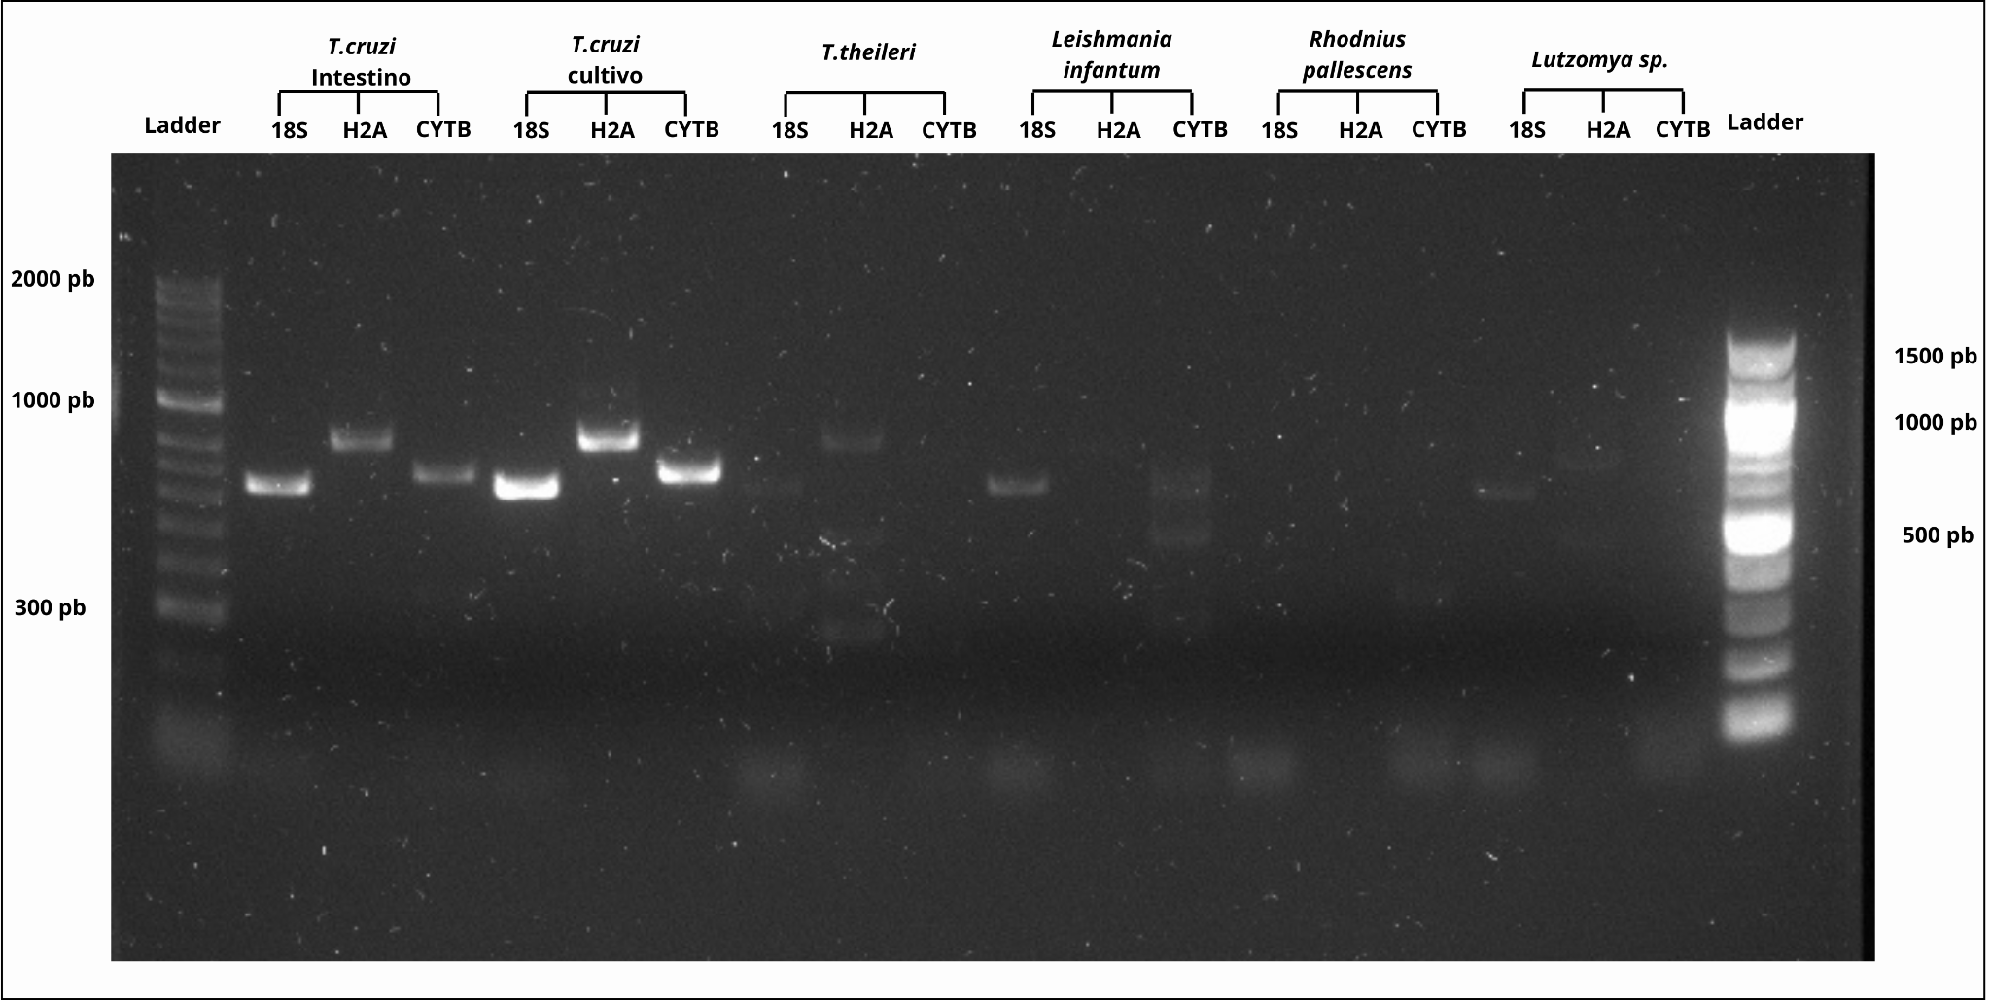

Annex 1. Validation of primers for the Cytb, 18s, and H2A genes in DNA from T. cruzi Silvio strain, T. cruzi extracted from the intestine of Rhodnius pallescens, Trypanosoma theileri, Leishmania infantum, Rhodnius pallescens, and Lutzomyia sp.

Annex Table 2. Statistics of the graphs

Figure | Description | Details
Figure 2E | Homogeneity of guide RNA (gRNA) replicas for SR18s, H2A, and Cytb | Replicas are homogeneous with p > 0.05
Figure 2F | Homogeneity of DNA extracted from culture, Rhodnius pallescens intestine, and reservoir samples | Culture: p = 0.343, Vector: p = 0.4160, Reservoir: p = 0.5182
Figure 4B | Normalized fluorescence data emitted by the cleavage of diluted amplified DNA from culture | 40 ng/µL: p = 0.4164, 20 ng/µL: p = 0.2404, 10 ng/µL: p = 0.240, 5 ng/µL: p = 0.2130, 1 ng/µL: p = 0.1531, Control: p = 0.1343
Figure 4D | Normalized fluorescence data emitted by the cleavage of diluted amplified DNA extracted from the intestine of R. pallescens | 40 ng/µL: p = 0.4164, 20 ng/µL: p = 0.2404, 10 ng/µL: p = 0.240, 5 ng/µL: p = 0.2130, 1 ng/µL: p = 0.1531, Control: p = 0.1343
Figure 6C | Normalized fluorescence data graph for pre-PCR dilutions | 0.76 ng/µL: p = 0.2055, 0.38 ng/µL: p = 0.0821, 0.19 ng/µL: p = 0.4785, 0.095 ng/µL: p = 0.3633, 0.0475 ng/µL: p = 0.4570, 0.02375 ng/µL: p = 0.5073

Annex Figure 3.
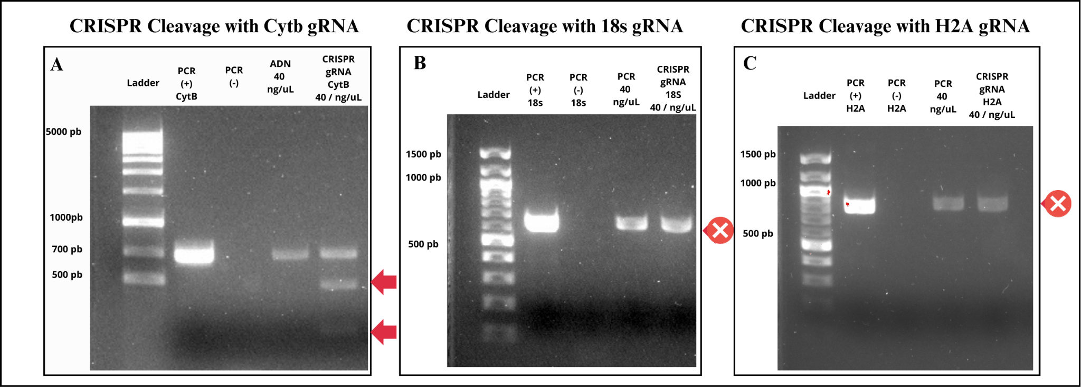
Figure 3. Evaluation of DNA cleavage in amplified samples. Lane 1: molecular weight marker. Lane 2: PCR reaction without amplified DNA. Lane 4: amplified DNA, diluted to 40 ng/µL. Lane 5: cleavage assessment at 40 ng/µL. A. Positive cleavage evaluation with the Cytb gRNA; arrows indicate the two fragments resulting from the cleavage. B. No evidence of cleavage with the 18s gRNA. C. No evidence of cleavage with the H2A gRNA. The “X” signal marks the band where cleavage is not observed.

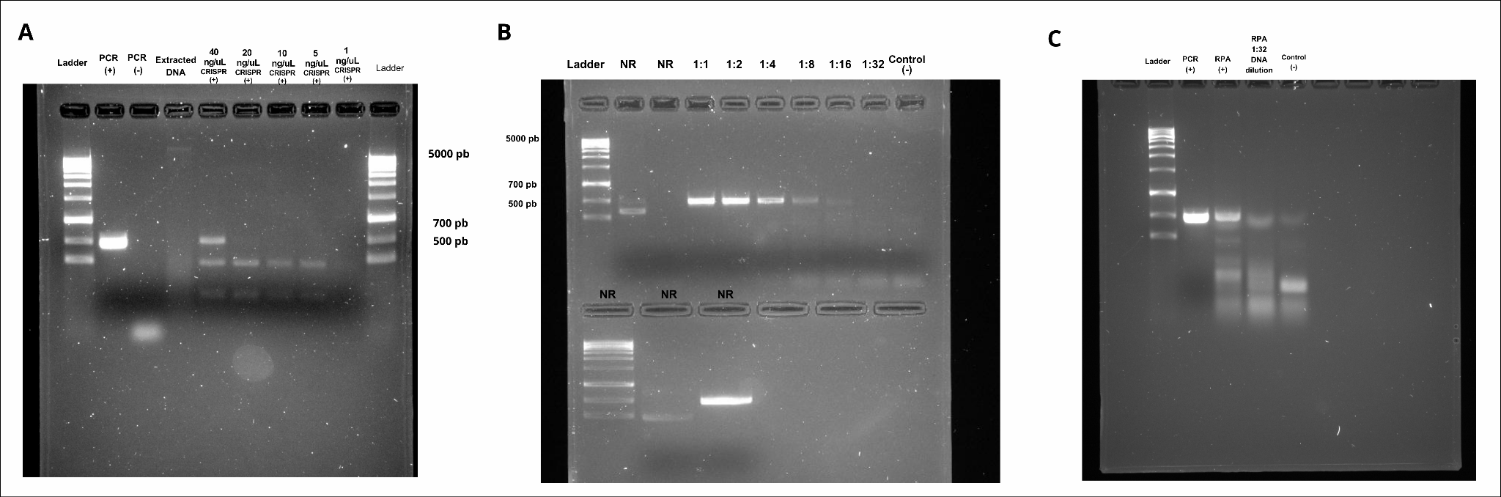
Annex Figure 4. Complete electrophoresis gels experiments

Figure 4. Uncropped gels obtained from the experiments.A. Gel shown in Figure 2F, dilution of amplified DNA. Lane 4 contains a test of total extracted DNA, which was not included in the final results. B. Gel shown in Figure 6A, dilution test of non-amplified DNA. Lanes marked as "NR" indicate they were irrelevant to the study. C. Gel is shown in Figure 6 F in its original size.

Annex Figure 5. qPCR curves Determination of parasite DNA concentration by qPCR
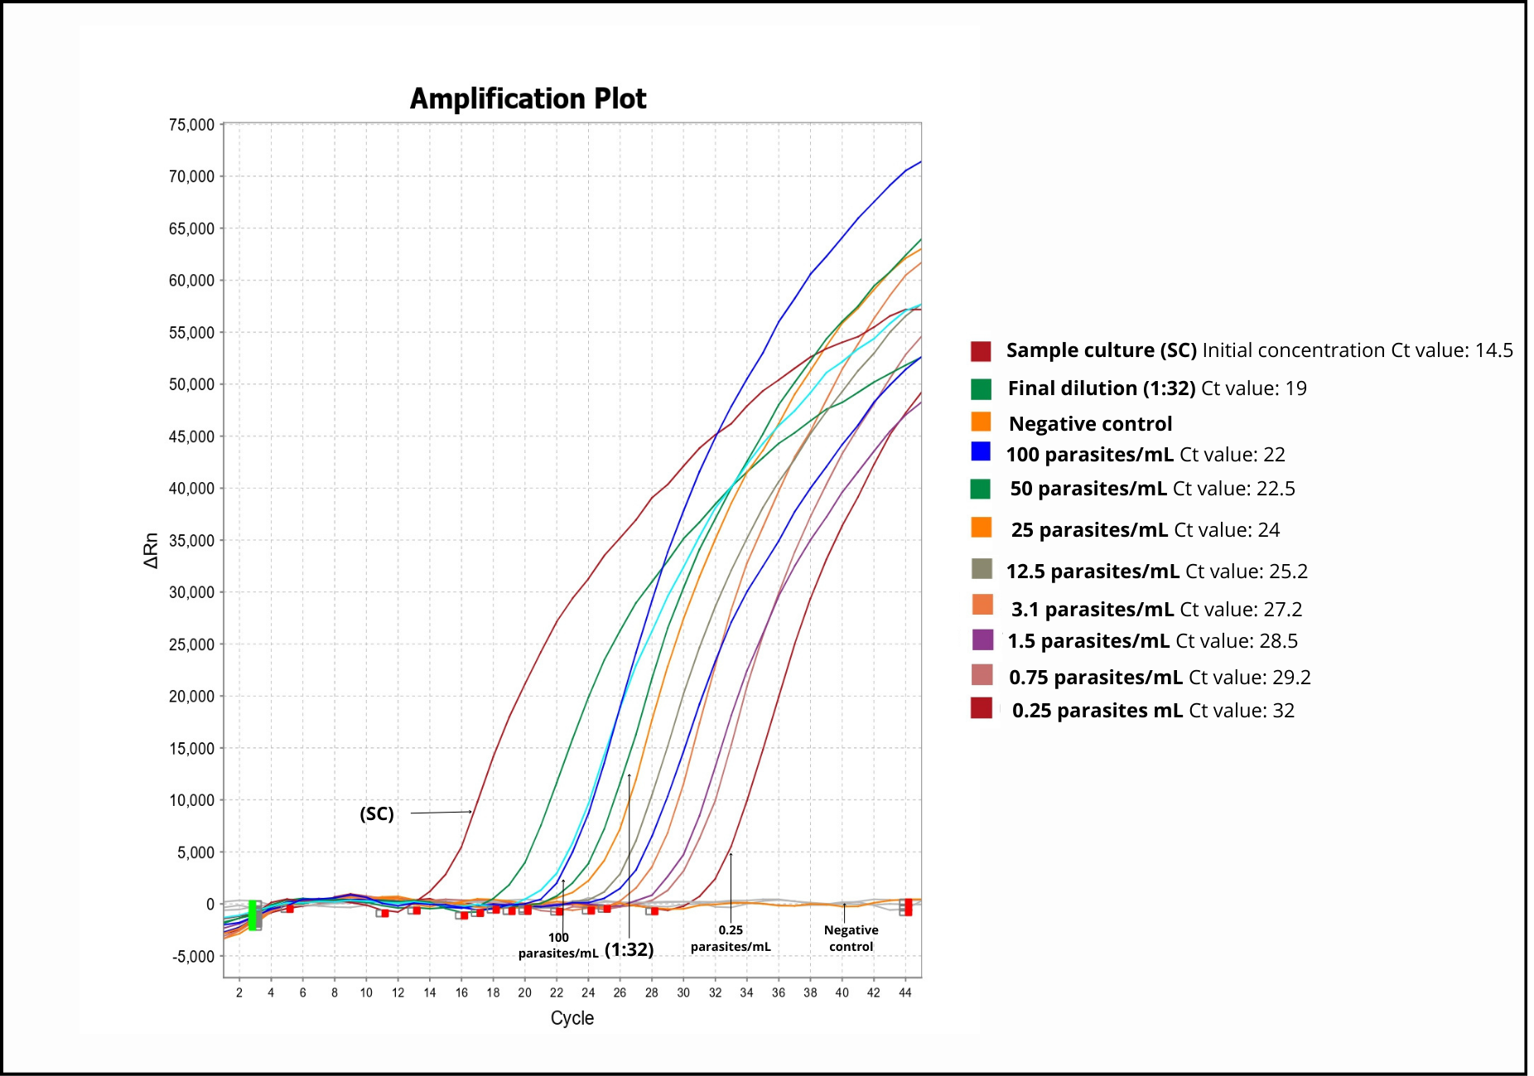

Annex Figure 6. Sequencing Results
Cytb FORWARD
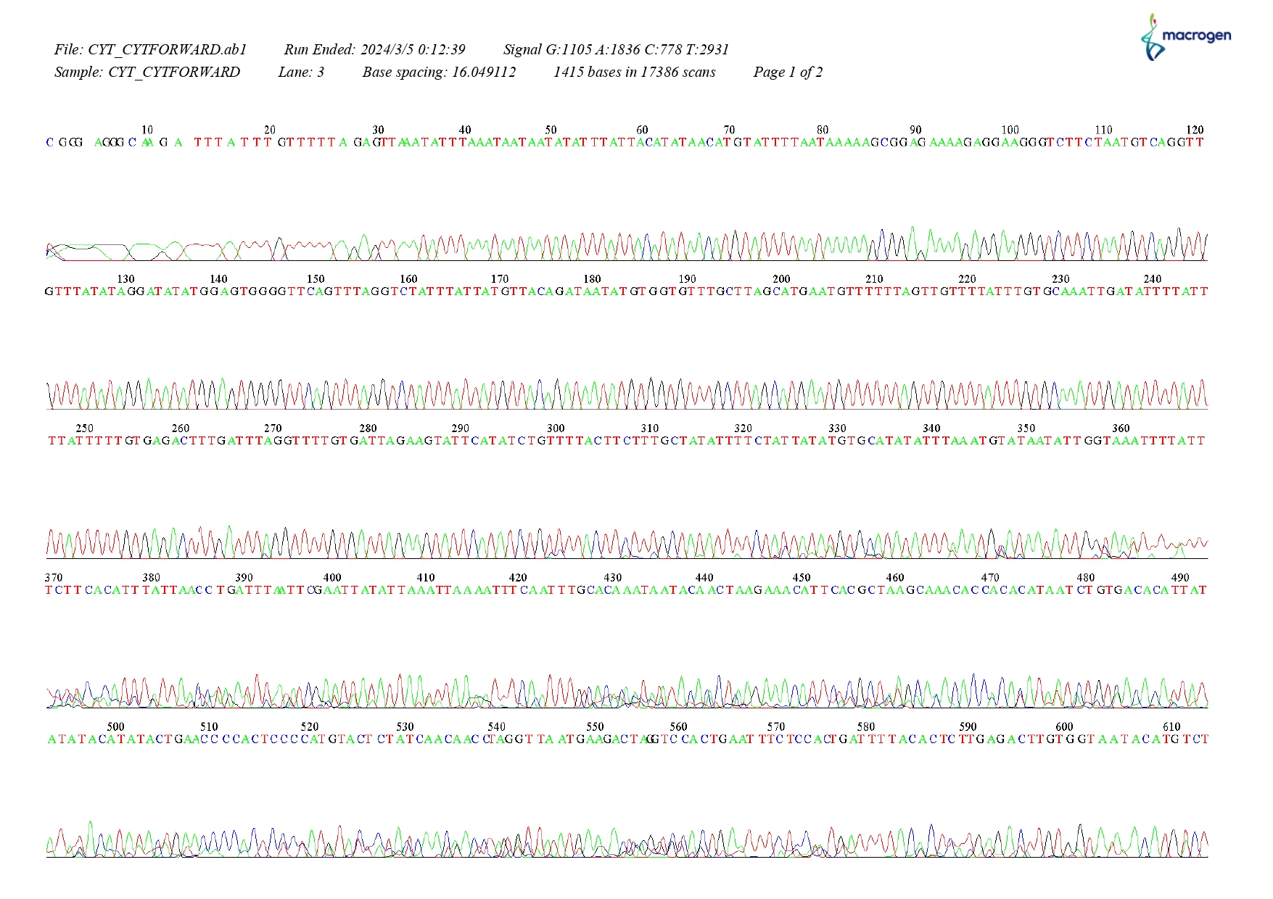
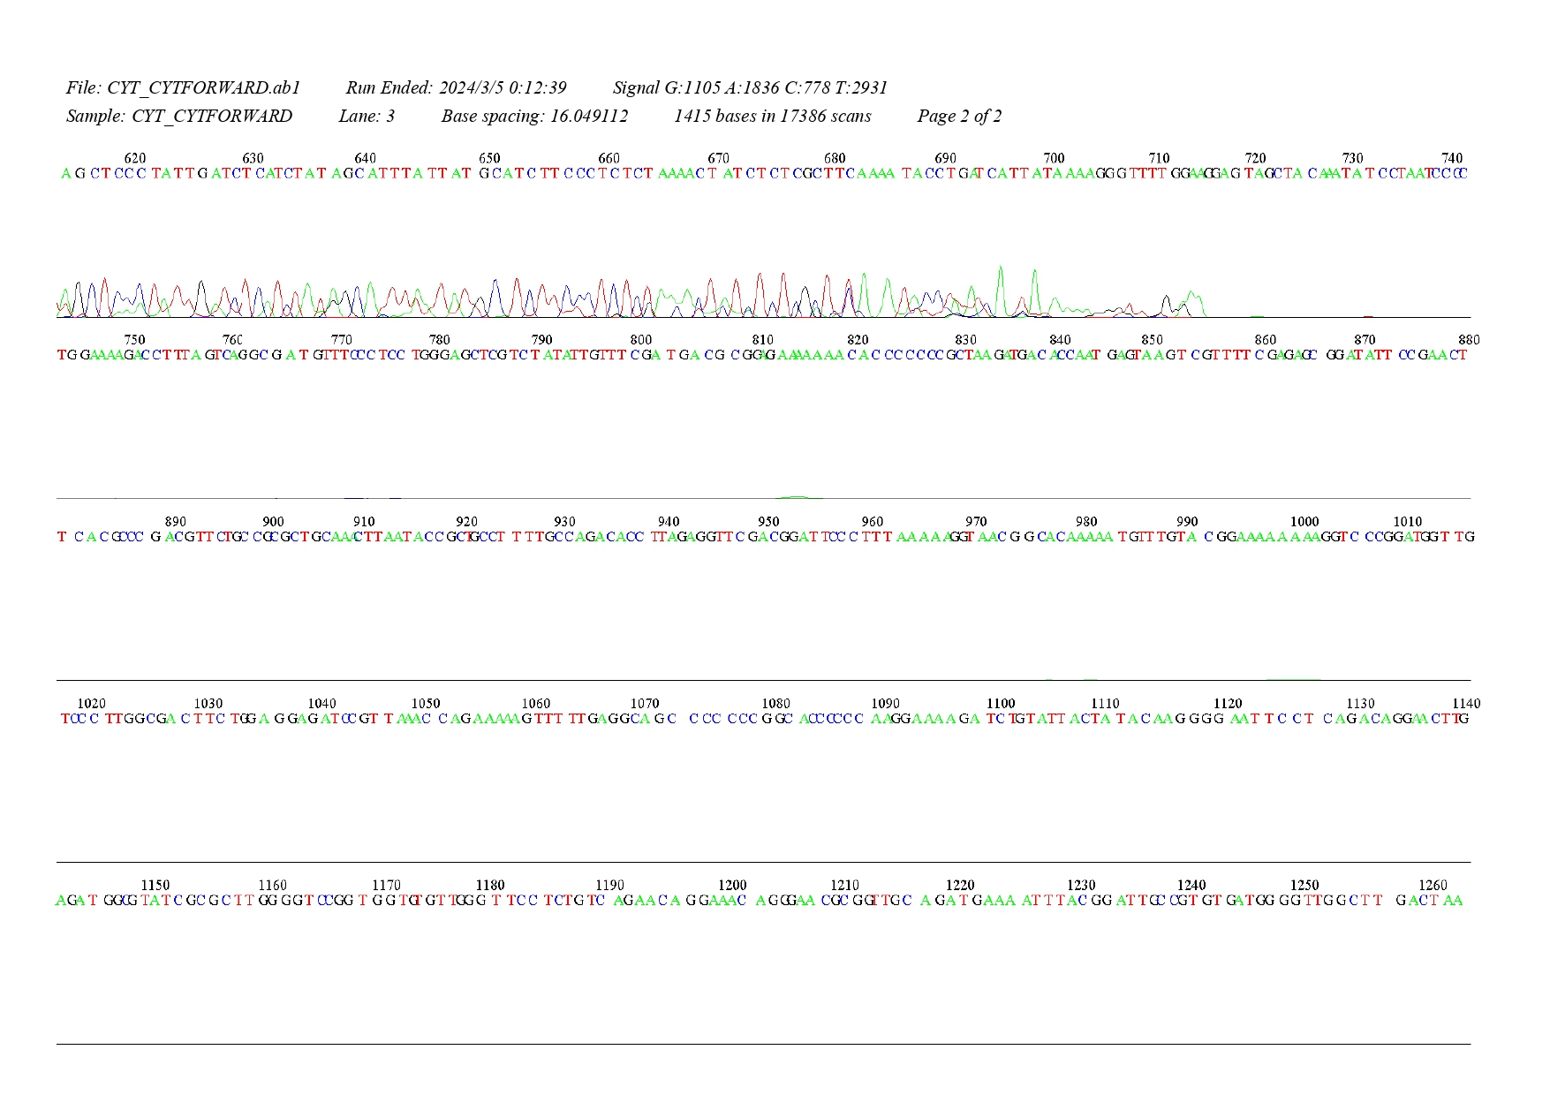

Cytb REVERSE

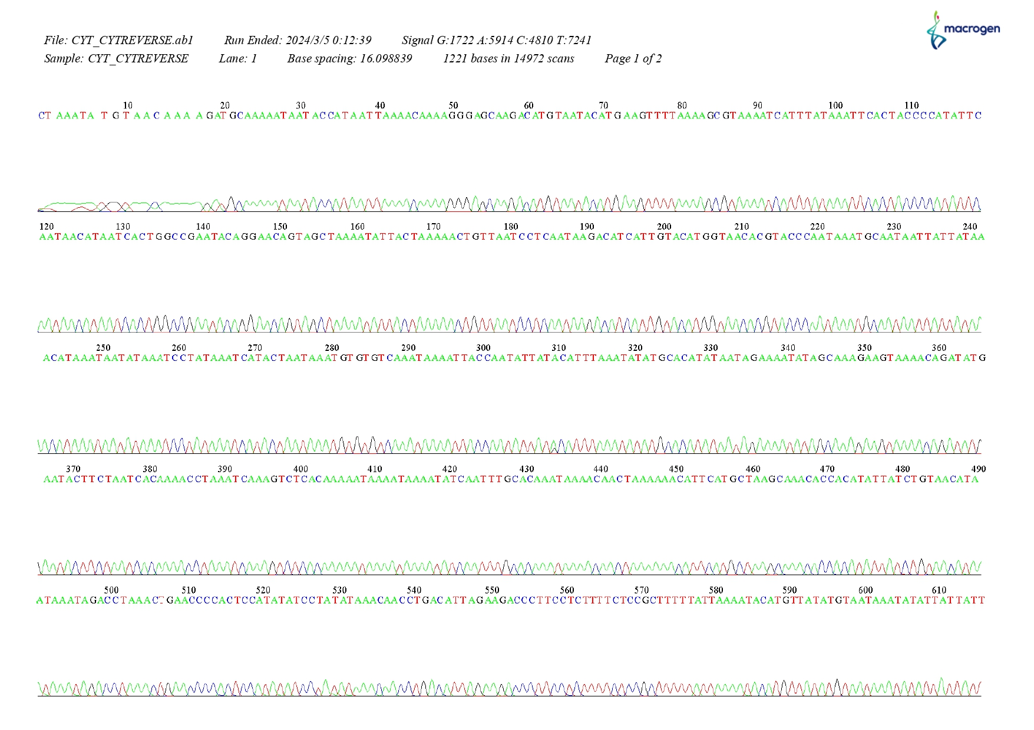
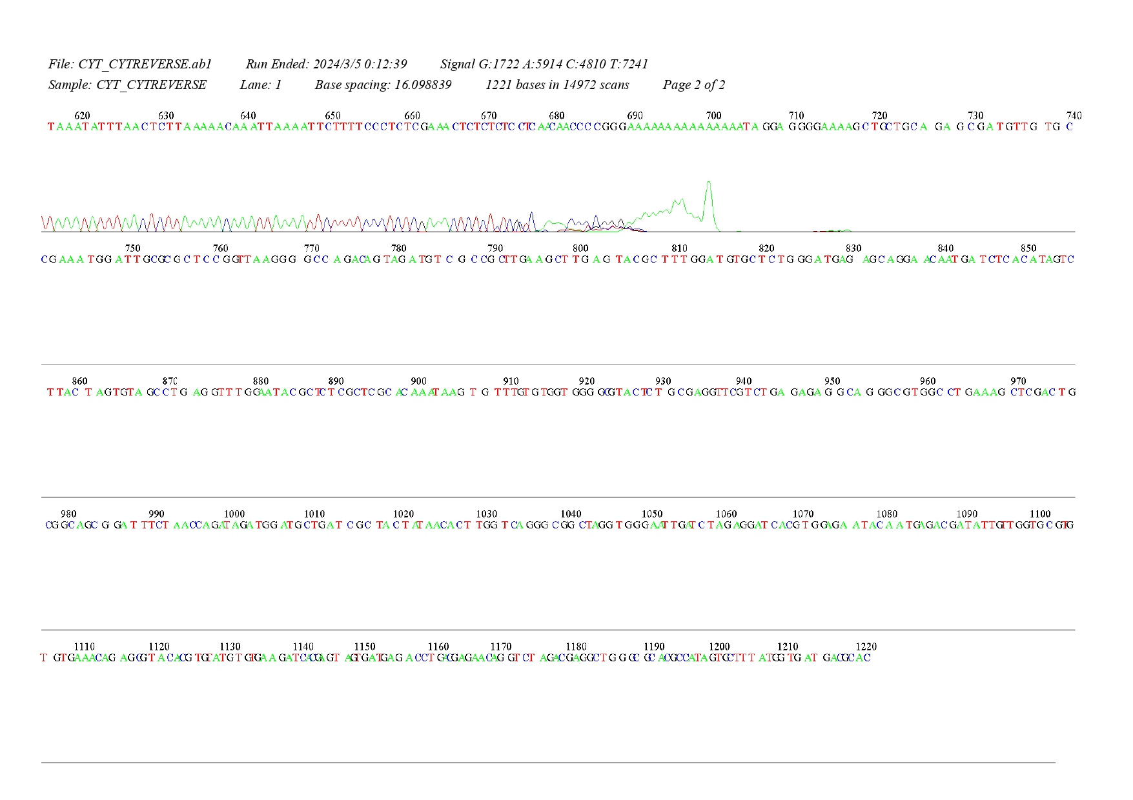

SR18s FORWARD
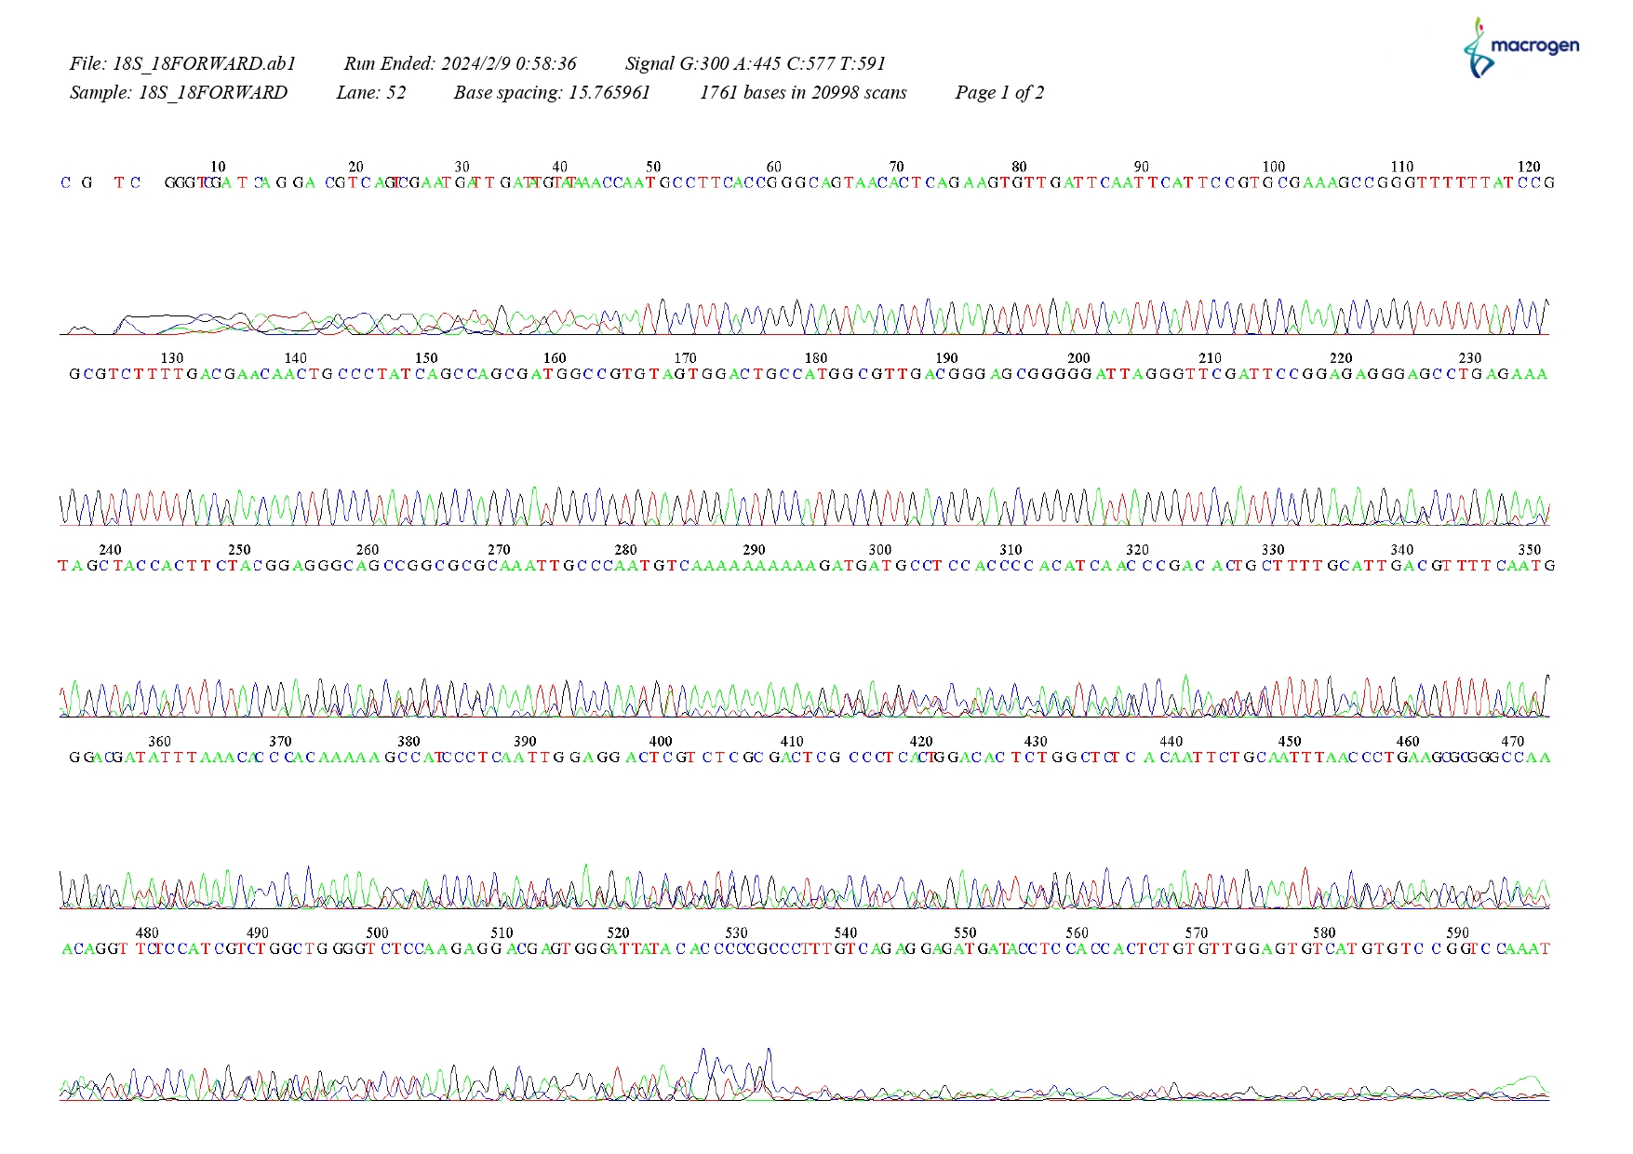
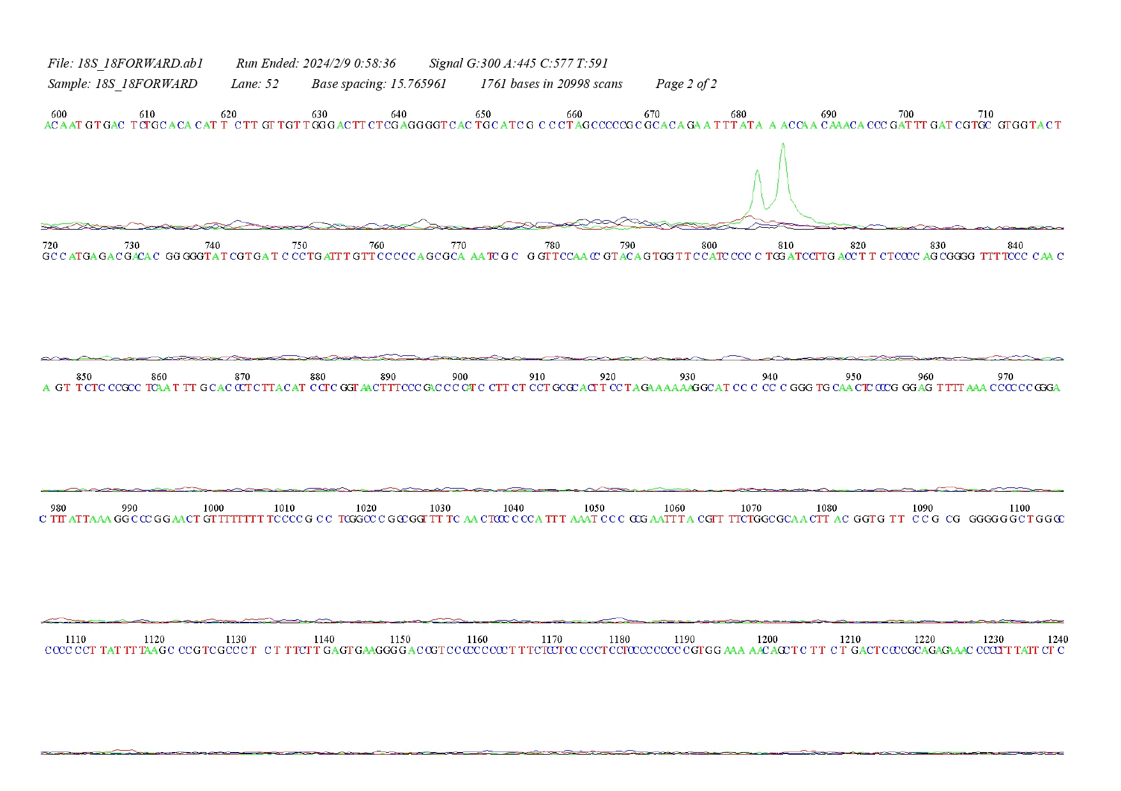

SR18s REVERSE

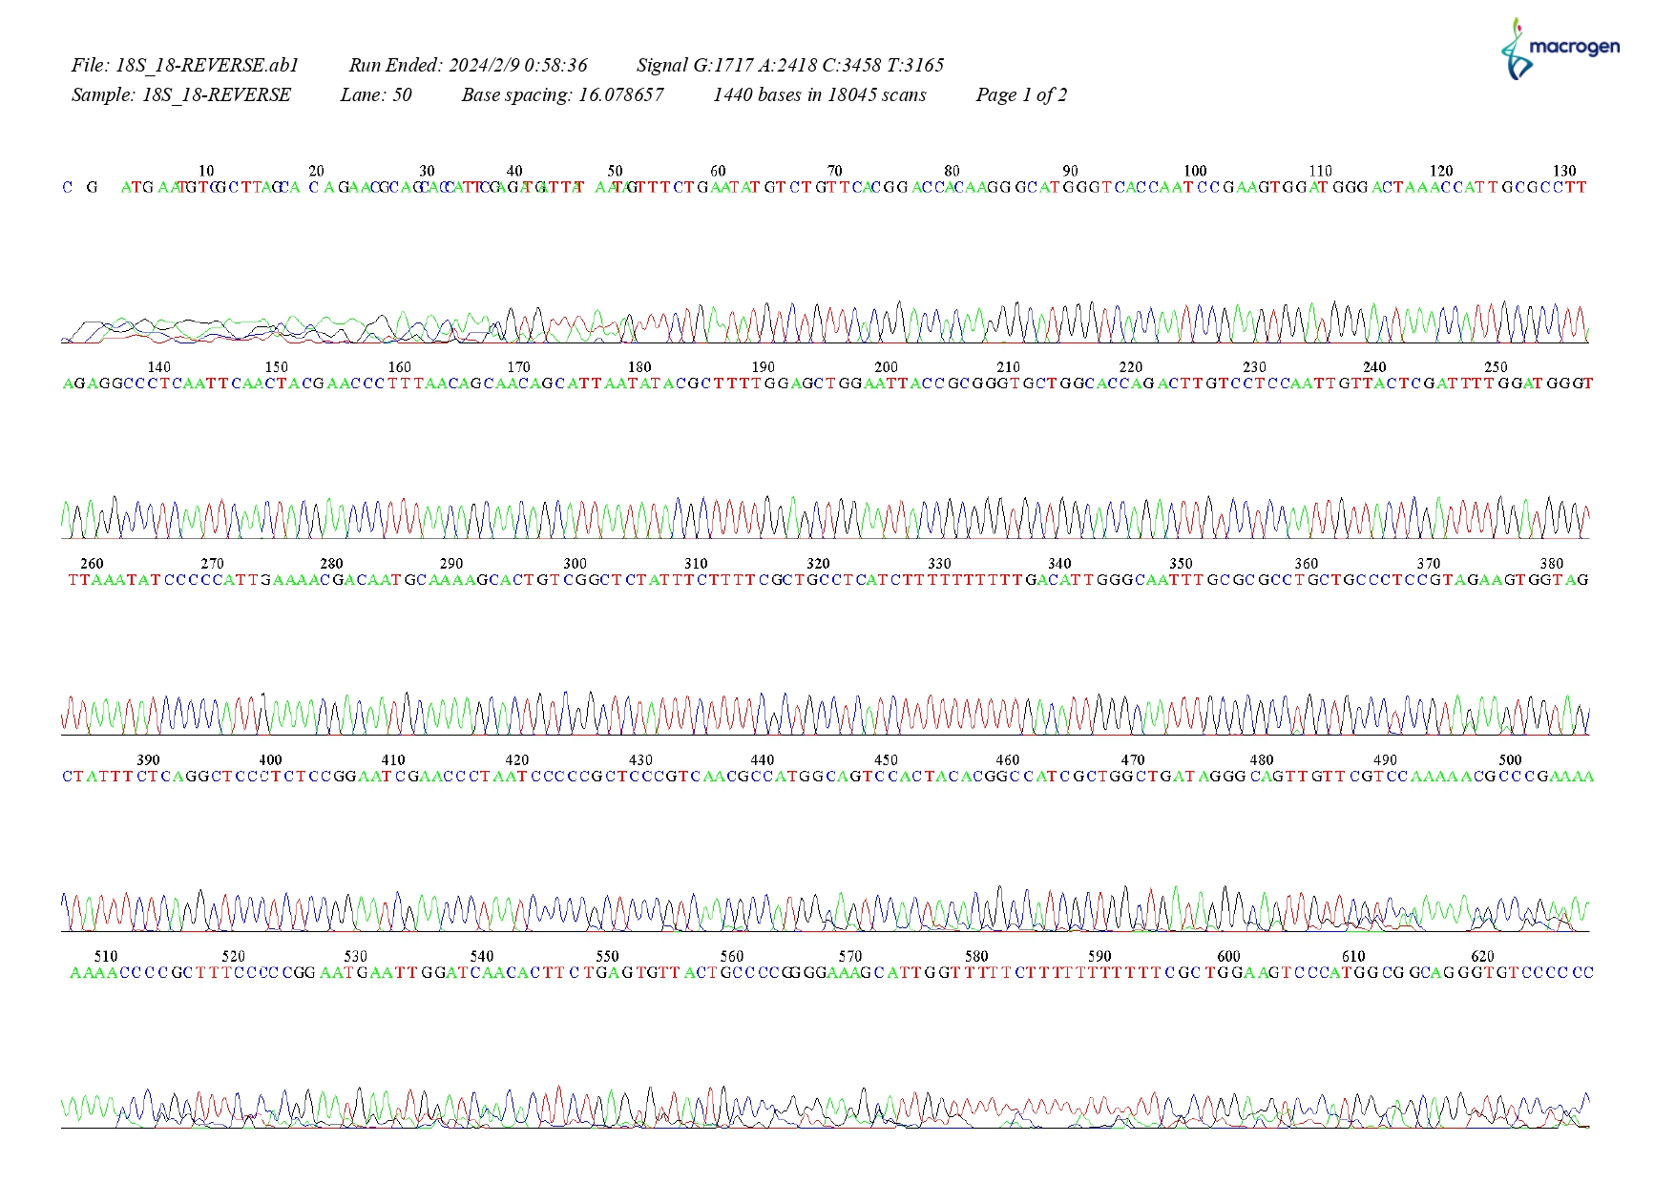
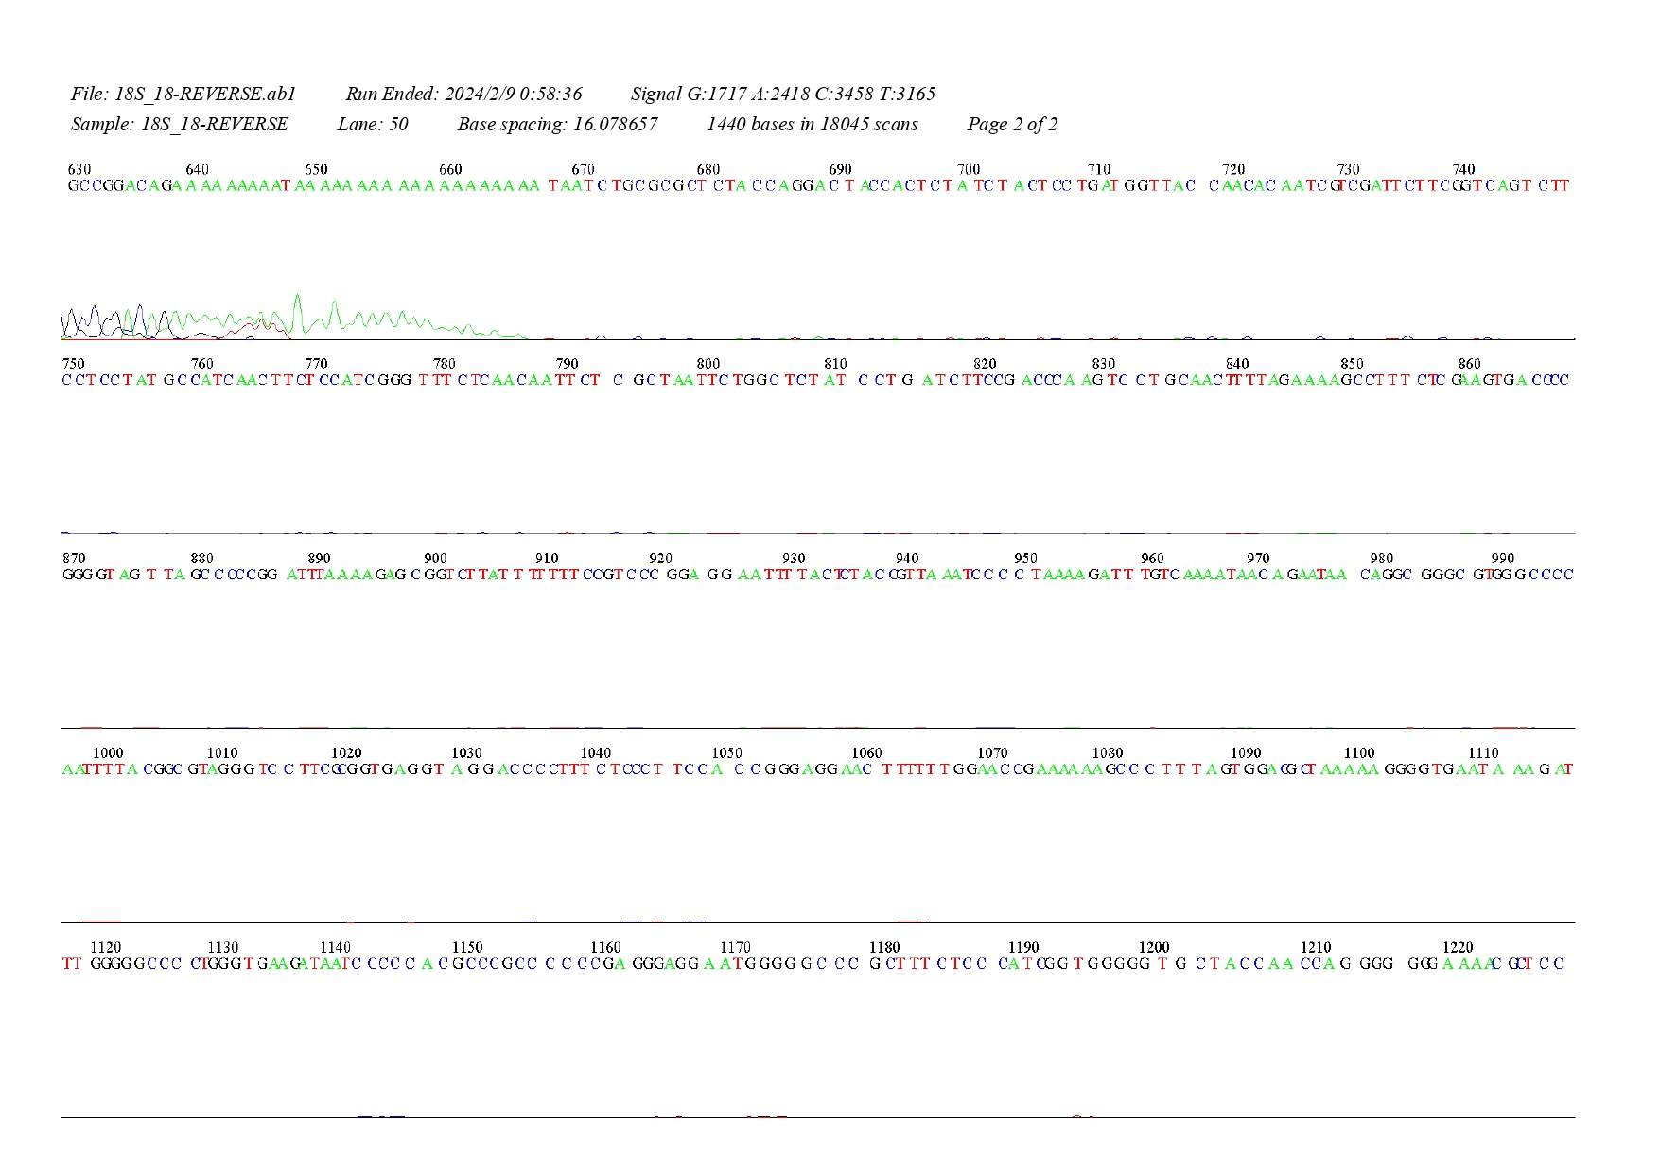

H2A FORWARD

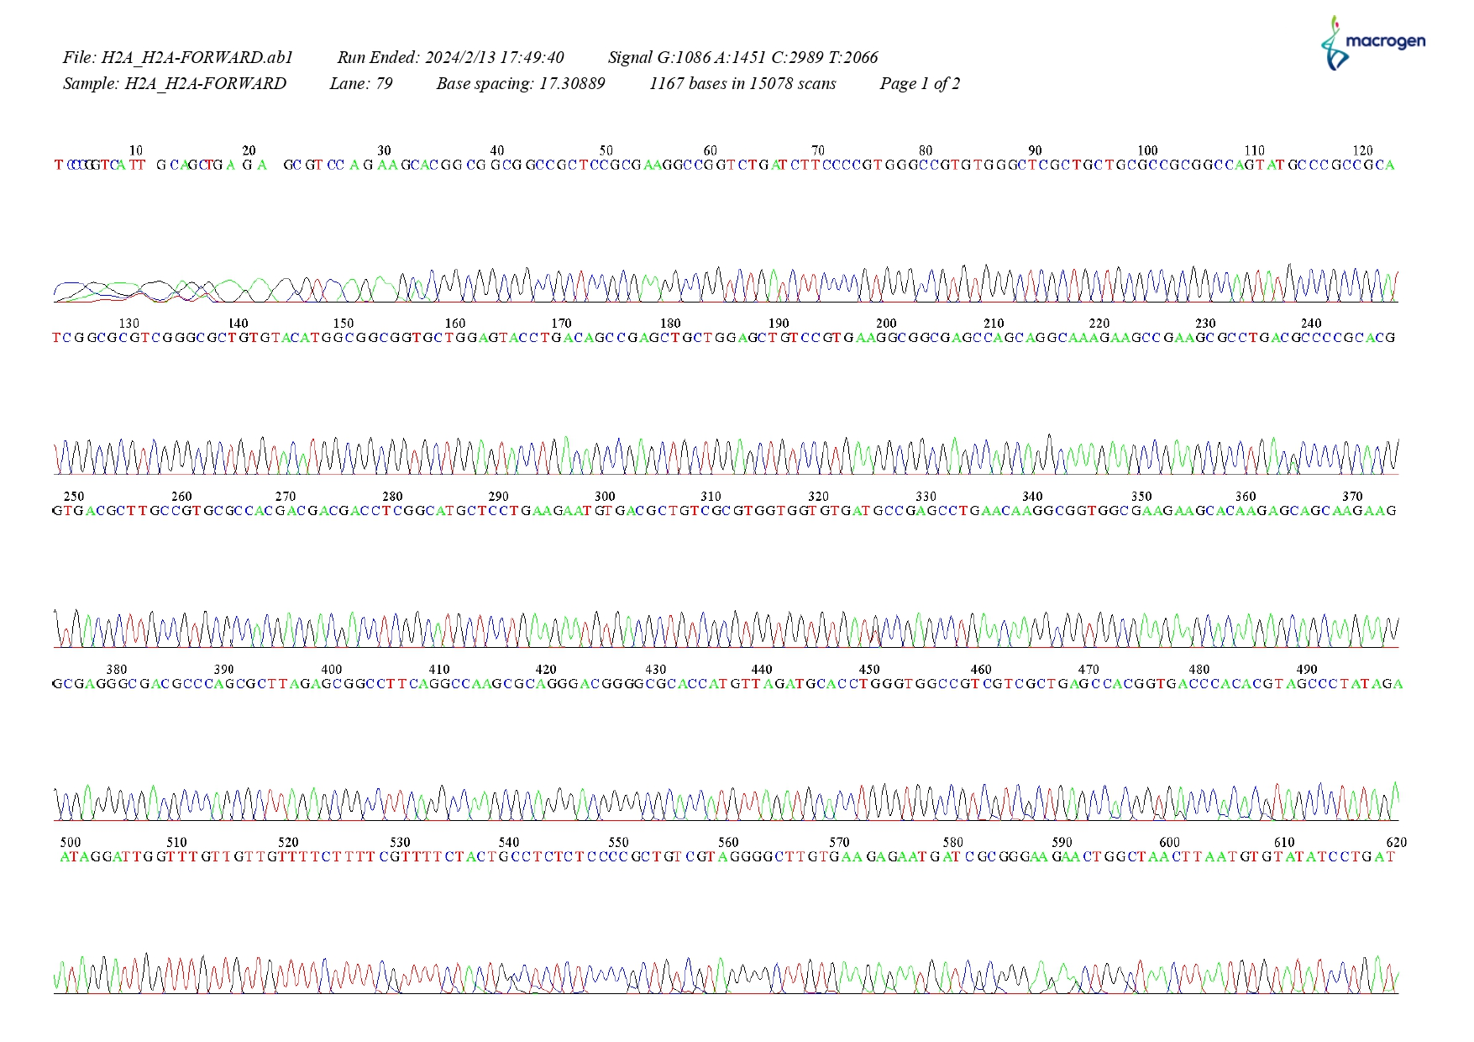
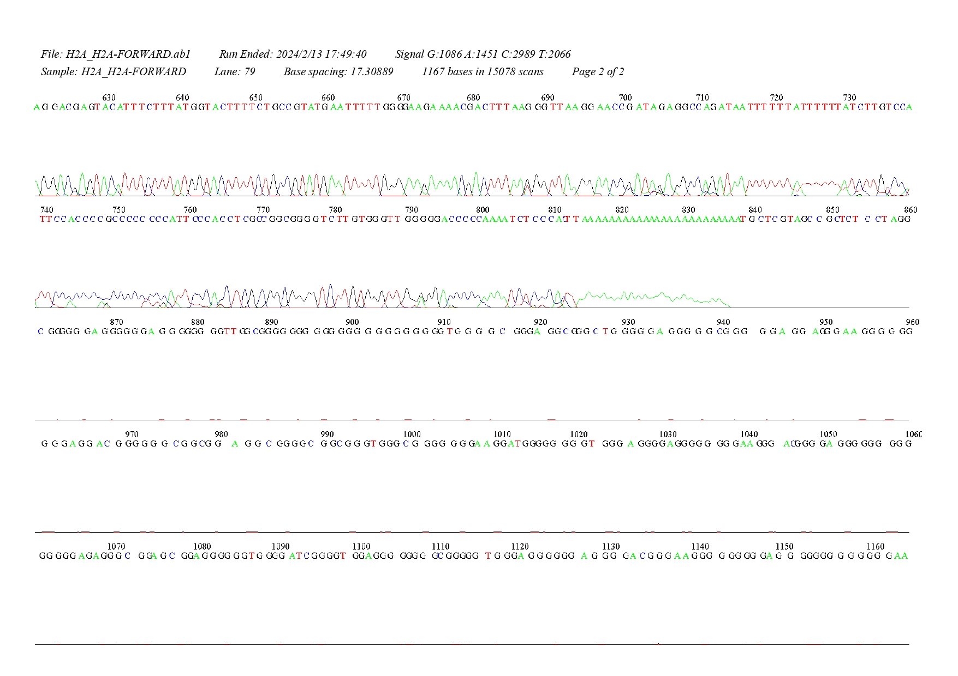

H2A REVERSE
