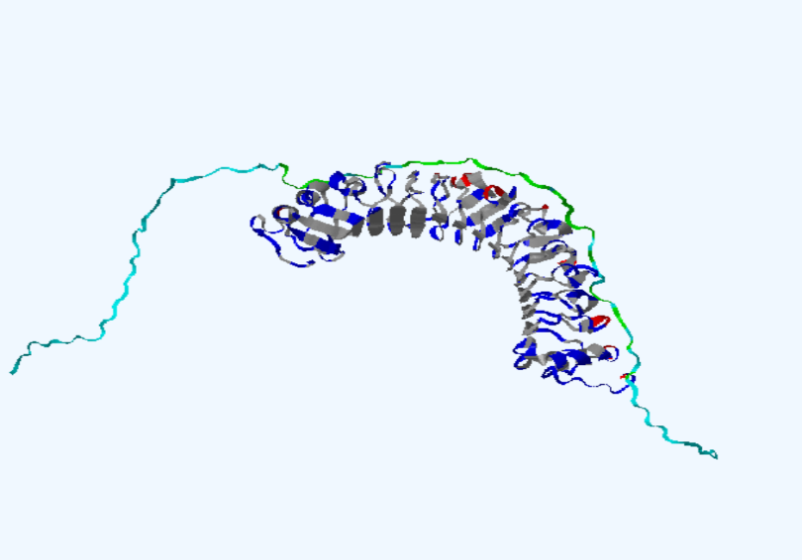
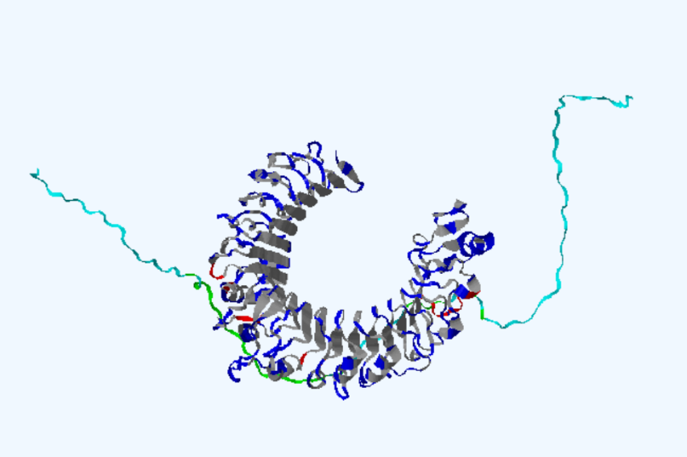
B
A

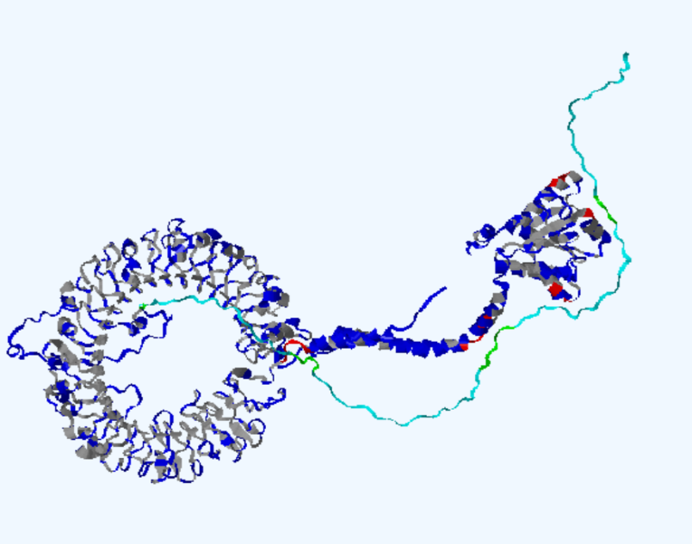
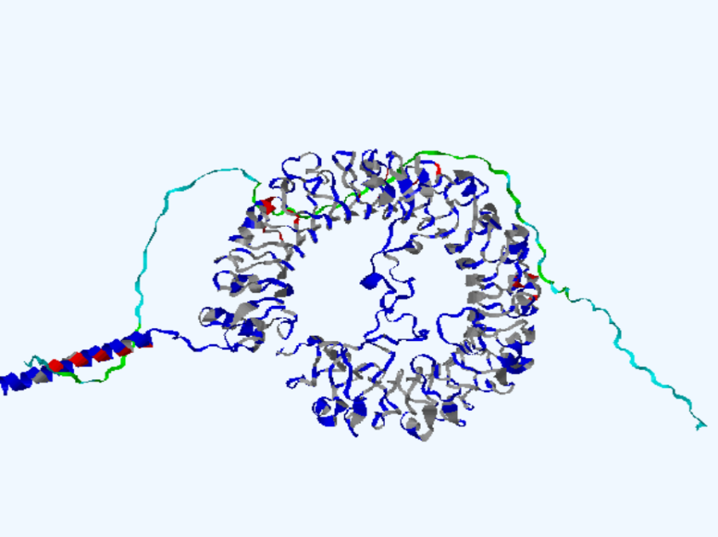
D
C

Figure 1S. Molecular docking analysis of the vaccination complexes with the HADDOCK v.2.4 server (A-D). Ribbon representation of the docked structures involving vaccine-TLR-2 (A), vaccine-TLR-4 (B), vaccine-TLR-7 (C) and vaccine-TLR-9 (D). The vaccine is shown in light blue, while the receptors are in dark blue.

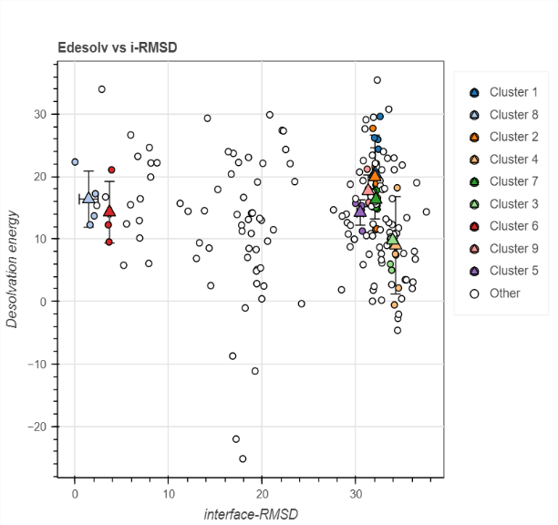
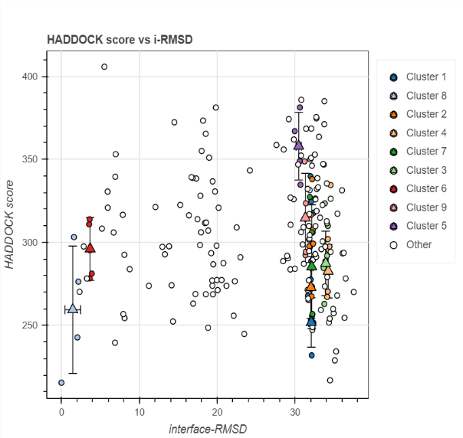
B
A

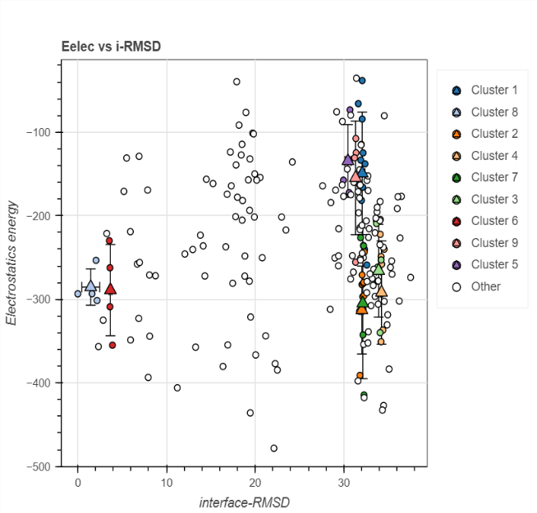
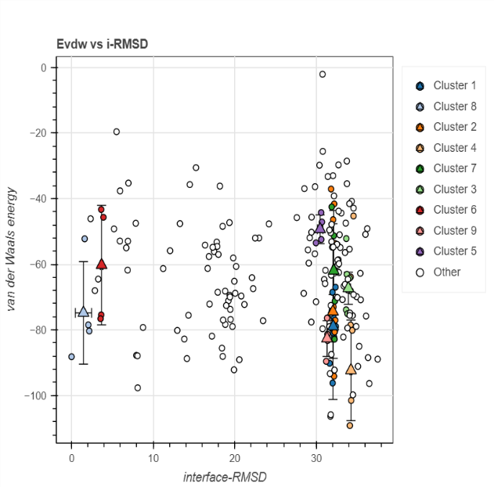
C
D

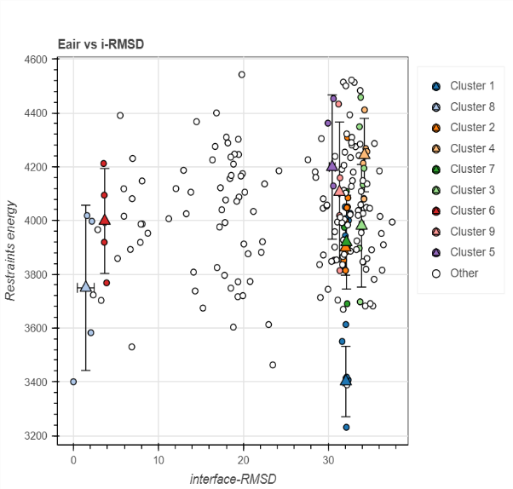
E

Figure 2S. Graphs obtained from HADDOCK v.2.4 server for vaccine-TLR-2 complex. (A) HADDOCK score vs i-RMSD, (B) Edsolv vs i-RMSD, (C) Evdw vs i-RMSD, (D) Eelec vs i-RMSD and (E) Eair vs i-RMSD.

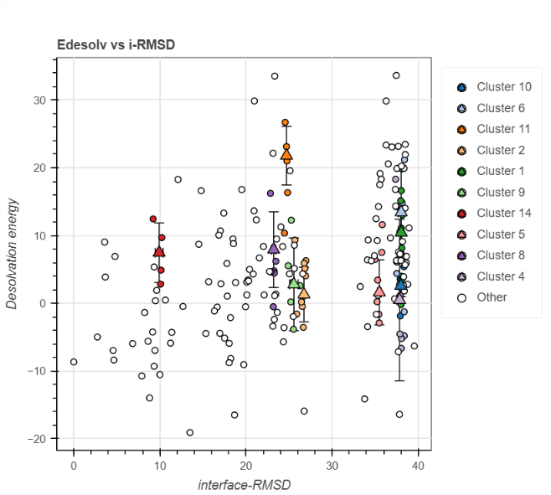
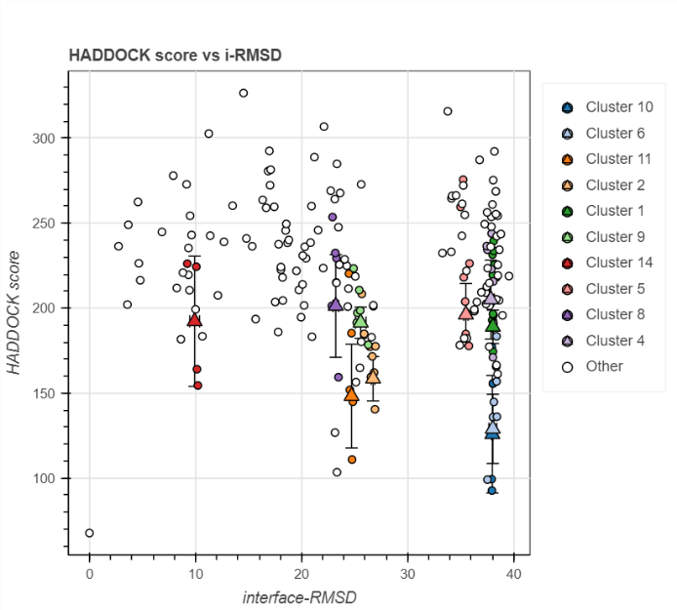
B
A

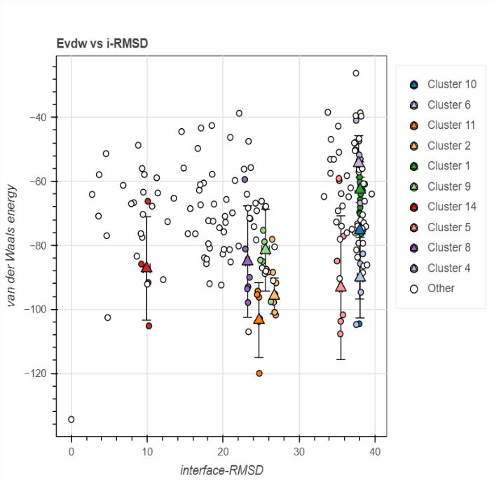
C
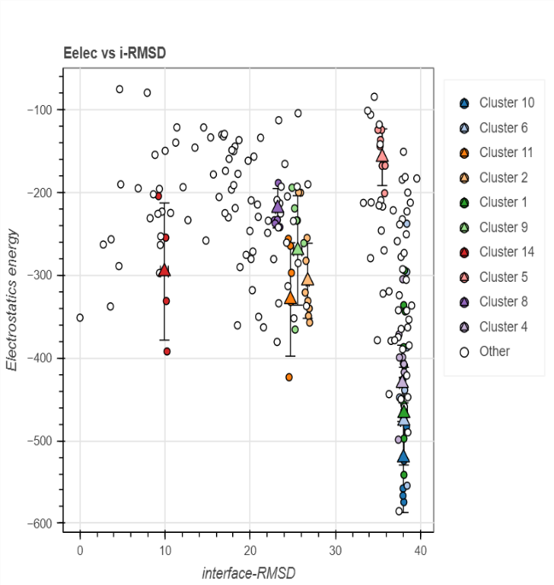
D

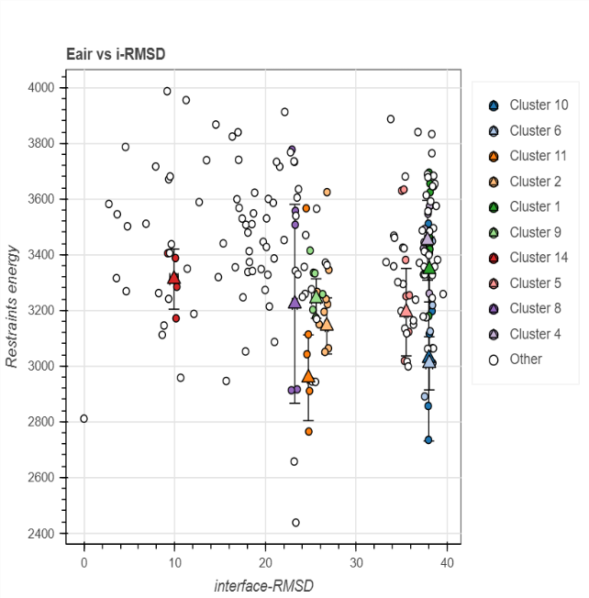
E

Figure 3S. Graphs obtained from HADDOCK v.2.4 server for vaccine-TLR-4 complex. (A) HADDOCK score vs i-RMSD, (B) Edsolv vs i-RMSD, (C) Evdw vs i-RMSD, (D) Eelec vs i-RMSD and (E) Eair vs i-RMSD.
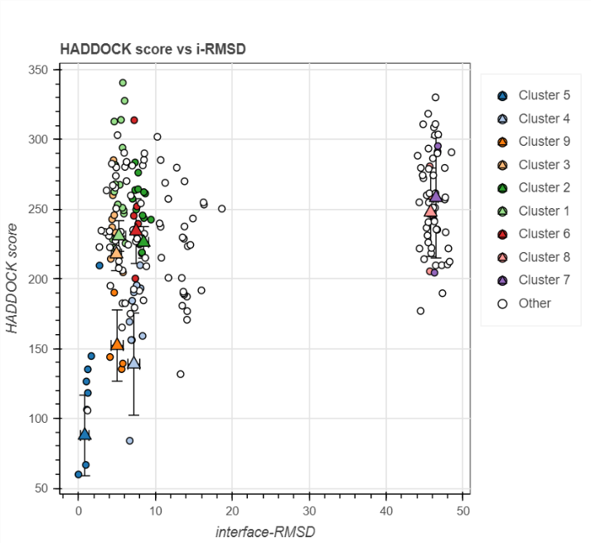
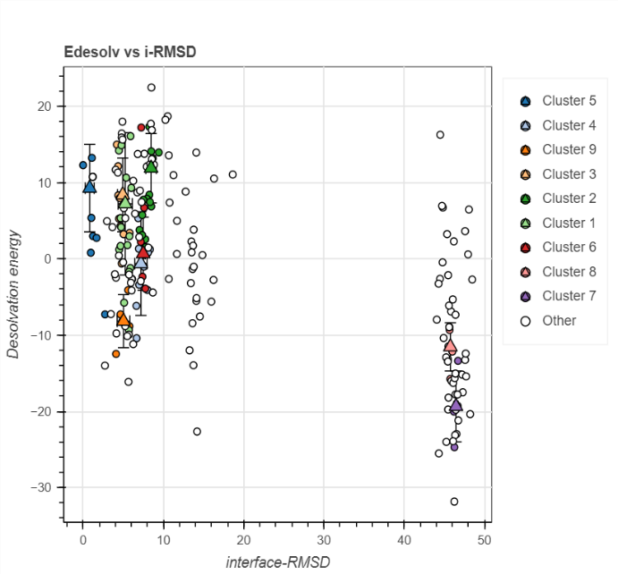
B
A

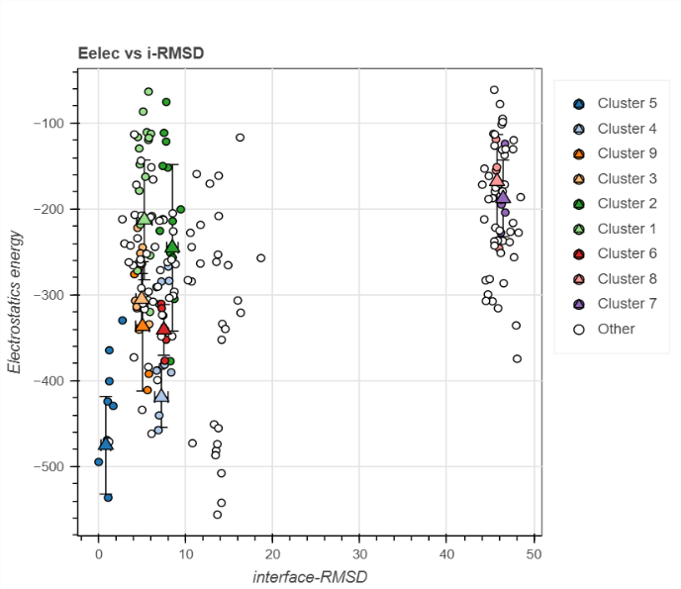
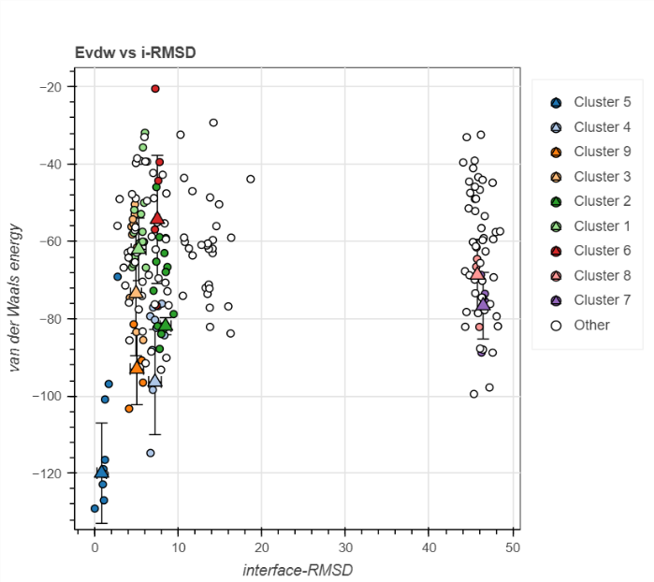
D
C

F
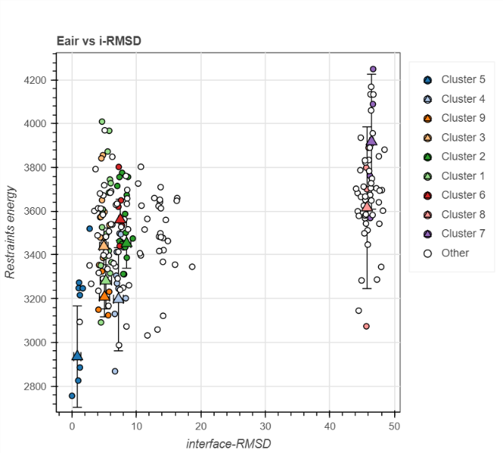
Figure 4S. Graphs obtained from HADDOCK v.2.4 server for vaccine-TLR-7 complex. (A) HADDOCK score vs i-RMSD, (B) Edsolv vs i-RMSD, (C) Evdw vs i-RMSD, (D) Eelec vs i-RMSD and (E) Eair vs i-RMSD.
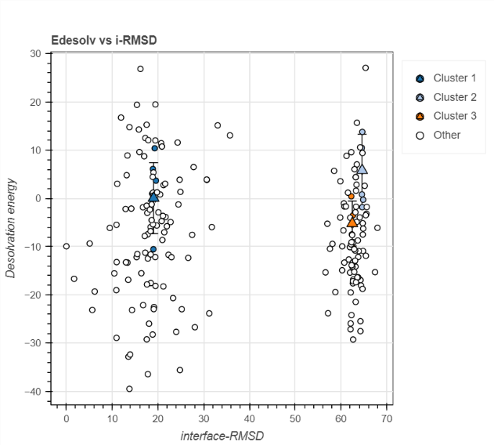
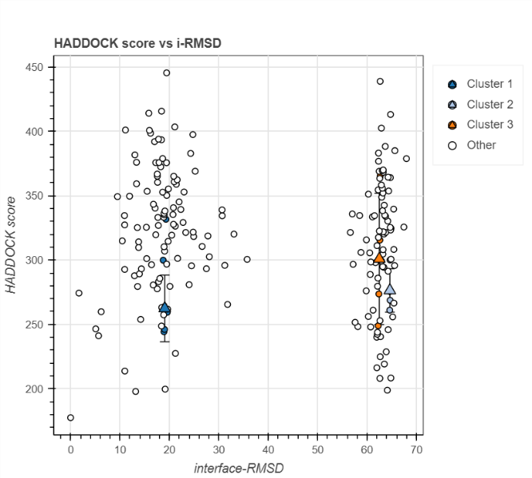
B
A

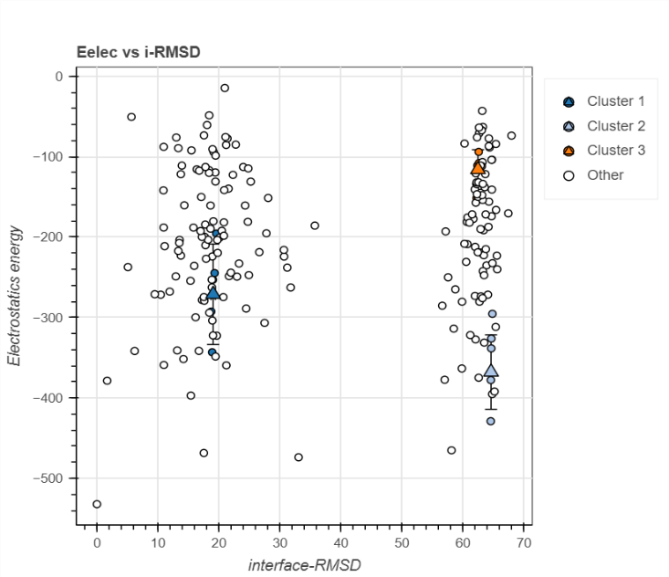
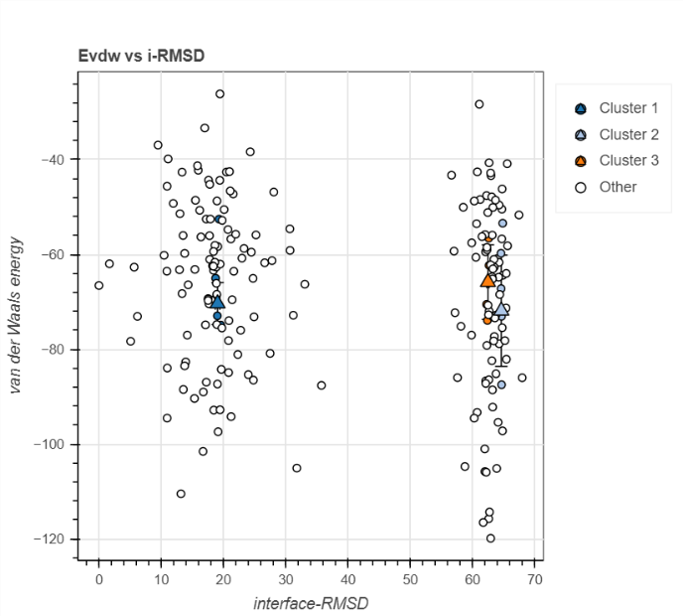
D
C

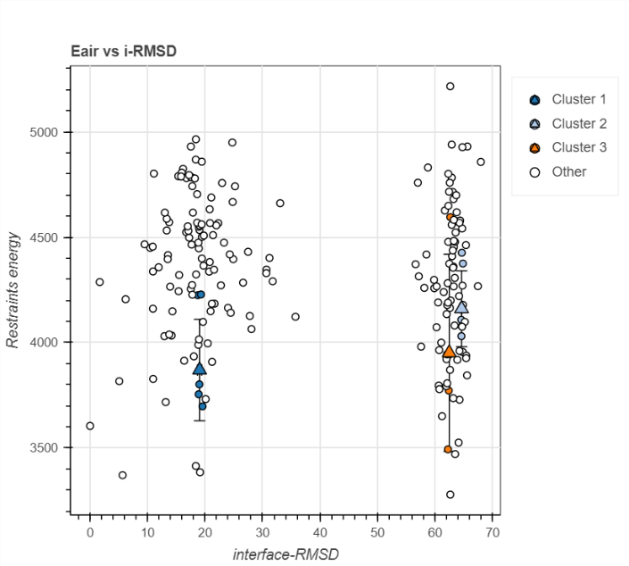
E

Figure 5S. Graphs obtained from HADDOCK v.2.4 server for vaccine-TLR-7 complex. (A) HADDOCK score vs i-RMSD, (B) Edsolv vs i-RMSD, (C) Evdw vs i-RMSD, (D) Eelec vs i-RMSD and (E) Eair vs i-RMSD.
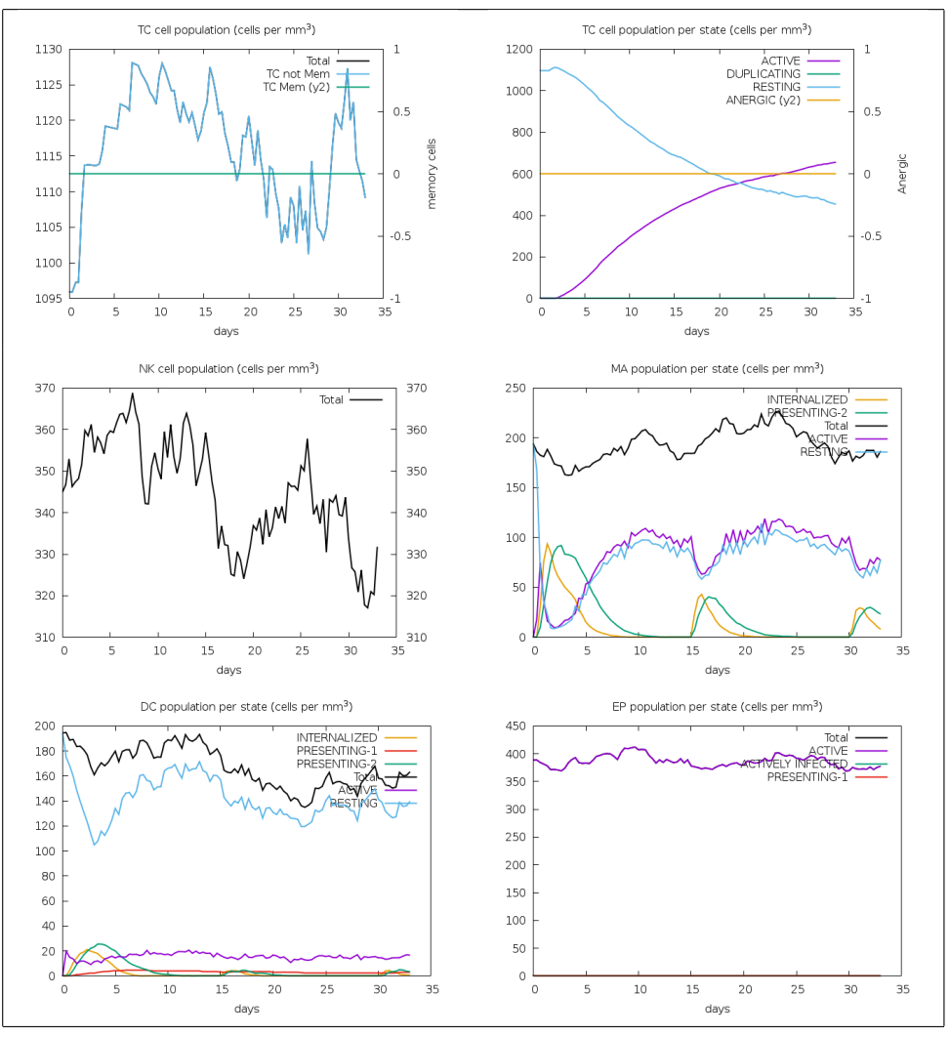
Figure 6S. Predictions of T cell responses generated by the C-ImmSim service. (A) The maturation of helper T cells (TH) alongside their memory cell lifespan, (B) The TH cell population relative to state cells, (C) The progression of NK cell populations, (D) MA populations per state, (E) DC cell population, (F) EP populations per state, following vaccine administration.

