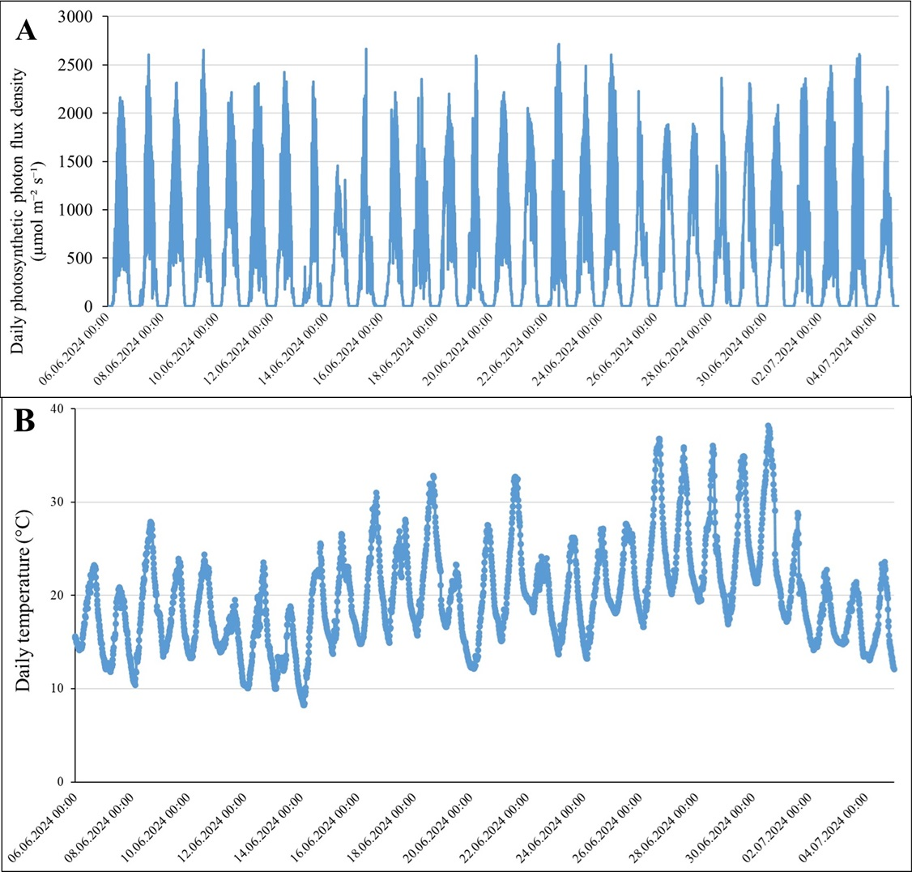
Supplementary Figure 1. (A) Daily photosynthetic photon flux density and (B) temperature recorded throughout the experimental period.

