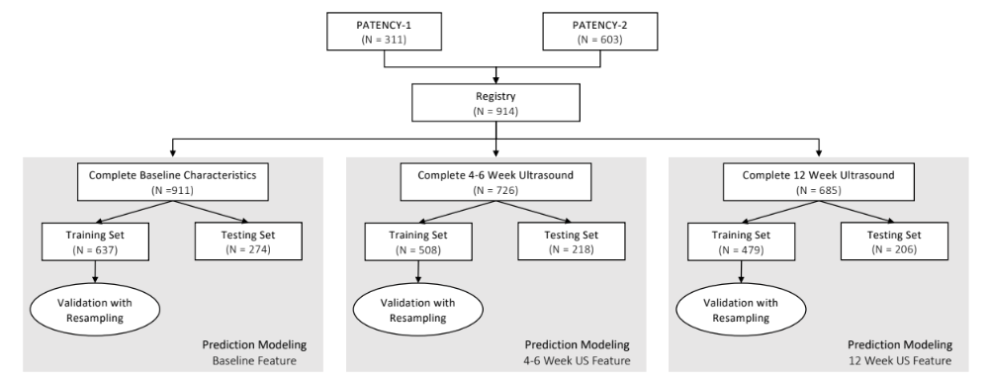

Supplemental Figure 1. Sample size flowchart and modeling breakdown into training and testing sets.

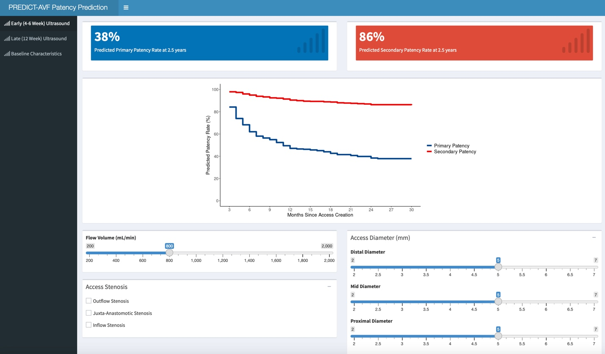

Supplemental Figure 2. Screen shot of PREDICT-AVF web app predicting primary and secondary patency. Users can switch between models using baseline characteristics, 4-6 weeks ,and 12 post-operative weeks ultrasound data.

