Synaptic markers are associated with cognitive decline after accounting for amyloid burden among an at-risk Alzheimer’s disease cohort

Supplemental Information

Supplemental Table 1.
Sample Characteristics of Participants of the Wisconsin Registry for Alzheimer’s Prevention and the Wisconsin Alzheimer’s Disease Research Center Studies Included in Aim 2 (n=346) of the Present Study
Variable |  | Aim 2 (limited) Sample  n=346 | A$β$- | A$β$+
 |  | Aim 2 (limited) Sample  n=346 | N(%)=241(69.7) | N(%)=105(30.3)
Demographics | Age (years) at Biomarker Visit | 66.18 (7.79) | 64.18 (7.29)* | 70.77 (6.94)*
Demographics | Age (years) at PACC Baseline | 56.73 (8.11) | 55.21 (7.27)* | 59.37 (8.88)*
Demographics | Women, n(%) | 235 (67.9%) | 165 (68.5%) | 70 (66.7%)
Demographics | White (non-Hispanic), n(%) | 312 (90.2%) | 215 (89.2%) | 97 (92.4%)
Demographics | Education total years  (median ± 25% quartile) | 16 (lower 25%=14,  upper 25%=18) | 16 (lower 25%=14,  upper 25%=18) | 16 (lower 25%=14,  upper 25%=18)
Demographics | Number of PACC visits (practice)  (median ± 25% quartile) | 5 (lower 25%=3,  upper 25%=6) | 5 (lower 25%=3,  upper 25%=6)* | 5 (lower 25%=3.5,  upper 25%=6)*
Cognitive Status at CSF Lumbar puncture | Cognitively Unimpaired, n(%) | 314 (90.8%) | 235 (97.5%)b | 79 (75.2%)a
Cognitive Status at CSF Lumbar puncture | Mild Cognitive Impairment, n(%) | 24 (6.9%) | 4 (1.2%)a | 20 (5.8%)b
Cognitive Status at CSF Lumbar puncture | Dementia, n(%) | 8 (2.3%) | 2 (0.8%)a | 6 (1.7%)b
AD Specific BiomarkerS | p-tau181 (pg/mL; M (s.d.) | 19.909 (8.839) | 16.454 (4.837)* | 27.841 (10.677)*
AD Specific BiomarkerS | Aβ42 (pg/mL; M (s.d.) | 1171.201 (460.449) | 1352.460 (399.567)* | 755.167 (289.825)*
AD Specific BiomarkerS | p-tau181/Aβ42 ratio | 0.021(0.017) | .012 (.003)* | .041 (.020)*
Neuronal Degeneration | NfL (pg/mL; M (s.d.) | 121.972 (59.079) | 106.915 (48.321)* | 156.532 (66.773)*
Synaptic FUNCTIONING | Ng (pg/mL; M (s.d.) | 948.971 (348.862) | 845.449 (275.605)* | 1186.567 (483.978)*
Synaptic FUNCTIONING | SNAP-25 (pg/mL; M (s.d.) | 2.420 (0.804) | 2.178 (.572)* | 2.974 (.974)*
Synaptic FUNCTIONING | NPTX2 (pg/mL; M (s.d.) | 6985.970 (2721.623) | 6923.040 (2605.596) | 7130.430 (2979.027)
Synaptic FUNCTIONING | SNAP-25/NPTX2 ratio | .00037 (.00014) | .00034 (.00009)* | .00046 (.00018)*
Note: N = 346 for each variable; Aβ = amyloid beta; pTau = phosphorylated tau. NfL = neurofilament light; Ng = neurogranin, SNAP-25 = synaptosomal-associated protein 25; NPTX2 = Neuronal pentraxin 2. Education was measured as total years of completed education. Biomarkers of neurotransmission (NfL, Ng, SNAP-25, and NPTX2) and AD-specific proteins (p-tau181/Aβ42) were measured in CSF samples. * indicates a significant difference in means between Amyloid positive (Aβ+) and Amyloid negative (Aβ-) individuals determined using a determined cut-point of .0195 for p-tau181/Aβ42 ratio. Differences in Amyloid status within participants who were cognitively unimpaired versus diagnosed with mild cognitive impairment or dementia at baseline were conducted using a Chi-square test of association; follow-up tests indicated significant differences in the number of participants observed versus anticipated within cognitive status group across Amyloid group.

Supplemental Table 2. ANOVA and post-hoc pairwise comparisons with effect sizes for biomarker differences by clinical diagnosis

 | CU | MCI | Dementia |  |  | CU vs MCI |  |  | CU vs Dementia |  |  | MCI vs Dementia
 | Group Mean |  |  | Overall F-test | p-value | Mean Difference | Cohen's D | 95% CI | Mean Difference | Cohen's D | 95% CI | Mean Difference | Cohen's D | Lower 2.5%
Aβ42 | 1183.862 | 802.069 | 788.3 | 13.547 | <.001 | 381.793 | 0.864 | 0.498, 1.229 | 395.562 | 0.883 | 0.180, 1.586 | 13.769 | 0.031 | -0.744, 0.806
p-tau181 | 18.614 | 32.228 | 26.739 | 43.889 | <.001 | -13.614 | -1.665 | -2.042, -1.286 | -8.125 | -1.083 | -1.787, -0.378 | 5.489 | 0.415 | -0.368, 1.192
p-tau181/Aβ42 | 0.019 | 0.05 | 0.044 | 68.794 | <.001 | -0.031 | -2.035 | -2.420, -1.647 | -0.025 | -1.817 | -2.527, -1.104 | 0.006 | 0.213 | -0.564, 0.988
NfL | 112.892 | 209.44 | 196.338 | 56.967 | <.001 | -96.548 | -1.813 | -2.193, -1.430 | -83.446 | -1.657 | -2.366, -0.946 | 13.102 | 0.179 | -0.598, 0.953
Ng | 920.365 | 1231.506 | 977.363 | 9.658 | <.001 | -311.141 | -0.807 | -1.171, -0.441 | -56.998 | -0.154 | -0.854, 0.547 | 254.143 | 0.505 | -0.281, 1.284
SNAP-25 | 2.315 | 3.324 | 2.776 | 22.239 | <.001 | -1.009 | -1.325 | -1.734, -0.913 | -0.461 | -0.641 | -1.343, 0.063 | 0.548 | 0.499 | -0.306, 1.297
NPTX2 | 7056.98 | 6364.15 | 4895.13 | 3.216 | 0.041 | 692.83 | 0.258 | -0.141, 0.658 | 2161.85 | 0.823 | 0.119, 1.527 | 1469.02 | 0.438 | -0.365, 1.234
SNAP-25/NPTX2 | 0.0003 | 0.0006 | 0.0007 | 82.093 | <.001 | -0.0003 | -2.180 | -2.608, -1.749 | -0.0004 | -3.159 | -3.897, -2.416 | -0.0001 | -0.424 | -1.220, 0.378

Note: CU = cognitively unimpaired, MCI = mild cognitive impairment; cognitive status determined by visit closest to CSF biomarker data collection; comparisons used raw concentrations of biomarkers; sample sizes differed depending on biomarker availability (see Table 2); Cohen’s D calculated for post-hoc pairwise comparisons; significant group differences are bolded.

Supplemental Table 3. Estimated effect of each biomarker by Aβ status ages 60, 70, and 80

Biomarker | Aβ status | Age | Est. | S.E. | 95% CI | t-value | p-value
“Aβ + only” model | n/a | 60 | -0.634 | 1.474 | -3.522, 2.254 | -0.430 | 0.667
“Aβ + only” model | n/a | 70 | -7.187 | 1.873 | -10.859, -3.516 | -3.837 | <0.0001
“Aβ + only” model | n/a | 80 | -13.741 | 2.985 | -19.592, -7.890 | -4.603 | <0.0001
“Aβ + NfL”  model | Aβ + | 60 | 4.112 | 2.721 | -1.221, 9.445 | 1.511 | 0.132
“Aβ + NfL”  model | Aβ + | 70 | -2.216 | 2.906 | -7.911, 3.479 | -0.763 | 0.446
“Aβ + NfL”  model | Aβ + | 80 | -8.544 | 4.302 | -16.975, -0.112 | -1.986 | 0.049
“Aβ + NfL”  model | Aβ - | 60 | 4.112 | 2.721 | -1.221, 9.445 | 1.511 | 0.132
“Aβ + NfL”  model | Aβ - | 70 | -2.216 | 2.906 | -7.911, 3.479 | -0.763 | 0.446
“Aβ + NfL”  model | Aβ - | 80 | -8.544 | 4.302 | -16.975, -0.113 | -1.986 | 0.049
“Aβ + Ng”  model | Aβ + | 60 | -1.725 | 0.982 | -3.650, 0.200 | -1.757 | 0.080
“Aβ + Ng”  model | Aβ + | 70 | -2.302 | 1.199 | -4.651, 0.048 | -1.920 | 0.056
“Aβ + Ng”  model | Aβ + | 80 | -4.625 | 2.424 | -9.375, 0.125 | -1.908 | 0.058
“Aβ + Ng”  model | Aβ - | 60 | 4.333 | 1.130 | 2.118, 6.547 | 3.835 | <0.0001
“Aβ + Ng”  model | Aβ - | 70 | 2.409 | 1.607 | -0.741, 5.559 | 1.499 | 0.135
“Aβ + Ng”  model | Aβ - | 80 | -3.903 | 3.547 | -10.855, 3.048 | -1.101 | 0.272
“Aβ + SNAP-25”  model | Aβ + | 60 | -2.180 | 1.041 | -4.220, -0.139 | -2.094 | 0.037
“Aβ + SNAP-25”  model | Aβ + | 70 | -2.321 | 1.126 | -4.527, -0.115 | -2.062 | 0.040
“Aβ + SNAP-25”  model | Aβ + | 80 | -4.946 | 1.778 | -8.431, -1.461 | -2.782 | 0.006
“Aβ + SNAP-25”  model | Aβ - | 60 | 2.494 | 1.112 | 0.315, 4.673 | 2.243 | 0.026
“Aβ + SNAP-25”  model | Aβ - | 70 | 2.353 | 1.311 | -0.216, 4.921 | 1.795 | 0.073
“Aβ + SNAP-25”  model | Aβ - | 80 | -0.272 | 1.926 | -4.048, 3.503 | -0.141 | 0.888
“Aβ + NPTX2”  model | Aβ + | 60 | -1.671 | 1.177 | -3.977, 0.636 | -1.420 | 0.157
“Aβ + NPTX2”  model | Aβ + | 70 | 0.996 | 1.403 | -1.754, 3.747 | 0.710 | 0.478
“Aβ + NPTX2”  model | Aβ + | 80 | 6.351 | 2.679 | 1.100, 11.601 | 2.370 | 0.019
“Aβ + NPTX2”  model | Aβ - | 60 | 3.710 | 0.827 | 2.089, 5.331 | 4.485 | <0.0001
“Aβ + NPTX2”  model | Aβ - | 70 | 3.864 | 1.194 | 1.524, 6.204 | 3.237 | 0.001
“Aβ + NPTX2”  model | Aβ - | 80 | 1.795 | 2.648 | -3.395, 6.986 | 0.678 | 0.498
“Aβ + SNAP25/NPTX2”  model | Aβ + | 60 | -2.851 | 0.750 | -4.322, -1.381 | -3.801 | <0.0001
“Aβ + SNAP25/NPTX2”  model | Aβ + | 70 | -5.249 | 0.870 | -6.955, -3.544 | -6.033 | <0.0001
“Aβ + SNAP25/NPTX2”  model | Aβ + | 80 | -9.877 | 1.413 | -12.646, -7.107 | -6.990 | <0.0001
“Aβ + SNAP25/NPTX2”  model | Aβ - | 60 | -2.851 | 0.750 | -4.322, -1.381 | -3.801 | <0.0001
“Aβ + SNAP25/NPTX2”  model | Aβ - | 70 | -5.249 | 0.870 | -6.955, -3.544 | -6.033 | <0.0001
“Aβ + SNAP25/NPTX2”  model | Aβ - | 80 | -9.876 | 1.413 | -12.645, -7.107 | -6.990 | <0.0001

Supplemental Figure 1. Age X Biomarker Associations

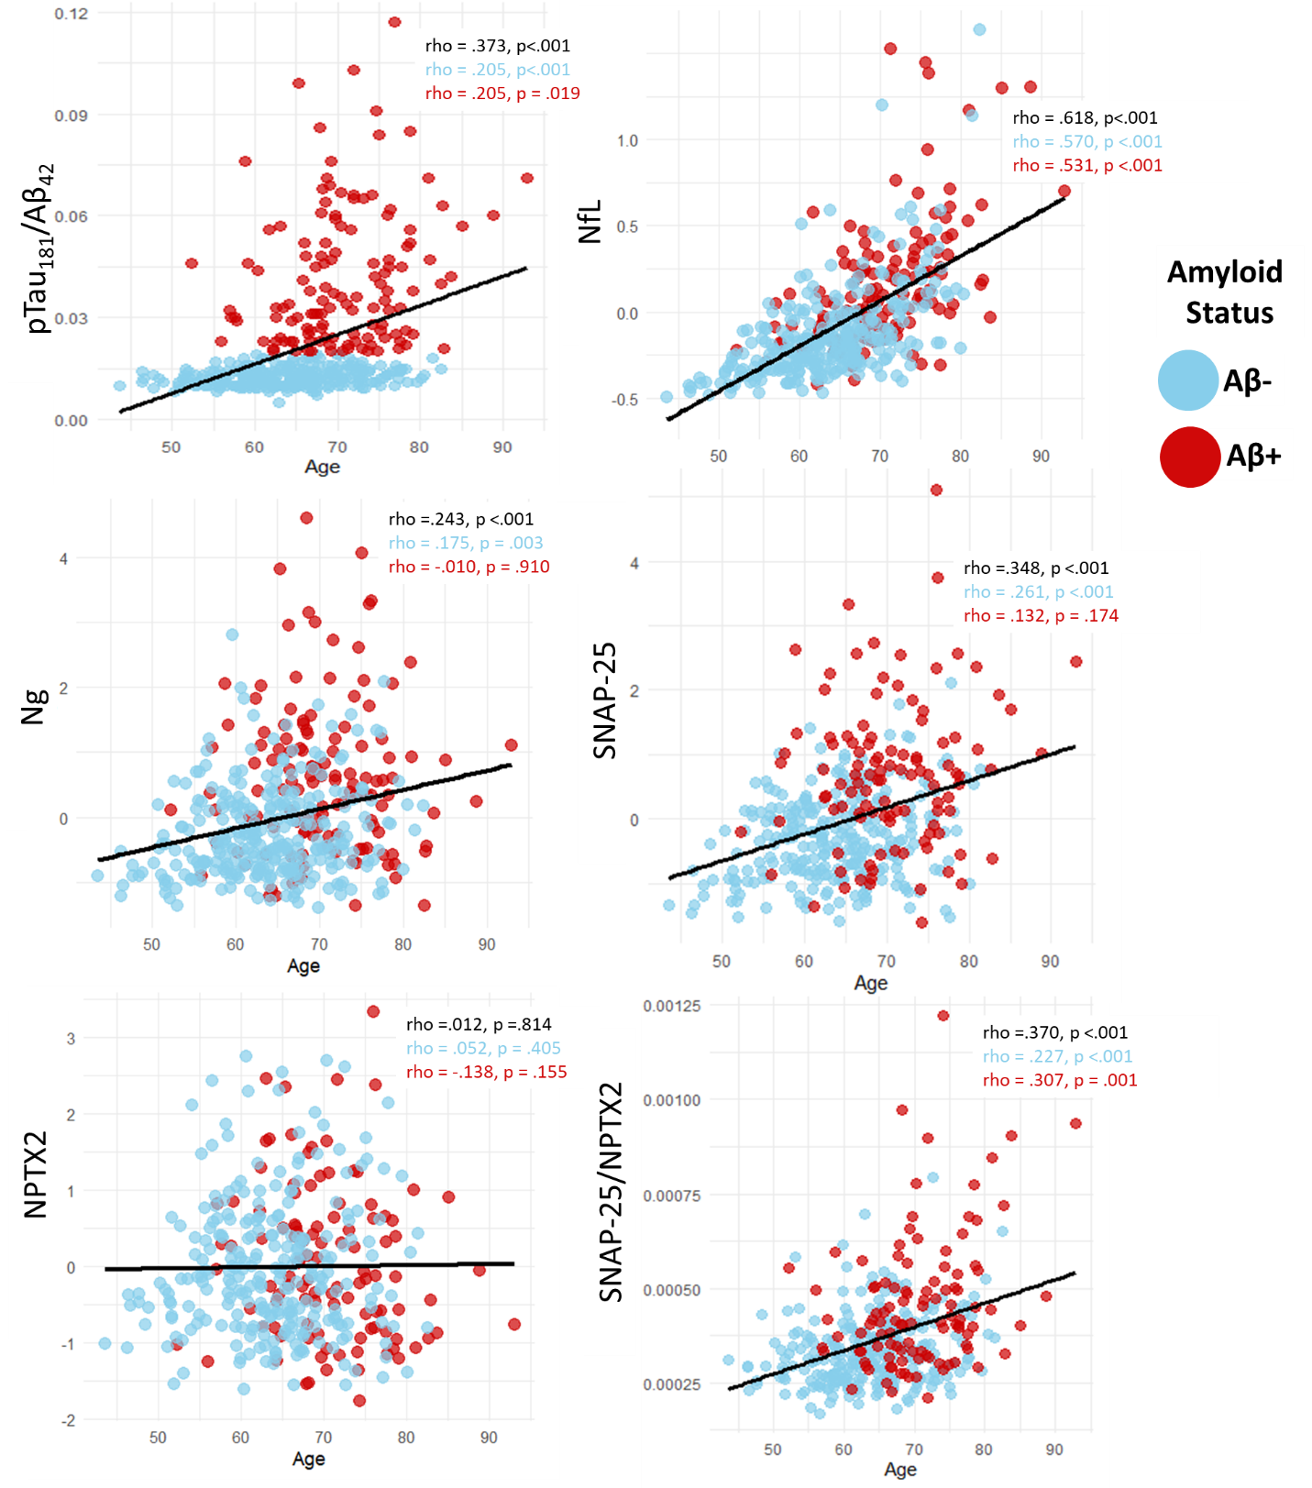

Figure Caption: Scatterplots illustrating simple relationships between Age and Biomarkers (p-tau181/Aβeta42, NfL, Ng, SNAP-25, NPTX2, and SNAP-25/NPTX2 ratio). Raw biomarker values were z-scored for ease of comparison across biomarkers and p-tau181/Aβeta42 and SNAP-25/NPTX2 are ratios. Aβ-/Aβ+ represents amyloid status (positivity) defined by the p-tau181/Aβeta42 cutoff score described in 2.3.2.3. Plots include average regression line estimating relationship between Age and Biomarker in black, and Spearman Correlations are presented for overall correlation, as well as by Aβ-/Aβ+ groups in blue and red, respectively.

Supplemental Figure 2. Group Differences (Amyloid +/- and Cognitive Status) in Biomarker Concentrations
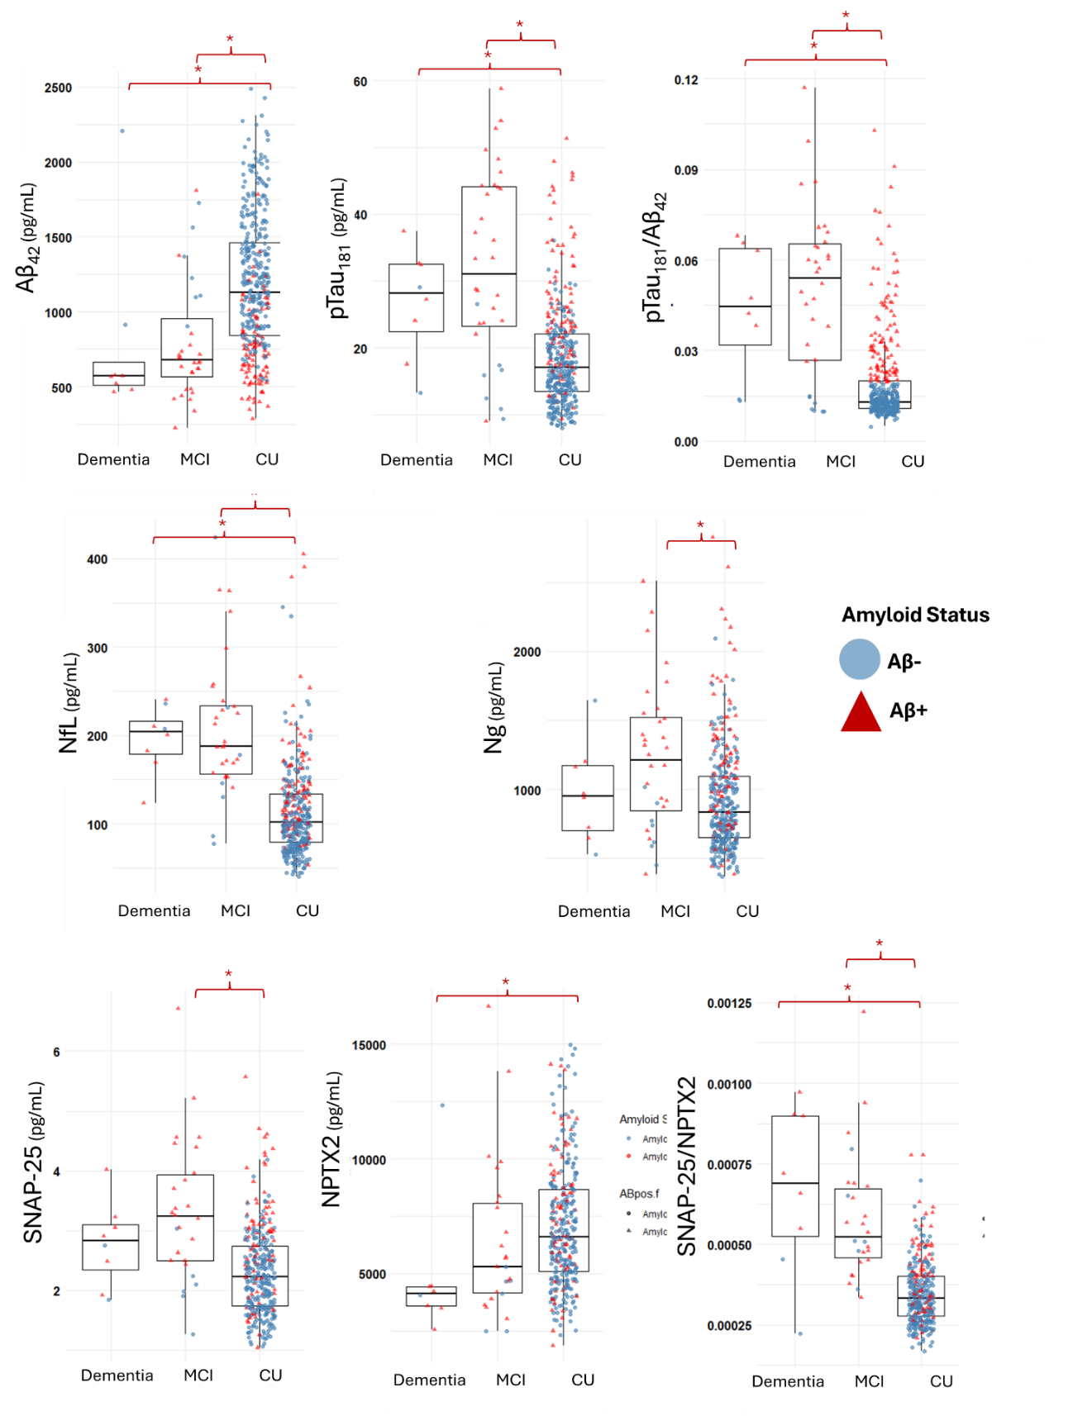
Figure Caption: Box plots illustrating clinical diagnosis group differences in CSF biomarker concentrations; Aβ+ represents amyloid status (positivity) defined by the p-tau181/Aβeta42 cutoff score described in 2.3.2.3; CU = cognitively unimpaired, MCI = mild cognitive impairment; cognitive status determined by visit closest to CSF biomarker data collection; comparisons used raw concentrations of biomarkers; sample sizes differed depending on biomarker availability (see Table 2); * indicate group differences between CU vs MCI, CI vs. Dementia, and MCI vs. Dementia, with significance levels and Cohen’s D effect sizes for the differences in Supplemental Table 2.

