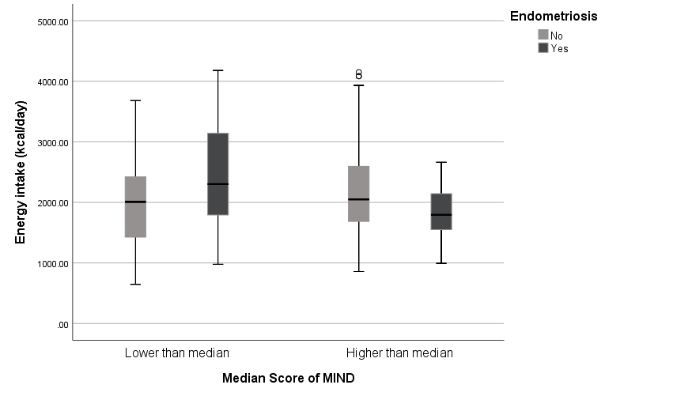
Figure 1. Box plot of energy intake by endometriosis and MIND diet score levels.
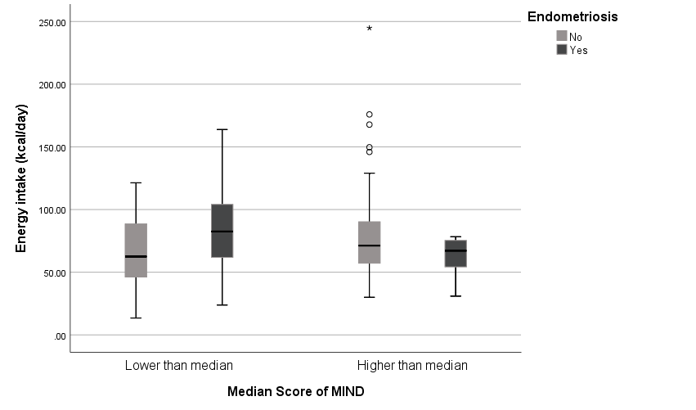
Figure 2. Box plot of protein intake by endometriosis and MIND diet score levels.

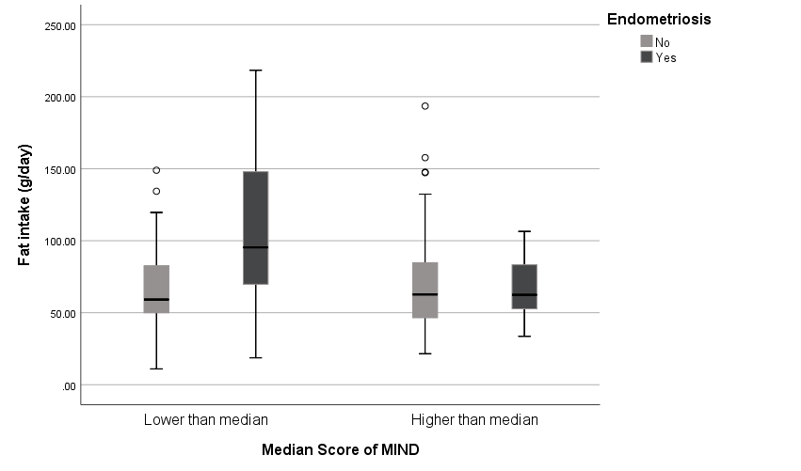
Figure 3. Box plot of fat intake by endometriosis and MIND diet score levels.
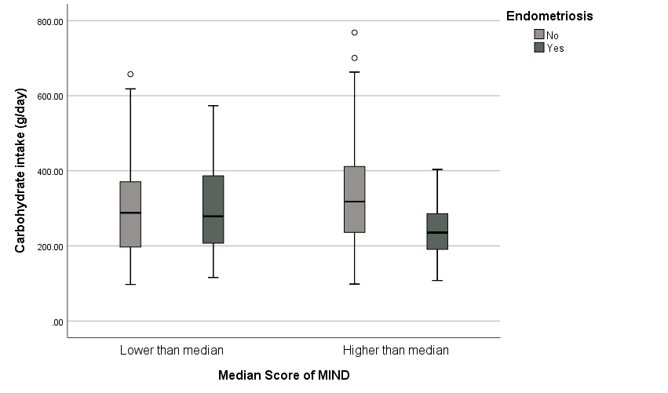
Figure 4. Box plot of carbohydrate intake by endometriosis and MIND diet score levels.

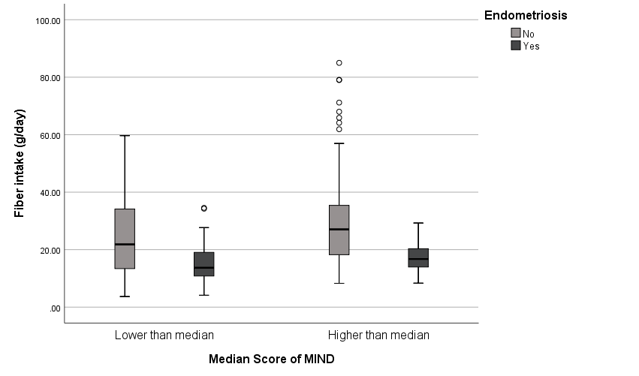
Figure 5. Box plot of fiber intake by endometriosis and MIND diet score levels.
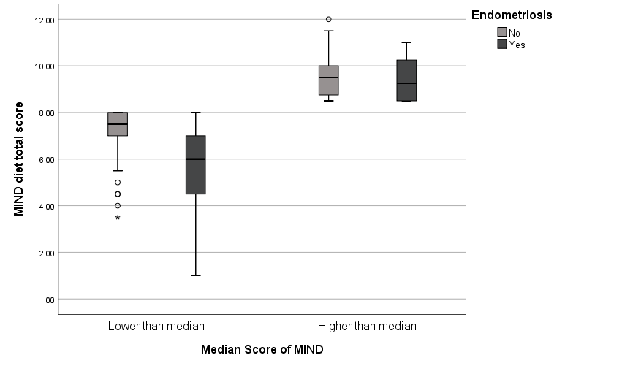
Figure 6. Box plot of MIND diet score by endometriosis and MIND diet score levels.

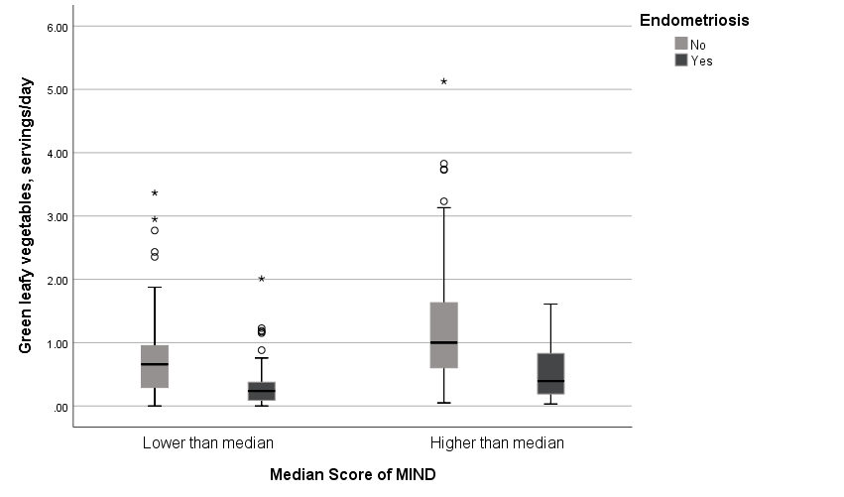
Figure 7. Box plot of green leafy vegetables intake by endometriosis and MIND diet score levels.
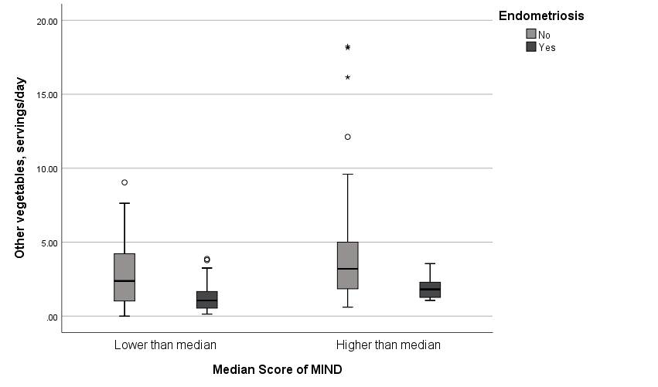
Figure 8. Box plot of other vegetables intake by endometriosis and MIND diet score levels.

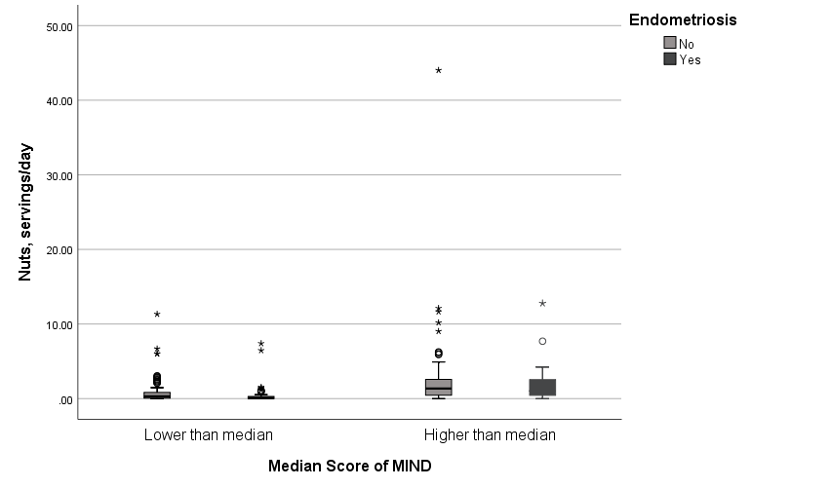
Figure 9. Box plot of nuts intake by endometriosis and MIND diet score levels.
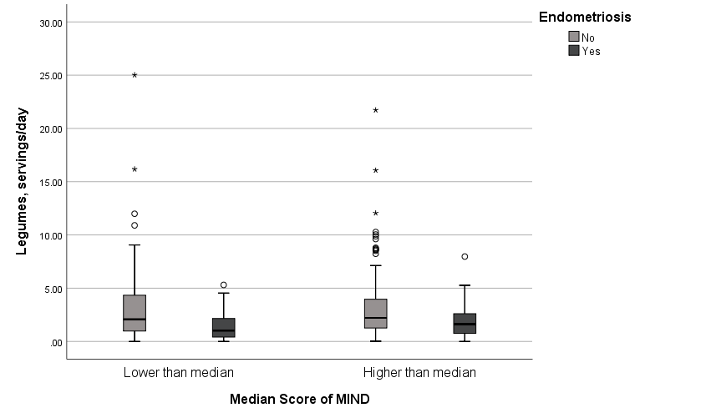
Figure 10. Box plot of legumes intake by endometriosis and MIND diet score levels.

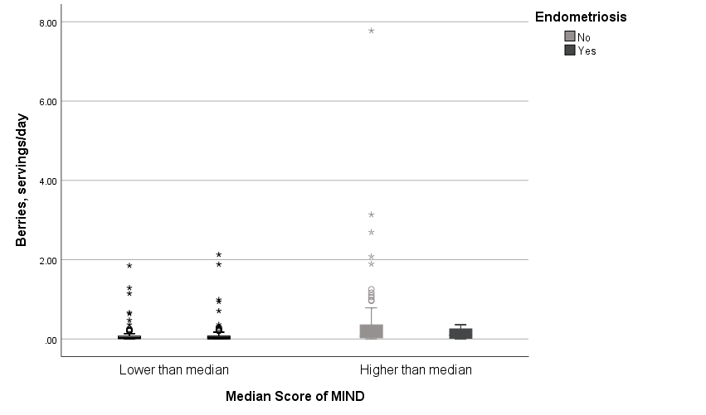
Figure 11. Box plot of berries intake by endometriosis and MIND diet score levels.
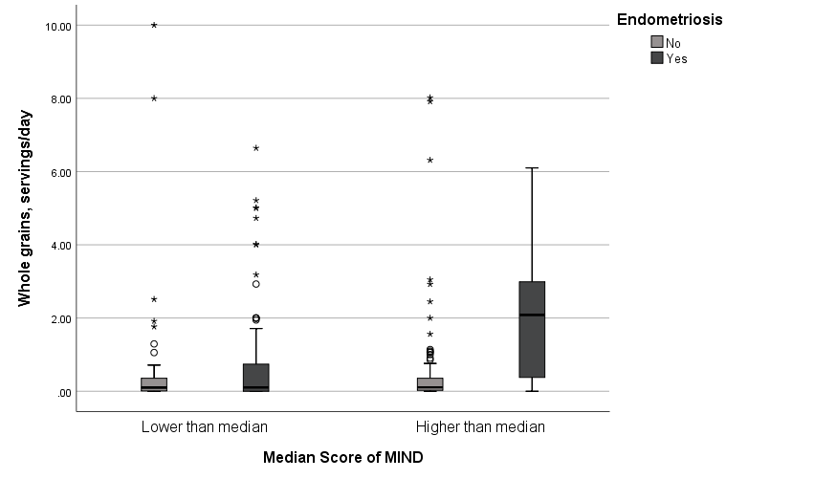
Figure 12. Box plot of whole grains intake by endometriosis and MIND diet score levels.

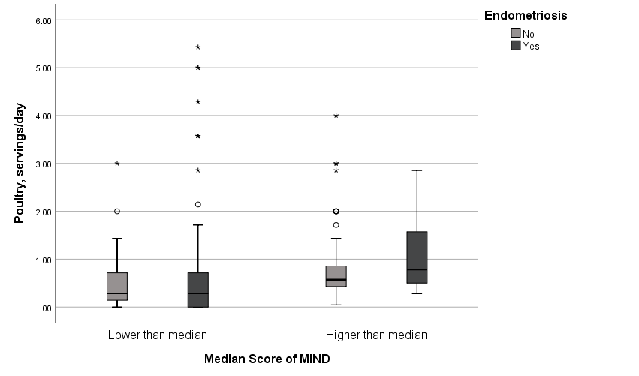
Figure 13. Box plot of poultry intake by endometriosis and MIND diet score levels.
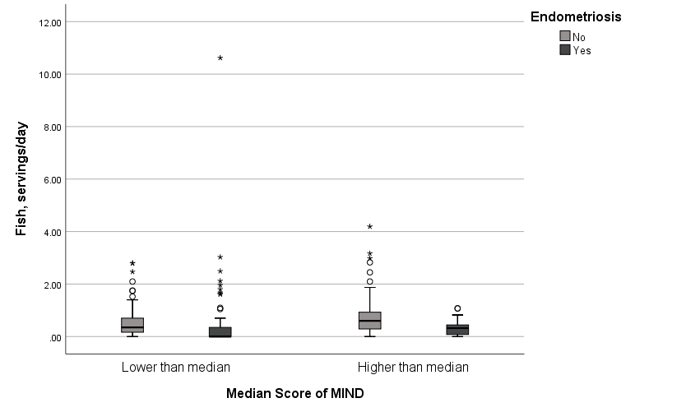
Figure 14. Box plot of fish intake by endometriosis and MIND diet score levels.

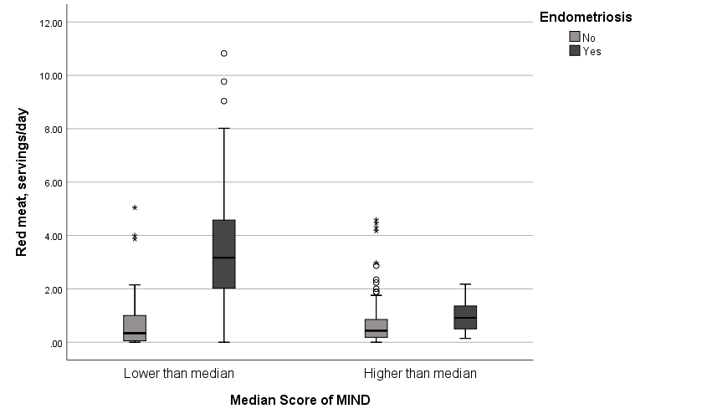
Figure 15. Box plot of red meats intake by endometriosis and MIND diet score levels.
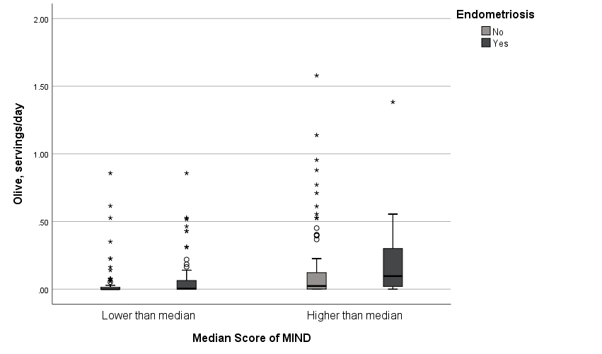
Figure 16. Box plot of olive intake by endometriosis and MIND diet score levels.

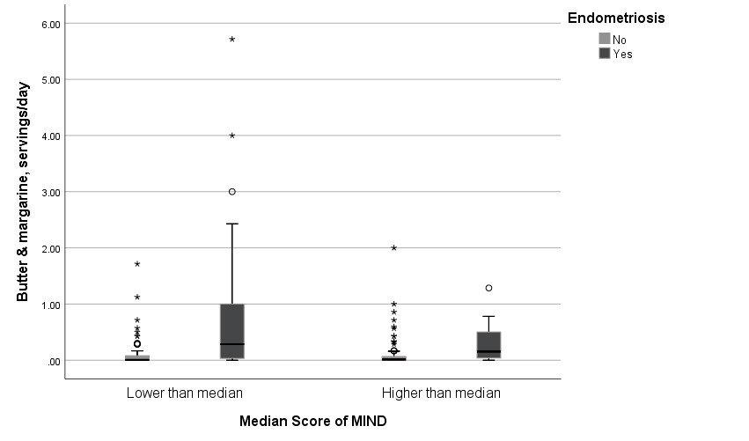
Figure 17. Box plot of butter and margarine intake by endometriosis and MIND diet score levels.
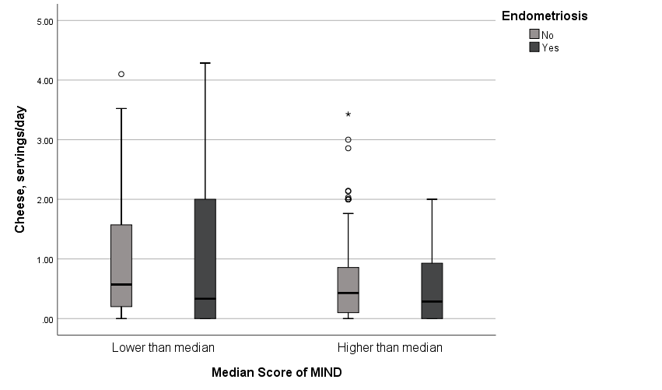
Figure 18. Box plot of cheese intake by endometriosis and MIND diet score levels.
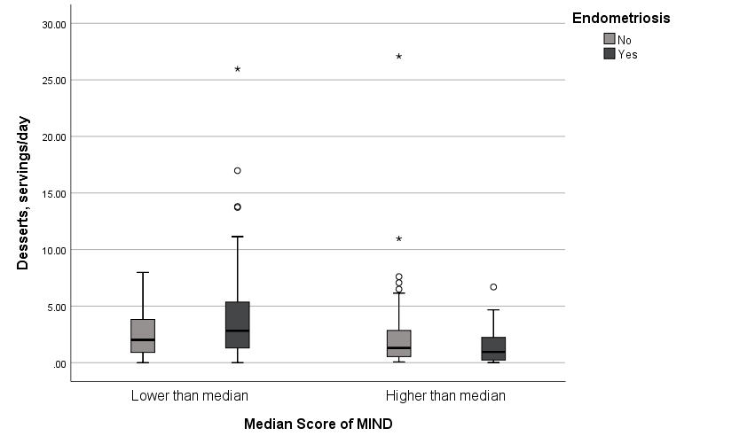
Figure 19. Box plot of desserts intake by endometriosis and MIND diet score levels.
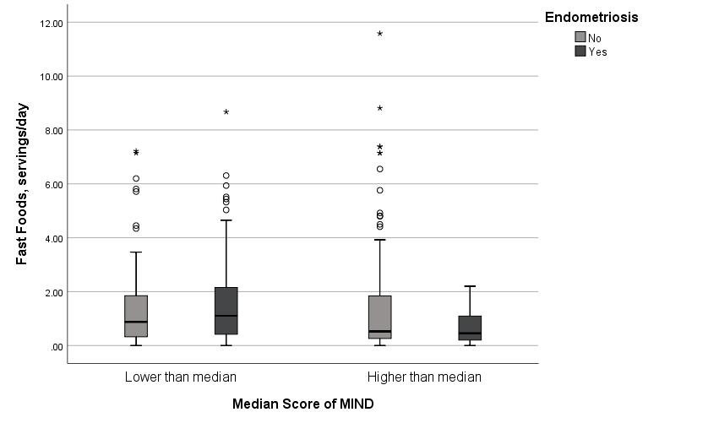
Figure 20. Box plot of fast foods intake by endometriosis and MIND diet score levels.

