S1. Mass spectrometry probes for amino compounds

S2. Survival data of aminos associated proteins.
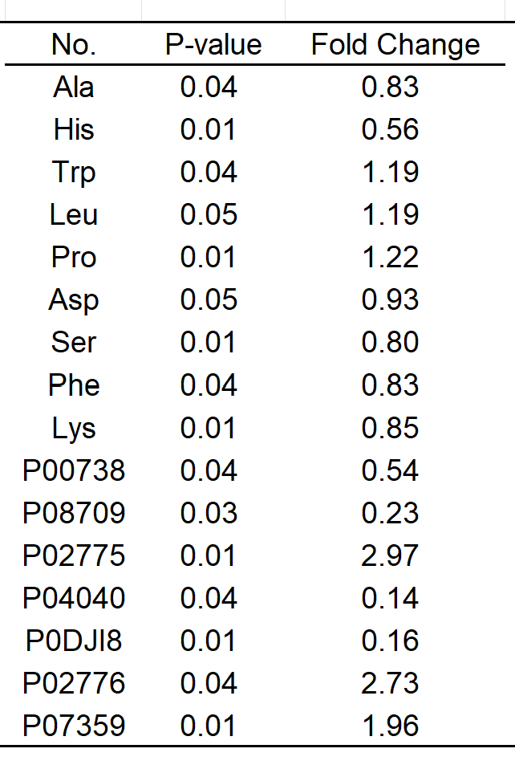

S3. Machine learning parameters based on aminos associated proteins.

Set | Pathology | Predicted |  | Mean Accuracy  (%)
Set | Pathology | HV | PCNSL | Mean Accuracy  (%)
Training | HV | 18 | 0 | 99.59
Training | PCNSL | 0 | 18 | 99.59
Test | HV | 12 | 0 | 93.68
Test | PCNSL | 0 | 12 | 93.68

Code
% 清空环境变量
warning off;
close all;
clear;
clc;
% 设置随机种子
rng(1);
% 导入数据
res = xlsread('机器学习.xlsx'); % 假设数据最后一列为标签（例如：1为患者，0为健康人）
% 数据分析
outdim = 1; % 最后一列为输出（标签）
f_ = size(res, 2) - outdim; % 输入特征维度
labels = res(:, end); % 标签信息
% 获取患者和健康人的索引
patient_idx = find(labels == 1);
healthy_idx = find(labels == 0);
% 计算各组训练集样本数（60%）
num_patient_train = round(0.6 * length(patient_idx));
num_healthy_train = round(0.6 * length(healthy_idx));
% 分别划分训练集和测试集索引
patient_train_idx = patient_idx(1:num_patient_train);
patient_test_idx = patient_idx(num_patient_train+1:end);
healthy_train_idx = healthy_idx(1:num_healthy_train);
healthy_test_idx = healthy_idx(num_healthy_train+1:end);
% 合并患者组和健康人组的训练集及测试集索引
trainIdx = [patient_train_idx; healthy_train_idx];
testIdx = [patient_test_idx; healthy_test_idx];
% 提取训练集和测试集数据
P_train = res(trainIdx, 1:f_);
T_train = res(trainIdx, f_+1:end);
P_test = res(testIdx, 1:f_);
T_test = res(testIdx, f_+1:end);
M = size(P_train, 1); % 训练样本数
N = size(P_test, 1); % 测试样本数
% 数据归一化
[p_train, ps_input] = mapminmax(P_train', 0, 1);
p_test = mapminmax('apply', P_test', ps_input);
p_train = p_train';
p_test = p_test';
% 模型参数
trees = 50; % 决策树数目
leaf = 2; % 最小叶子数
Method = 'classification'; % 分类模式
% 初始化存储变量
num_iterations = 2000;
accuracy_train_all = zeros(num_iterations, 1);
accuracy_test_all = zeros(num_iterations, 1);
importance_all = zeros(num_iterations, f_);
oob_error_all = zeros(num_iterations, trees);
% 交叉验证参数
k = 5; % 5折交叉验证
cv = cvpartition(M, 'KFold', k);
cv_accuracy = zeros(k, 1);
% 循环训练和评估
for iter = 1:num_iterations
% 交叉验证
for fold = 1:k
% 获取当前折的训练和验证集索引
trainIdx_cv = training(cv, fold);
valIdx_cv = test(cv, fold);
% 构造当前折的数据
p_train_cv = p_train(trainIdx_cv, :);
t_train_cv = T_train(trainIdx_cv);
p_val_cv = p_train(valIdx_cv, :);
t_val_cv = T_train(valIdx_cv);
% 训练模型
net_cv = TreeBagger(trees, p_train_cv, t_train_cv, ...
'Method', Method, 'OOBPrediction', 'on', ...
'OOBPredictorImportance', 'on', 'MinLeafSize', leaf);
% 在验证集上进行预测
t_pred_val = predict(net_cv, p_val_cv);
T_pred_val = str2double(t_pred_val);
cv_accuracy(fold) = sum(T_pred_val == t_val_cv) / numel(t_val_cv) * 100;
end
% 计算当前迭代的交叉验证平均准确率
mean_cv_accuracy = mean(cv_accuracy);
% 在完整训练集上训练模型
net = TreeBagger(trees, p_train, T_train, ...
'Method', Method, 'OOBPrediction', 'on', ...
'OOBPredictorImportance', 'on', 'MinLeafSize', leaf);
% 计算特征重要性
importance = net.OOBPermutedPredictorDeltaError;
importance_all(iter, :) = importance;
% 计算袋外误差
oob_error = oobError(net);
oob_error_all(iter, :) = oob_error;
% 在训练集上进行预测
t_sim_train = predict(net, p_train);
T_sim_train = str2double(t_sim_train);
accuracy_train = sum(T_sim_train == T_train) / M * 100;
accuracy_train_all(iter) = accuracy_train;
% 在测试集上进行预测
t_sim_test = predict(net, p_test);
T_sim_test = str2double(t_sim_test);
accuracy_test = sum(T_sim_test == T_test) / N * 100;
accuracy_test_all(iter) = accuracy_test;
% 可选：显示进度
if mod(iter, 100) == 0
fprintf('Iteration %d/%d completed. CV Accuracy: %.2f%%\n', iter, num_iterations, mean_cv_accuracy);
end
end
% 计算平均准确率和标准差
mean_accuracy_train = mean(accuracy_train_all);
std_accuracy_train = std(accuracy_train_all);
mean_accuracy_test = mean(accuracy_test_all);
std_accuracy_test = std(accuracy_test_all);
fprintf('训练集平均准确率: %.2f%% (std: %.2f%%)\n', mean_accuracy_train, std_accuracy_train);
fprintf('测试集平均准确率: %.2f%% (std: %.2f%%)\n', mean_accuracy_test, std_accuracy_test);
% 绘制平均误差曲线
mean_oob_error = mean(oob_error_all, 1);
figure;
plot(1:trees, mean_oob_error, 'b-', 'LineWidth', 1);
legend('平均误差曲线');
xlabel('决策树数目');
ylabel('误差');
xlim([1, trees]);
grid on;
title('平均袋外误差曲线');
% 绘制平均特征重要性
mean_importance = mean(importance_all, 1);
figure;
bar(mean_importance);
legend('特征重要性');
xlabel('特征');
ylabel('重要性');
title('平均特征重要性');

