Optimizing Aedes albopictus Rearing: Effects of alternative larval diets on immature and adult performance
Supplementary materials
Results
Immature survival
Table S1: Survival (%) of Aedes albopictus immatures, when reared in four different larval diets(CAA: reference diet including cat food, fish food and brewers’ yeast, UTH-YM: isoproteinic CAA-based diet in which brewer's yeast has been replaced by Tenebrio molitor insect meal, UTH-BSF: isoproteinic CAA-based diet in which brewer's yeast has been replaced by Hermetia illucens insect meal and UTH-ENT: isoproteinic CAA-based diet in which brewer's yeast has been replaced by dry mass of Enterobacter spp.), within the different developmental stages (L1-L2, L2-L3, L3-L4, L4-Pupae, Pupae-Adult, L1-Adult).
Survival within immature developmental stages % (n)
Larval diet | L1 | L1-L2 | L2-L3 | L3-L4 | L4- Pupae | Pupae- Adult | L1- Adult
CAA | 1200 | 88 (1060) | 98 (1038) | 97 (1004) | 99 (991) | 95 (942) | 78,5a (942)
UTH-YM | 1200 | 89 (1071) | 94 (1006) | 98 (982) | 99 (975) | 96 (934) | 78a (934)
UTH-BSF | 1200 | 95 (1131) | 98 (1109) | 96 (1060) | 98 (1043) | 96 (997) | 83a (997)
UTH-ENT | 1200 | 85 (1019) | 97 (990) | 97 (959) | 98 (932) | 96 (898) | 75a (898)

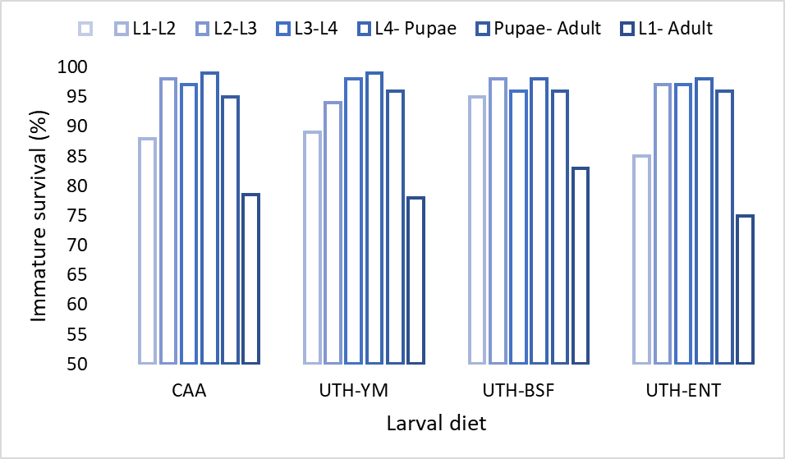
Figure S1: Barplot showing Aedes albopictus immature survival per larval diet (column one: CAA: reference diet including cat food, fish food and brewers’ yeast, column two: UTH-YM: isoproteinic CAA-based diet in which brewer's yeast has been replaced by Tenebrio molitor insect meal, column three: UTH-BSF isoproteinic CAA-based diet in which brewer's yeast has been replaced by Hermetia illucens insect meal and column four: UTH-ENT isoproteinic CAA-based diet in which brewer's yeast has been replaced by dry mass of Enterobacter spp). Each column consists of six bars representing the different developmental stages, the presented order is L1-L2, L2-L3, L3-L4, L4-Pupae, Pupae-Adult & total survival (L1-Adult).
Table S2: Pairwise comparisons, as resulted from binary regression, of total immature survival of Aedes albopictus, in the four larval diets tested (CAA: reference diet including cat food, fish food and brewers’ yeast, UTH-YM: isoproteinic CAA-based diet in which brewer's yeast has been replaced by Tenebrio molitor insect meal, UTH-BSF: isoproteinic CAA-based diet in which brewer's yeast has been replaced by Hermetia illucens insect meal and UTH-ENT: isoproteinic CAA-based diet in which brewer's yeast has been replaced by dry mass of Enterobacter spp.).
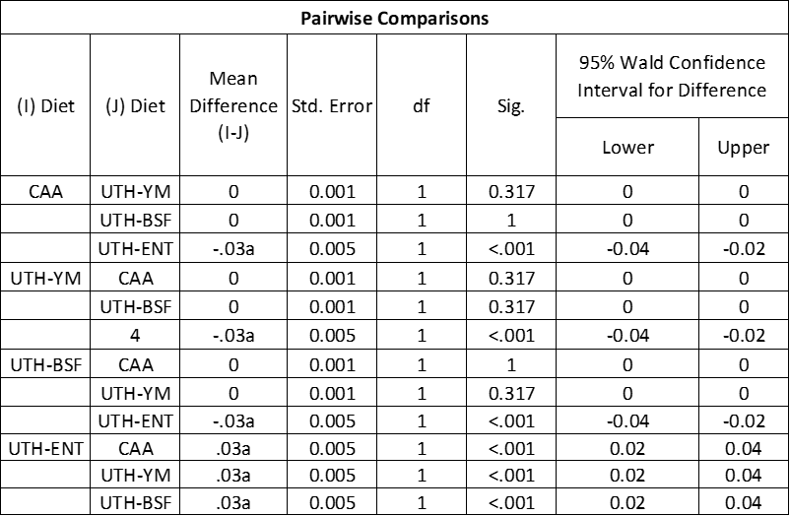
Immatures developmental duration
Table S3: Pairwise comparisons, as resulted from log rank test, of developmental duration of Aedes albopictus immatures, trough the different stages (L1-L2, L2-L3, L3-L4, L4-Pupae, Pupae-Adult), in the four larval diets tested (CAA:reference diet including cat food, fish food and brewers’ yeast, UTH-YM: isoproteinic CAA-based diet in which brewer's yeast has been replaced by Tenebrio molitor insect meal, UTH-BSF: isoproteinic CAA-based diet in which brewer's yeast has been replaced by Hermetia illucens insect meal and UTH-ENT: isoproteinic CAA-based diet in which brewer's yeast has been replaced by dry mass of Enterobacter spp.).
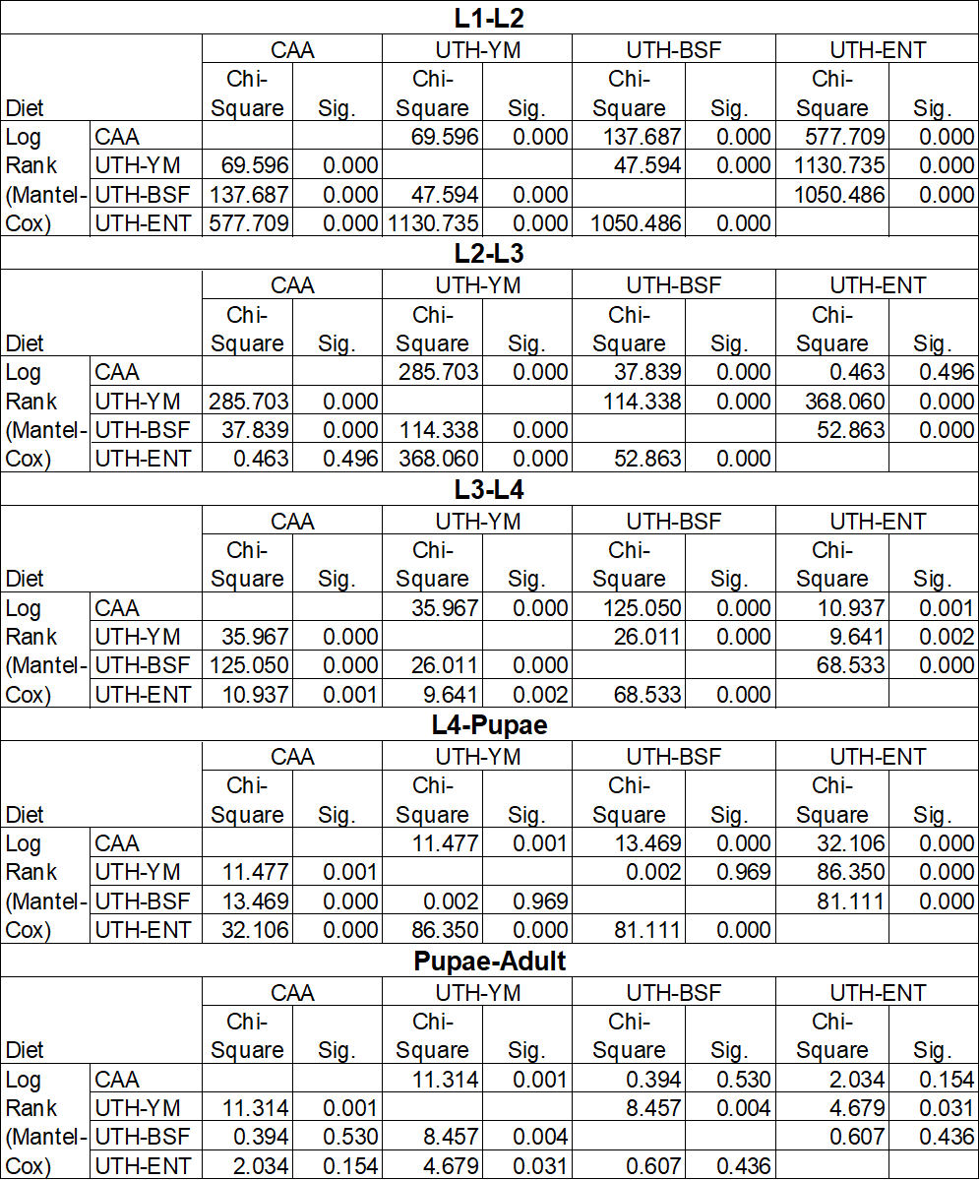

Table S4: : Developmental duration (days ± SE) of Aedes albopictus immatures, when reared in four different larval diets(CAA: reference diet including cat food, fish food and brewers’ yeast, UTH-YM: isoproteinic CAA-based diet in which brewer's yeast has been replaced by Tenebrio molitor insect meal, UTH-BSF: isoproteinic CAA-based diet in which brewer's yeast has been replaced by Hermetia illucens insect meal and UTH-ENT: isoproteinic CAA-based diet in which brewer's yeast has been replaced by dry mass of Enterobacter spp.), within the different developmental stages (L1-L2, L2-L3, L3-L4, L4-Pupae, Pupae-Adult, L1-Adult).
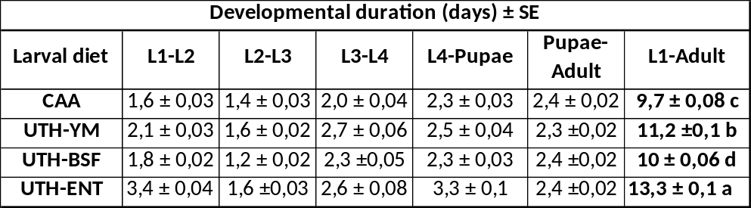
The proportion of total immature developmental duration (L1–Adult) spent in each developmental stage was calculated using data from Table S4. Specifically, for each diet, the duration of each individual stage (L1–L2, L2–L3, L3–L4, L4–Pupae, Pupae–Adult) was divided by the total developmental time from L1 to Adult, resulting in a proportional value. These proportions were then used to visualize (Figure S2) how developmental time is distributed across stages under each dietary treatment.
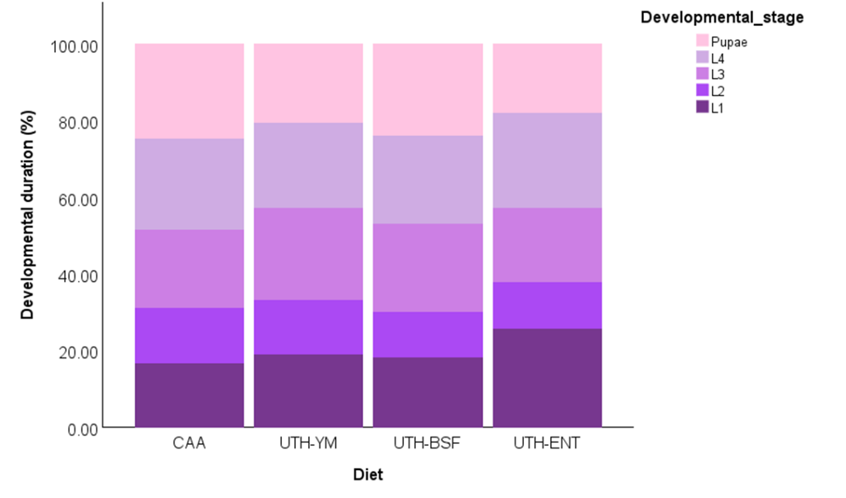
Figure S2: Proportion of total immature developmental duration (L1-Adult) spent in the different developmental stages (L1, L2, L3, L4, Pupae), of Aedes albopictus larvae reared in four different larval diets (CAA: reference diet including cat food, fish food and brewers’ yeast, UTH-YM: isoproteinic CAA-based diet in which brewer's yeast has been replaced by Tenebrio molitor insect meal, UTH-BSF: isoproteinic CAA-based diet in which brewer's yeast has been replaced by Hermetia illucens insect meal and UTH-ENT: isoproteinic CAA-based diet in which brewer's yeast has been replaced by dry mass of Enterobacter spp.).

Adult survival for a 20-day period
Table S5: Pairwise comparisons, as resulted from log rank test, of Aedes albopictus female and male survival for a 20-day period, following their emergence of rearing in the four larval diets tested (CAA:reference diet including cat food, fish food and brewers’ yeast, UTH-YM: isoproteinic CAA-based diet in which brewer's yeast has been replaced by Tenebrio molitor insect meal, UTH-BSF: isoproteinic CAA-based diet in which brewer's yeast has been replaced by Hermetia illucens insect meal and UTH-ENT: isoproteinic CAA-based diet in which brewer's yeast has been replaced by dry mass of Enterobacter spp.).
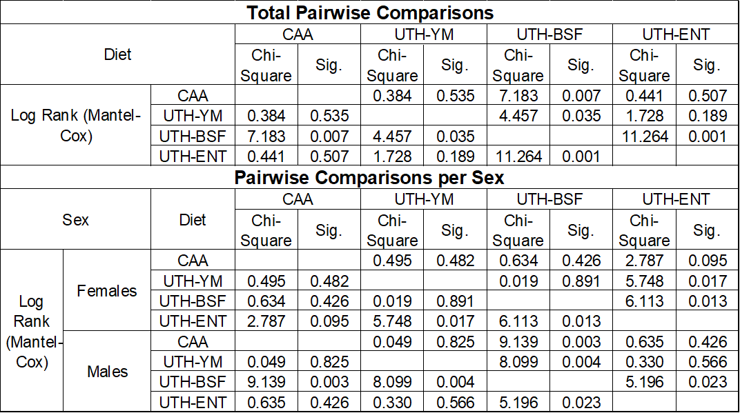
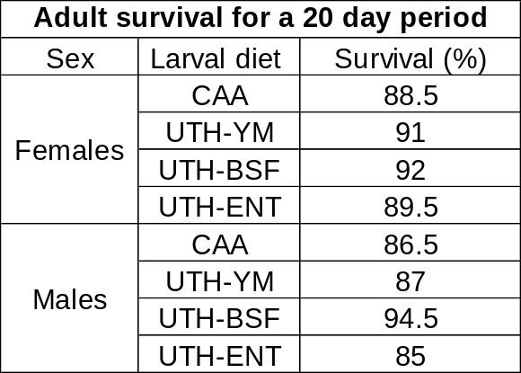
Table S6: Survival (%) of Aedes albopictus females and males, for a 20-day period following their emergence of rearing in the four larval diets tested (CAA: reference diet including cat food, fish food and brewers’ yeast, UTH-YM: isoproteinic CAA-based diet in which brewer's yeast has been replaced by Tenebrio molitor insect meal, UTH-BSF: isoproteinic CAA-based diet in which brewer's yeast has been replaced by Hermetia illucens insect meal and UTH-ENT: isoproteinic CAA-based diet in which brewer's yeast has been replaced by dry mass of Enterobacter spp.), within the different developmental stages (L1-L2, L2-L3, L3-L4, L4-Pupae, Pupae-Adult, L1-Adult).
Materials and Methods
Table S7: Amount of crude protein (g/100g), based on literature, contained in the different ingredients (Hermetia illucens: BSF, Tenebrio molitor: YM, Brewers’ yeast: BY and Enterobacter spp.:ENT) used to create the isoproteinic diets tested (CAA: reference diet including cat food, fish food and brewers’ yeast, UTH-YM: isoproteinic CAA-based diet in which brewer's yeast has been replaced by Tenebrio molitor insect meal, UTH-BSF: isoproteinic CAA-based diet in which brewer's yeast has been replaced by Hermetia illucens insect meal and UTH-ENT: isoproteinic CAA-based diet in which brewer's yeast has been replaced by dry mass of Enterobacter spp.).
Diet ingridient | Crude protein (g/100g) | Reference
Hermetia illucens (BSF) | 43.1 | [1]
Hermetia illucens (BSF) | 41.1 | [2]
Hermetia illucens (BSF) | 43.9 | [3]
Hermetia illucens (BSF) | 35 | [4]
Hermetia illucens (BSF) | 40.1 | [5]
Hermetia illucens (BSF) | 27.5 | [6]
Hermetia illucens (BSF) | 39.2 | [7]
Hermetia illucens (BSF) | 47.6 | [8]
Hermetia illucens (BSF) | 44.6 | [9]
Tenebrio molitor (YM) | 45.6 | [10]
Tenebrio molitor (YM) | 43 | [11]
Tenebrio molitor (YM) | 18.6 | [12]
Βrewer's yeast (BΥ) | 20 | [13]
Enterobacter spp. (ENT) | 54.7 | [14]

Table S8: Amount of aminoacids (%), based on literature, contained in the different ingredients (Hermetia illucens: BSF, Tenebrio molitor: YM, Brewers’ yeast: BY and Enterobacter spp.:ENT) used to create the isoproteinic diets tested (CAA: reference diet including cat food, fish food and brewers’ yeast, UTH-YM: isoproteinic CAA-based diet in which brewer's yeast has been replaced by Tenebrio molitor insect meal, UTH-BSF: isoproteinic CAA-based diet in which brewer's yeast has been replaced by Hermetia illucens insect meal and UTH-ENT: isoproteinic CAA-based diet in which brewer's yeast has been replaced by dry mass of Enterobacter spp.).
Amino acids contained in diet ingridients (%)
Diet ingridients | BSF | BSF | BSF | BSF | BSF | BSF | BSF | YM | YM | BY | ENT
Amino acid
Histidine (HIS) | 0.14 | 0.14 | 0.33 | 0.48 | 0.10 | 0.14 | 0.32 | 0.30 | 0.06 | 0.24 | 0.42
Isoleucine (ILE) | 0.19 | 0.18 | 0.47 | 0.48 | 0.19 | 0.21 | 0.16 | 0.40 | 0.08 | 0.18 | 0.54
Leucine (LEU) | 0.31 | 0.28 | 0.78 | 0.77 | 0.32 | 0.29 | 0.27 | 1.00 | 0.14 | 0.28 | 0.80
Lysine (LYS) | 0.23 | 0.28 | 0.68 | 0.74 | 0.27 | 0.26 | 0.23 | 0.30 | 0.11 | 0.31 | 0.76
Threonine (THR) | 0.16 | 0.16 | 0.44 | 0.45 | 0.27 | 0.17 | 0.18 | 0.30 | 0.08 | 0.12 | 0.58
Valine (VAL) | 0.28 | 0.25 | 0.68 | 0.67 | 0.29 | 0.29 | 0.19 | 0.60 | 0.13 | 0.26 | 0.70
Aspartic acid (ASP) | 0.37 | 0.39 | 0.73 | 1.03 | - | 0.36 | - | 1.00 | 0.15 | 0.26 | 0.78
Glutamic acid (GLU) | 0.46 | 0.46 | 1.31 | 1.02 | - | 0.38 | 0.45 | 3.50 | 0.21 | 1.84 | 0.67
Serine (SER) | 0.16 | 0.18 | 0.49 | 0.41 | 0.19 | 0.15 | 0.16 | 0.70 | 0.09 | 0.24 | 0.45
Glycine (GLY) | 0.25 | 0.25 | 0.62 | 0.54 | 0.27 | 0.25 | 0.18 | 0.60 | 0.10 | 0.17 | 0.51
Arginine (ARG) | 0.20 | 0.21 | 0.55 | 0.62 | 0.22 | 0.19 | 0.21 | 0.80 | 0.14 | 0.56 | 0.98
Alanine (ALA) | 0.28 | 0.26 | 0.82 | 0.62 | - | 0.27 | 0.23 | 0.60 | 0.16 | 1.29 | 0.4
Tyrosine (TYR) | - | - | 0.67 | 0.60 | 0.27 | 0.27 | 0.26 | 0.40 | 0.12 | - | 0.31
Phenylalanine (PHE) | 0.16 | 0.16 | 0.78 | 0.62 | 0.18 | 0.19 | 0.19 | 0.60 | 0.07 | 0.19 | 0.49
Proline (PRO) | 0.25 | 0.24 | 0.67 | 0.62 | - | 0.23 | 0.22 | - | 0.13 | - | 0.39
Methionine (MET) | 0.07 | 0.08 | 0.21 | 0.06 | 0.06 | 0.07 | 0.22 | - | 0.03 | 0.06 | 0.52
Tryptophan (TRP) | 0.05 | - | - | - | 0.06 | 0.06 | - | - | 0.02 | - | 0.22
Cysteine (CYS) | 0.02 | 0.04 | 0.08 | 0.05 | 0.04 | 0.03 | - | - | 0.02 | - | 0.24
Asparagine (ASN) | - | - | - | - | - | - | 0.36 | - | - | -
Taurine | - | - | - | - | - | - | - | - | <0.001 | -
Reference | [1] | [3] | [4] | [15] | [16] | [17] | [7] | [18] | [12] | [13] | [14]
Table S9: Amount (gr) of ingrients used in the four isoproteinic larval diets used for the laboratory rearing of 300 Aedes albopictus larvae.
Amount (gr) of ingredients per 300 larvae
Larval diet | Catfood | Fishfood | Brewer's Yeast | BSF | YM | Enterobacter sp.
CAA | 0,640 | 0,048 | 0,112
UTH-BSF | 0,640 | 0,048 |  | 0,133
UTH-YM | 0,640 | 0,048 |  |  | 0,163
UTH-ENT | 0,640 | 0,048 |  |  |  | 0,094
References
1. Spranghers, T. et al. Nutritional composition of black soldier fly (Hermetia illucens) prepupae reared on different organic waste substrates. Journal of the Science of Food and Agriculture, 97 (8), 2594-2600 (2017)
2. Shumo, M. et al. The nutritive value of black soldier fly larvae reared on common organic waste streams in Kenya. Scientific reports, 9 (1), 10110 (2019).

3. Onsongo, V. O. et al. Insects for income generation through animal feed: effect of dietary replacement of soybean and fish meal with black soldier fly meal on broiler growth and economic performance. Journal of economic entomology, 111 (4), 1966-1973 (2018).
4. Rawski, M., Mazurkiewicz, J., Kierończyk, B., & Józefiak, D. Black soldier fly full-fat larvae meal as an alternative to fish meal and fish oil in Siberian sturgeon nutrition: The effects on physical properties of the feed, animal growth performance, and feed acceptance and utilization. Animals, 10 (11), 2119 (2020).
5. de Souza Vilela, J. et al. Black soldier fly larvae in broiler diets improve broiler performance and modulate the immune system. Animal Nutrition, 7 (3), 695-706. (2021).
6. Tyshko, N. V. et al. The comprehensive studies of Hermetia illucens larvae protein’s biological value. Problems of Nutrition, 90, 49-58 (2021).
7. Liu, C., Wang, C., & Yao, H. Comprehensive resource utilization of waste using the black soldier fly (Hermetia illucens (L.)) (Diptera: Stratiomyidae). Animals, 9 (6), 349 (2019).
8. Zulkifli, N. F. N. M. et al. Nutritional value of black soldier fly (Hermetia illucens) larvae processed by different methods. Plos one, 17 (2), e0263924 (2022).
9. Tschirner, M., & Simon, A. Influence of different growing substrates and processing on the nutrient composition of black soldier fly larvae destined for animal feed. Journal of insects as food and feed, 1 (4), 249-259 (2015).
10. Costa, S. et al. Evaluation of Tenebrio molitor larvae as an alternative food source. NFS journal, 21, 57-64. (2020).
11. Megido, R. C. et al. Effect of household cooking techniques on the microbiological load and the nutritional quality of mealworms (Tenebrio molitor L. 1758). Food Research International, 106, 503-508 (2018).

12. Finke, M. D. Complete nutrient content of four species of commercially available feeder insects fed enhanced diets during growth. Zoo biology, 34 (6), 554-564 (2015).

13. Yalçın, S., Erol, H., Özsoy, B., & Onbaşılar, I. Effects of the usage of dried brewing yeast in the diets on the performance, egg traits and blood parameters in quails. Animal, 2 (12), 1780-1785 (2008).
14. Azis, K. et al. Biochemical and nutritional characterization of the medfly gut symbiont Enterobacter sp. AA26 for its use as probiotics in sterile insect technique applications. BMC biotechnology, 19, 1-10 (2019).

15. Müller, A., Wolf, D., & Gutzeit, H. O. The black soldier fly, Hermetia illucens–a promising source for sustainable production of proteins, lipids and bioactive substances. Zeitschrift für Naturforschung C, 72 (9-10), 351-363 (2017).

16. Shah, A. A. et al. Nutritional composition of various insects and potential uses as alternative protein sources in animal diets. Animal Bioscience, 35 (2), 317 (2022).
17. Romano, N., Fischer, H., Kumar, V., Francis, S. A., & Sinha, A. K. Productivity, conversion ability, and biochemical composition of black soldier fly (Hermetia illucens) larvae fed with sweet potato, spent coffee or dough. International Journal of Tropical Insect Science, 1-8. (2022).
18. Kröncke, N., & Benning, R. Influence of dietary protein content on the nutritional composition of mealworm larvae (Tenebrio molitor L.). Insects, 14 (3), 261 (2023).

