Supplementary Tables
Supplementary Table 1. Search strategy including key terms, databases (PubMed, Scopus and Embase) and the number of results retrieved.
Query | Search Strategy | PubMed | Scopus | Embase
#1 | 'bladder':ti,ab,kw | 195272 | 287124 | 325483
#2 | cancer:ti,ab,kw OR carcinoma:ti,ab,kw OR tumor:ti,ab,kw | 3296770 | 5028086 | 6349559
#3 | urethral:ti,ab,kw OR urethra:ti,ab,kw | 49961 | 75358 | 83147
#4 | recurrence:ti,ab,kw | 405315 | 620074 | 1578844
#5 | urothelial | 25907 | 42508 | 119923
#6 | radical AND cystectomy | 22116 | 21550 | 39228
#7 | #1 AND #2 AND #4 AND #5 AND #6 AND #7 | 111 | 176 | 521

Supplementary Table 2. PRISMA checklist.
Section and Topic | Item # | Checklist item | Location where item is reported
TITLE
Title | 1 | Identify the report as a systematic review. | Page 1
ABSTRACT
Abstract | 2 | See the PRISMA 2020 for Abstracts checklist. | Page 3-4
INTRODUCTION
Rationale | 3 | Describe the rationale for the review in the context of existing knowledge. | Page 5
Objectives | 4 | Provide an explicit statement of the objective(s) or question(s) the review addresses. | Page 5
METHODS
Eligibility criteria | 5 | Specify the inclusion and exclusion criteria for the review and how studies were grouped for the syntheses. | Page 10
Information sources | 6 | Specify all databases, registers, websites, organisations, reference lists and other sources searched or consulted to identify studies. Specify the date when each source was last searched or consulted. | Page 10
Search strategy | 7 | Present the full search strategies for all databases, registers and websites, including any filters and limits used. | Table S1
Selection process | 8 | Specify the methods used to decide whether a study met the inclusion criteria of the review, including how many reviewers screened each record and each report retrieved, whether they worked independently, and if applicable, details of automation tools used in the process. | Page 10, Figure S1
Data collection process | 9 | Specify the methods used to collect data from reports, including how many reviewers collected data from each report, whether they worked independently, any processes for obtaining or confirming data from study investigators, and if applicable, details of automation tools used in the process. | Page 10
Data items | 10a | List and define all outcomes for which data were sought. Specify whether all results that were compatible with each outcome domain in each study were sought (e.g. for all measures, time points, analyses), and if not, the methods used to decide which results to collect. | Page 10
Data items | 10b | List and define all other variables for which data were sought (e.g. participant and intervention characteristics, funding sources). Describe any assumptions made about any missing or unclear information. | Page 10
Study risk of bias assessment | 11 | Specify the methods used to assess risk of bias in the included studies, including details of the tool(s) used, how many reviewers assessed each study and whether they worked independently, and if applicable, details of automation tools used in the process. | Page 10
Effect measures | 12 | Specify for each outcome the effect measure(s) (e.g. risk ratio, mean difference) used in the synthesis or presentation of results. | Page 10
Synthesis methods | 13a | Describe the processes used to decide which studies were eligible for each synthesis (e.g. tabulating the study intervention characteristics and comparing against the planned groups for each synthesis (item #5)). | Page 10
Synthesis methods | 13b | Describe any methods required to prepare the data for presentation or synthesis, such as handling of missing summary statistics, or data conversions. | Page 10
Synthesis methods | 13c | Describe any methods used to tabulate or visually display results of individual studies and syntheses. | Page 10
Synthesis methods | 13d | Describe any methods used to synthesize results and provide a rationale for the choice(s). If meta-analysis was performed, describe the model(s), method(s) to identify the presence and extent of statistical heterogeneity, and software package(s) used. | Page 10
Synthesis methods | 13e | Describe any methods used to explore possible causes of heterogeneity among study results (e.g. subgroup analysis, meta-regression). | Page 10
Synthesis methods | 13f | Describe any sensitivity analyses conducted to assess robustness of the synthesized results. | Page 10
Reporting bias assessment | 14 | Describe any methods used to assess risk of bias due to missing results in a synthesis (arising from reporting biases). | Page 10
Certainty assessment | 15 | Describe any methods used to assess certainty (or confidence) in the body of evidence for an outcome. | Page 10
RESULTS
Study selection | 16a | Describe the results of the search and selection process, from the number of records identified in the search to the number of studies included in the review, ideally using a flow diagram. | Figure S1
Study selection | 16b | Cite studies that might appear to meet the inclusion criteria, but which were excluded, and explain why they were excluded. | Figure S1
Study characteristics | 17 | Cite each included study and present its characteristics. | Table S6
Risk of bias in studies | 18 | Present assessments of risk of bias for each included study. | Table S7
Results of individual studies | 19 | For all outcomes, present, for each study: (a) summary statistics for each group (where appropriate) and (b) an effect estimate and its precision (e.g. confidence/credible interval), ideally using structured tables or plots. | Page 13-15, Figure 6, Table S7
Results of syntheses | 20a | For each synthesis, briefly summarise the characteristics and risk of bias among contributing studies. | Page 13-15, Figure 6, Table S7
Results of syntheses | 20b | Present results of all statistical syntheses conducted. If meta-analysis was done, present for each the summary estimate and its precision (e.g. confidence/credible interval) and measures of statistical heterogeneity. If comparing groups, describe the direction of the effect. | Page 13-15, Figure 6, Table S7
Results of syntheses | 20c | Present results of all investigations of possible causes of heterogeneity among study results. | Page 13-15, Figure 6, Table S7
Results of syntheses | 20d | Present results of all sensitivity analyses conducted to assess the robustness of the synthesized results. | Page 13-15, Figure 6, Table S7
Reporting biases | 21 | Present assessments of risk of bias due to missing results (arising from reporting biases) for each synthesis assessed. | Page 13-15, Figure 6, Table S7
Certainty of evidence | 22 | Present assessments of certainty (or confidence) in the body of evidence for each outcome assessed. | Page 13-15, Figure 6, Table S7
DISCUSSION
Discussion | 23a | Provide a general interpretation of the results in the context of other evidence. | Page 15
Discussion | 23b | Discuss any limitations of the evidence included in the review. | Page 18
Discussion | 23c | Discuss any limitations of the review processes used. | Page 18
Discussion | 23d | Discuss implications of the results for practice, policy, and future research. | Page 18
OTHER INFORMATION
Registration and protocol | 24a | Provide registration information for the review, including register name and registration number, or state that the review was not registered. | Page 9-10
Registration and protocol | 24b | Indicate where the review protocol can be accessed, or state that a protocol was not prepared. | Page 9-10
Registration and protocol | 24c | Describe and explain any amendments to information provided at registration or in the protocol. | Page 9-10
Support | 25 | Describe sources of financial or non-financial support for the review, and the role of the funders or sponsors in the review. | Page 19
Competing interests | 26 | Declare any competing interests of review authors. | Page 19
Availability of data, code and other materials | 27 | Report which of the following are publicly available and where they can be found: template data collection forms; data extracted from included studies; data used for all analyses; analytic code; any other materials used in the review. | Page 19

Supplementary Table 3. Baseline characteristic of the patients.
 | With UR (n=39) | Without UR (n=434) | p value
Age at surgery (years)
<60 | 3 (7.7%) | 75 (17.3%) | 0.187
≥60 | 36 (92.3%) | 359 (82.7%)
CCI
≤2 | 6 (15.4%) | 103 (23.7%) | 0.323
≥3 | 33 (84.6%) | 331 (76.3%)
History of smoking
No | 23 (59.0%) | 289 (66.6%) | 0.432
Yes | 16 (41.0%) | 145 (33.4%)
History of TURBT due to NMIBC
No | 24 (61.5%) | 291 (67.1%) | 0.602
Yes | 15 (38.5%) | 143 (32.9%)
Performed urethral frozen section
No | 38 (97.4%) | 428 (98.6%) | 1.000
Yes | 1 (2.6%) | 6 (1.4%)
Tumor grade
Low grade | 0 (0.0%) | 21 (4.8%) | 0.318
High grade | 39 (100.0%) | 413 (95.2%)
Tumor stage
≤pT2 | 22 (56.4%) | 264 (60.8%) | 0.712
≥pT3 | 17 (43.6%) | 170 (39.2%)
Lymph node status
Negative | 31 (79.5%) | 370 (85.3%) | 0.467
Positive | 8 (20.5%) | 64 (14.7%)
Concomitant CIS
No | 28 (71.8%) | 375 (86.4%) | 0.026
Yes | 11 (28.2%) | 59 (13.6%)
Tumor multifocality
No | 10 (25.6%) | 237 (54.6%) | 0.001
Yes | 29 (74.4%) | 197 (45.4%)
Prostate involvement
No | 33 (84.6%) | 397 (91.5%) | 0.256
Yes | 6 (15.4%) | 37 (8.5%)
Bladder neck involvement
No | 31 (79.5%) | 380 (87.4%) | 0.237
Yes | 8 (20.5%) | 54 (12.4%)
Bladder trigone involvement
No | 25 (64.1%) | 336 (77.4%) | 0.093
Yes | 14 (35.9%) | 98 (22.6%)
Lymphovascular invasion
No | 22 (56.4%) | 297 (68.4%) | 0.175
Yes | 17 (43.6%) | 137 (31.6%)
Perineural invasion
No | 34 (87.2%) | 347 (80.0%) | 0.378
Yes | 5 (12.8%) | 87 (20.0%)
Tumor size
<3 cm | 15 (38.5%) | 136 (31.3%) | 0.462
>=3cm | 24 (61.5%) | 298 (68.7%)
Surgery approach
RARC | 2 (5.1%) | 44 (10.1%) | 0.071
LRC | 37 (94.9%) | 351 (80.9%)
ORC | 0 (0.0%) | 39 (9.0%)
Urinary diversion type
Ileal conduit | 11 (28.8%) | 103 (23.7%) | 0.667
Cutaneous ureterostomy | 28 (71.8%) | 331 (76.3%)
Adjuvant chemotherapy
No | 35 (89.7%) | 374 (86.2%) | 0.704
Yes | 4 (10.3%) | 60 (13.8%)
UR= urethral recurrence, CCI= Charlson Comorbidity Index, TURBT= Transurethral resection of bladder tumor, RARC= Robot-assisted laparoscopic radical cystectomy, LRC= Laparoscopic radical cystectomy, ORC= Open radical cystectomy.

Supplementary Table 4. Baseline characteristic of the patients in the train and test set.
 | Test set (n=93) | Train set (n=380) | p value
Age at surgery (years)
<60 | 12 (12.9%) | 66 (17.4%)
>=60 | 81 (87.1%) | 314 (82.6%) | 0.377
CCI
≤2 | 18 (19.4%) | 91 (23.9%)
≥3 | 75 (80.6%) | 289 (76.1%) | 0.421
History of smoking
No | 65 (69.9%) | 247 (65.0%)
Yes | 28 (30.1%) | 133 (35.0%) | 0.441
History of TURB due to NMIBC
No | 66 (71.0%) | 249 (65.5%)
Yes | 27 (29.0%) | 131 (34.5%) | 0.382
Performed urethral frozen section
No | 91 (97.8%) | 375 (98.7%)
Yes | 2 (2.2%) | 5 (1.3%) | 0.906
Tumor grade
Low grade | 2 (2.2%) | 19 (5.0%)
High grade | 91 (97.8%) | 361 (95.0%) | 0.360
Tumor stage
≤pT2 | 60 (64.5%) | 226 (59.5%)
≥pT3 | 33 (35.5%) | 154 (40.5%) | 0.439
Lymph node status
Negative | 90 (86.0%) | 321 (84.5%)
Positive | 13 (14.0%) | 59 (15.5%) | 0.833
Concomitant CIS
No | 82 (88.2%) | 321 (84.5%)
Yes | 11 (11.8%) | 59 (15.5%) | 0.461
Tumor multifocality
No | 55 (59.1%) | 192 (50.5%)
Yes | 38 (40.9%) | 188 (49.5%) | 0.169
Prostate involvement
No | 83 (89.2%) | 347 (91.3%)
Yes | 10 (10.8%) | 33 (8.7%) | 0.674
Bladder neck involvement
No | 80 (86.0%) | 331 (87.1%)
Yes | 13 (14.0%) | 49 (12.9%) | 0.915
Bladder trigone involvement
No | 73 (78.5%) | 288 (75.8%)
Yes | 20 (21.5%) | 92 (24.2%) | 0.679
Lymphovascular invasion
No | 66 (71.0%) | 253 (66.6%)
Yes | 27 (29.0%) | 127 (33.4%) | 0.493
Perineural invasion
No | 77 (82.8%) | 304 (80.0%)
Yes | 16 (17.2%) | 76 (20.0%) | 0.642
Tumor size
<3 cm | 28 (30.1%) | 123 (32.4%)
>=3 cm | 65 (69.9%) | 257 (67.6%) | 0.768
Surgery approach
RARC | 78 (83.9%) | 310 (81.6)
LRC | 6 (6.5%) | 33 (8.7%)
ORC | 9 (9.7%) | 37 (9.7%) | 0.779
Urinary diversion type
Ileal conduit | 21 (22.6%) | 93 (24.5%)
Cutaneous ureterostomy | 72 (77.4%) | 287 (75.5%) | 0.805
Adjuvant chemotherapy
No | 81 (87.1%) | 328 (86.3%)
Yes | 12 (12.9%) | 52 (13.7%) | 0.977
UR= urethral recurrence, CCI= Charlson Comorbidity Index, TURBT= Transurethral resection of bladder tumor, RARC= Robot-assisted laparoscopic radical cystectomy, LRC= Laparoscopic radical cystectomy, ORC= Open radical cystectomy.
Supplementary Table 5. Baseline characteristic of the included studies in the meta-analysis.
First author  (year) | Country | Study type | Recruitment  period | Number of patients (UR patients/total sample sizes) | Gender (male/female) in total (UR) patients | Type of diversion  (ONB / non-ONB) in  total (UR) patients | Pathological type (TCC / others) | Median (range/IQR) follow-up, mo | ROS score
Ali-El-Dein B 2009 | Egypt | RC | 1995-2003 | 2/180 | 0/180（0/2） | 180/0 (2/0) | 39/141 | 57（5-137） | 8
Balcı U 2015 | Turkey | RC | 1991-2003 | 11/287 | 287/0（11/0） | 141/146 (2/9) | 287/0 | 28.60（8-122） | 8
Boorjian SA 2011 | America | RC | 1980-2000 | 85/1506 | 1230/276（78/7） | 242/1243 (5/80) | 1506/0 | 162（126-220.8） | 7
Boström PJ 2009 | Finland | RC | 1986-2005 | 10/248 | 201/47（10/0） | 96/152 | 239/9 | 102（24-264） | 8
Chen H 2016 | America | RC | 2002-2014 | 5/111 | 72/39 (4/1) | 47/64 (4/1) | 111/0 | 40.8(3-155) | 7
Chen ME 1997 | America | RC | 1985-1995 | 9/115 | 0/115（0/9） | 115/0 (9/0) | 115/0 | NR | 6
Cho KS 2009 | Korea | RC | 1986-2004 | 13/294 | 294/0（13/0） | 0/294 (0/13) | 294/0 | 54（6-227） | 8
Clark PE 2004 | America | RC | 1971-1997 | 47/1054 | 843/211 (47/0) | NR | 1054/0 | 121.2 | 7
Fakhreldin I 2016 | Egypt | RC | 1988-2010 | 59/2050 | 2050/0（59/0） | NR | NR | 24 | 8
 |  |  |  | 8/472 | 0/472（0/8） | NR | NR | 24 | 8
Freeman JA 1996 | America | RC | 1971-1993 | 34/436 | 436/0 (34/0) | 174/262 (5/29) | 436/0 | 72 (12-252) | 7
Gakis G 2015 | Germany, Egypt, Czech Republic | RC | 1994-2011 | 7/297 | 0/297 (0/7) | 297/0 (7/0) | 151/146 | 64 (25-116) | 8
Huguet J 2008 | Spain | RC | 1978-2003 | 34/729 | 729/0 (34/0) | 219/510 (5/29) | 729/0 | 38 (8-121) | 8
Khanna A 2021 | America | RC | 1980-2018 | 144/2930 | NR | NR | NR | 58.8（19.2-132） | 7
Lee DH 2020 | Korea | RC | 2010-2017 | 7/348 | 348/0 (7/0) | 348/0 (7/0) | 276/72 | 29.8 (5.6–130.0) | 8
Levinson AK 1990 | America | RC | 1969-1976 | 6/124 | 124/0（6/0） | 0/124 | 124/0 | 67 | 8
Liu Z 2020 | China | RC | 2007-2015 | 30/310 | 310/0 (30/0) | 0/310 (0/30) | NR | Without UR: 38.00 (22.00, 54.50)  With UR :49.00 (40.00, 60.00) | 8
 |  |  |  | 17/131 | 131/0 (17/0) | 0/131 (0/17) | NR | Without UR: 24.50 (10.00, 35.25)  With UR :28.00 (15.00, 35.75) | 8
Merrill SB 2017 | USA | RC | 1980-2007 | 98/1798 | 1474/323 | NR | 1797/0 | 127.2（81.6-182.4） | 7
Nieder AM 2004 | America | RC | 1992-2003 | 8/218 | 218/0（8/0） | 108/110 (1/7) | NR | 42 | 8
Perlis N 2013 | Canada, Finland | RC | 1992–2008  (Canada)  1986–2005 (Finland) | 18/503 | 397/106 (15/3) | 154/420 (6/12) | 503/0 | 58 | 7
Rodríguez-Serrano A 2021 | Spain | RC | 2008-2016 | 5/142 | 115/27 (5/0) | 23/119 (0/5) | 142/0 | 68.5 | 7
Roth B 2019 | Romania | RC | 1986-2017 | 45/803 | 703/100 | 803/0 (45/0) | 803/0 | 62（21-128） | 8
Stein JP 2005 | America | Case control | 1971-1997 | 45/768 | 768/0 (45/0) | 395/371 (16/29) | 768/0 | 156 | 8
Taylor JM 2010 | America | RC | 1980-2004 | 6/260 | 250/10 (6/0) | 260/0 (6/0) | NR | 54 (0–187.2) | 8
Varol C 2004 | Switzerland | RC | 1985-2001 | 15/371 | NR (15/0) | 371/0 (15/0) | NR | NR | 5
Yossepowitch O 2003 | America | Case control | 1989-2002 | 3/214 | 206/8 (3/0) | 214/0 (3/0) | NR | 32.8 (1-153) | 8
Yu J 2023 | Korea | RC | 2012-2022 | 33/612 | 612/0（33/0） | 271/341 (7/26) | 612/0 | ONB: 42.4 (23.6-61.3)  Non-ONB: 28.7 (14.9-62.3) | 8
Zabbo A 1984 | America | RC | 1960-1979 | 7/119 | 119/0 (7/0) | NR | NR | NR | 7
Zhou X 2018 | China | RC | 1998-2013 | 8/282 | 210/72 (7/1) | 282/0 (8/0) | 282/0 | 56 (1-174) | 8
Our study  2024 | China | RC | 2010-2022 | 26/339 | 339/0 (26/0) | 82/257 (9/17) | 339/0 | 44 (6-168) | 8
 |  |  |  | 13/144 | 144/0 (13/0) | 32/112 (2/11) | 144/0 | 46 (6-156) | 8
UR= urethral recurrence, ONB = orthotopic neobladder, TCC= transitional cell carcinoma, RC= retrospective cohort, IQR = interquartile range, NR = not reported
Supplementary Table 6. Results of quality assessment using the Newcastle–Ottawa Scale for the included studies.
Study | Selection |  |  |  | Comparability | Exposure |  |  | Scores
Study | S1 | S2 | S3 | S4 | C1 | E1 | E2 | E3 | Scores
Ali-El-Dein B 2009 | ★ | ★ | ★ | ★ | ★☆ | ★ | ★ | ★ | 8
Balcı U 2015 | ★ | ★ | ★ | ★ | ★☆ | ★ | ★ | ★ | 8
Boorjian SA 2011 | ★ | ★ | ★ | ★ | ☆☆ | ★ | ★ | ★ | 7
Bostrom PJ 2009 | ★ | ★ | ★ | ★ | ★☆ | ★ | ★ | ★ | 8
Chen H 2016 | ★ | ★ | ★ | ★ | ☆☆ | ★ | ★ | ★ | 7
Chen ME 1997 | ★ | ★ | ★ | ★ | ★☆ | ★ | ☆ | ☆ | 6
Cho KS 2009 | ★ | ★ | ★ | ★ | ★☆ | ★ | ★ | ★ | 8
Clark PE 2004 | ★ | ★ | ★ | ★ | ☆☆ | ★ | ★ | ★ | 7
Fakhreldin I 2016 | ★ | ★ | ★ | ★ | ★☆ | ★ | ★ | ★ | 8
Freeman JA 1996 | ★ | ★ | ★ | ★ | ☆☆ | ★ | ★ | ★ | 7
Gakis G 2015 | ★ | ★ | ★ | ★ | ★☆ | ★ | ★ | ★ | 8
Huguet J 2008 | ★ | ★ | ★ | ★ | ★☆ | ★ | ★ | ★ | 8
Khanna A 2021 | ★ | ★ | ★ | ★ | ☆☆ | ★ | ★ | ★ | 7
Lee DH 2020 | ★ | ★ | ★ | ★ | ★☆ | ★ | ★ | ★ | 8
Levinson AK 1990 | ★ | ★ | ★ | ★ | ★☆ | ★ | ★ | ★ | 8
Liu Z 2020 | ★ | ★ | ★ | ★ | ★☆ | ★ | ★ | ★ | 8
Merrill SB 2017 | ★ | ★ | ★ | ★ | ☆☆ | ★ | ★ | ★ | 7
Nieder AM 2004 | ★ | ★ | ★ | ★ | ★☆ | ★ | ★ | ★ | 8
Perlis N 2013 | ★ | ★ | ★ | ★ | ☆☆ | ★ | ★ | ★ | 7
Rodríguez-Serrano A 2021 | ★ | ★ | ★ | ★ | ☆☆ | ★ | ★ | ★ | 7
Roth B 2019 | ★ | ★ | ★ | ★ | ★☆ | ★ | ★ | ★ | 8
Stein JP 2005 | ★ | ★ | ★ | ★ | ★☆ | ★ | ★ | ★ | 8
Taylor JM 2010 | ★ | ★ | ★ | ★ | ★☆ | ★ | ★ | ★ | 8
Varol C 2004 | ★ | ★ | ★ | ★ | ☆☆ | ★ | ☆ | ☆ | 5
Yossepowitch O 2003 | ★ | ★ | ★ | ★ | ★☆ | ★ | ★ | ★ | 8
Yu J 2023 | ★ | ★ | ★ | ★ | ★☆ | ★ | ★ | ★ | 8
Zabbo A 1984 | ★ | ★ | ★ | ★ | ★☆ | ★ | ☆ | ★ | 7
Zhou X 2018 | ★ | ★ | ★ | ★ | ★☆ | ★ | ★ | ★ | 8
Our study | ★ | ★ | ★ | ★ | ★☆ | ★ | ★ | ★ | 8
Abbreviations: S1, adequate definition of cases: S2, representativeness of the cases: S3, selection of controls: S4, definition of controls: C1, control for important factors; E1, ascertainment of exposure; E2, the same method of ascertainment for cases and controls; E3, nonresponse rate. represents one score.

Supplementary Table 7. Meta-analysis results of the risk factors for urethral recurrence after radical cystectomy.
Variable |  | Heterogeneity |  | Pooled HR |  | Bias
 |  | I² | P value | HR (95%CI) | P value | Begg’s test p value | Egger’s test p value
Patient-specific predictors | Age | 13.9% | 0.325 | 1.11 (0.88-1.40) | 0.390 | 0.806 | 0.490
Patient-specific predictors | Gender | 37.2% | 0.102 | 1.21 (0.83-1.79) | 0.325 | 0.640 | 0.304
Patient-specific predictors | History of smoking | 0.0% | 0.268 | 1.14 (0.90-1.44) | 0.269 | 0.024 | 0.001
Patient-specific predictors | History of TURBT | 68.5% | 0.042 | 2.56 (1.17-5.61) | 0.019 | 0.296 | 0.486
Tumor-specific predictors | Bladder neck or trigeminal or prostate involvement | 63.44% | <0.001 | 3.39 (2.52-4.55) | <0.001 | 0.707 | 0.712
Tumor-specific predictors | Tumor multifocality | 49.9% | 0.030 | 2.05 (1.44-2.93) | <0.001 | 0.276 | 0.076
Tumor-specific predictors | Tumor size | 0.0% | 0.550 | 0.86 (0.50-1.50) | 0.599 | 1.000 | 1.000
Tumor-specific predictors | Tumor stage | 78.7% | <0.001 | 1.17 (0.69-1.99) | 0.560 | 0.726 | 0.592
Tumor-specific predictors | Lymph node positive | 22.0% | 0.234 | 0.89 (0.61-1.30) | 0.548 | 0.350 | 0.160
Tumor-specific predictors | Tumor grade | 85.1% | <0.001 | 0.87 (0.28-2.70) | 0.811 | 1.000 | 0.586
Tumor-specific predictors | Concomitant CIS | 57.7% | 0.285 | 1.74 (1.17-2.59) | 0.006 | 0.913 | 0.957
Tumor-specific predictors | Lymphovascular invasion | 0.0% | 0.640 | 1.95 (1.07-3.53) | 0.028 | 1.000 | 1.000
Tumor-specific predictors | Perineural invasion | 0.0% | 0.785 | 0.75 (0.32-1.76) | 0.507 | 1.000 | 1.000
Treatment-specific predictors | Diversion type | 43.0% | 0.063 | 0.47 (0.36-0.62) | <0.001 | 0.533 | 0.777
Treatment-specific predictors | Urethral margin status | 77.5% | 0.001 | 2.46 (0.45-13.49) | 0.229 | 0.462 | 0.905
Treatment-specific predictors | Neoadjuvant chemotherapy or adjuvant chemotherapy | 48.2% | 0.043 | 1.36 (1.05-1.77) | 0.019 | 0.721 | 0.851

Supplementary Figures
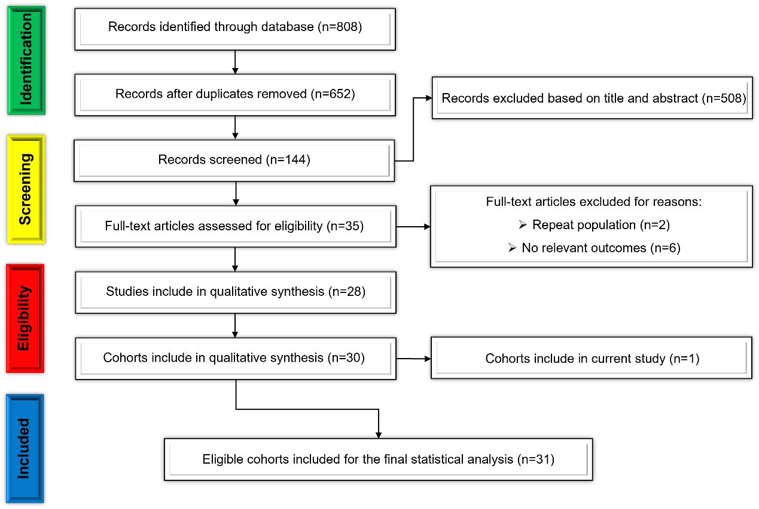
Supplementary Figure1. The selection flow diagram of studies included in the meta-analysis.
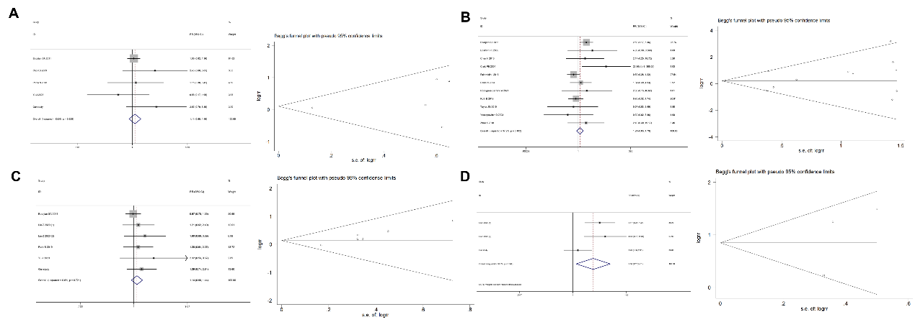 Supplementary Figure 2. Forest plot and funnel plot presenting the effects of age (A), sex (B), smoking history (C) and history of transurethral resection of bladder tumours (D) on the URFS score after RC for BC patients.

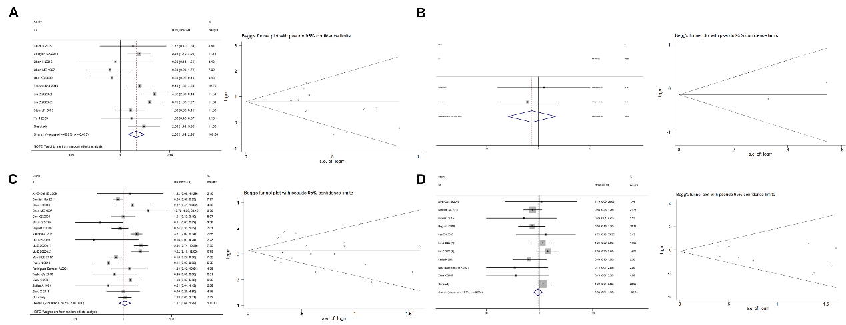
Supplementary Figure 3. Forest and funnel plots presenting the effects of tumour multifocality (A), tumour size (B), tumour stage (C) and lymph node positivity (D) on URFS after RC for BC patients.
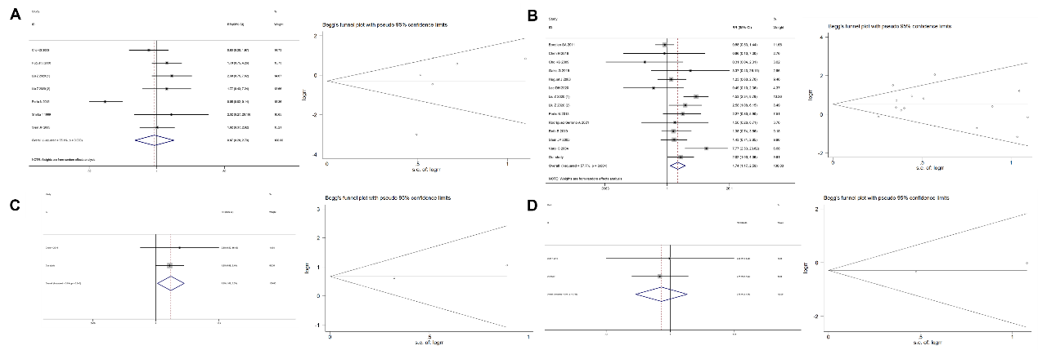
Supplementary Figure 4. Forest and funnel plots presenting the effects of tumour grade (A), concomitant carcinoma in situ (B), lymphovascular invasion (C) and perineural invasion (D) on URFS after RC for BC.
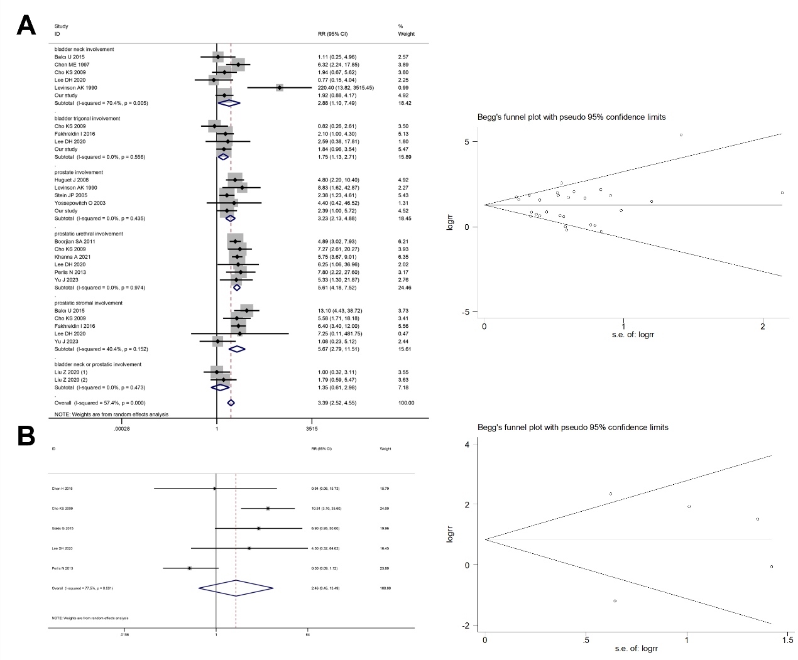
Supplementary Figure 5. Forest plot and funnel plot presenting the effects of bladder neck or trigeminal or prostate involvement (A) and urethral margin status (B) on URFS after RC for BC.
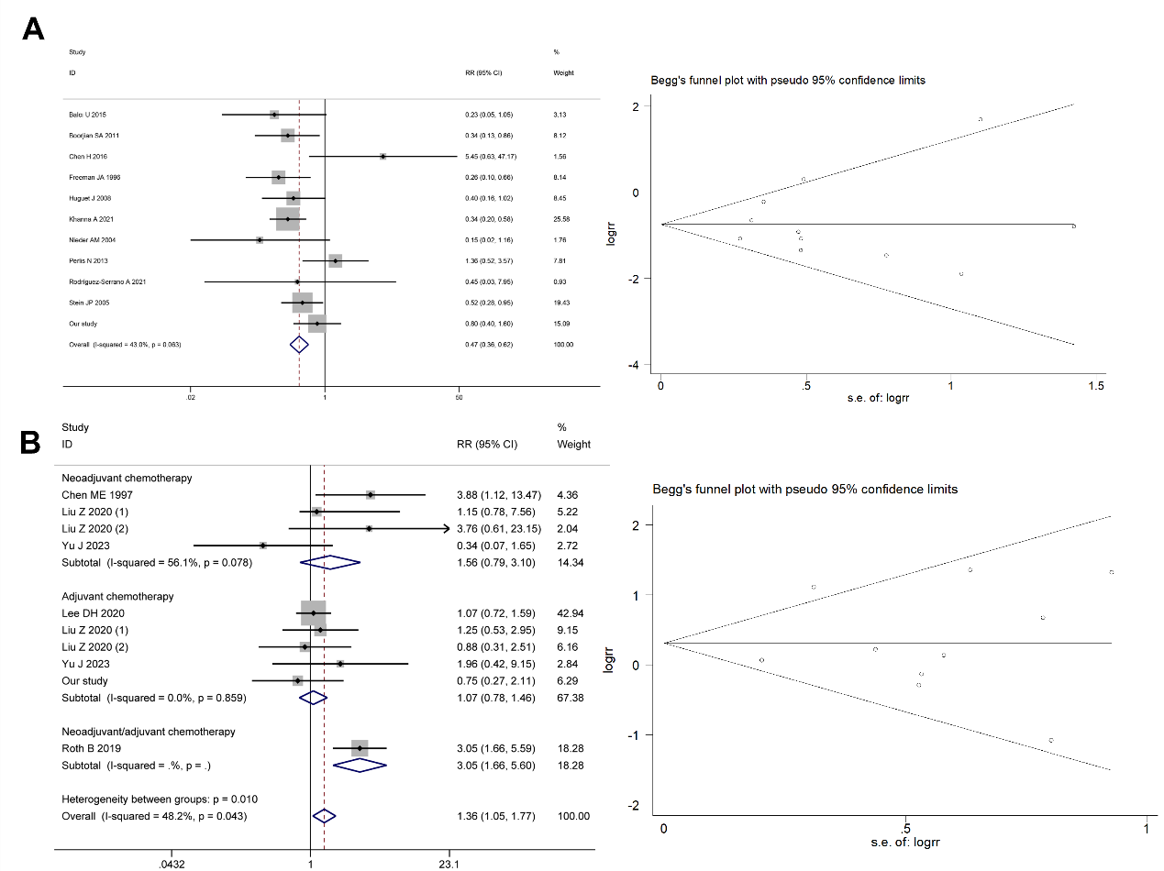
Supplementary Figure 6. Forest and funnel plots presenting the effects of diversion type (A) and neoadjuvant and adjuvant chemotherapy (B) on URFS after RC in BC patients.

