Supporting Information
Table S1. Demographic and clinical characteristics of the study cohort
Characteristic | Mean (SD), median [IQR], or frequency
Male (%) | 87.3
Age (years) | 71.8 (8.1)
BMI (kg/m²) | 21.9 (3.5)
Current or former smoker (%) | 97.8
Smoking exposure (pack-years) | 50.0 [37.1, 75.0]
History of asthma (%) | 17.6
ICS use (%) | 51.9
LABD use (%) | 90.3
LAMA use (%) | 15.7
LABA use (%) | 20.3
LAMA/LABA use (%) | 54.3
FEV₁ (L) | 1.4 (0.7)
ppFEV₁ (%) | 53.9 (22.9)
FEV₁/FVC (%) | 48.9 (12.8)
CRP (mg/dL) | 0.1 [0.1, 0.3]
Abbreviations: SD, standard deviation; IQR, interquartile range; BMI, body mass index; ICS, inhaled corticosteroid; LABD, long-acting bronchodilator; LAMA, long-acting muscarinic antagonist; LABA, long-acting β₂-agonist; FEV₁, forced expiratory volume in 1 s; ppFEV₁, percent predicted FEV₁; FVC, forced vital capacity; CRP, C-reactive protein.
Age, BMI, FEV₁, ppFEV₁, and FEV₁/FVC are presented as mean (SD), whereas smoking exposure and CRP level are presented as median [IQR] because of a skewed distribution. Other variables are given as percentages.

Table S2. Cause-specific mortality rates according to the GOLD classification
Causes of death | Mortality rates (per 1,000 person years) |  |  |  | P for  trend
Causes of death | Stage I  (n = 57) | Stage II  (n = 137) | Stage III  (n = 109) | Stage IV  (n = 67) | P for  trend
Respiratory diseases | 3.9 | 3.4 | 13.0 | 51.8 | < 0.01
Cardiovascular diseases | 0.0 | 1.7 | 2.2 | 0.0 | 0.89
Primary lung cancer | 0.0 | 3.4 | 4.3 | 0.0 | 0.87
Other malignancies | 0.0 | 0.0 | 4.3 | 8.0 | 0.046
Infectious diseases | 3.9 | 0.0 | 2.2 | 0.0 | 0.51
Other/unspecified | 3.9 | 3.4 | 8.7 | 27.9 | < 0.01
Abbreviation: GOLD, Global Initiative for Chronic Obstructive Lung Disease.

Table S3. Cause-specific mortality rates according to the STAR classification
Causes of death | Mortality rates (per 1,000 person years) |  |  |  | P for  trend
Causes of death | Stage I  (n = 87) | Stage II  (n = 98) | Stage III  (n = 88) | Stage IV  (n = 97) | P for  trend
Respiratory diseases | 2.6 | 9.6 | 18.9 | 24.9 | < 0.01
Cardiovascular diseases | 0.0 | 4.8 | 0.0 | 0.0 | 0.54
Primary lung cancer | 0.0 | 7.2 | 0.0 | 2.5 | 0.99
Other malignancies | 0.0 | 0.0 | 2.7 | 7.5 | 0.09
Infectious diseases | 2.6 | 0.0 | 2.7 | 0.0 | 0.54
Other/unspecified | 7.9 | 0.0 | 8.1 | 20.0 | 0.04
Abbreviation: STAR, STaging of Airflow obstruction by Ratio.

Figure S1. Distributions of study participants according to disease severity based on the GOLD and STAR classifications.
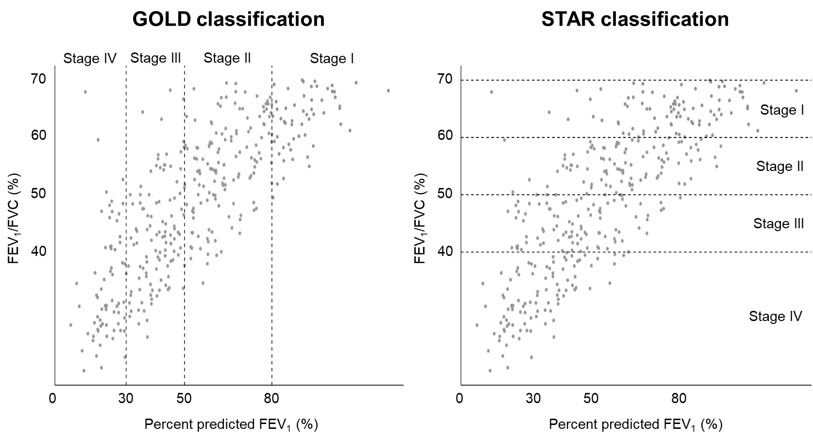

Abbreviations: GOLD, Global Initiative for Chronic Obstructive Lung Disease; STAR, STaging of Airflow obstruction by Ratio; FEV₁, forced expiratory volume in 1 s; FVC, forced vital capacity.

Figure S2. Bangdiwala agreement plot comparing GOLD and STAR classifications.
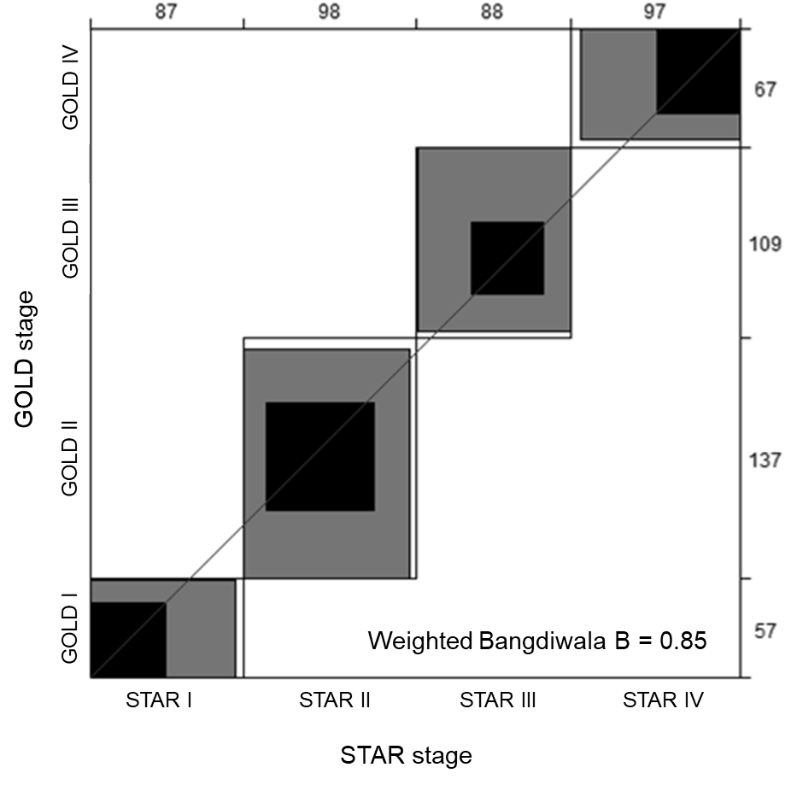

The plot is displayed as an N × N square, where N represents the total sample size. Each large rectangle shows the maximum possible agreement based on the marginal totals, with successively lighter-shaded rectangles representing partial agreement. Each dark rectangle indicates complete agreement, and perfect agreement would occur if all groups formed dark squares aligned along a 45-degree diagonal line. The numbers on the top and right axes indicate the distribution of subjects across STAR and GOLD stages, respectively.
Abbreviations: GOLD, Global Initiative for Chronic Obstructive Lung Disease; STAR, STaging of Airflow obstruction by Ratio.

Figure S3. Kaplan-Meier survival curves according to the GOLD classification for study participants receiving (right panel) or not receiving (left panel) inhalation therapy.
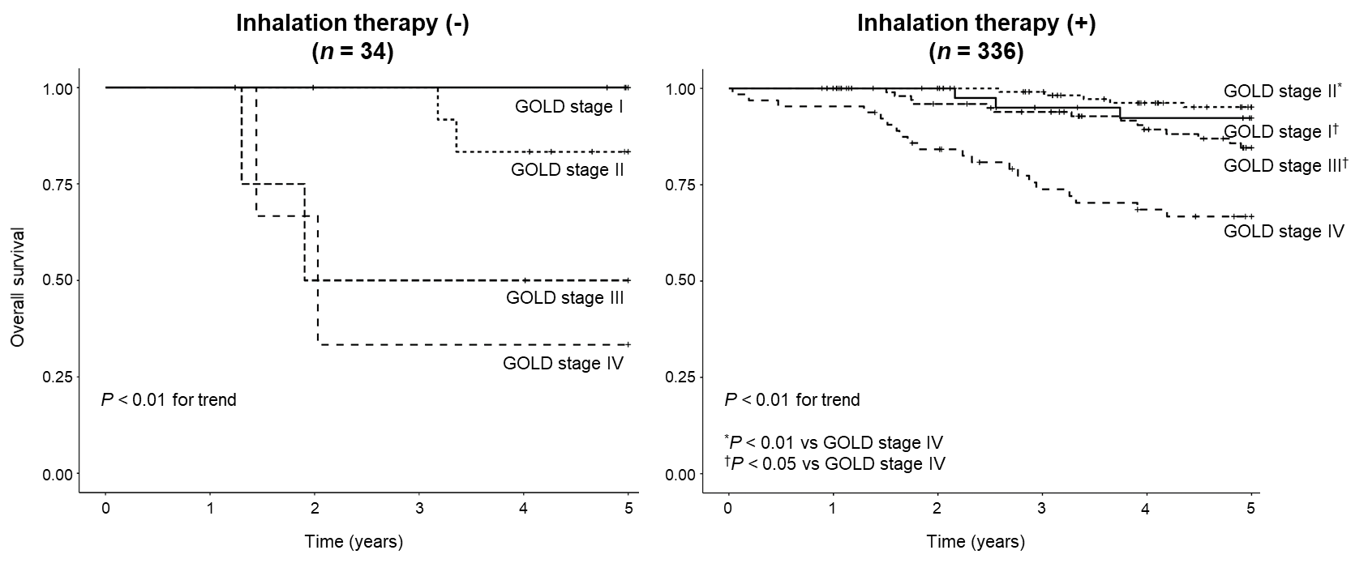

Inhalation therapy included inhaled corticosteroids and long-acting bronchodilators.
Abbreviation: GOLD, Global Initiative for Chronic Obstructive Lung Disease.

Figure S4. Multivariable-adjusted HRs for respiratory disease–related mortality across GOLD and STAR stages.
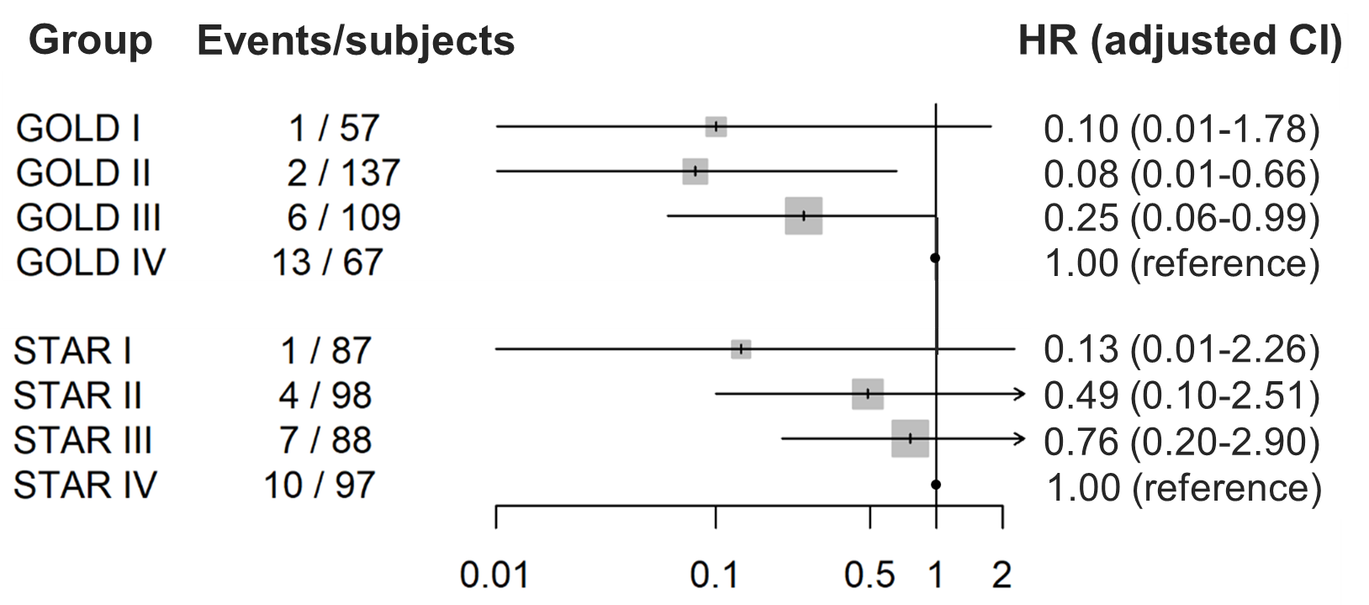

Adjustments were made for age, sex, body mass index, smoking exposure level, use of inhaled corticosteroids, use of long-acting bronchodilators, history of asthma, and CRP level.
Abbreviations: HR, hazard ratio; CI, confidence interval; GOLD, Global Initiative for Chronic Obstructive Lung Disease; STAR, STaging of Airflow obstruction by Ratio.

Figure S5. Kaplan-Meier survival curves according to the STAR classification for study participants receiving (right panel) or not receiving (left panel) inhalation therapy.
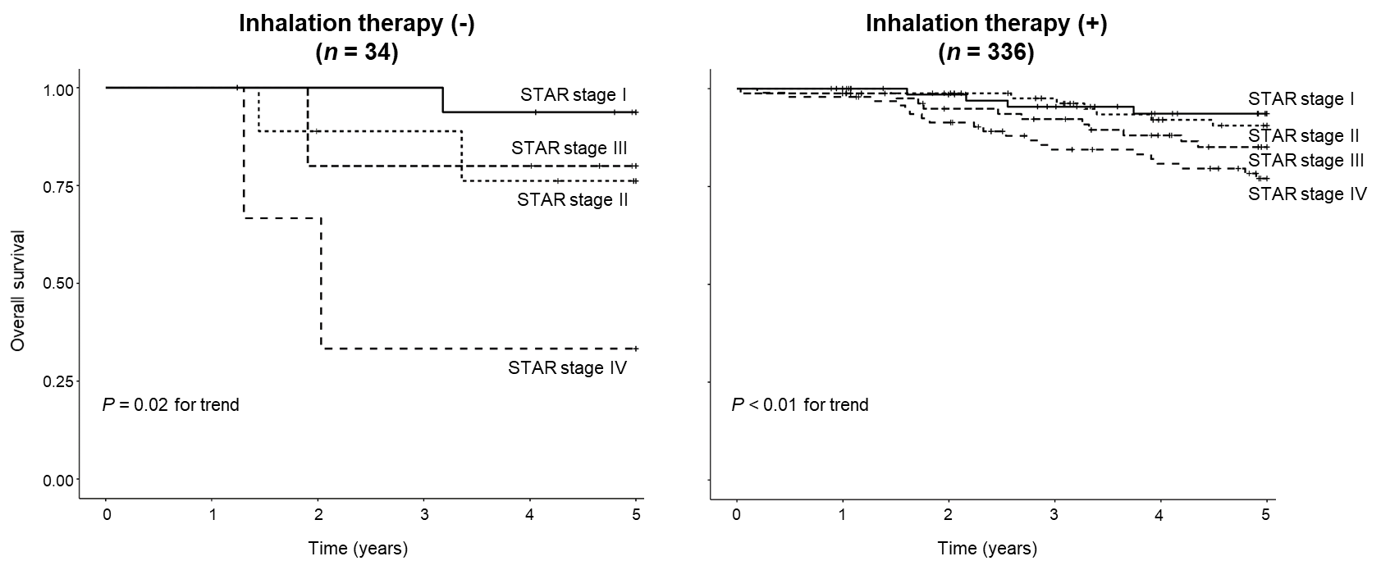

Inhalation therapy included inhaled corticosteroids and long-acting bronchodilators.
Abbreviation: STAR, STaging of Airflow obstruction by Ratio.

Figure S6. Kaplan-Meier survival curves according to the ADO index quartiles (left panel) and mADO index quartiles (right panel).
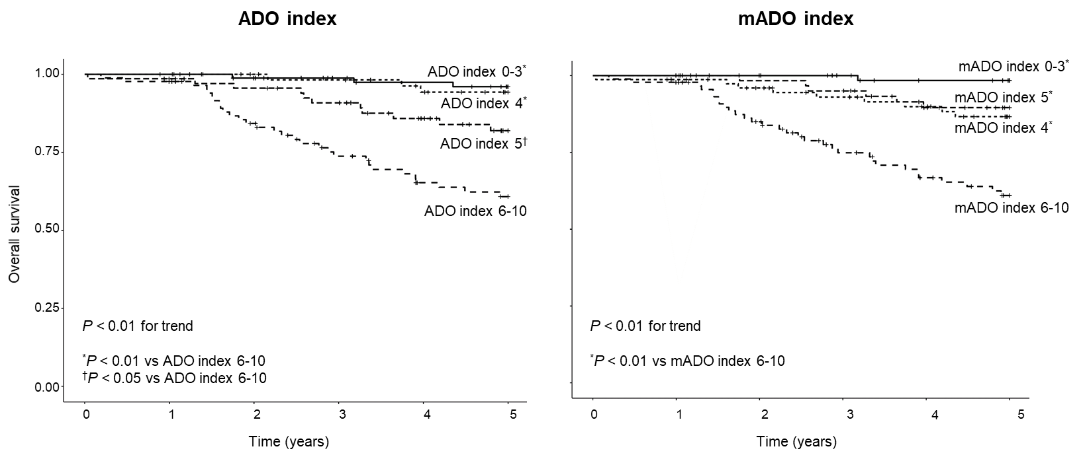

Abbreviations: ADO, age, dyspnea, and airflow obstruction; mADO, modified ADO.

Figure S7. Multivariable-adjusted HRs for all-cause mortality across quartiles of the ADO and mADO index.
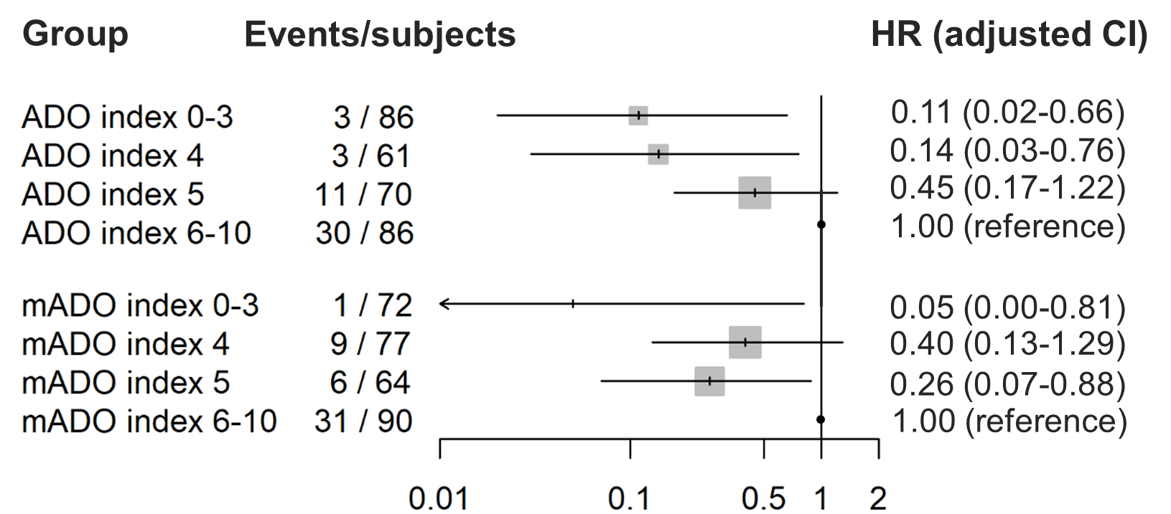

Adjustments were made for sex, body mass index, smoking exposure level, use of inhaled corticosteroids, use of long-acting bronchodilators, history of asthma, and C-reactive protein level.
Abbreviations: HR, hazard ratio; CI, confidence interval; ADO, age, dyspnea, and airflow obstruction; mADO, modified ADO.

Figure S8. Cumulative incidence function curves for the probability of moderate to severe COPD exacerbations according to the ADO index quartiles (left panel) and mADO index quartiles (right panel).
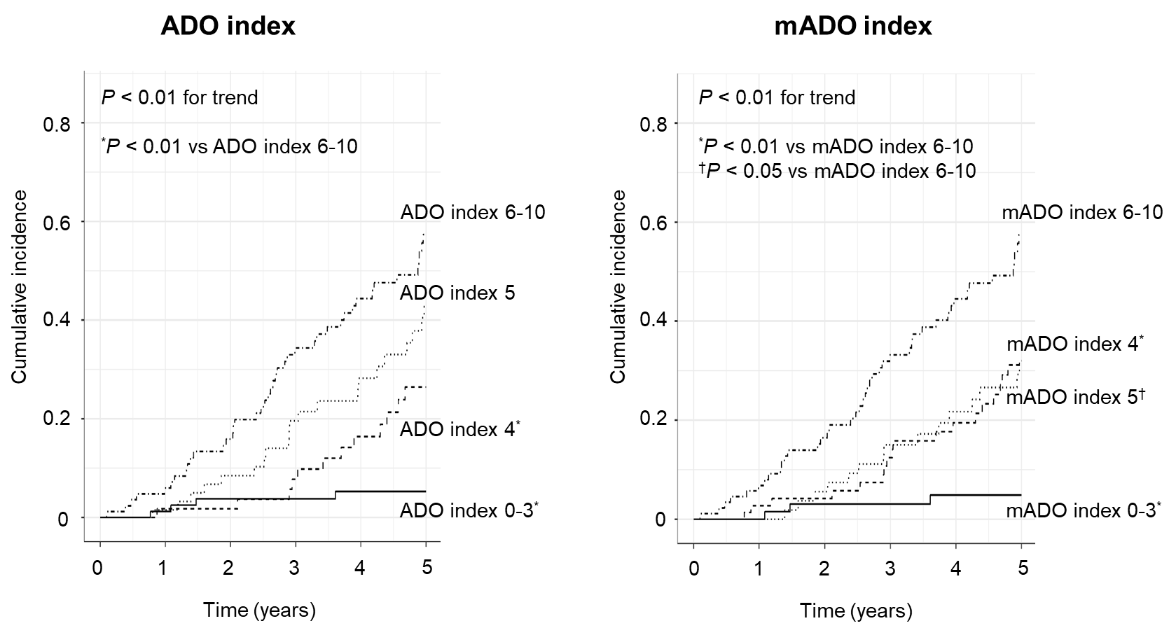

Abbreviations: COPD, chronic obstructive pulmonary disease; ADO, age, dyspnea, and airflow obstruction; mADO, modified ADO.

Figure S9. Multivariable-adjusted SHRs for moderate to severe COPD exacerbations across quartiles of the ADO and mADO index.
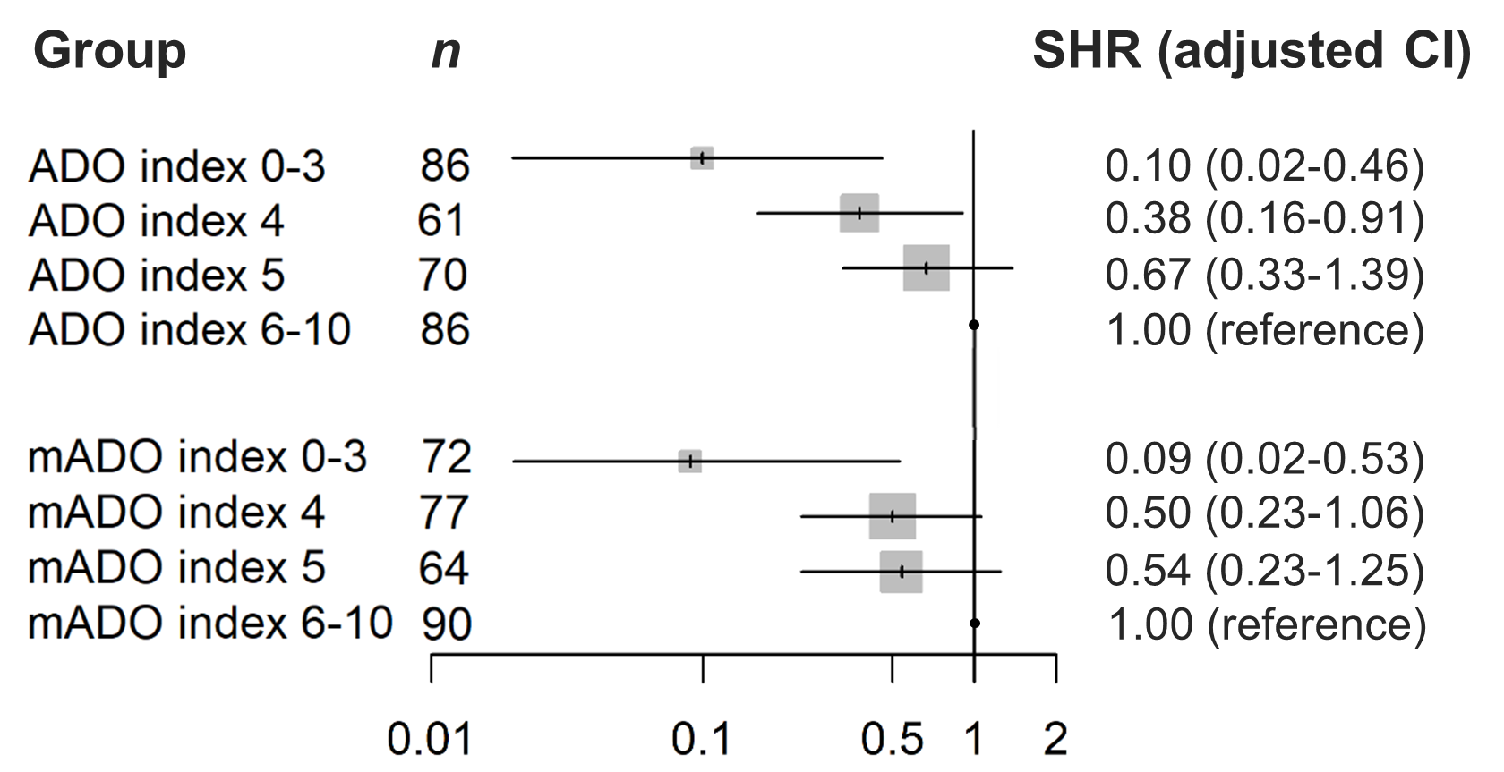

Adjustments were made for sex, body mass index, smoking exposure level, use of inhaled corticosteroids, use of long-acting bronchodilators, history of asthma, and C-reactive protein level.
Abbreviations: COPD, chronic obstructive pulmonary disease; SHR, subdistribution hazard ratio; CI, 95% confidence interval; ADO, age, dyspnea, and airflow obstruction; mADO, modified ADO.

