Supplementary Information
“In silico analysis of human TLR3 missense single nucleotide polymorphisms and their potential association with cancer”
Mohini Agarwal¹, Manish Kumar¹, Sarthak Dahiya², Anoop Kumar³, Rupal Tripathi⁴ & Kumud Bala¹*

Affiliation of the Authors
- Amity Institute of Biotechnology, Amity University Uttar Pradesh, Noida, India
- Amity Institute of Pharmacy, Amity University, Noida, India
- National Institute of Biologicals, Sector-62, Noida, India
- Rajiv Gandhi Cancer Institute and Research Centre, Delhi, India

*Corresponding Author- Prof. (Dr.) Kumud Bala, Professor
Therapeutics and Molecular Diagnostics Lab, Lab No.-319, J-3 Block, Amity Institute of Biotechnology, Amity University, Noida, Uttar Pradesh
kbala@amity.edu, 9811292212.

T-COFFEE RESULTS
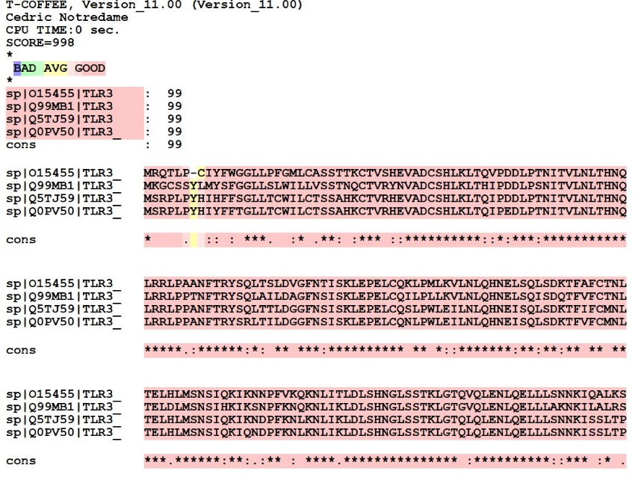
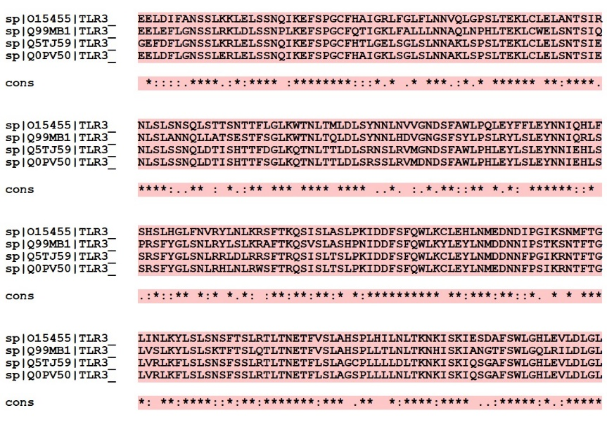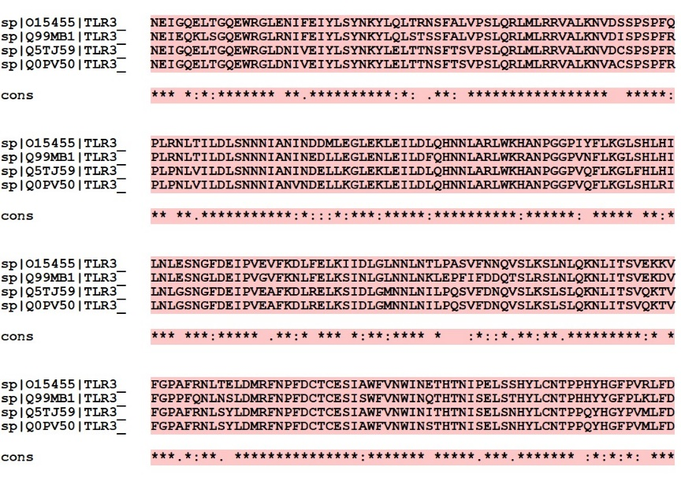
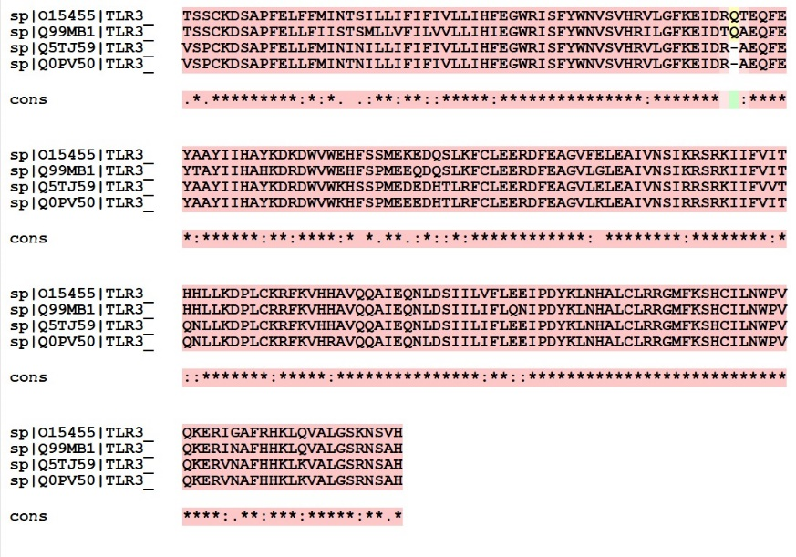
Figure S1: Multiple sequences alignment results using T-Coffee for TLR3 sequence of different species like Homo sapiens, Mus musculus, Bos taurus and Boselaphus tragocamelus with uniport ID O15455, Q99MB1, Q5TJ59 and Q0PV50.

CLUSTER OMEGA
CLUSTAL O(1.2.4) multiple sequence alignment

sp|Q99MB1|TLR3_MOUSE MKGCSSYLMYSFGGLLSLWILLVSSTNQCTVRYNVADCSHLKLTHIPDDLPSNITVLNLT 60
sp|O15455|TLR3_HUMAN MRQTLP-CIYFWGGLLPFGMLCASSTTKCTVSHEVADCSHLKLTQVPDDLPTNITVLNLT 59
sp|Q5TJ59|TLR3_BOVIN MSRPLPYHIHFFSGLLTCWILCTSSAHKCTVRHEVADCSHLKLTQIPDDLPTNITVLNLT 60
sp|Q0PV50|TLR3_BOSTR MSRPLPYHIYFFTGLLTCWILCTSSAHKCTVRHEVADCSHLKLTQIPEDLPTNITVLNLT 60
* :: : *** :* .**: :*** ::**********::*:***:********

sp|Q99MB1|TLR3_MOUSE HNQLRRLPPTNFTRYSQLAILDAGFNSISKLEPELCQILPLLKVLNLQHNELSQISDQTF 120
sp|O15455|TLR3_HUMAN HNQLRRLPAANFTRYSQLTSLDVGFNTISKLEPELCQKLPMLKVLNLQHNELSQLSDKTF 119
sp|Q5TJ59|TLR3_BOVIN HNQLRRLPPANFTRYSQLTTLDGGFNSISKLEPELCQSLPWLEILNLQHNEISQLSDKTF 120
sp|Q0PV50|TLR3_BOSTR HNQLRRLPPANFTRYSRLTILDGGFNSISKLEPELCQNLPWLEILNLQHNEISQLSDKTF 120
******** :******:*: ** ***:********** ** *::*******:**:**:**

sp|Q99MB1|TLR3_MOUSE VFCTNLTELDLMSNSIHKIKSNPFKNQKNLIKLDLSHNGLSSTKLGTGVQLENLQELLLA 180
sp|O15455|TLR3_HUMAN AFCTNLTELHLMSNSIQKIKNNPFVKQKNLITLDLSHNGLSSTKLGTQVQLENLQELLLS 179
sp|Q5TJ59|TLR3_BOVIN IFCMNLTELHLMSNSIQKIKNDPFKNLKNLIKLDLSHNGLSSTKLGTQLQLENLQELLLS 180
sp|Q0PV50|TLR3_BOSTR VFCMNLTELHLMSNSIQKIQNDPFKNLKNLIKLDLSHNGLSSTKLGTQLQLENLQELLLS 180
** *****.******:**:.:** : ****.*************** :**********:

sp|Q99MB1|TLR3_MOUSE KNKILALRSEELEFLGNSSLRKLDLSSNPLKEFSPGCFQTIGKLFALLLNNAQLNPHLTE 240
sp|O15455|TLR3_HUMAN NNKIQALKSEELDIFANSSLKKLELSSNQIKEFSPGCFHAIGRLFGLFLNNVQLGPSLTE 239
sp|Q5TJ59|TLR3_BOVIN NNKISSLTPGEFDFLGNSSLKRLELSSNQIKEFSPGCFHTLGELSGLSLNNAKLSPSLTE 240
sp|Q0PV50|TLR3_BOSTR NNKISSLTPEELDFLGNSSLERLELSSNQIKEFSPGCFHAIGKLSGLSLNNAKLSPSLTE 240
:*** :* *::::.****.:*:**** :********:::*.* .* ***.:*.* ***

sp|Q99MB1|TLR3_MOUSE KLCWELSNTSIQNLSLANNQLLATSESTFSGLKWTNLTQLDLSYNNLHDVGNGSFSYLPS 300
sp|O15455|TLR3_HUMAN KLCLELANTSIRNLSLSNSQLSTTSNTTFLGLKWTNLTMLDLSYNNLNVVGNDSFAWLPQ 299
sp|Q5TJ59|TLR3_BOVIN KLCLELSNTSIENLSLSSNQLDTISHTTFDGLKQTNLTTLDLSRNSLRVMGNDSFAWLPH 300
sp|Q0PV50|TLR3_BOSTR KLCLELSNTSIENLSLSSNQLDTISHTTFSGLKQTNLTTLDLSRSSLRVMDNDSFAWLPH 300
*** **:****.****:..** : *.:** *** **** **** ..*. :.*.**::**

sp|Q99MB1|TLR3_MOUSE LRYLSLEYNNIQRLSPRSFYGLSNLRYLSLKRAFTKQSVSLASHPNIDDFSFQWLKYLEY 360
sp|O15455|TLR3_HUMAN LEYFFLEYNNIQHLFSHSLHGLFNVRYLNLKRSFTKQSISLASLPKIDDFSFQWLKCLEH 359
sp|Q5TJ59|TLR3_BOVIN LEYLSLEYNNIEHLSSRSFYGLSNLRRLDLRRSFTRQSISLTSLPKIDDFSFQWLKCLEY 360
sp|Q0PV50|TLR3_BOSTR LEYLSLEYNNIEHLSSRSFYGLSNLRHLNLRWSFTRQSISLTSLPKIDDFSFQWLKCLEY 360
*.*: ******::* :*::** *:* *.*: :**:**:**:* *:********** **:

sp|Q99MB1|TLR3_MOUSE LNMDDNNIPSTKSNTFTGLVSLKYLSLSKTFTSLQTLTNETFVSLAHSPLLTLNLTKNHI 420
sp|O15455|TLR3_HUMAN LNMEDNDIPGIKSNMFTGLINLKYLSLSNSFTSLRTLTNETFVSLAHSPLHILNLTKNKI 419
sp|Q5TJ59|TLR3_BOVIN LNMDDNNFPGIKRNTFTGLVRLKFLSLSNSFSSLRTLTNETFLSLAGCPLLLLDLTKNKI 420
sp|Q0PV50|TLR3_BOSTR LNMEDNNFPSIKRNTFTGLVRLKFLSLSNSFSSLRTLTNETFLSLAGSPLLLLNLTKNKI 420
***:**::*. * * ****: **:****::*:**:*******:*** .** *:****:*

sp|Q99MB1|TLR3_MOUSE SKIANGTFSWLGQLRILDLGLNEIEQKLSGQEWRGLRNIFEIYLSYNKYLQLSTSSFALV 480
sp|O15455|TLR3_HUMAN SKIESDAFSWLGHLEVLDLGLNEIGQELTGQEWRGLENIFEIYLSYNKYLQLTRNSFALV 479
sp|Q5TJ59|TLR3_BOVIN SKIQSGAFSWLGHLEVLDLGLNEIGQELTGQEWRGLDNIVEIYLSYNKYLELTTNSFTSV 480
sp|Q0PV50|TLR3_BOSTR SKIQSGAFSWLGHLEVLDLGLNEIGQELTGQEWRGLDNIVEIYLSYNKYLELTTNSFTSV 480
*** ..:*****:*.:******** *:*:******* **.**********:*: .**: *

sp|Q99MB1|TLR3_MOUSE PSLQRLMLRRVALKNVDISPSPFRPLRNLTILDLSNNNIANINEDLLEGLENLEILDFQH 540
sp|O15455|TLR3_HUMAN PSLQRLMLRRVALKNVDSSPSPFQPLRNLTILDLSNNNIANINDDMLEGLEKLEILDLQH 539
sp|Q5TJ59|TLR3_BOVIN PSLQRLMLRRVALKNVDCSPSPFRPLPNLVILDLSNNNIANINDELLKGLEKLEILDLQH 540
sp|Q0PV50|TLR3_BOSTR PSLQRLMLRRVALKNVACSPSPFRPLPNLVILDLSNNNIANVNDELLKGLEKLEILDLQH 540
**************** *****:** **.***********:*:::*:***:*****:**

sp|Q99MB1|TLR3_MOUSE NNLARLWKRANPGGPVNFLKGLSHLHILNLESNGLDEIPVGVFKNLFELKSINLGLNNLN 600
sp|O15455|TLR3_HUMAN NNLARLWKHANPGGPIYFLKGLSHLHILNLESNGFDEIPVEVFKDLFELKIIDLGLNNLN 599
sp|Q5TJ59|TLR3_BOVIN NNLARLWKHANPGGPVQFLKGLFHLHILNLGSNGFDEIPVEAFKDLRELKSIDLGMNNLN 600
sp|Q0PV50|TLR3_BOSTR NNLARLWKHANPGGPVQFLKGLSHLRILNLGSNGFDEIPVEAFKDLRELKSIDLGMNNLN 600
********:******: ***** **:**** ***:***** .**:* *** *:**:****

sp|Q99MB1|TLR3_MOUSE KLEPFIFDDQTSLRSLNLQKNLITSVEKDVFGPPFQNLNSLDMRFNPFDCTCESISWFVN 660
sp|O15455|TLR3_HUMAN TLPASVFNNQVSLKSLNLQKNLITSVEKKVFGPAFRNLTELDMRFNPFDCTCESIAWFVN 659
sp|Q5TJ59|TLR3_BOVIN ILPQSVFDNQVSLKSLSLQKNLITSVQKTVFGPAFRNLSYLDMRFNPFDCTCESIAWFVN 660
sp|Q0PV50|TLR3_BOSTR ILPQSVFDNQVSLKSLSLQKNLITSVQKTVFGPAFRNLSYLDMRFNPFDCTCESIAWFVN 660
* :*::*.**:**.*********:* **** *:**. ***************:****

sp|Q99MB1|TLR3_MOUSE WINQTHTNISELSTHYLCNTPHHYYGFPLKLFDTSSCKDSAPFELLFIISTSMLLVFILV 720
sp|O15455|TLR3_HUMAN WINETHTNIPELSSHYLCNTPPHYHGFPVRLFDTSSCKDSAPFELFFMINTSILLIFIFI 719
sp|Q5TJ59|TLR3_BOVIN WINITHTNISELSNHYLCNTPPQYHGYPVMLFDVSPCKDSAPFELLFMININILLIFIFI 720
sp|Q0PV50|TLR3_BOSTR WINSTHTNISELSNHYLCNTPPQYHGFPVMLFDVSPCKDSAPFELLFMINTNILLIFIFI 720
*** ***** ***.******* :*:*:*: ***.* *********:*:*. .:**:**::

sp|Q99MB1|TLR3_MOUSE VLLIHIEGWRISFYWNVSVHRILGFKEIDTQAEQFEYTAYIIHAHKDRDWVWEHFSPMEE 780
sp|O15455|TLR3_HUMAN VLLIHFEGWRISFYWNVSVHRVLGFKEIDRQTEQFEYAAYIIHAYKDKDWVWEHFSSMEK 779
sp|Q5TJ59|TLR3_BOVIN VLLIHFEGWRISFYWNVSVHRVLGFKEIDR-AEQFEYAAYIIHAYKDRDWVWKHSSPMED 779
sp|Q0PV50|TLR3_BOSTR VLLIHFEGWRISFYWNVSVHRVLGFKEIDR-AEQFEYAAYIIHAYKDRDWVWKHFSPMEE 779
*****:***************:******* :*****:******:**:****:* * **.

sp|Q99MB1|TLR3_MOUSE QDQSLKFCLEERDFEAGVLGLEAIVNSIKRSRKIIFVITHHLLKDPLCRRFKVHHAVQQA 840
sp|O15455|TLR3_HUMAN EDQSLKFCLEERDFEAGVFELEAIVNSIKRSRKIIFVITHHLLKDPLCKRFKVHHAVQQA 839
sp|Q5TJ59|TLR3_BOVIN EDHTLRFCLEERDFEAGVLELEAIVNSIRRSRKIIFVVTQNLLKDPLCKRFKVHHAVQQA 839
sp|Q0PV50|TLR3_BOSTR EDHTLRFCLEERDFEAGVLKLEAIVNSIRRSRKIIFVITQNLLKDPLCKRFKVHRAVQQA 839
:*::*:************: ********:********:*::*******:*****:*****

sp|Q99MB1|TLR3_MOUSE IEQNLDSIILIFLQNIPDYKLNHALCLRRGMFKSHCILNWPVQKERINAFHHKLQVALGS 900
sp|O15455|TLR3_HUMAN IEQNLDSIILVFLEEIPDYKLNHALCLRRGMFKSHCILNWPVQKERIGAFRHKLQVALGS 899
sp|Q5TJ59|TLR3_BOVIN IEQNLDSIILIFLEEIPDYKLNHALCLRRGMFKSHCILNWPVQKERVNAFHHKLKVALGS 899
sp|Q0PV50|TLR3_BOSTR IEQNLDSIILIFLEEIPDYKLNHALCLRRGMFKSHCILNWPVQKERVNAFHHKLKVALGS 899
**********:**::*******************************:.**:***:*****

sp|Q99MB1|TLR3_MOUSE RNSAH 905
sp|O15455|TLR3_HUMAN KNSVH 904
sp|Q5TJ59|TLR3_BOVIN RNSAH 904
sp|Q0PV50|TLR3_BOSTR RNSAH 904
:**.*

Figure S2: Multiple sequences alignment results using CLUSTAL-OMEGAfor TLR3 sequence of different species like Homo sapiens, Mus musculus, Bos taurus and Boselaphus tragocamelus with uniport ID O15455, Q99MB1, Q5TJ59 and Q0PV50

NETSURF RESULTS
- N284I
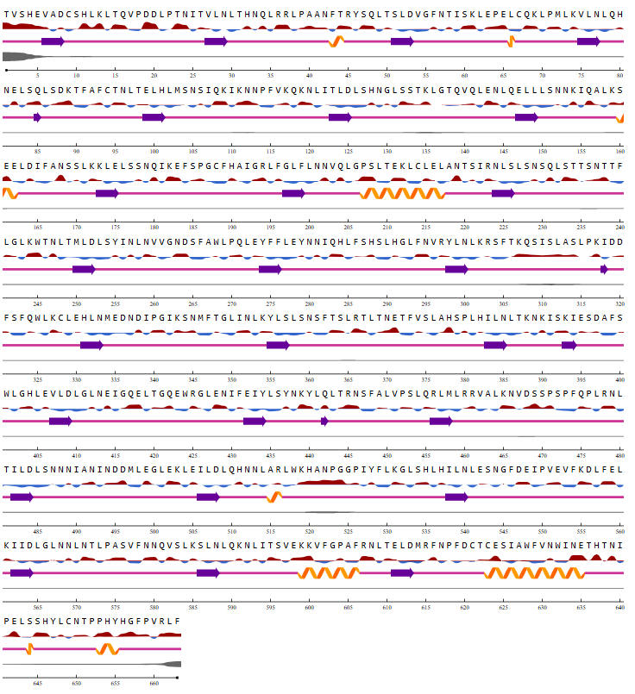

- C37R
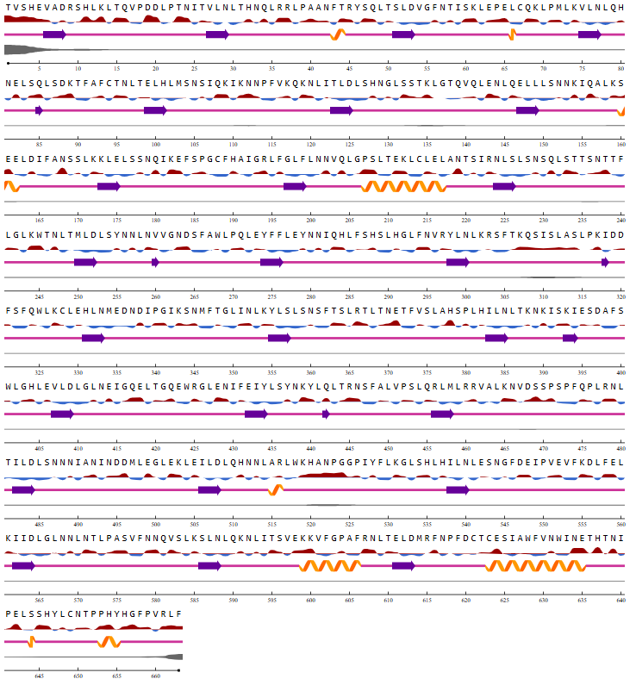
- L360P
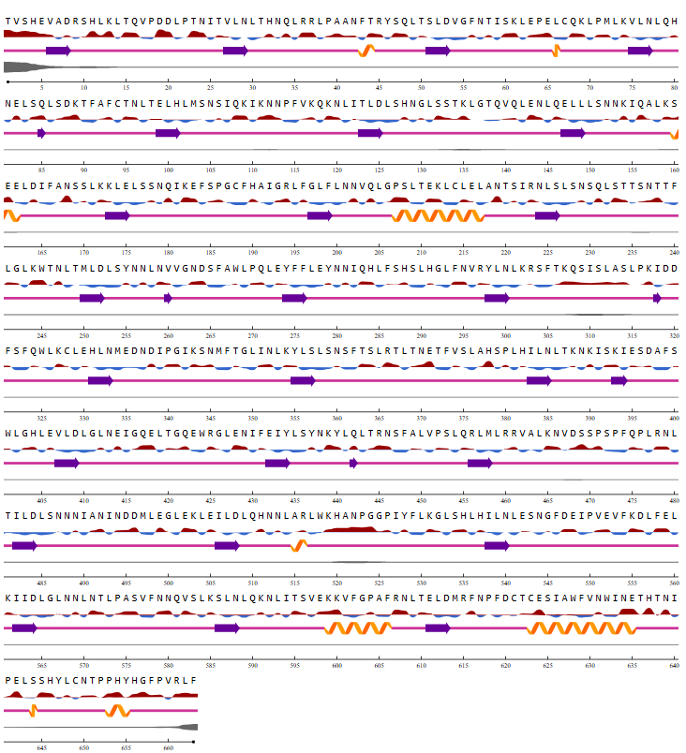
- Q538I
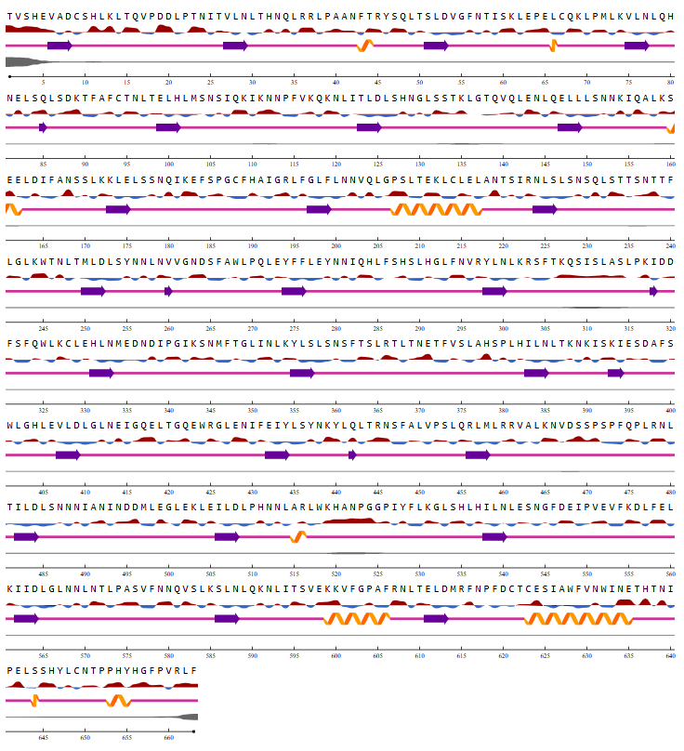
Figure S3: Net Surf result analysis of selected SNPs a) N284I, b) C37R, c) L360P, and d) Q538P.

Table S1: FATHMM-MKL based analysis of selected 4 mutations
Chromoso4me | Mutation | Position | Variant | Non-Coding Score | Non-Coding Groups | Coding Score | Coding Groups | Further Information
4 | N284I | 18703691 | A/T | 0.99253 | ADB | 0.99256 | AEFDBI | Highly likely pathogenic
4 | C37R | 186997882 | T/C | 0.99346 | AB | 0.98728 | AEFBI | Strong evidence of being deleterious, especially with high non-coding impact
4 | Q538P | 18704453 | A/C | 0.99086 | AB | 0.98311 | AEFBI | High likelihood of functional disruption
4 | L360P | 187003919 | T/C | 0.99325 | AB | 0.99103 | AEFBI | significant pathogenic potential in both coding and non-coding

Predictions are given as p-values in the range [0, 1]: values above 0.5 are predicted to be deleterious, while those below 0.5 are predicted to be neutral or benign. P-values close to the extremes (0 or 1) are the highest-confidence predictions that yield the highest accuracy.

Table S2: FATHMM-XF based analysis of selected 4 mutation
Mutation |  | Position | Variant |  | Further Information
  Chromosome
  Coding Score
N284I | 4 | 187003691 | A/T | 0.871397
  pathogenic
C37R | 4 | 186997882 |  | 0.937443
  T/C
  pathogenic
Q538P | 4 | 187004453 | A/C | -
  No prediction found
L360P | 4 | 187003919 | T/C
  0.934636
  pathogenic

Predictions are given as p-values in the range [0, 1]: values above 0.5 are predicted to be deleterious, while those below 0.5 are predicted to be neutral or benign. P-values close to the extremes (0 or 1) are the highest-confidence predictions that yield the highest accuracy.

RAMAPLOT DIFFERENT RESULTS
5GS0
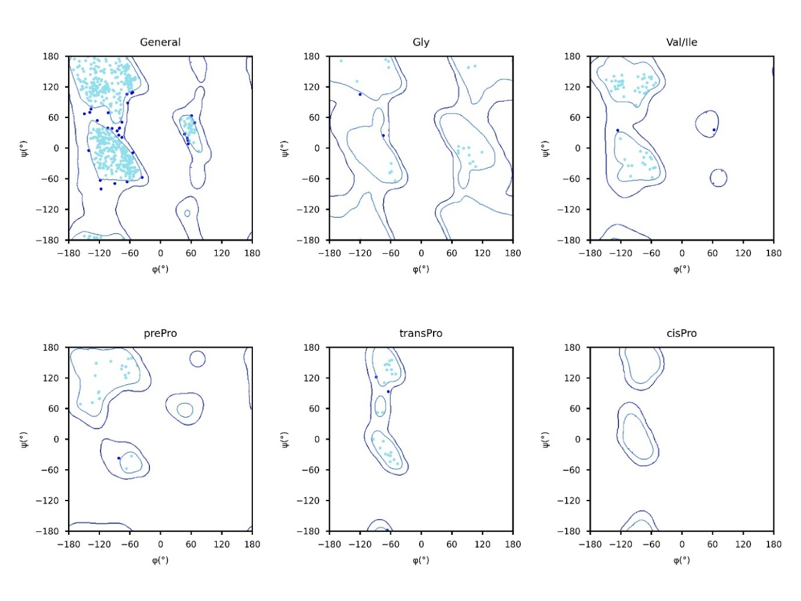
Figure S4.1: 2D Ramachandran plot of six distinct categories of 5GS0: (a) general case (Ala and remaining 15 amino acids), (b) Gly, (c) Val/Ile, (d) pre-Pro, (e) trans-Pro & (f) cis-Pro.
Here, cyan blue and red dots represent torsion angles of favoured, allowed and disallowed regions respectively.

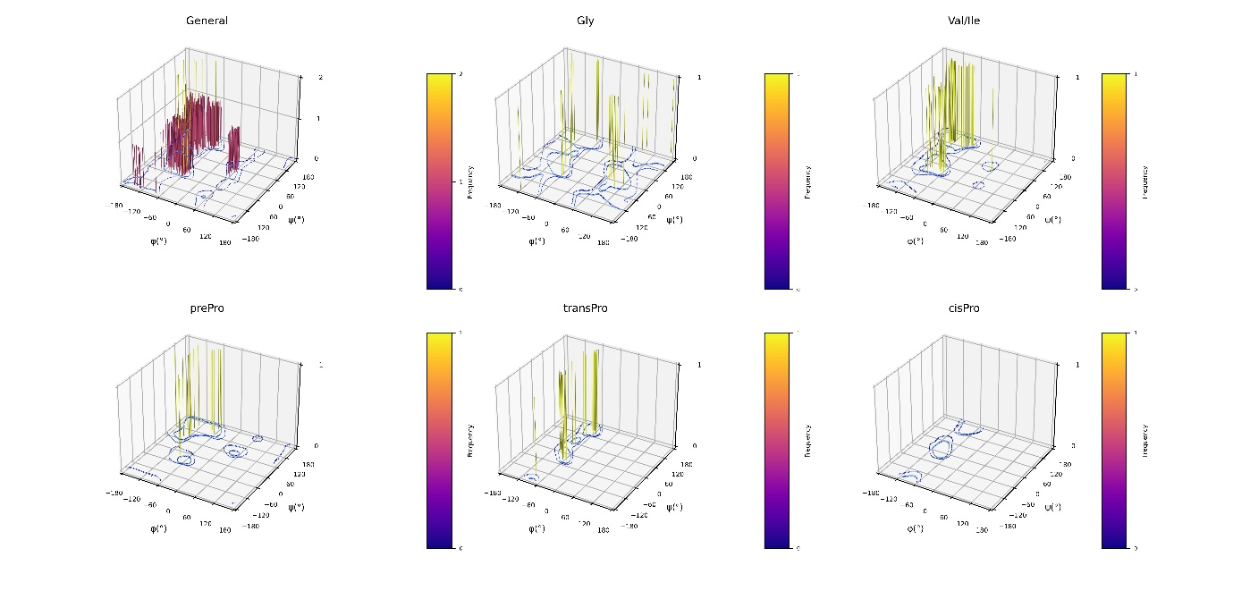Figure S4.2: 3D Ramachandran plot of six distinct categories of 5GS0: (a) general case (Ala and remaining 15 amino acids), (b) Gly, (c) Val/Ile, (d) pre-Pro, (e) trans-Pro & (f) cis-Pro.
Here, bars represent frequency of torsion angles.

L360P
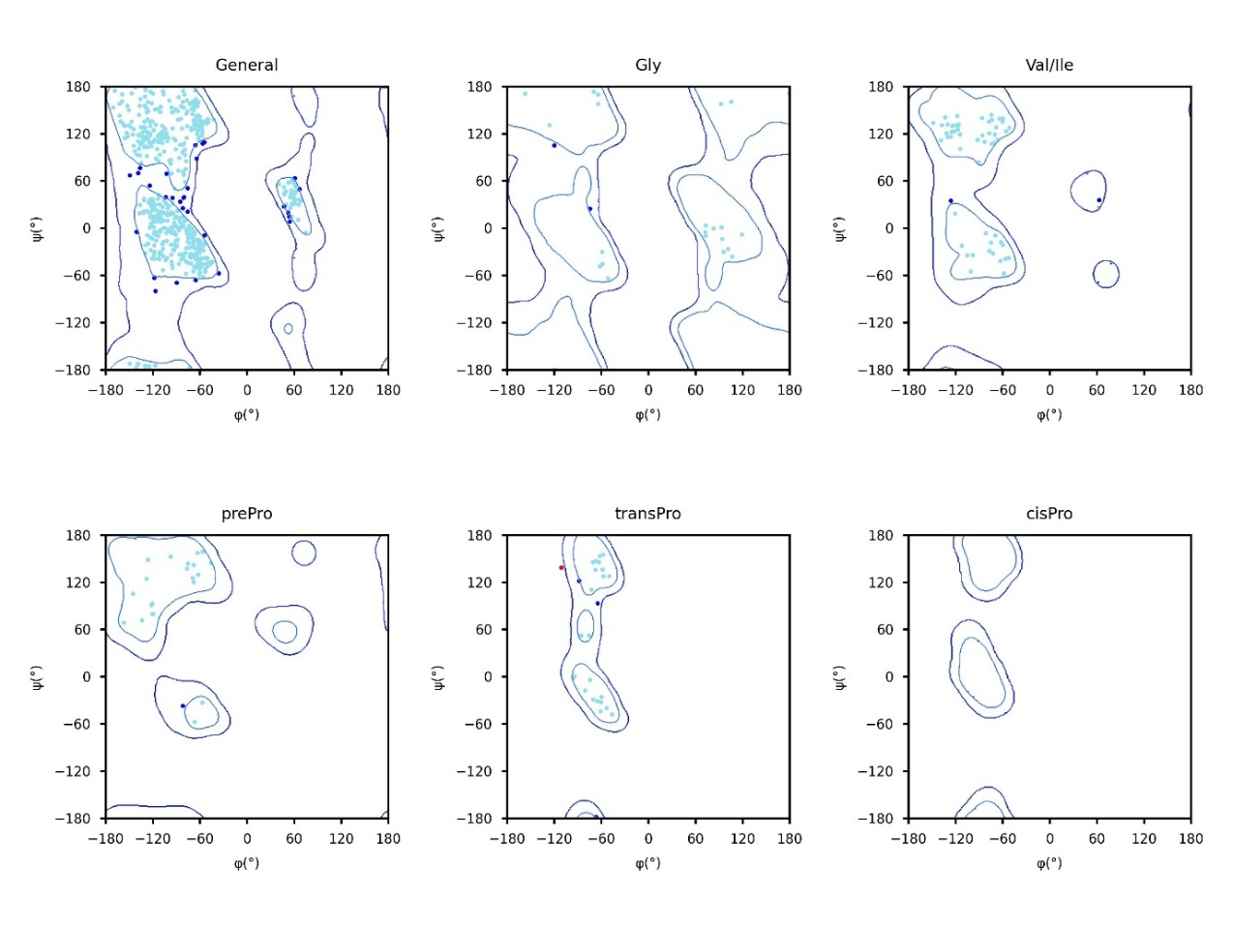
Figure S5.1: 2D Ramachandran plot of six distinct categories of L360P: (a) general case (Ala and remaining 15 amino acids), (b) Gly, (c) Val/Ile, (d) pre-Pro, (e) trans-Pro & (f) cis-Pro.
Here, cyan blue and red dots represent torsion angles of favoured, allowed and disallowed regions respectively.
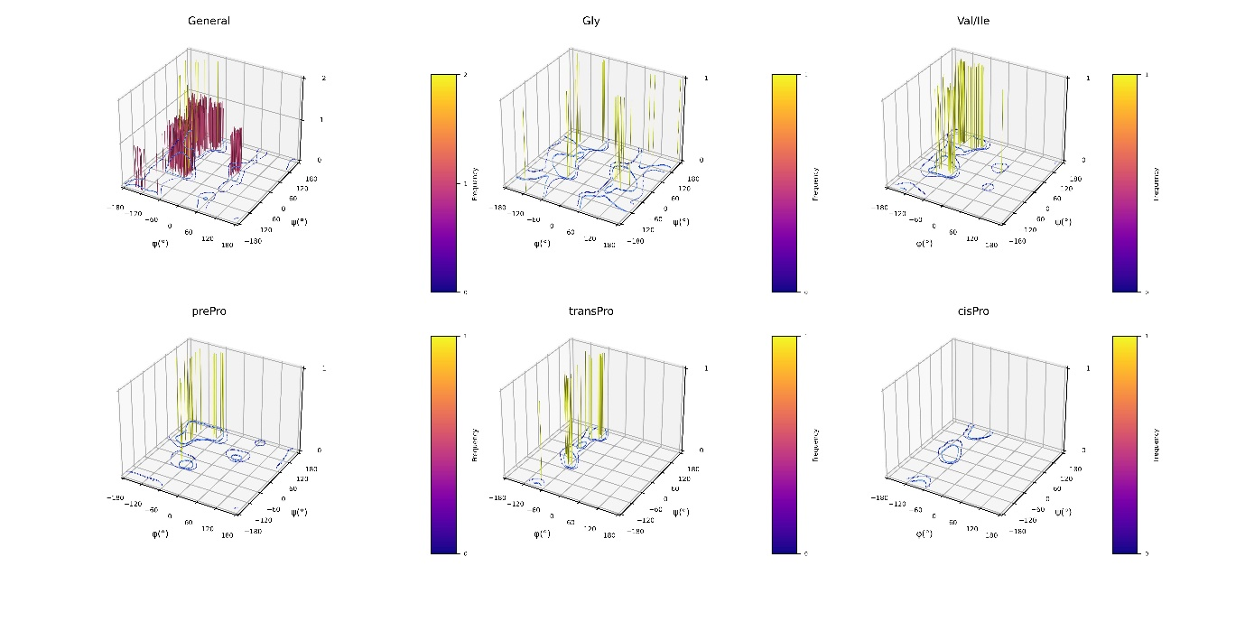
Figure S5.2: 3D Ramachandran plot of six distinct categories of L360P: (a) general case (Ala and remaining 15 amino acids), (b) Gly, (c) Val/Ile, (d) pre-Pro, (e) trans-Pro & (f) cis-Pro.
Here, bars represent frequency of torsion angles.

N248I
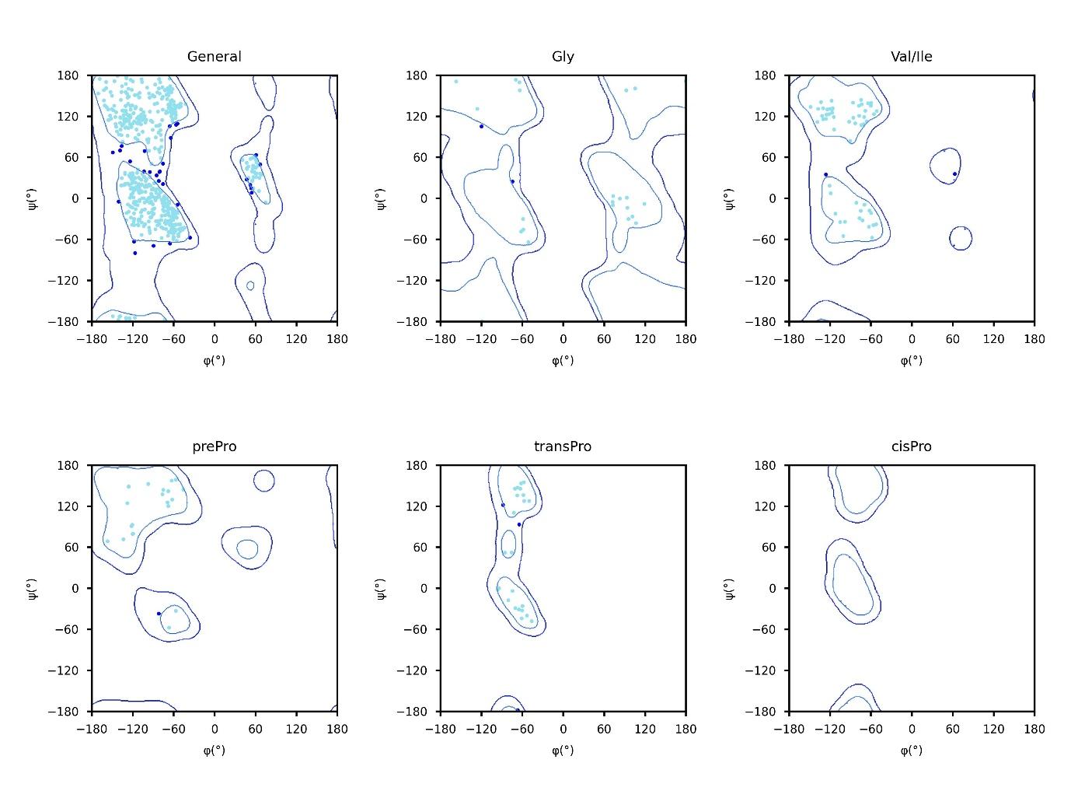
Figure S6.1: 2D Ramachandran plot of six distinct categories of N248I: (a) general case (Ala and remaining 15 amino acids), (b) Gly, (c) Val/Ile, (d) pre-Pro, (e) trans-Pro & (f) cis-Pro.
Here, cyan blue and red dots represent torsion angles of favoured, allowed and disallowed regions respectively.
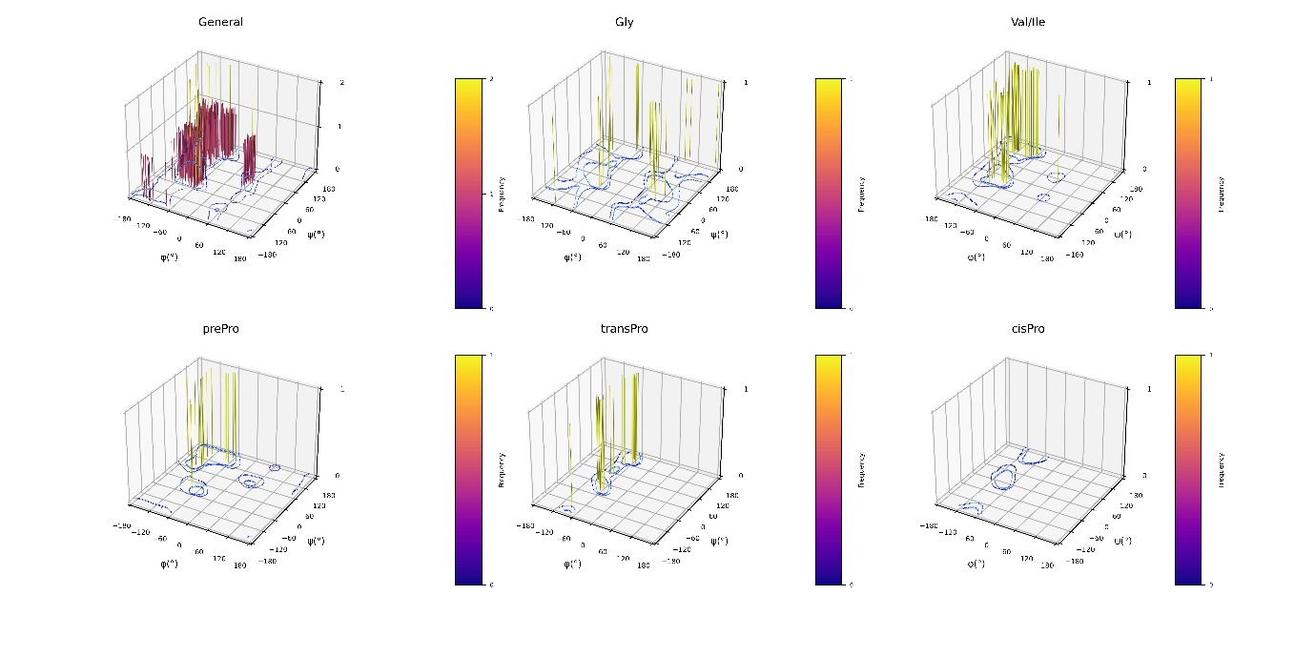
Figure S6.2: 3D Ramachandran plot of six distinct categories of N248I: (a) general case (Ala and remaining 15 amino acids), (b) Gly, (c) Val/Ile, (d) pre-Pro, (e) trans-Pro & (f) cis-Pro.
Here, bars represent frequency of torsion angles.

C37R
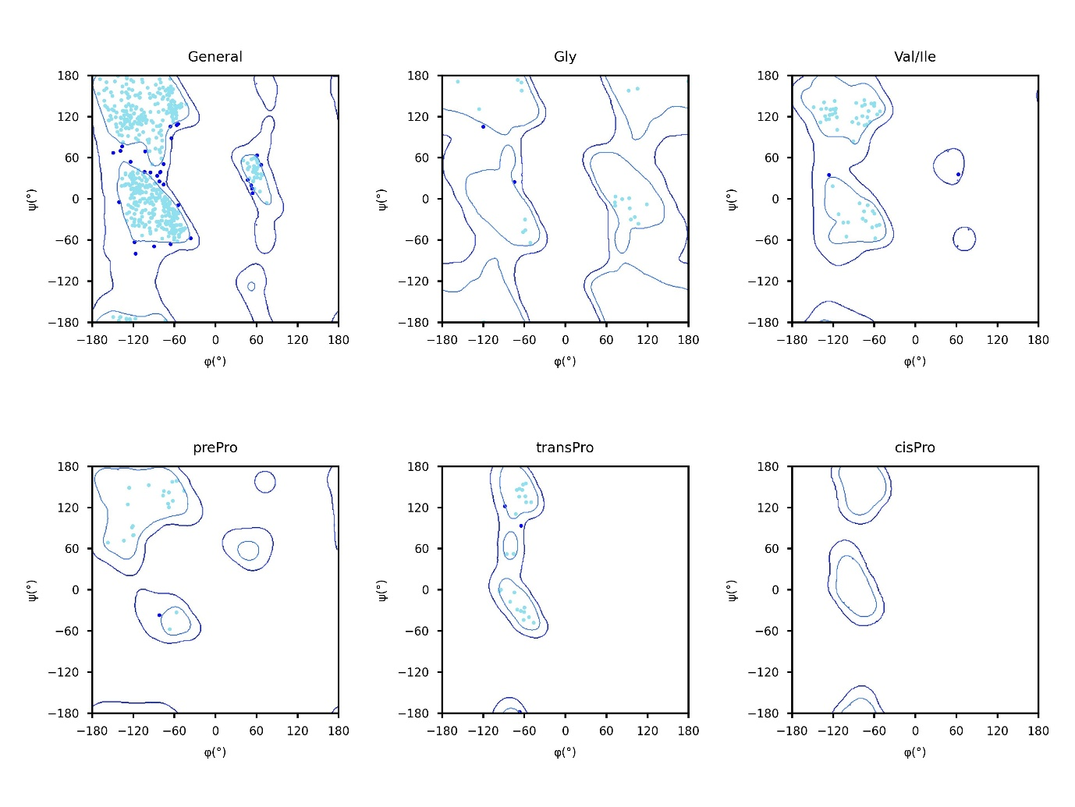
Figure S7.1: 2D Ramachandran plot of six distinct categories of C37R: (a) general case (Ala and remaining 15 amino acids), (b) Gly, (c) Val/Ile, (d) pre-Pro, (e) trans-Pro & (f) cis-Pro.
Here, cyan blue and red dots represent torsion angles of favoured, allowed and disallowed regions respectively.
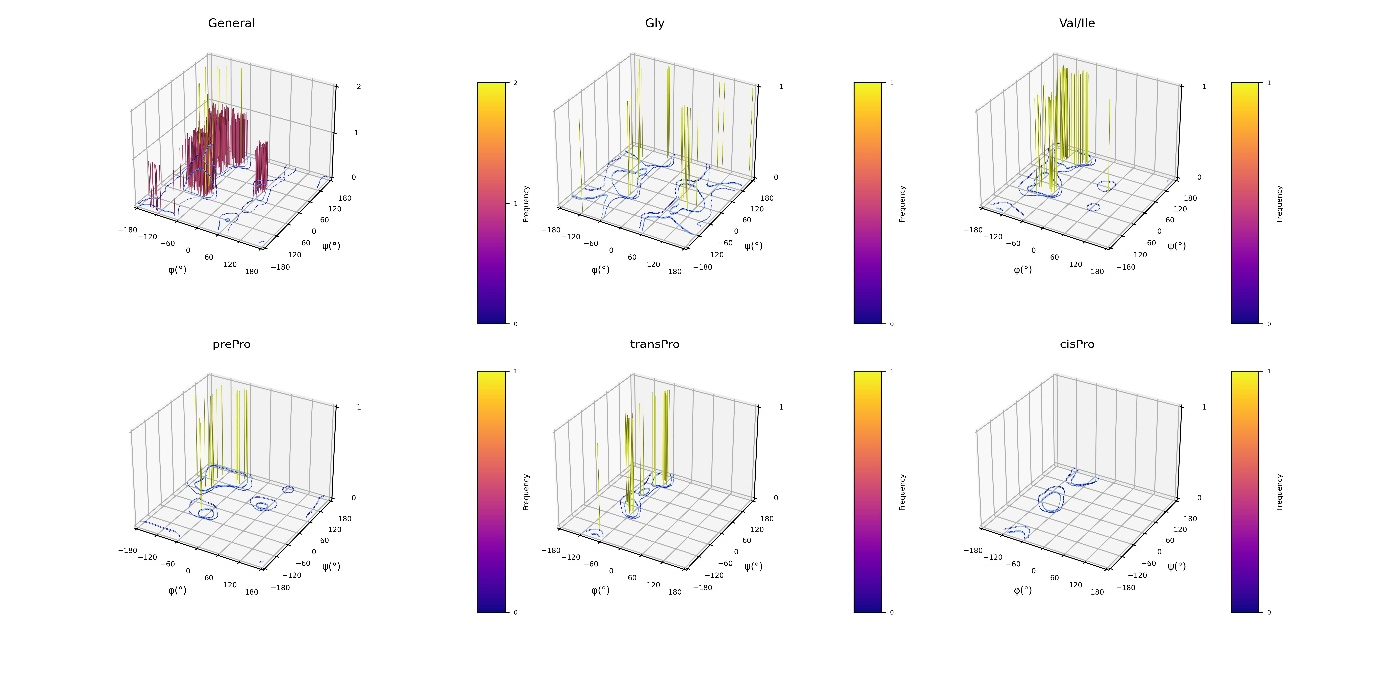
Figure S7.2: 3D Ramachandran plot of six distinct categories of C37R: (a) general case (Ala and remaining 15 amino acids), (b) Gly, (c) Val/Ile, (d) pre-Pro, (e) trans-Pro & (f) cis-Pro.
Here, bars represent frequency of torsion angles.

Q538P
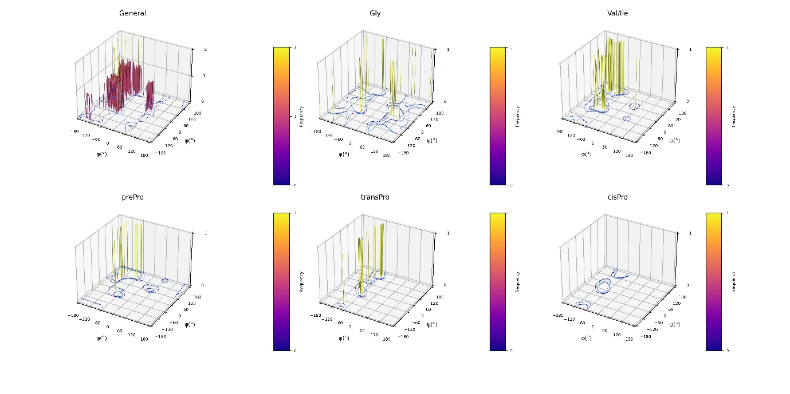
Figure S8.1: 3D Ramachandran plot of six distinct categories of Q538P: (a) general case (Ala and remaining 15 amino acids), (b) Gly, (c) Val/Ile, (d) pre-Pro, (e) trans-Pro & (f) cis-Pro.
Here, bars represent frequency of torsion angles.
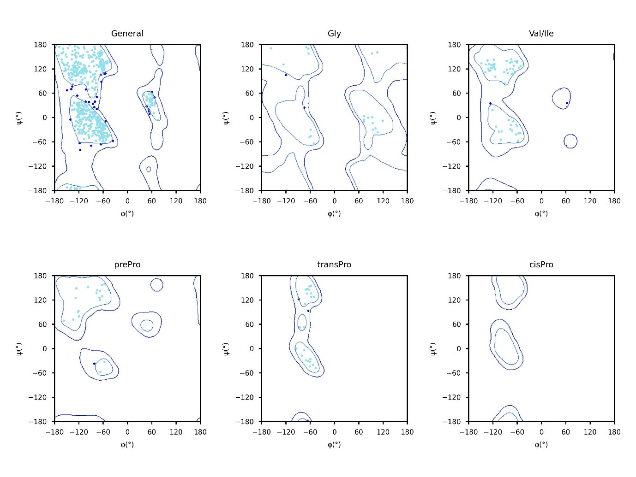
Figure S8.2: 2D Ramachandran plot of six distinct categories of Q538P: (a) general case (Ala and remaining 15 amino acids), (b) Gly, (c) Val/Ile, (d) pre-Pro, (e) trans-Pro & (f) cis-Pro.
Here, cyan blue and red dots represent torsion angles of favoured, allowed and disallowed regions respectively.

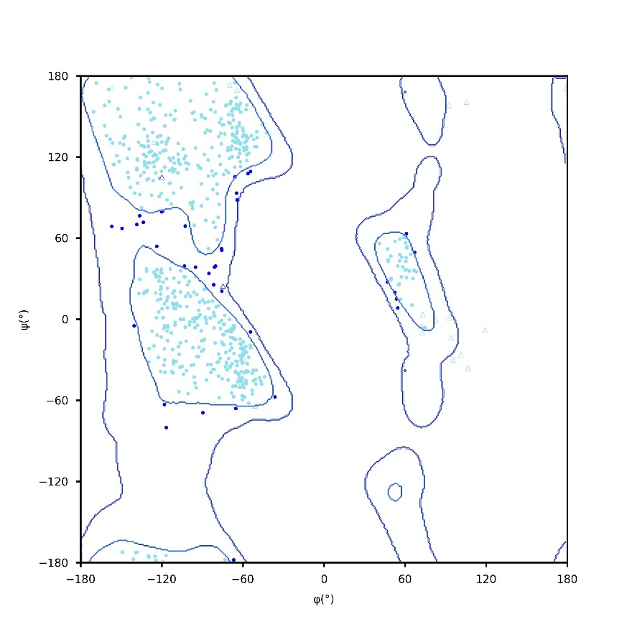
Figure S8.3: Standard 2D Ramachandran Plot of Q538P
Here, cyan, blue and red (dots/triangles) represent torsion angles of favoured, allowed and disallowed regions respectively; dot represents residues other than glycine and triangles represents glycine.
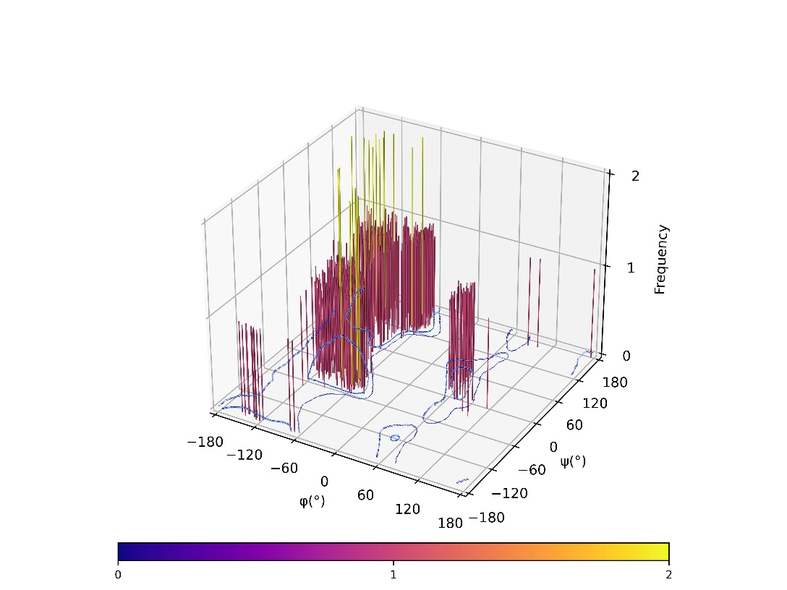
Figure S8.4: Standard 3D Ramachandran plot of Q538P
Here, bar represents frequency of torsion angles.

ALPHAFOLD
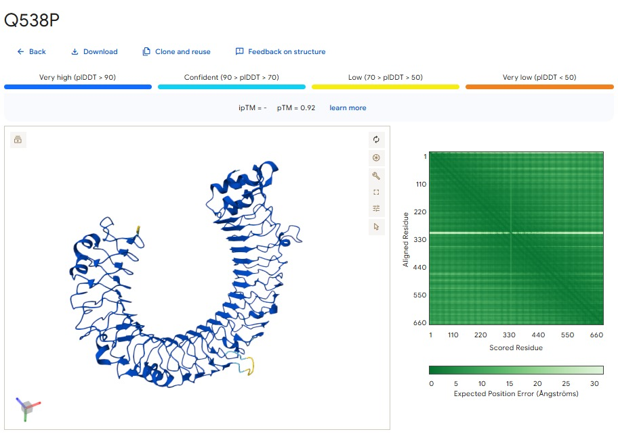
Figure S9: ALPHAFOLD Result of Q538P

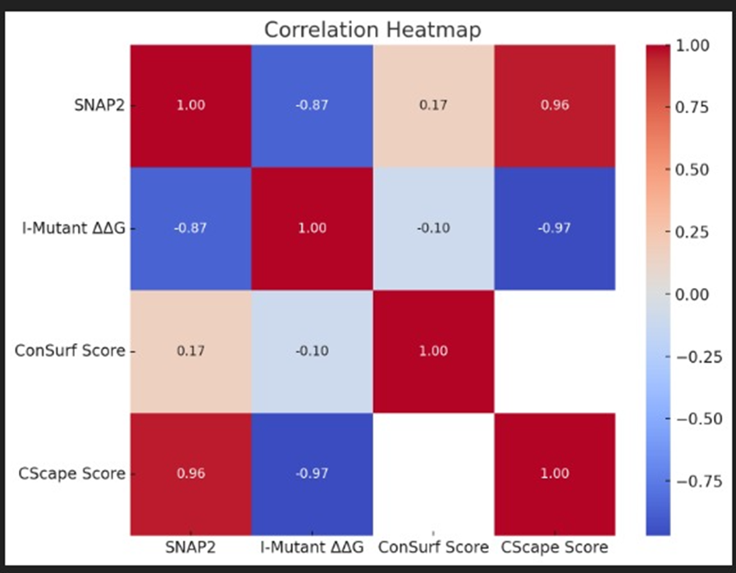
Figure S10: Spearman correlation analysis visualized in the heatmap

