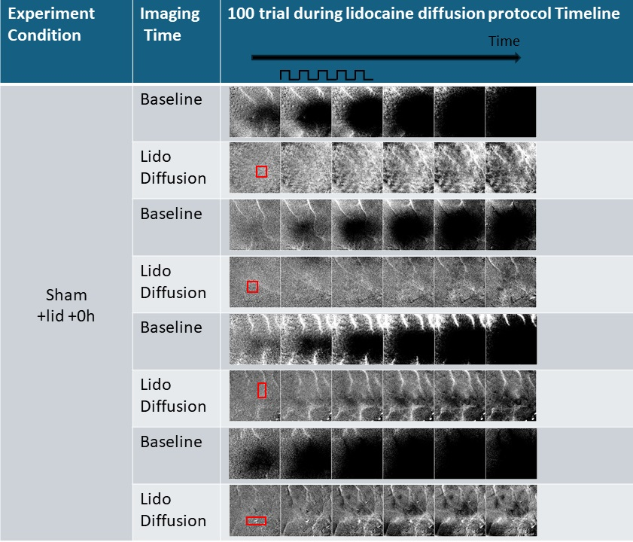
Supplementary Figure 1. Four representative results of ISOI from group 2 (sham+lido+stim) using condensed whisker stimulation protocol. Red boxes in prestimulus frame indicate area of lidocaine diffusion. All images are 6mm by 6mm.

