Supplementary document

Two-photon polymerization based 4D printing of poly(N-isopropylacrylamide) hydrogel microarchitectures for reversible shape morphing

Ebrahim Yarali^{1,2,*}, Ayman Ahmed Mubeen¹, Kai Cussen¹, Lennart van Zanten¹, Vahid Moosabeiki¹, Amir A. Zadpoor¹, Angelo Accardo^{2,*,#}, Mohammad J. Mirzaali^{1,*,#}

¹Department of Biomechanical Engineering, and ²Department of Precision and Microsystems Engineering, Faculty of Mechanical Engineering, Delft University of Technology, Mekelweg 2, 2628 CD, Delft, the Netherlands

*Corresponding authors: E.yarali@tudelft.nl, A.Accardo@tudelft.nl, M.J.Mirzaali@tudelft.nl
#: These authors jointly supervised this work

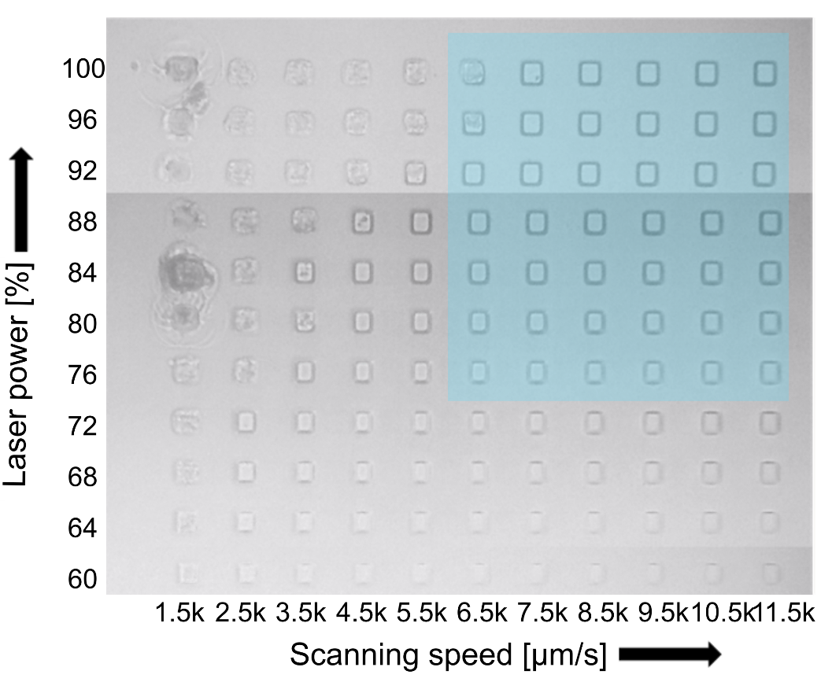
Figure S1. Optical image of a dose test study performed on a pNIPAM photoresist (400 mg NIPAM, 40 mg Mbis, and 15 mg LAP in 450 µL of ethylene glycol), where the laser power and scanning speed were varied from 60% to 100%, and 1500 to 11,500 µm/s, respectively. The blue highlight region indicates the optimal dose range for 4D printing of the pNIPAM. Note that the laser power of the laser source in mW can be calculated as “laser power [mW]= 50×laser power [%]”.

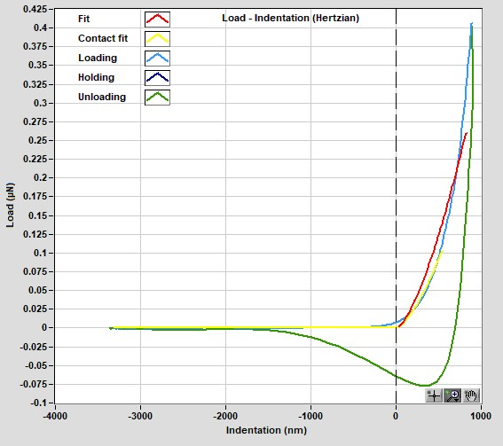 | 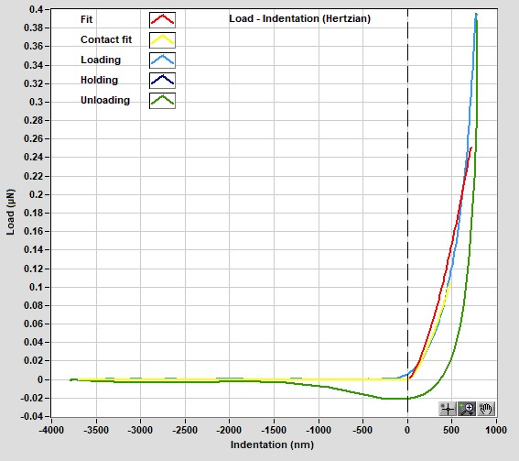
Figure S2. Representative nanoindentation loading–unloading curves of pNIPAM hydrogel blocks (HLP region) fitted using the Hertzian model. The left and right plots correspond to two different indentation depths, illustrating minor differences in unloading behavior due to local adhesion effects.

