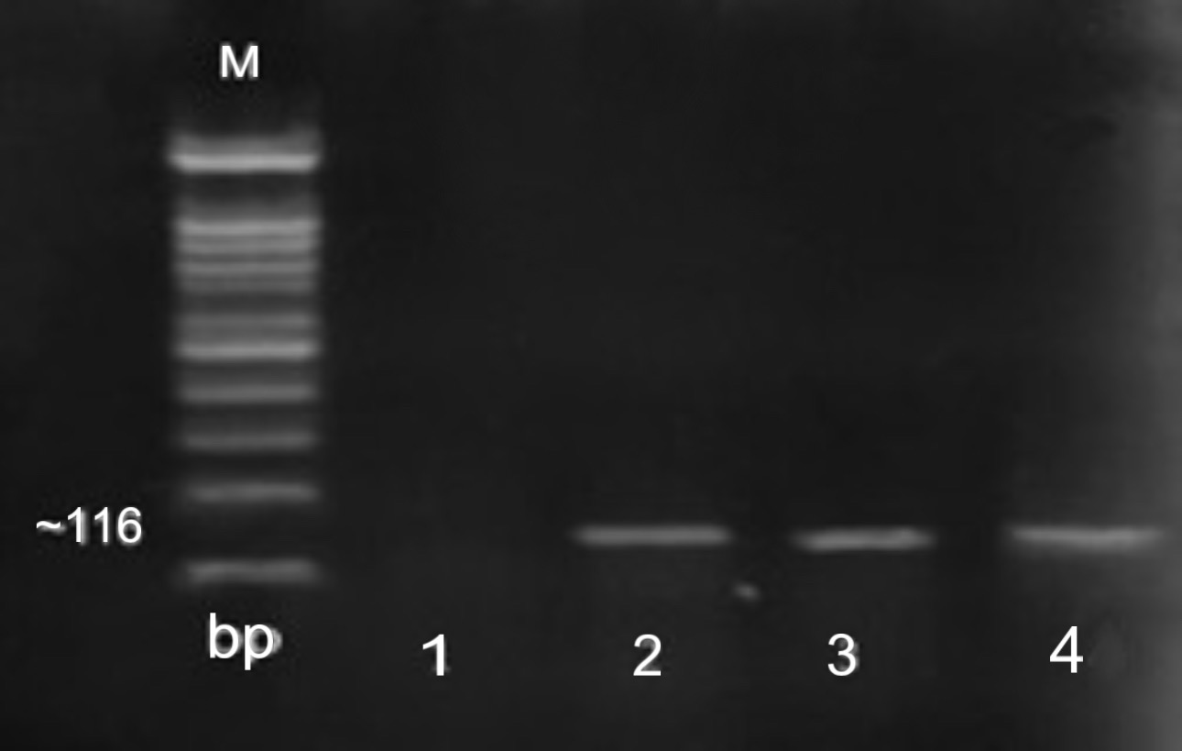
Supplementary 1: Agarose gel of PCR products related to C. cayetanensis. Lane M, 100 bp molecular size marker; lane 1: negative control, lanes 2: positive control lane 3,4: positive cases.

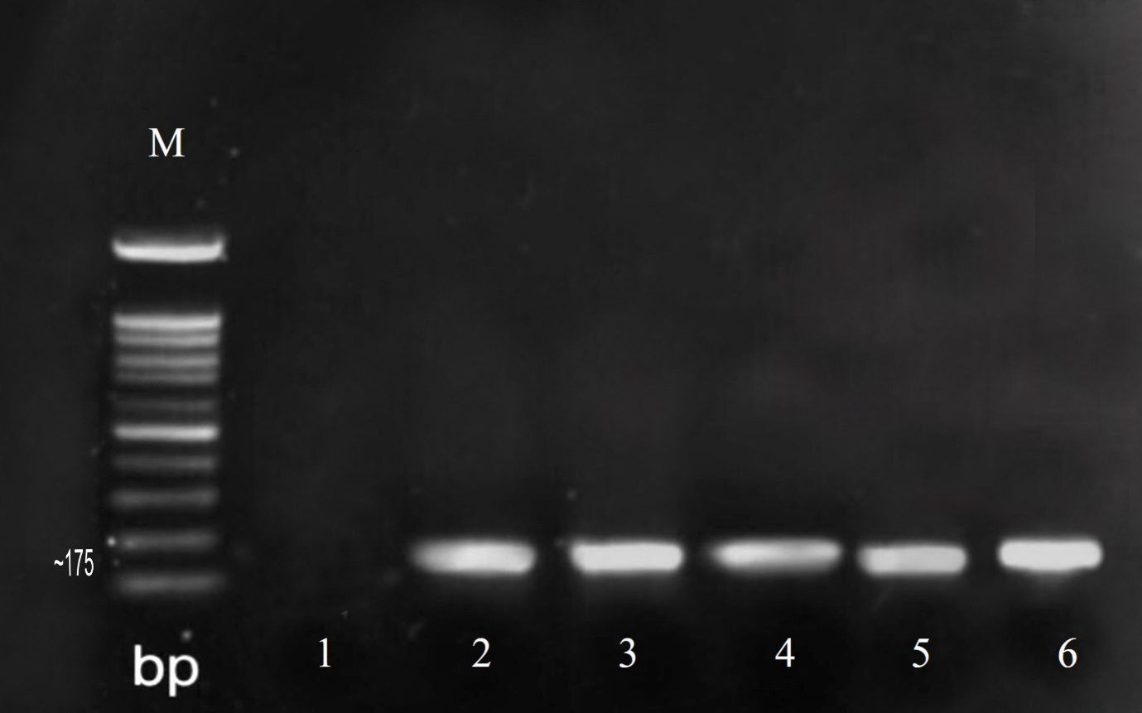
Supplementary 2: Agarose gel of PCR products related to C. belli . Lane M, 100 bp molecular size marker; lane 1: negative control, lanes 2: positive control lane 3,4: positive cases.

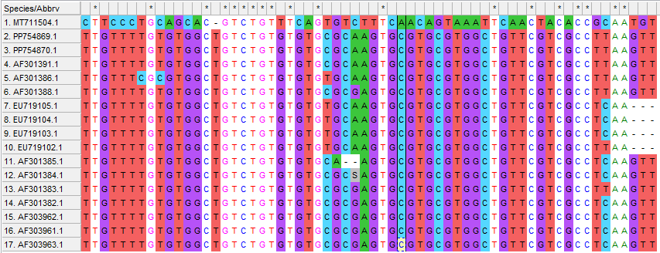
Supplementary 3: Alignment data related to C. cayetanensis.

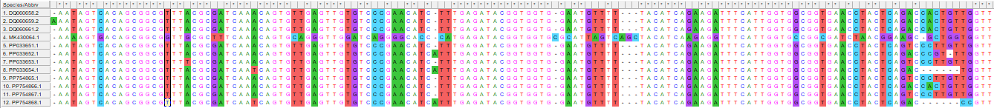
Supplementary 4: Alignment data related to C. belli.

