Supplementary Materials
Figure S1.
Distribution of the number of children across the entire sample.
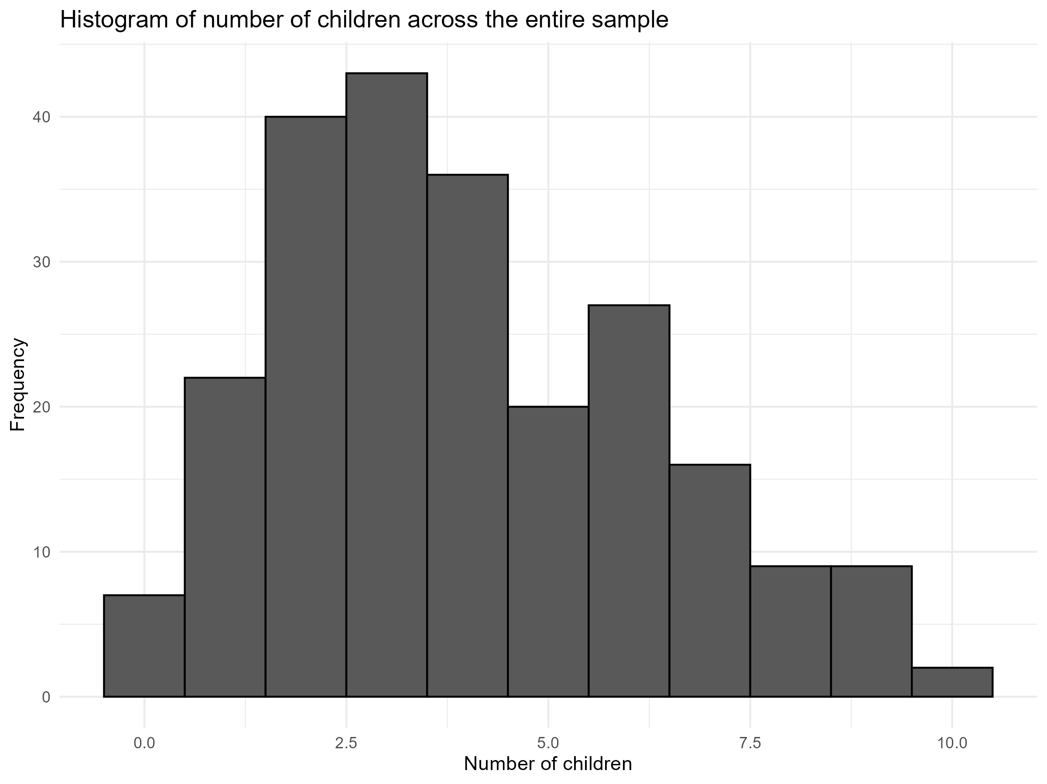

Figure S2.
Distribution of the number of children across artists.
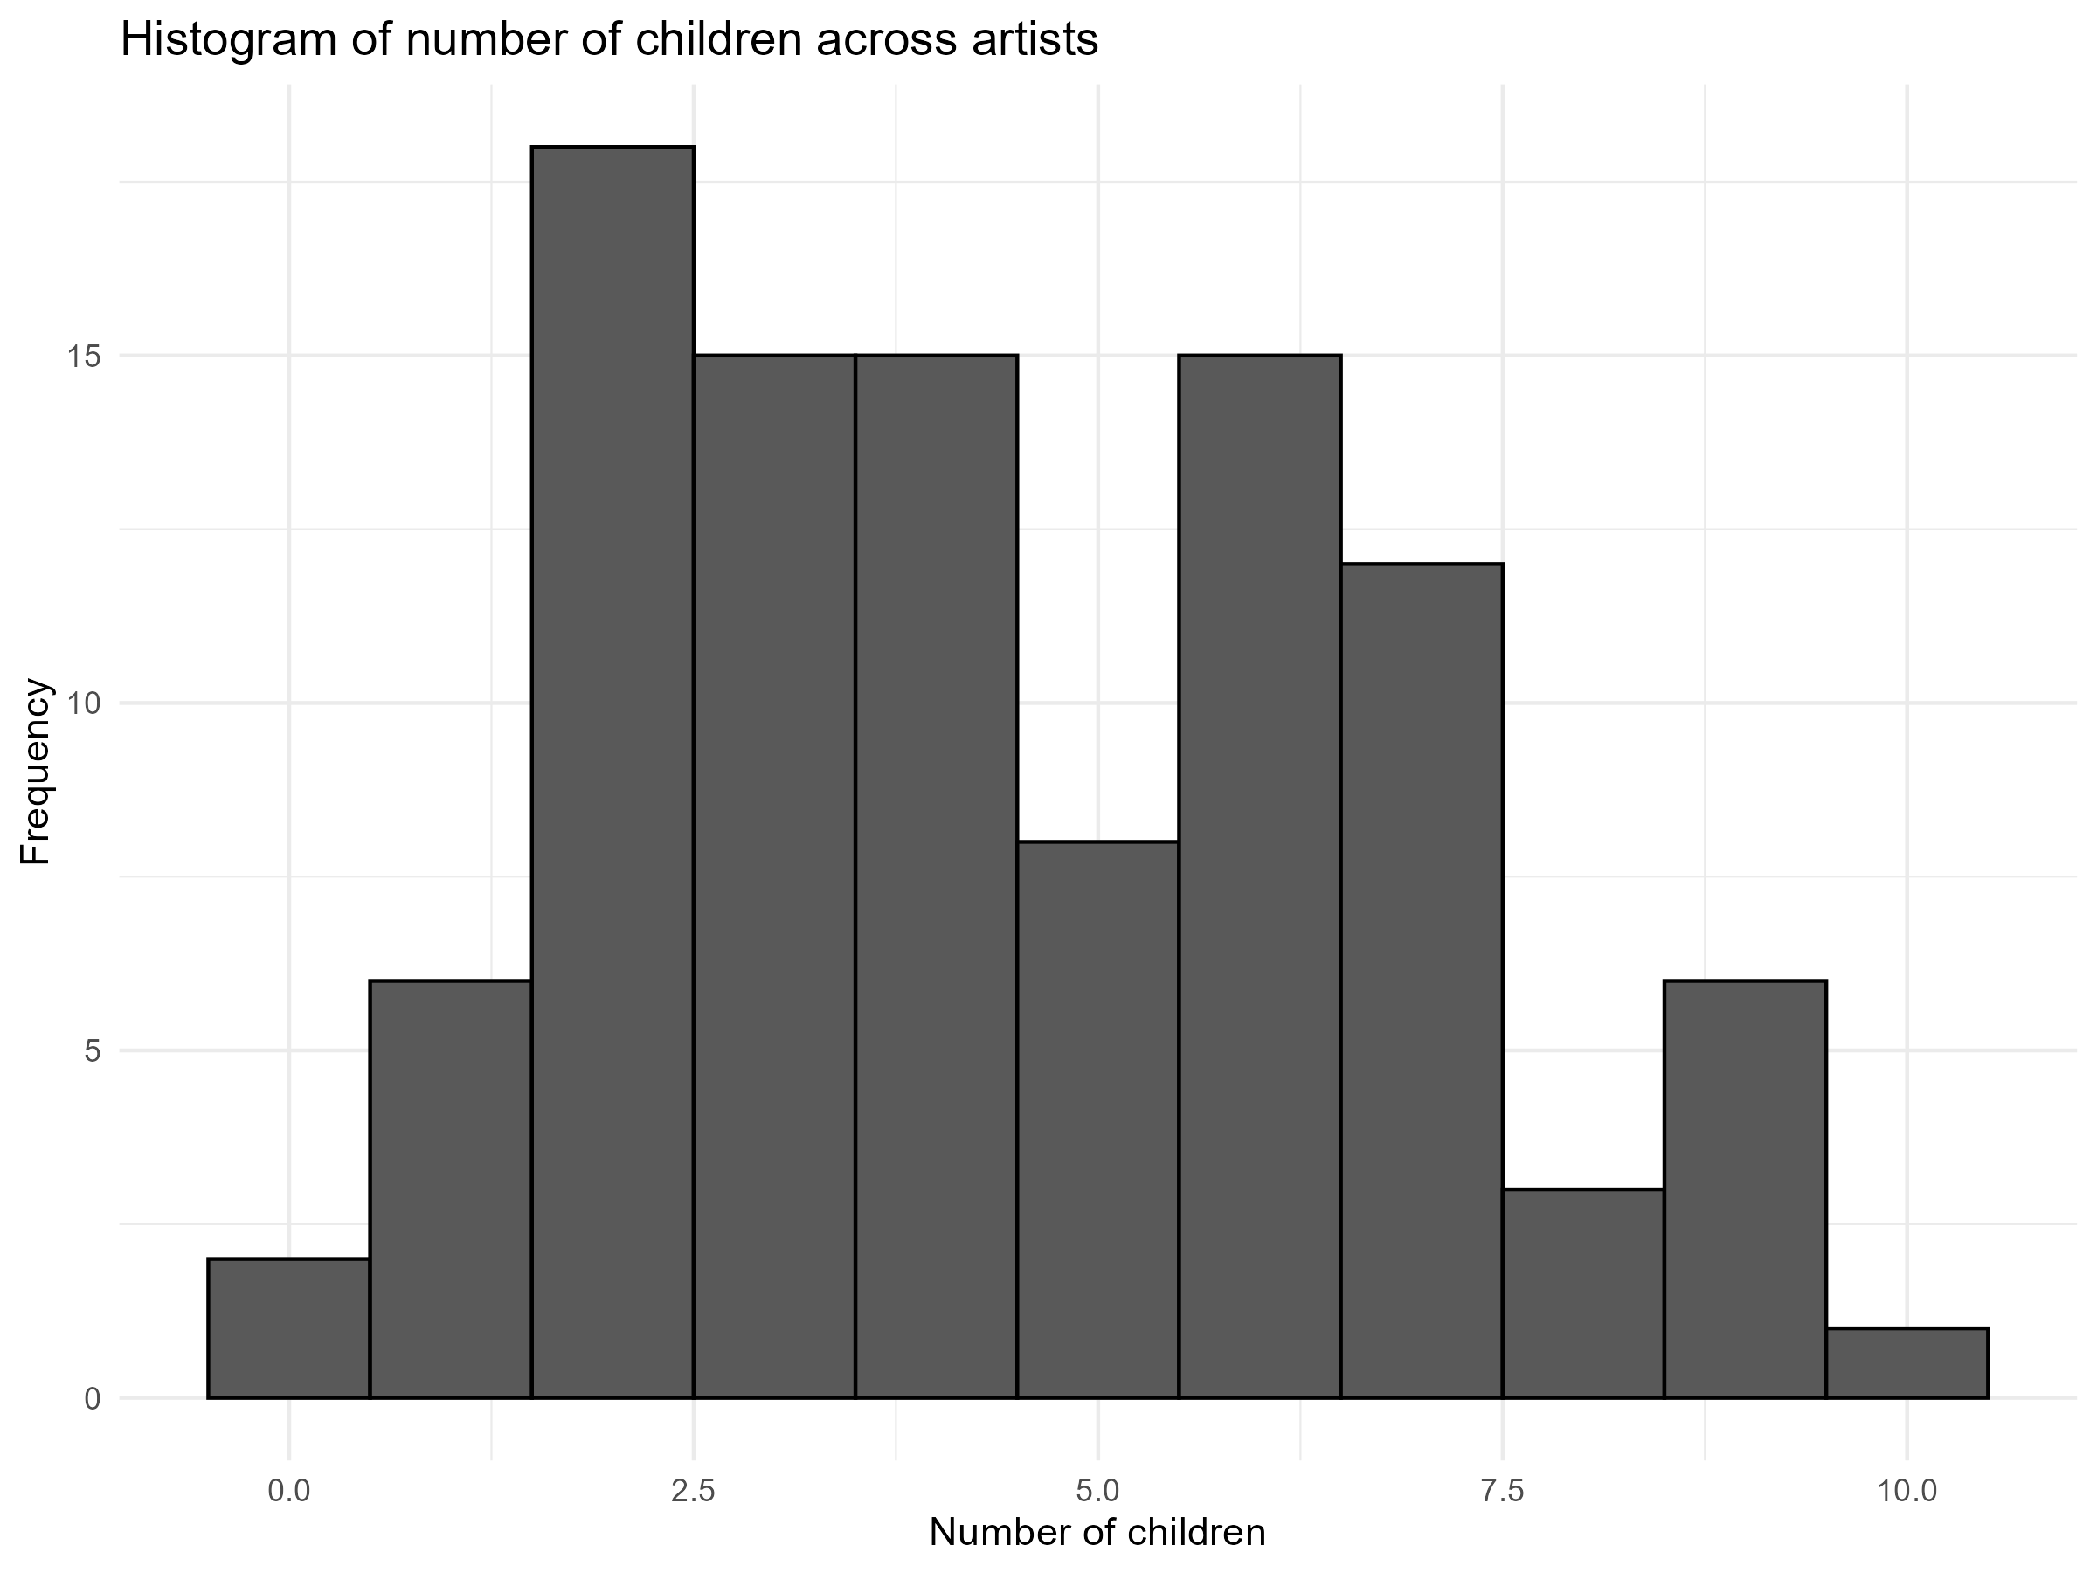
Figure S3.
Distribution of the number of children across non-artists.
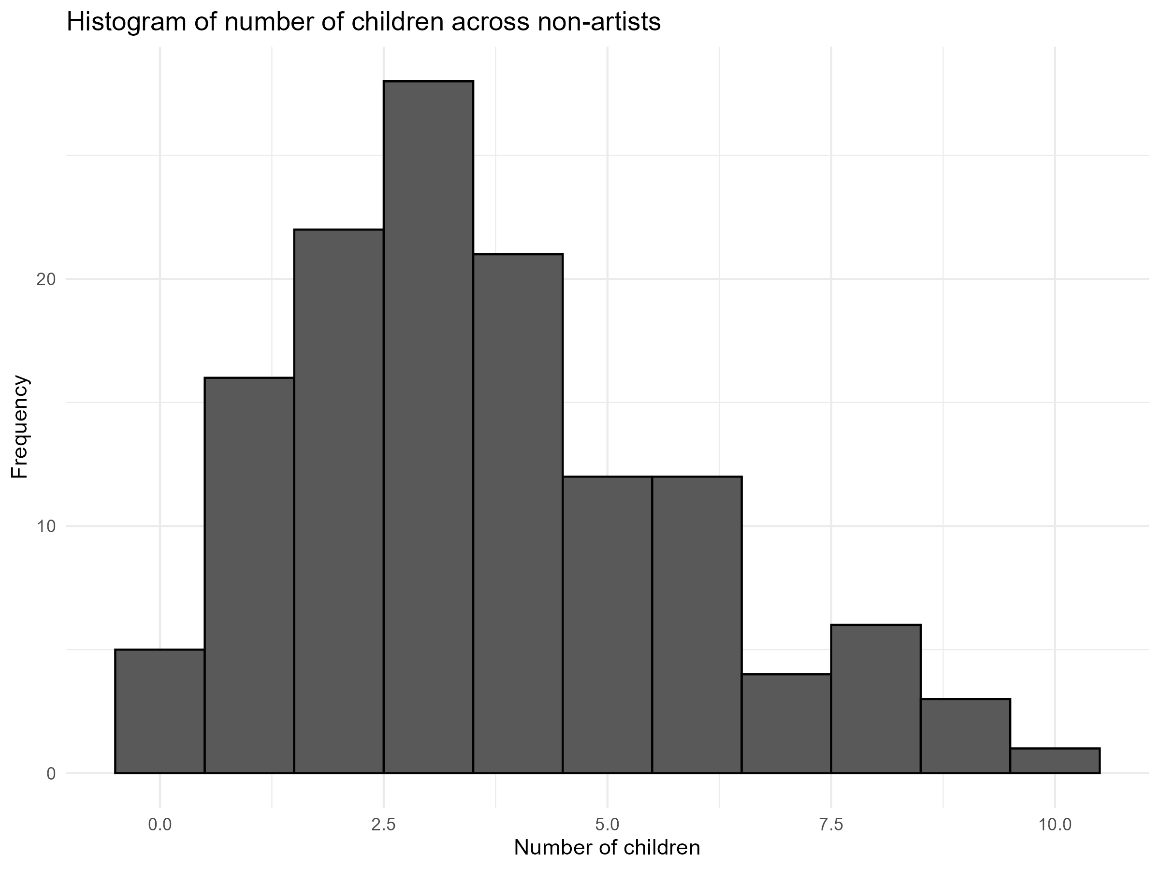

Table S1
The results of the linear regression models with reproductive success (i.e., the number of children) as the outcome variable and being an artist as a predictor variable in the first model, and being and artist, conscientiousness, creativity, and visuo-motor coordination as predictor variables in the second model, controlling for age and society (i.e., Asmat and Kamoro).
 | Models controlling for a linear relationship between the number of children and age and society
 | Adj. r² = 0.222, F(2,228) = 31.9, p < 0.001*** |  |  |  |  | Adj. r² = 0.310, F(5,225) = 21.7, p < 0.001***
Predictor | b | β | SE | 95% CI | p | b | β |  | SE | 95% CI | p
Being an artist ª | 0.521 | 0.112 | 0.059 | [-0.004, 0.229] | 0.059 | -0.281 | -0.06 |  | 0.063 | [-0.185, 0.064] | 0.341
Age | 0.087 | 0.449 | 0.059 | [ 0.334, 0.565] | < .001*** | 0.095 | 0.49 | 0.055 |  | [ 0.382, 0.599] | < .001***
Society | 0.596 | 0.258 | 0.119 | [ 0.023, 0.493] | 0.032* | 0.715 | 0.31 | 0.112 |  | [ 0.088, 0.531] | 0.006**
Conscientiousness ^{b} |  |  |  |  |  | 0.750 | 0.241 | 0.058 |  | [ 0.127, 0.355] | < .001***
Creativity ^{c} |  |  |  |  |  | 0.653 | 0.201 |  | 0.061 | [ 0.081, 0.320] | 0.001***
Visuo-motor Coordination ^{d} |  |  |  |  |  | 0.100 | 0.091 |  | 0.057 | [-0.021, 0.203] | 0.112
Note. * p < 0.05, ** p < 0.01, *** p < 0.001; ª – a dichotomous variable of being an artist or not (with 0 coded as non-artists and 1 as artists); ^{b} – a mean score on the conscientiousness scale); ^{c} – the total amount of generated uses for a stone; ^{d} – a mean of the right- and left-hand score on the visuo-motor coordination test.

