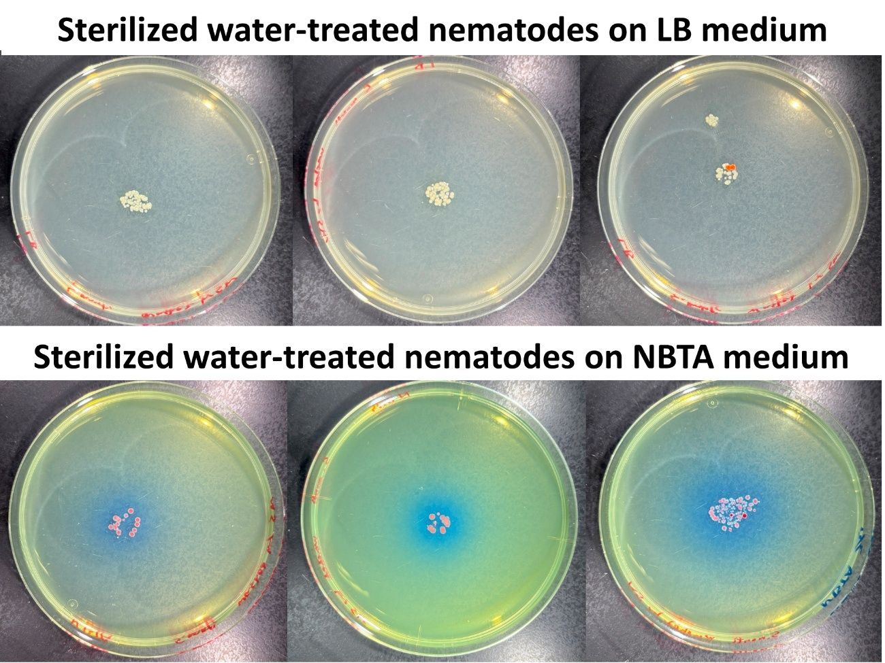
Fig. S1. After being washed three times with sterile water, the nematodes were placed on LB or NBTA medium for 10 minutes, resulting in the appearance of numerous colonies.

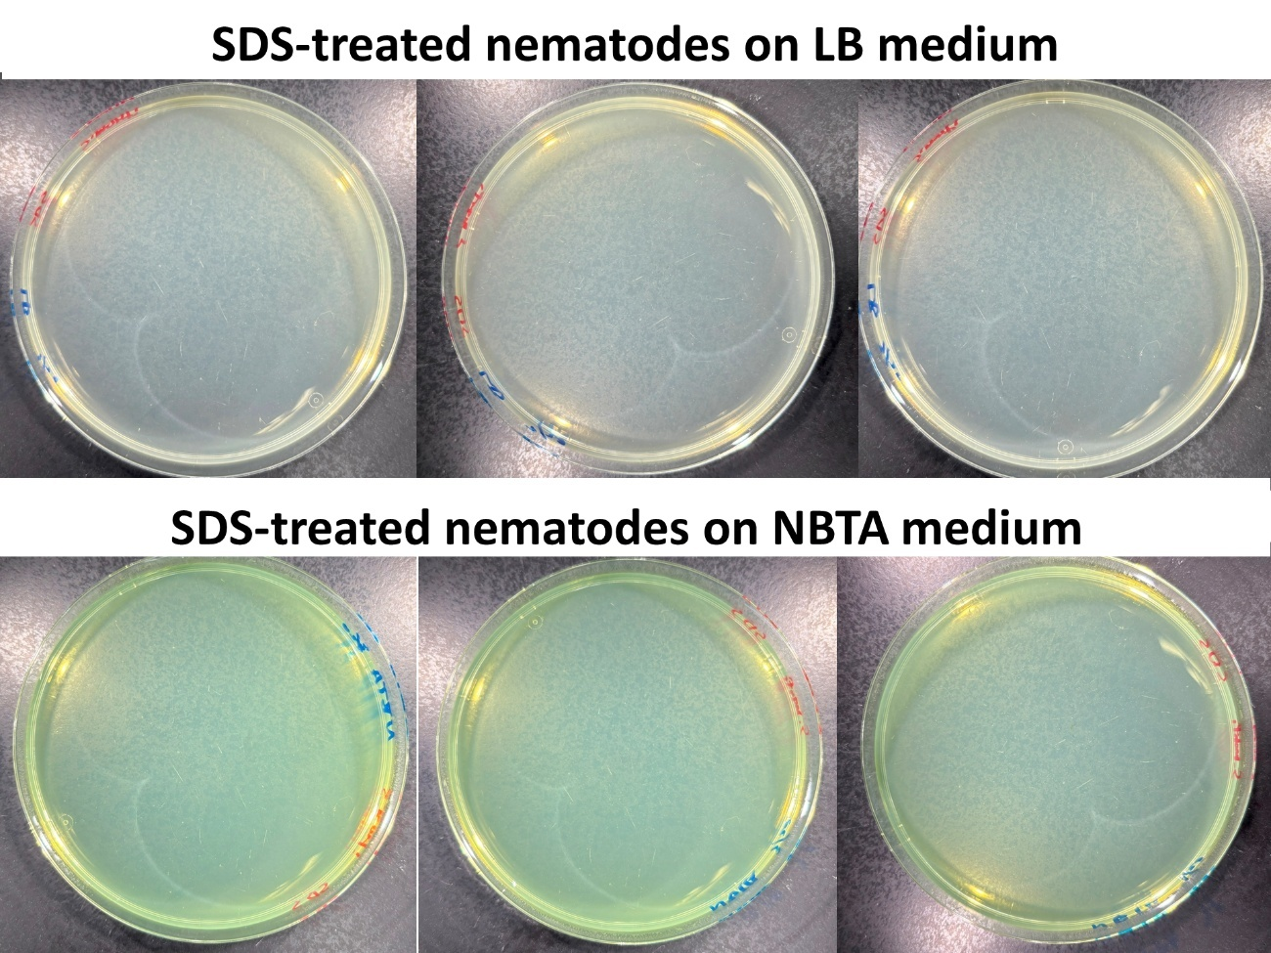
Fig. S2. After surface sterilization with SDS, the nematodes were placed on LB or NBTA medium for 10 minutes, resulting in no colony formation.

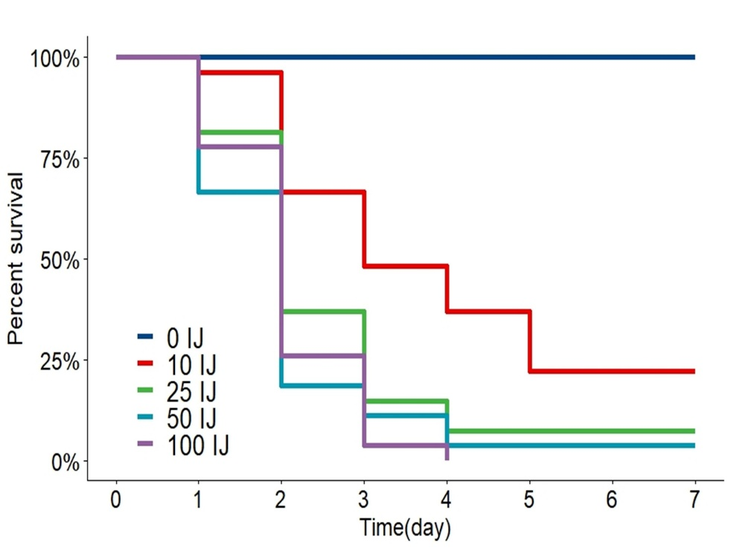
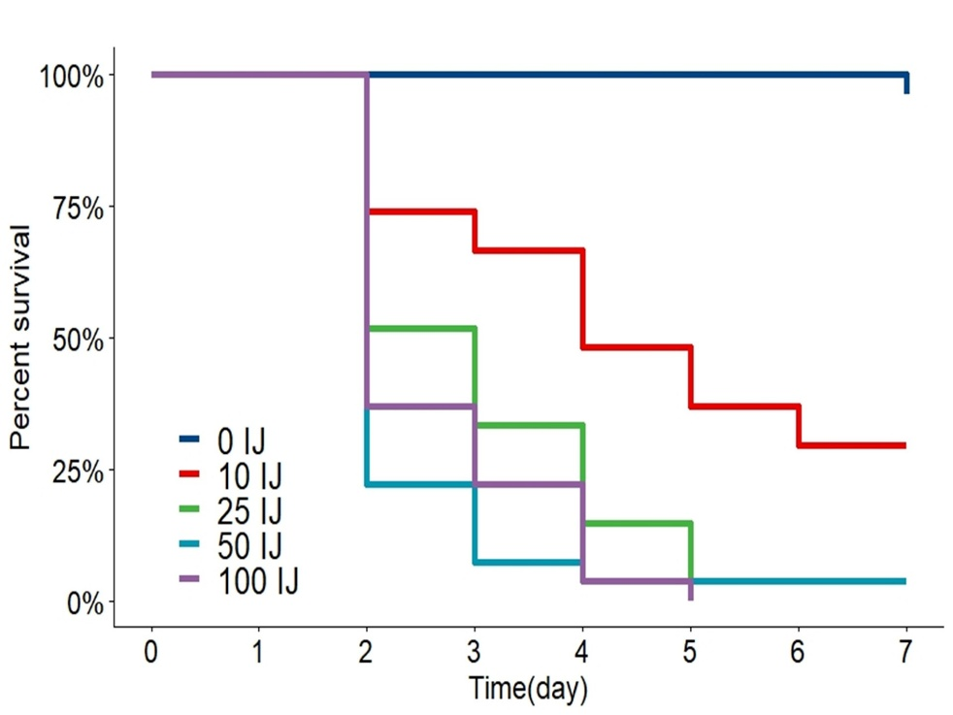
Fig. S3. Survival curves of G. mellonella larvae following EPN infection at various concentrations (0, 10, 25, 50, and 100 IJs). These curves are based on data from three independent experiments with a total sample size of N=27. (A) Pathogenicity of Steinernema monticolum KHA701. (B) Pathogenicity of Heterorhabditis bacteriophora TT01.

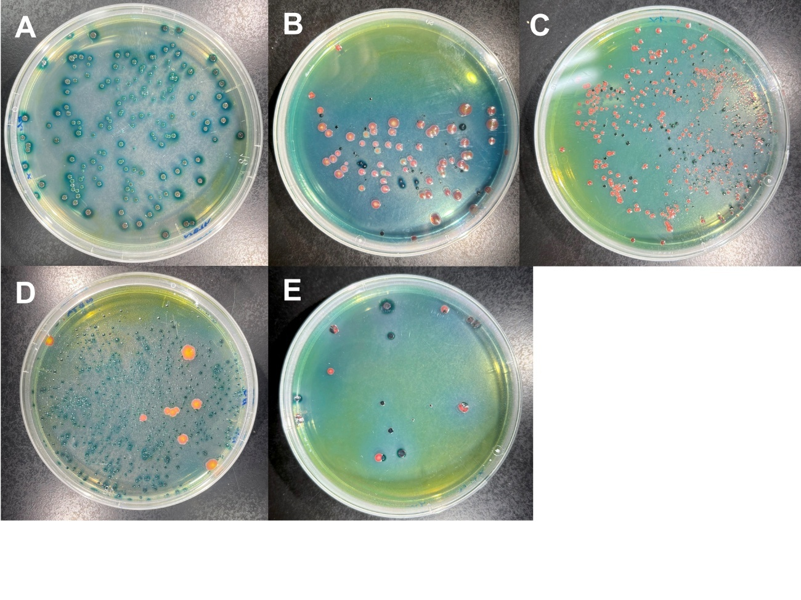
Fig. S4. In the bacterial re-isolation experiment, five bacterial combinations were tested: (A) X. hominickii + X. hominickii, (B) X. hominickii + E. miricola, (C) X. hominickii + P. protegens, (D) X. hominickii + S. marcescens, and (E) X. hominickii + Staphylococcus sp. X. hominickii is easily identified by the blue colonies it forms on NBTA medium.

Table S1. Pathogenicity of S. monticolum KHA701 against various arthropods
Order | Family | Species | N | Mortality
Araneae | Nephilidae | Nephila clavata | 6 | 100%
Blattodea | Blattellidae | Blattella germanica | 3 | 100%
Blattodea | Blattellidae | Blattella nipponica | 3 | 100%
Coleoptera | Tenebrionidae | Zophobas morio | 3 | 33%
Diptera | Bibionidae | Bibio tenebrosus | 5 | 100%
Diptera | Limoniidae | Epiphragma subinsignis | 3 | 100%
Diptera | Syrphidae | Episyrphus balteatus | 3 | 100%
Hemiptera | Cicadellidae | Nephotettix cincticeps | 3 | 67%
Hemiptera | Pentatomidae | Erthesina fullo | 4 | 25%
Hymenoptera | Formicidae | Crematogaster osakensis | 3 | 100%
Lepidoptera | Arctiidae | Lithosia quadra | 8 | 100%
Lepidoptera | Lymantriidae | Lymantria dispar | 3 | 100%
Lepidoptera | Noctuidae | Asota ficus | 4 | 100%
Mantodea | Mantidae | Hierodula chinensis | 3 | 100%
Orthoptera | Gryllidae | Teleogryllus emma | 3 | 100%

