 |  | Df | Sum Sq. | Mean Sq. | F-value | p-value
Rp49 | Photoperiod (Ph) | 1 | 1.6 | 1.6 | 0.3 | 0.566
Rp49 | Genotype (Gt) | 1 | 0.3 | 0.3 | 0.1 | 0.802
Rp49 | Zeitgeber (ZT) | 5 | 30.0 | 6.0 | 1.2 | 0.296
Rp49 | Ph:Gt | 1 | 8.3 | 8.3 | 1.7 | 0.192
Rp49 | Ph:ZT | 5 | 24.1 | 4.8 | 1.0 | 0.423
Rp49 | Gt:ZT | 5 | 20.4 | 4.1 | 0.8 | 0.520
Rp49 | Ph:Gt:ZT | 5 | 23.6 | 4.7 | 1.0 | 0.436
RpL19 | Photoperiod (Ph) | 1 | 2.5 | 2.5 | 0.8 | 0.375
RpL19 | Genotype (Gt) | 1 | 1.3 | 1.3 | 0.4 | 0.526
RpL19 | Zeitgeber (ZT) | 5 | 21.0 | 4.2 | 1.3 | 0.252
RpL19 | Ph:Gt | 1 | 7.0 | 7.0 | 2.3 | 0.137
RpL19 | Ph:ZT | 5 | 12.9 | 2.6 | 0.8 | 0.533
RpL19 | Gt:ZT | 5 | 16.6 | 3.3 | 1.1 | 0.385
RpL19 | Ph:Gt:ZT | 5 | 12.9 | 2.6 | 0.8 | 0.532
Supplementary Table S1: No significant differences were identified in the transcription of housekeeping genes Rp49 and RpL19 in mosquitoes from different rearing photoperiods, Zeitgebers, and genotypes, nor any interactions therebetween.

Supplementary Fig. S1: Non-diapausing and diapausing egg follicles dissected from females of Culex pipiens. Under long-day, diapause-averting photoperiods, egg follicles from reproductive females exceed 75 µm in diameter (A). Under short-day, diapause-inducing conditions, egg follicles from non-reproductive females remain under 50 µm in diameter (B).

Supplementary Fig. S2: The cycle mutation does not alter transcriptional differences in Ilp, InR, or AT, but was associated with a slight increase in FOXO. The relative mRNA abundance of the seasonal endocrine genes insulin-like peptide (A), insulin receptor (B), allatotropin (C), and forkhead transcription factor (D). Wild type mosquitoes are represented by white boxes, while CpCyc–/– mosquitoes are represented by gray boxes. Black points indicate bioreplicates comprised of 5 mosquito heads each.

Supplementary Fig. S3: The cycle mutation is not associated with arrhythmic locomotor activity under a normal light:dark photoperiod. (A) Heterozygous CpCyc^{+/–} and homozygous CpCyc–/– mosquitoes. Blue bars indicate mean pixels moved per 30 min bin. Numbers on the X-axis indicate circadian time where 0’s and 24’s indicate when the lights turn on. The white bars over the graph indicate the photophase, while the black bars indicate the scotophase. (B) Autocorrelation and periodogram plots calculated from heterozygous and homozygous mosquitoes.

Supplementary Fig. S4: The cycle mutation is associated with arrhythmic locomotor activity in some short day-reared mosquitoes moved to constant darkness. Blue bars indicate mean pixels moved per 30 min bin. Numbers on the X-axis indicate circadian time where 0’s and 24’s indicate when the lights turn on. The hashed bars over the graph indicate the subjective photophase, while the black bars indicate the subjective scotophase, under constant darkness.

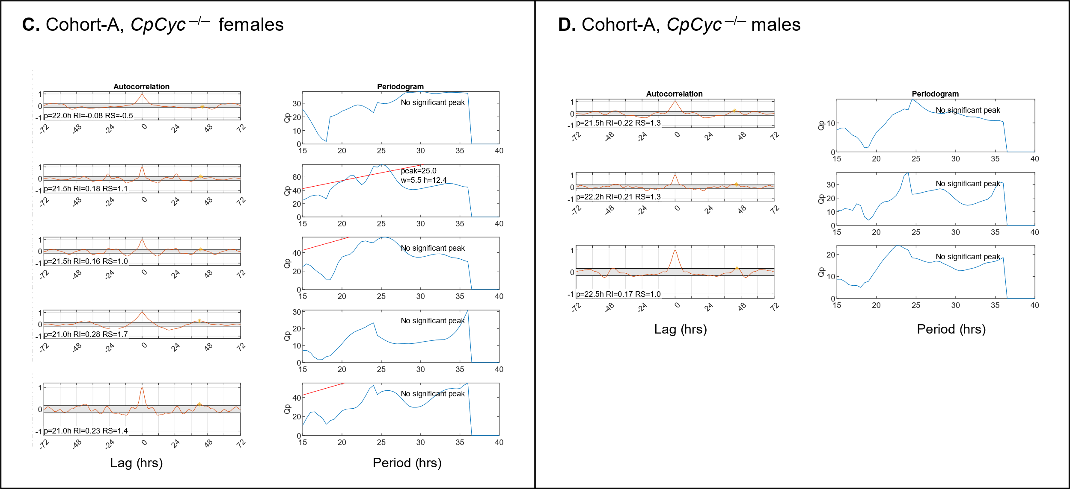
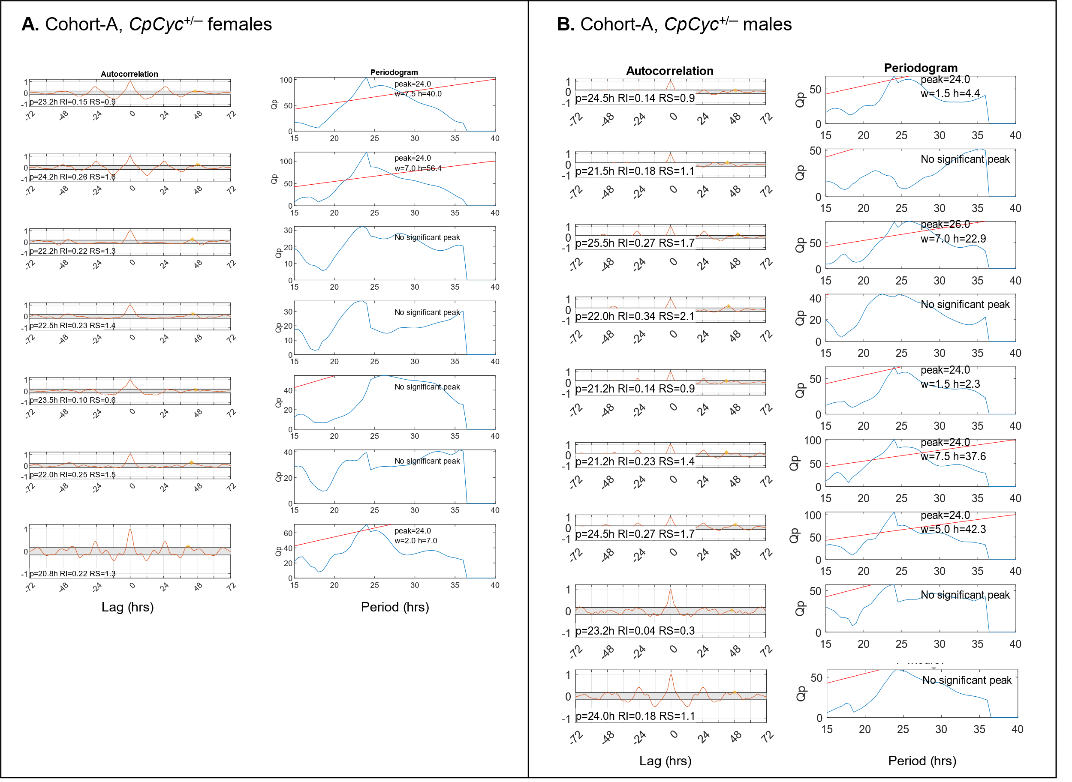

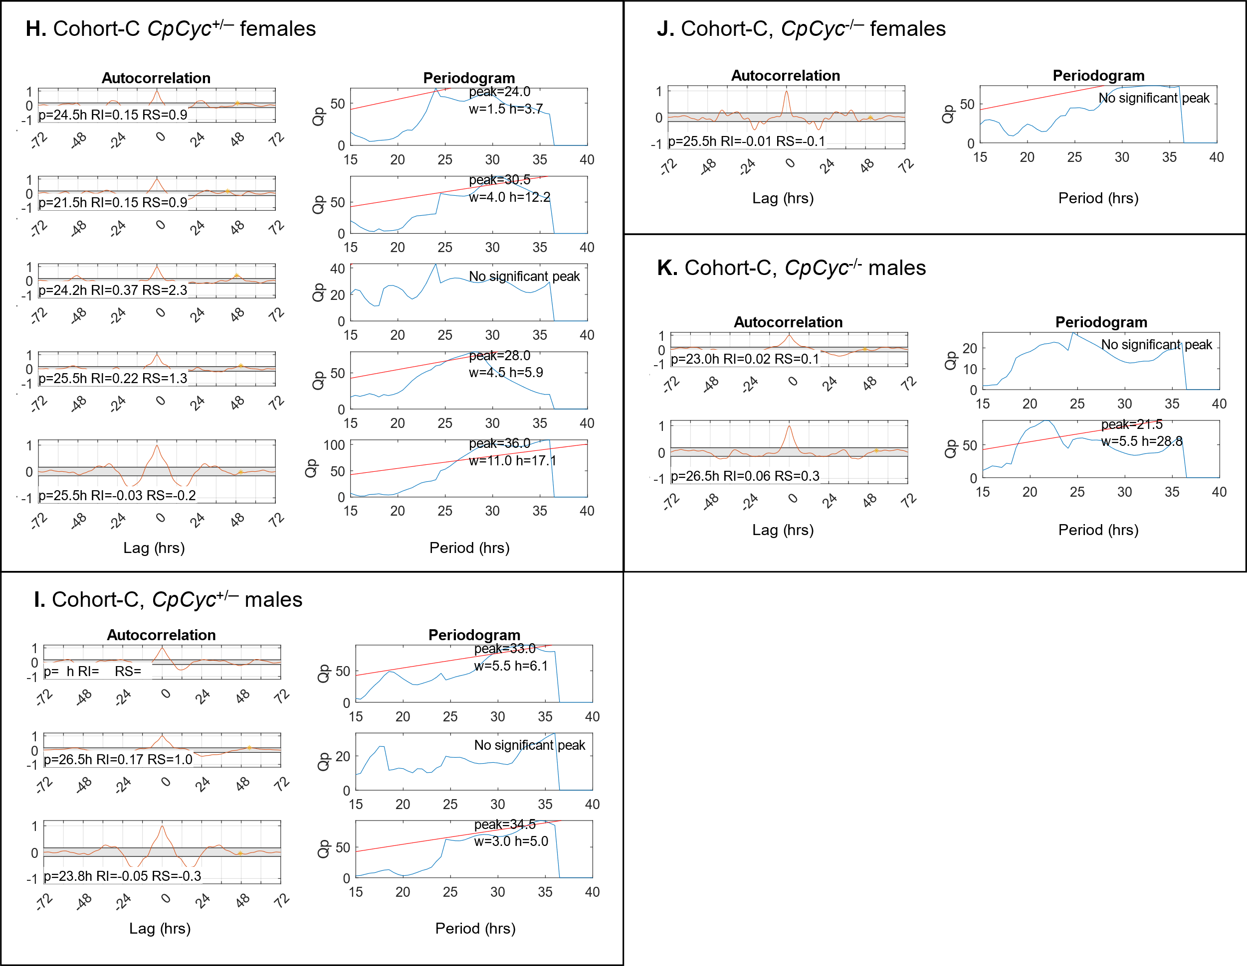
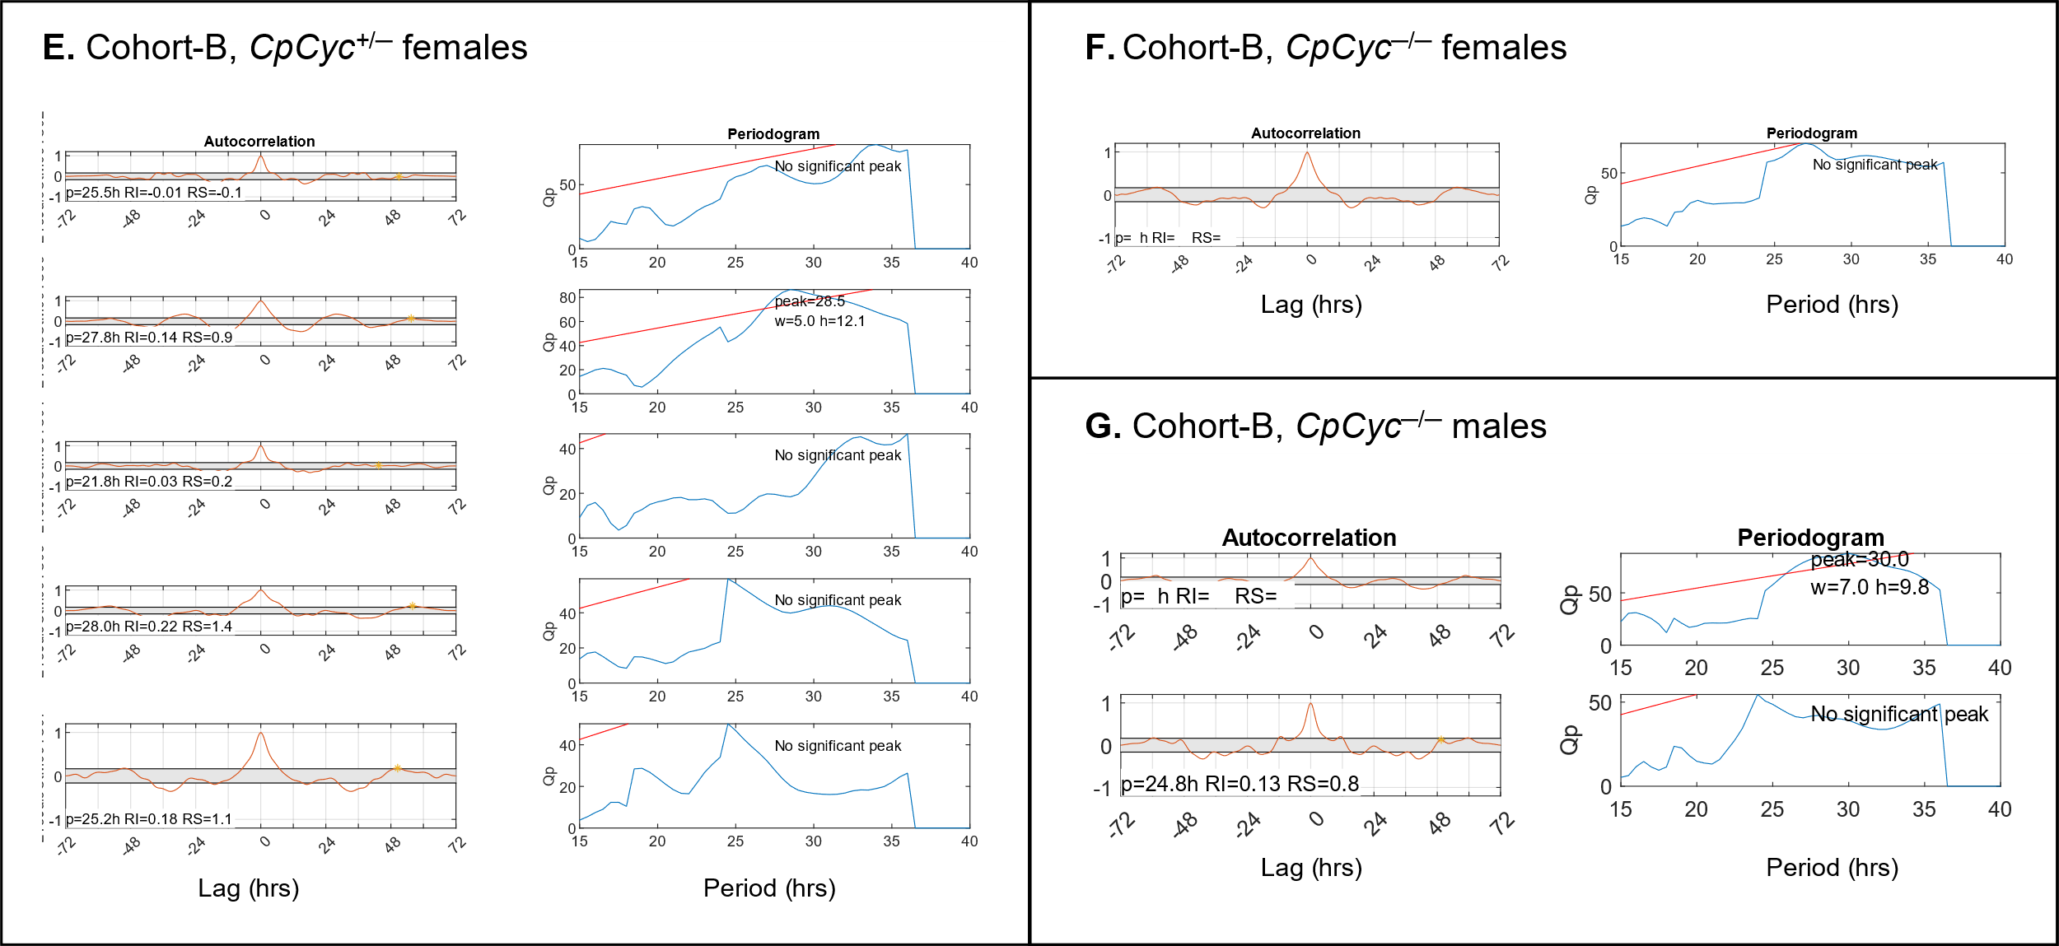

Supplementary Fig. S5: Autocorrelation and periodogram analyses indicate that significantly more homozygotes are arrhythmic than heterozygotes. Each row presents the paired autocorrelation and periodogram plots for a single mosquito from one of three long day-reared cohorts.

