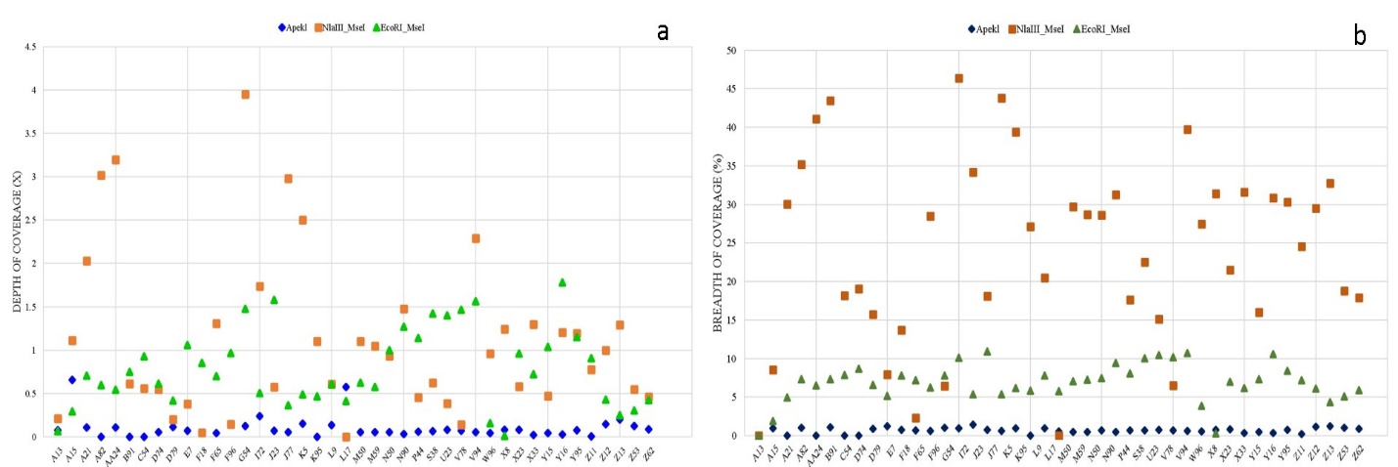
Fig. S5 a) Depth of coverage (X) b) Breadth of coverage (%)

