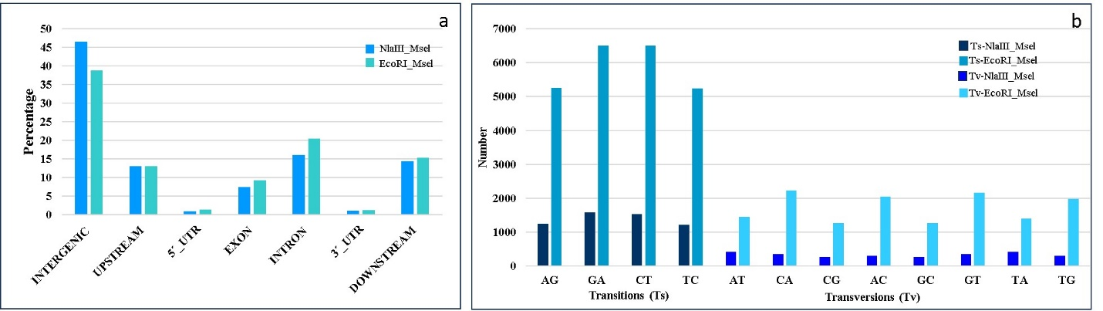
Fig. S8 a) Distribution of SNPs based on their location in respective predicted gene models in the safflower genome b) Transition (Ts) and Transversion (Tv) counts in NlaIII_Msel and EcoRI_Msel

