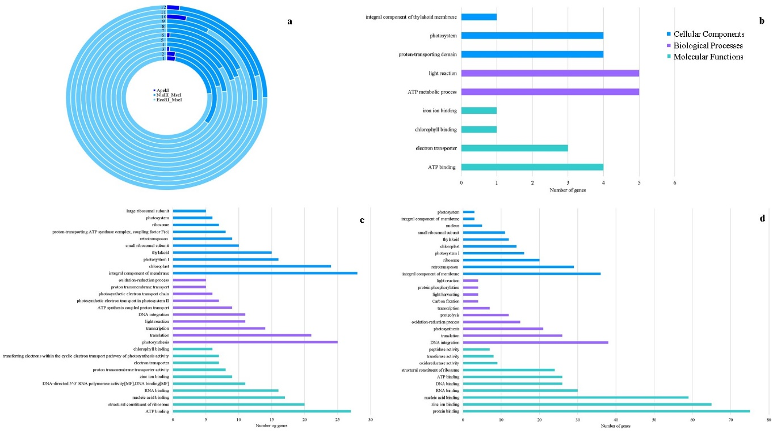
Fig. S7 a) Chromosome wise coverage of core genes by ApeKI, NlaIII_Msel EcoRI_Msel Note: The circle's size does not correspond to total number of genes per chromosome. Gene Ontology b) ApeKI c) NlaIII_Msel d) EcoRI_Msel

