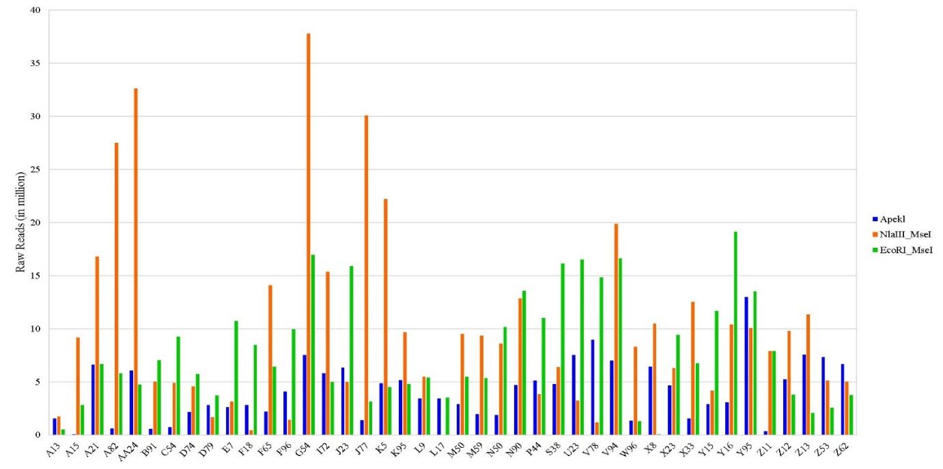
Fig. S3 Distribution pattern of raw reads per sample using different restriction enzymes

