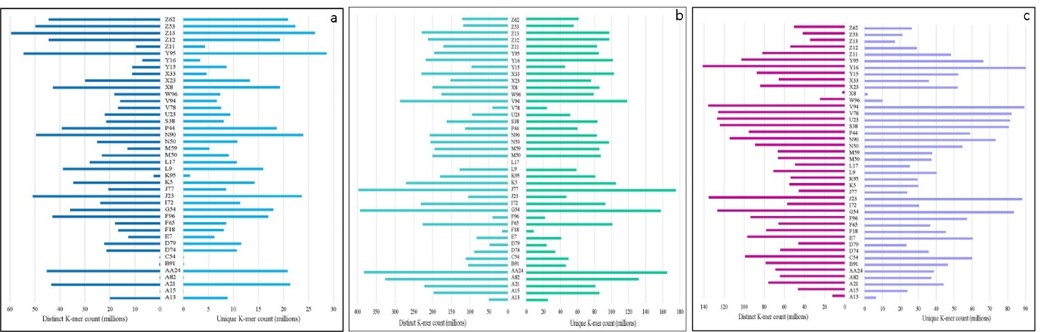
Fig. S6 Distinct and unique k-mer count, a) ApeKI, b) NlaIII_Msel and c) EcoRI_Msel

