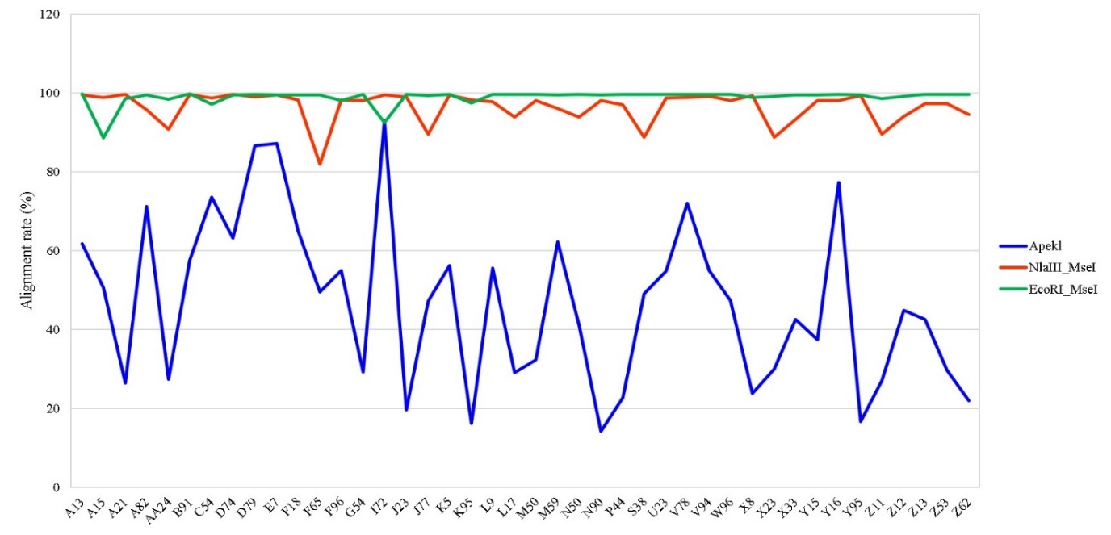
Fig. S4 Alignment rate of trimmed data using different restriction enzymes

