Supplementary information
Biogenic design of silicious architectures on moso bamboo culm
Makoto Kazama¹ • Hiroto Watanabe¹ • Chikako Hasekura² • Takumi Wakabayashi¹• Takaaki Ishigure¹ • Yuya Oaki¹ • Hiroaki Imai^{1*}

¹School of Integrated Design Engineering, Keio University, 3-14-1 Hiyoshi, Kohoku-ku, Yokohama 223-8522, Japan.
² Faculty of Agriculture, Tokyo University of Agriculture, 1737 Funako, Atsugi 243-0034, Japan.
E-mail*: hiroaki@applc.keio.ac.jp

Figure S1 Schematic illustrations and photos of bamboo and bamboo shoots.
Figure S2 Plane-viewed SEM images with elemental mapping of the epidermal layer of a bamboo culm.
Figure S3 Cross-sectional SEM images and schematic illustrations of the silica wedges in the epidermal layer.
Figure S4 SEM images of the outer and inner sides of the silicified epidermal layer after removal of organic matter.
Figure S5 SEM images of silica wedges and silicified epidermal cells before and after the treatment with cellulase.
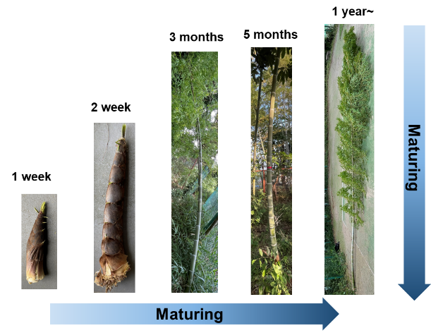
Figure S6 Cross-sectional elemental mapping images of the silica wedge and silicified epidermal cell.
Figure S7 Illustrations of the Si–O–Si network structure and Raman spectra of biosilicas after heat treatment.
Figure S8 Hardness and modulus of biosilicas in the cortex of a bamboo culm wall.
Figure S9 Illustrations of the silicification process and SEM images of an epidermal cell wall.
Figure S10 Schematic illustrations showing the conditions of the numerical simulation.

Table S1 Hardness and Young's modulus of biosilicas

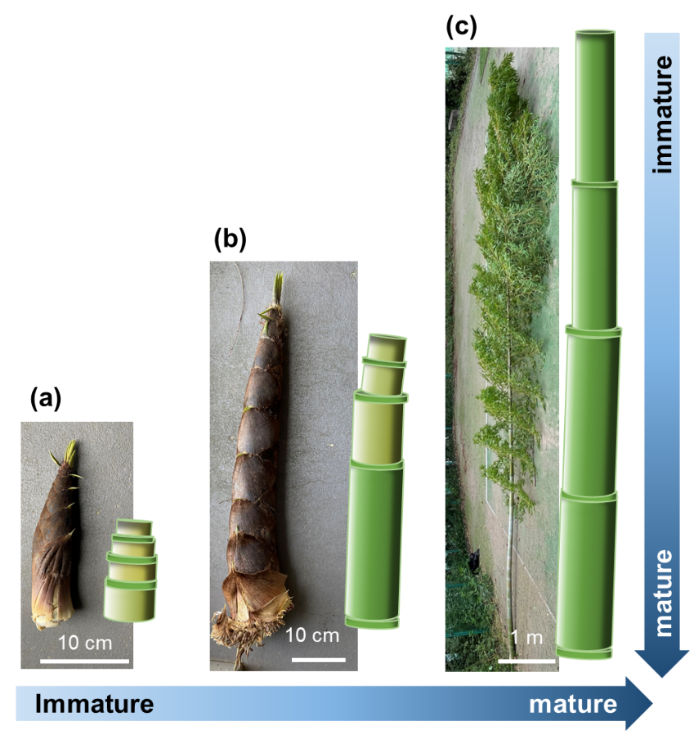

Figure S1. Photos and schematic illustrations of bamboo shoots and culm that grew for different periods after the emergence. (a) 1 week, (b) 2 weeks, and (c) 16 weeks (4 months). The degree of maturation increases from the top to the base of a culm.

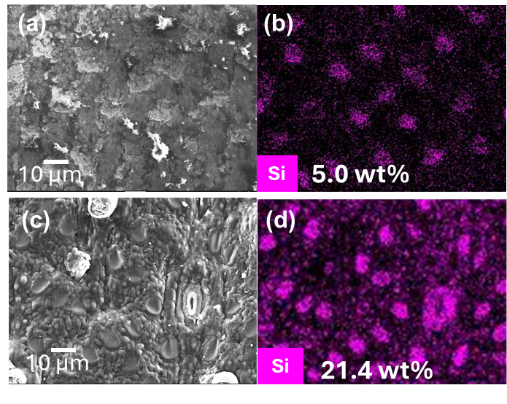

Figure S2. Plane-viewed SEM images with elemental (Si) mapping of the epidermal layer of a bamboo culm before (a, b) and after (c, d) removal of cuticular wax by a chemical treatment with hypochlorite.

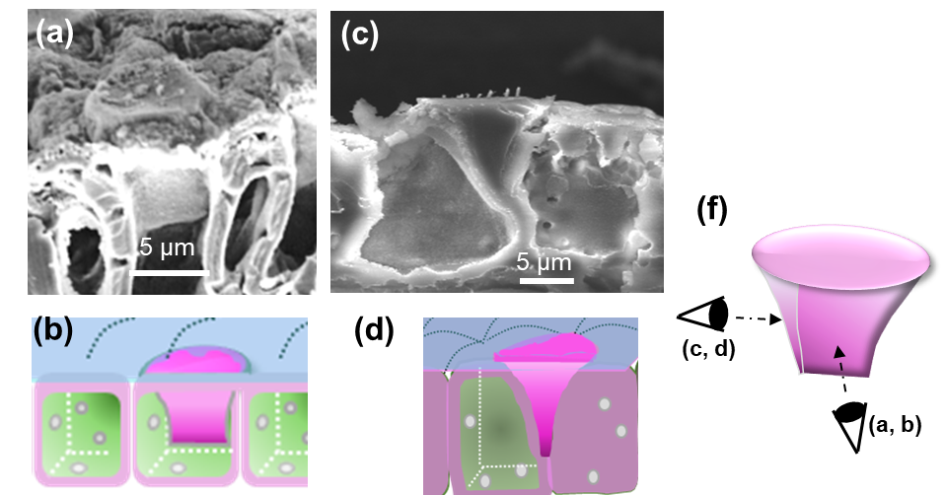

Figure S3. Cross-sectional SEM images (a, c) and schematic illustrations (b, d, f) of the silica wedges embedded in the epidermal layer of a bamboo culm. The view directions were indicated in (f).

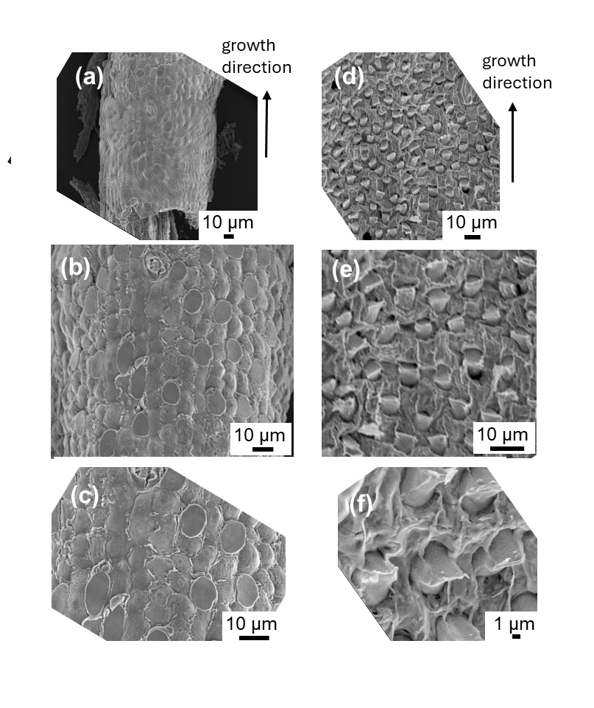

Figure S4. SEM images of the outer (a–c) and inner (d–f) sides of the silicified epidermal layer of a bamboo shoot after removal of organic matter by calcination.

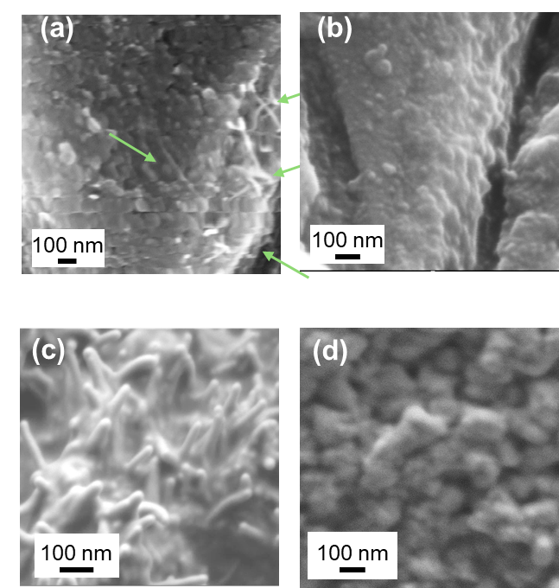

Figure S5. Enlarged SEM images of silica wedges (a, b) and silicified epidermal cells (c, d) before (a, c) and after (b, d) the treatment with cellulase.

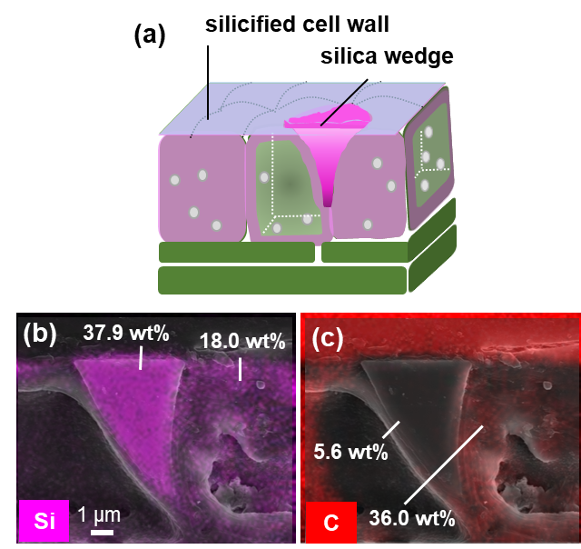

Figure S6. Cross-sectional elemental mapping images for Si (b) and carbon (c) and schematic illustration (a) of the silica wedge and silicified epidermal cell. Silica contents (wt%) were calculated from the silicon contents evaluated by EDS using the molecular weight ratio of SiO₂ (M: 60) and Si (M: 28).

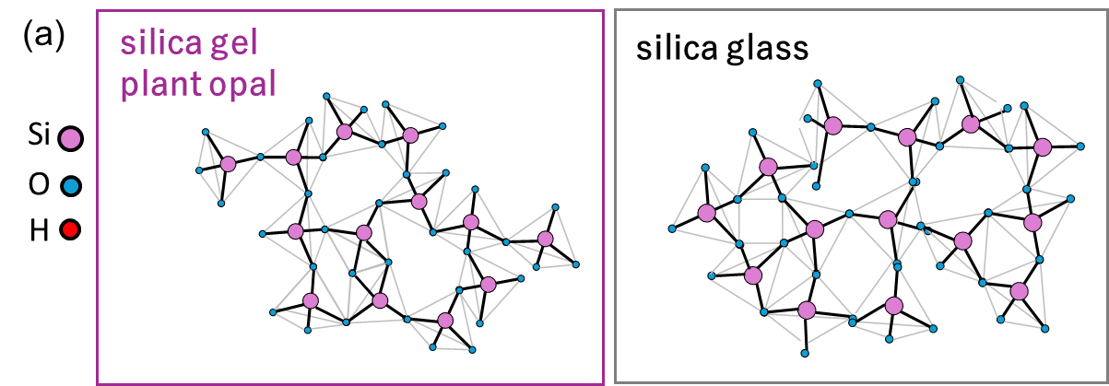

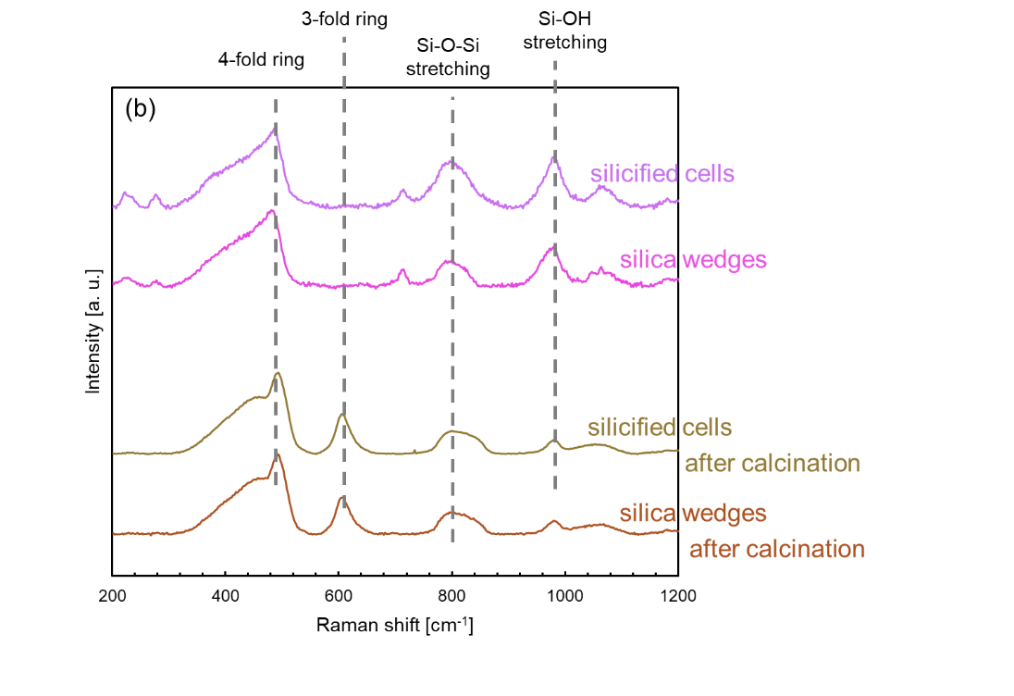

Figure S7. Illustrations of the Si-O–Si network structures of biosilicas and silica glass (a) and Raman spectra of bioilicas (b) after heat treatment.

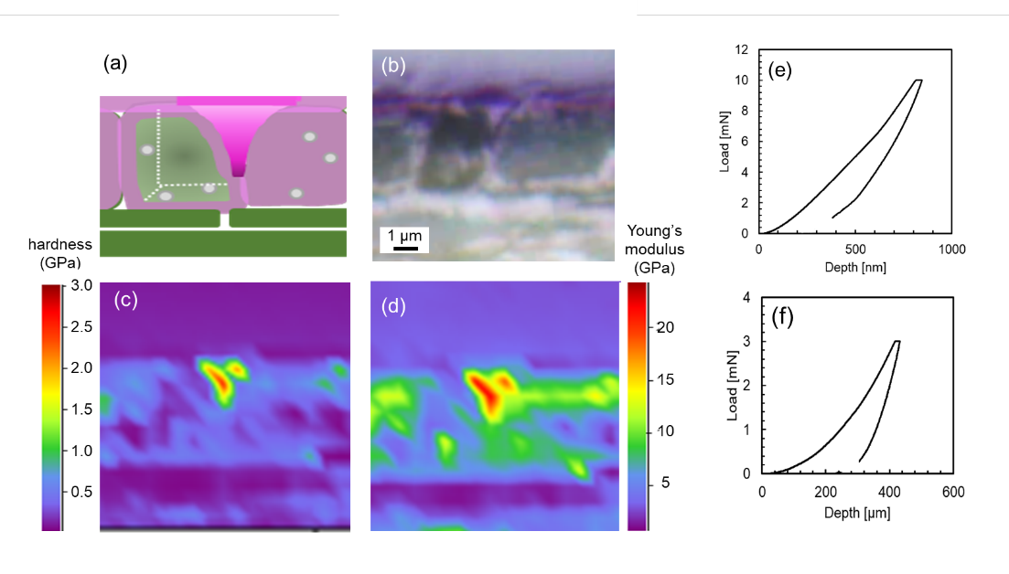

Figure S8. Schematic illustration (a), an optical micrograph (b), and hardness (c) and Young’s modulus (d) mapping images of cross section of a raw bamboo culm cortex embedded in resin. Indents were repeated in a grid with a spacing of 3 μm × 3 μm. Typical indentation curves for wedge silicas (e) and epidermal cells (f).

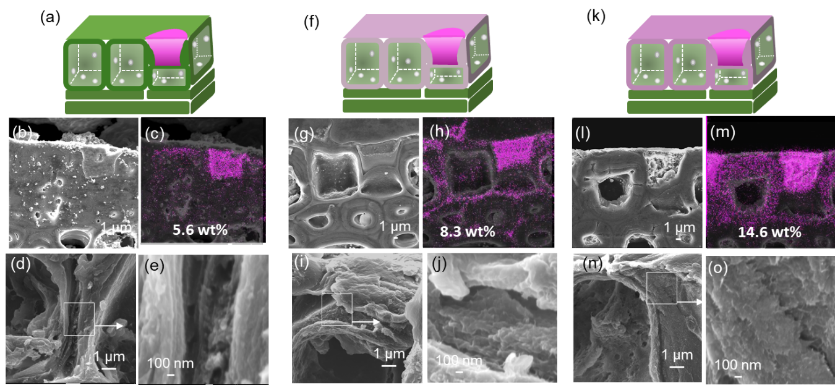

Figure S9. Illustrations of the silicification process (a, f, k) and SEM images (b, d, e, g, i, j, l, n, o), and elemental (Si) mapping (c, h, m) of an epidermal cell wall of 30th (a–e) and 20th (f–j) internodes form the base of the shoot that grew for 4 months after the emergence, and 10th internode form the base of the shoot that grew for 5 months after the emergence (k–o). The cross sections of an epidermal cell wall were exposed after supercritical drying (d, e, i, j, n, o), and subsequent polishing (b, g, l).

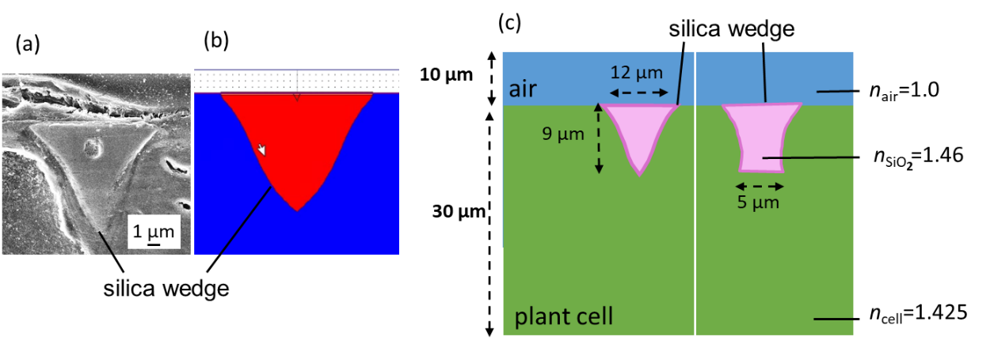

Figure S10. A cross-sectional SEM image (a) and illustrations of a model used for the numerical simulation (b, c) of a silica wedge. The incident light angle (θ) was fixed at 0° and 40°. The light wavelength was set at 660 nm,¹ which is the maximum absorption wavelength for chloroplast. The refractive indices (n) of biosilicas and the matrix of a culm cortex were approximated by the value of amorphous silicas (n = 1.46) (or cellulose (n = 1.46–1.47))² and by the average value of water and plant cells (n = 1.425),³ respectively.
Based on the actual geometry of biosilicas in the epidermal layer of a bamboo culm, a 3D model (b, c) was created for a silica wedge 9 µm in height with a bottom ridge 5 µm in length with a round head 12 µm in diameter using Rsoft Photonics CAD Suite. The curves of the wedge shape were reproduced by a mathematical approximation of the actual cross-sectional view (b). Numerical simulations based on the beam propagation method (BPM) were conducted using BeamPROP (RSoft) to analyze the light path in the culm cortex near the silica wedge. As shown in the schematic illustration (c), the measurement area was set up to 30 µm plant cells with a silica wedge placed on the surface with air at a distance of 10 µm from the light source. The width of the incident light source was set to 2 μm to ensure that the measurement does not exceed the detection limit. The incident beam diameter at the top surface of the wedge (at Z = 10 µm) was ~6 µm. The input light was assumed to be a circular beam with uniform intensity within the beam cross section.

Table S1. Hardness (H) and Young's modulus (E) of the biosilicas in bamboo culm, culm cortex cells without biosilicas, and biosilicas in rice leaves.⁴

 | hardness (H) [GPa] | Modulus (E) [GPa]
silica wedges | 2.1±0.4 | 20.0±2.1
epidermal cell walls | 0.69±0.20 | 10.1±3.1
hypodermal and transitional cells | 0.20±0.09 | 4.2 ±1.9
fan-shaped silicas⁴ | 2.5 ±1.0 | 20±2.4
silica plates⁴ | 0.37±0.16 | 3.5±1.3

References
- Terashima, I., Fujita, T., Inoue, T., Chow, W. S. & Oguchi, R. Green light drives leaf photosynthesis more efficiently than red light in strong white light: Revisiting the enigmatic question of why leaves are green. Plant Cell Physiol. 50, 684–697 (2009).
- Kasarova, S. N., Sultanova, N. G., Ivanov, C. D. & Nikolov, I. D. Analysis of the dispersion of optical plastic materials. Opt. Mater. 29, 1481–1490 (2007)
- Gausman, H. W., Allen, W. A. & Escobar, D. E. Refractive Index of Plant Cell Walls. Appl. Opt. 13, 109–111 (1974).
- Sato, K. et al. Effects of nanostructured biosilica on rice plant mechanics. RSC Adv. 7, 13065–13071 (2017).

