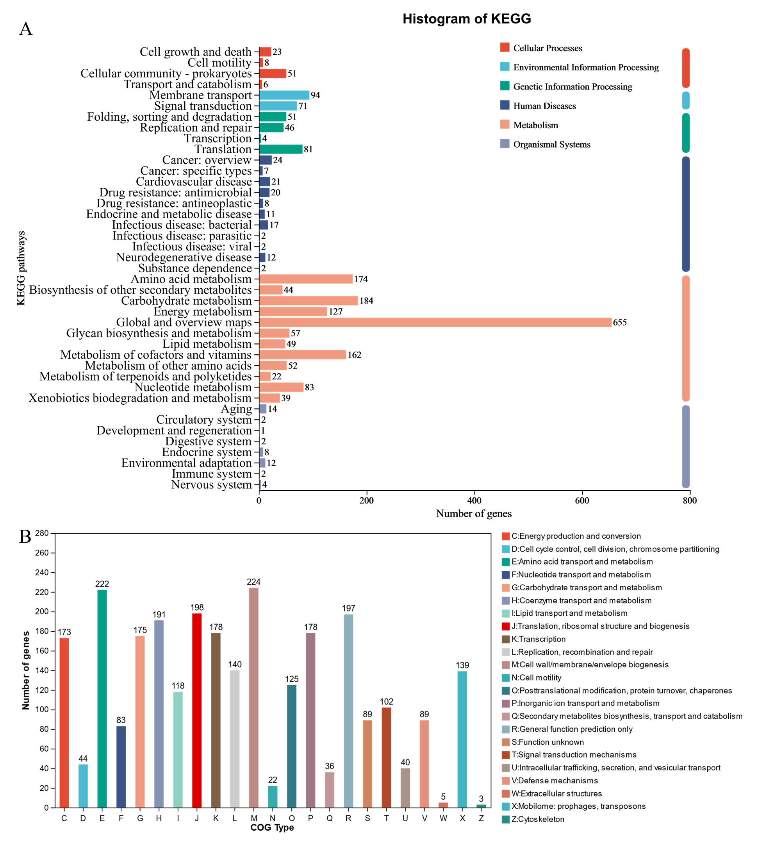
Supplementary Fig. 1. The KEGG (A) and COG (B) classification and functional categories of K. sucrofermentans SMEG01.

