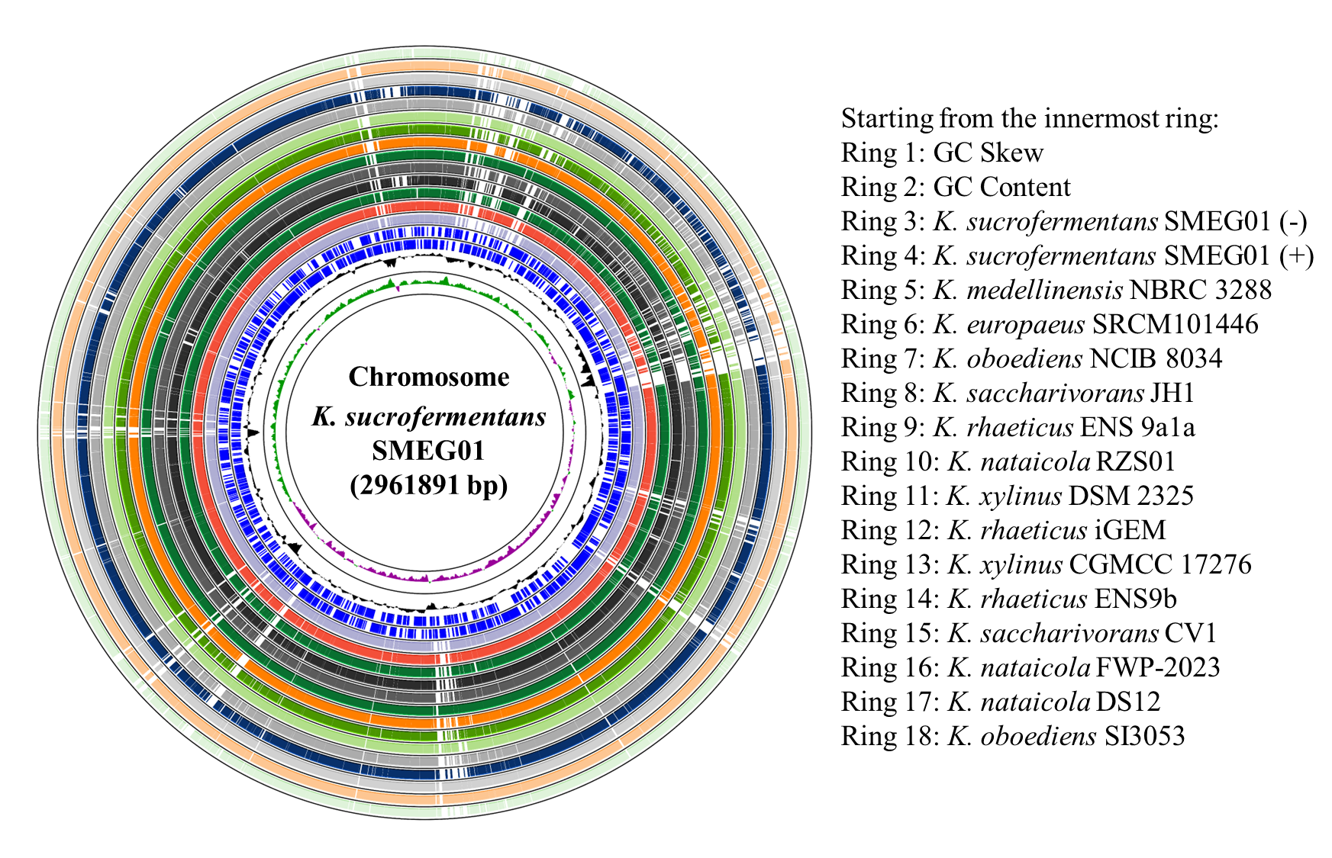
Supplementary Fig. 2. Circular genome comparison

