Supplementary Figure S1.
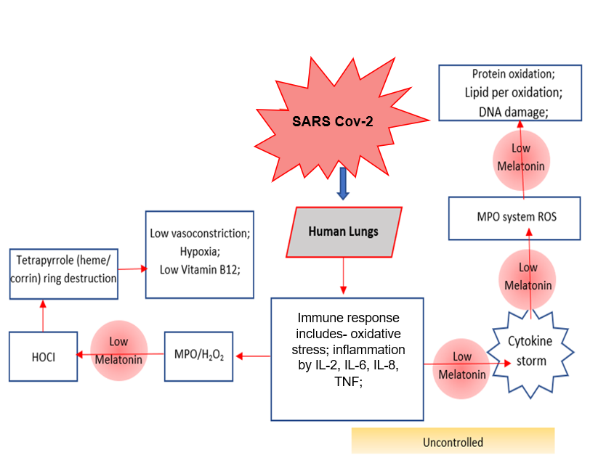
Supplementary Figure S1. The mechanism of uncontrolled health issues due to the lower melatonin concentration among COVID-19 patients; SARS-CoV-2 infection initiates an aggressive immune response in the lungs, characterized by excessive production of pro-inflammatory cytokines (IL-2, IL-6, IL-8, TNF-α) and oxidative stress. This leads to activation of the myeloperoxidase (MPO) system and generation of reactive oxygen species (ROS), including hydrogen peroxide (H₂O₂) and hypochlorous acid (HOCl). In the context of diminished melatonin levels—a key endogenous antioxidant and immunomodulator—ROS accumulation results in significant cellular damage, including protein oxidation, lipid peroxidation, and DNA injury. Low melatonin also contributes to impaired vasoconstriction, hypoxia, and reduced vitamin B12 levels due to tetrapyrrole ring disruption. The cumulative effect of unchecked oxidative stress and inflammatory signaling promotes a cytokine storm and uncontrolled immune activation, potentially leading to severe or fatal outcomes

