Isolation and Identification of the Cis-Abienol-Degrading Klebsiella oxytoca T2L Strain and its Aroma Products

- Stability of cis-abienol in the culture media
We assessed the stability of cis-abienol in the medium without the involvement of the strain, to determine that the degradation products were exclusively generated by the T2L strain's action. Using UPLC, we measured the initial concentration (0h), the concentration during fermentation (48h), and the final concentration (96h) of cis-abienol in the medium. It was observed that there were no significant changes in the cis-abienol content, indicating its stable presence in the medium. Consequently, we concluded that all degradation products were produced by the T2L strain's activity. Additionally, the pH of the medium at this point was 7.
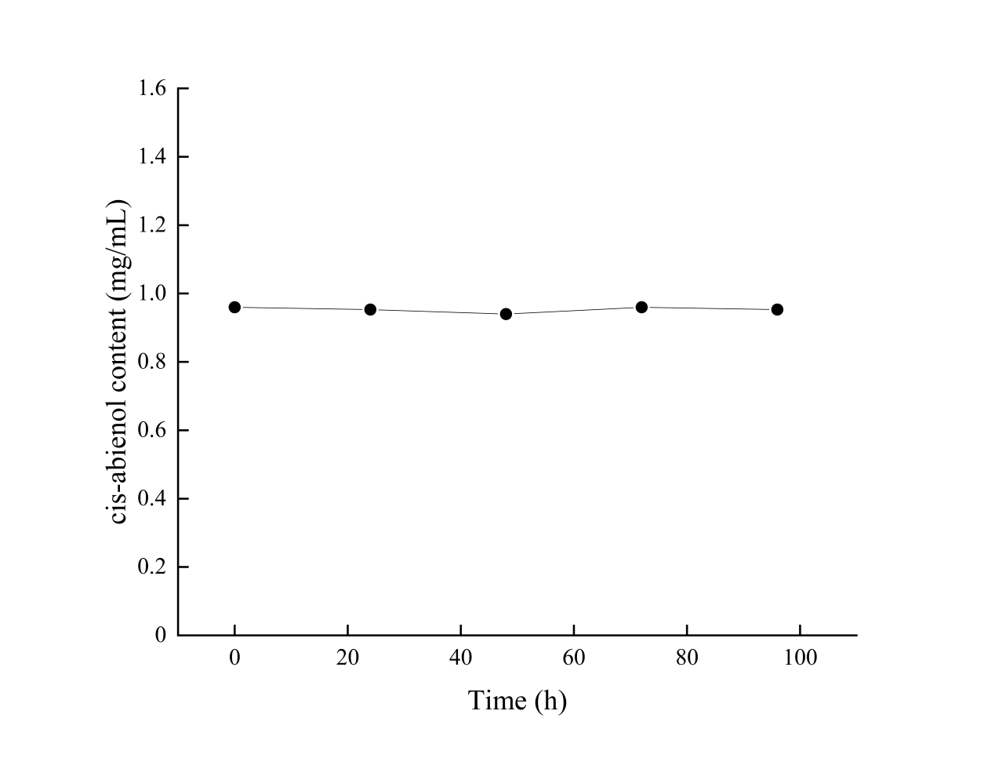
Figure S1. Stability of cis-abienol in culture media
- Influence of varing pH value on cis-abienol in culture medium
Through investigating the impact of pH on the degradation efficiency of cis-abienol, it was discovered that the degradation rate slightly increased at a pH of 9.0. To further explore this, we studied the changes in cis-abienol content in the medium at both pH 9 and pH 5, without the addition of the strain. Utilizing UPLC analysis, we found no significant variations in the cis-abienol content at the initial (0h), intermediate (48h), and final (96h) stages of fermentation. Based on these observations, we can confidently attribute these findings to the action of strain T2L.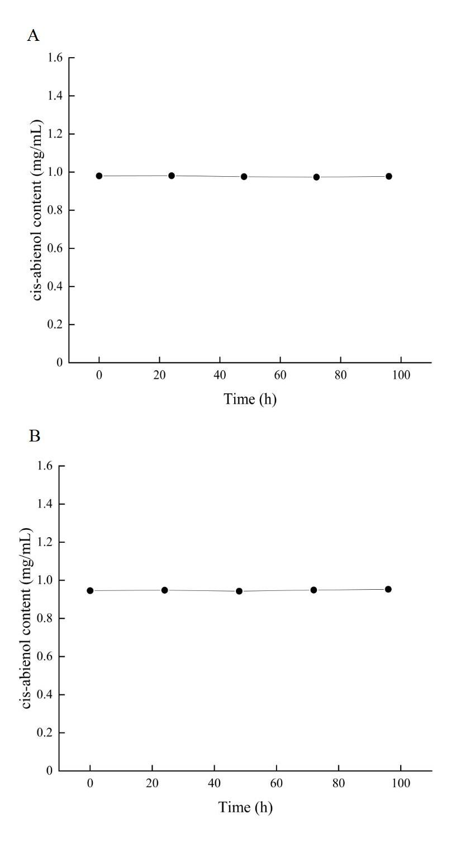
Figure S2. Effect of pH value on cis-abienol in culture medium with different pH. A. pH 5; B. pH 9
- Monitoring of pH value during fermentation
During the cultivation of strains, real-time pH monitoring was not implemented, and in the comparative experiments involving different pH values, we solely observed the impact of the initial pH on the strains' response. To supplement this, we conducted an additional experiment where we selected a single carbon source (glucose) and two nitrogen sources (ammonium sulfate and peptone). We tested the pH value throughout the fermentation process and compared pH readings at different times of the fermentation. Our results revealed that there were no significant changes in the pH value during the entire fermentation process.
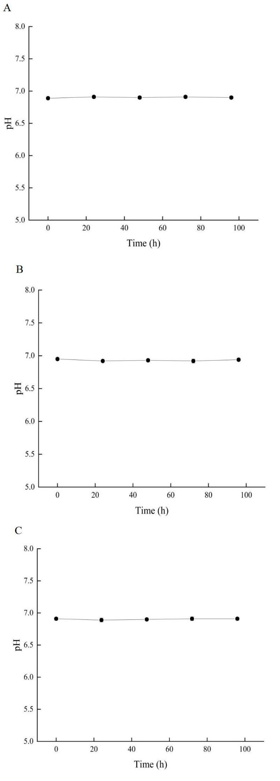
Figure S3. pH analysis of the whole fermentation process with different substances in the medium using T2L. A. Glucose; B. Ammonium sulfate; C. Peptone.
- GC-MS analysis results of the compounds in Figure 4
All GC-MS data were compared by NIST 20.L spectral library

Compound 1: n-Nonenylsuccinic anhydride
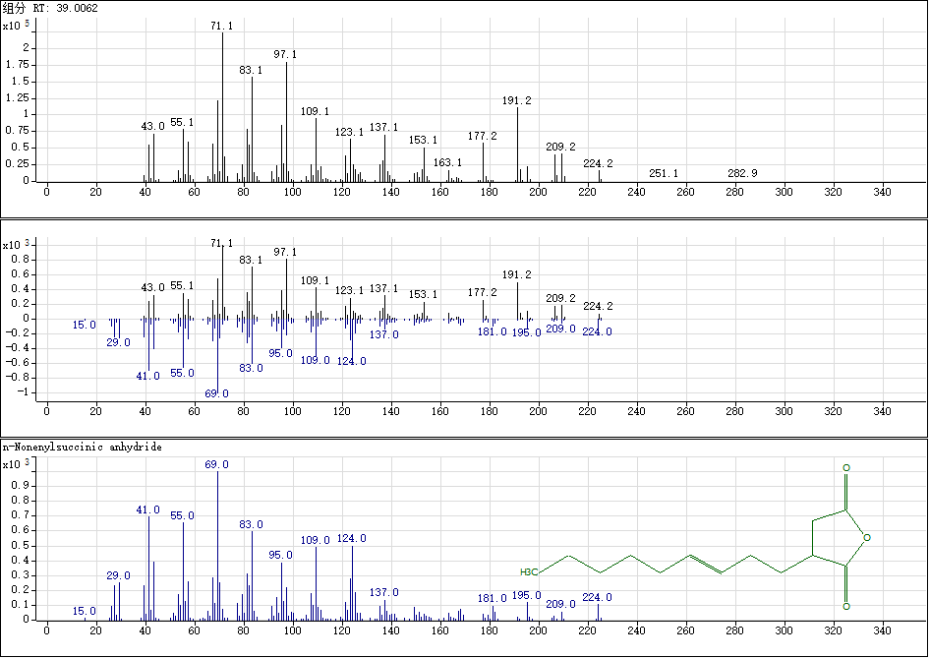

Compound 2：Sclaral (sclareolide lactol)
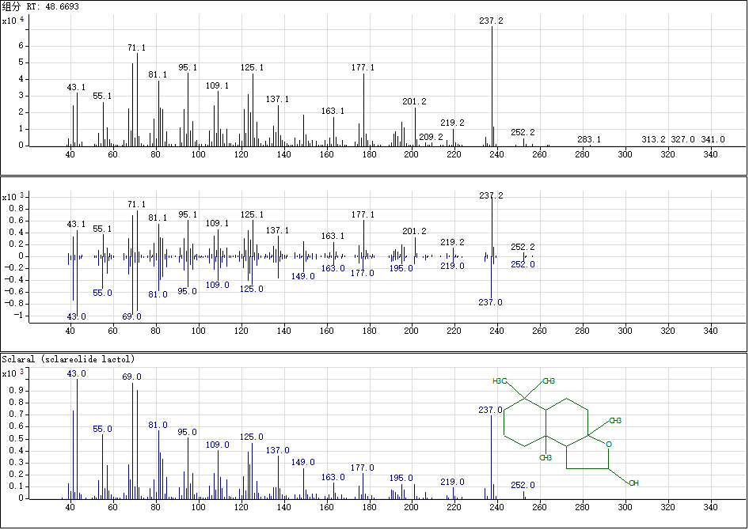

Compound3：Amberonne (isomer3) analog
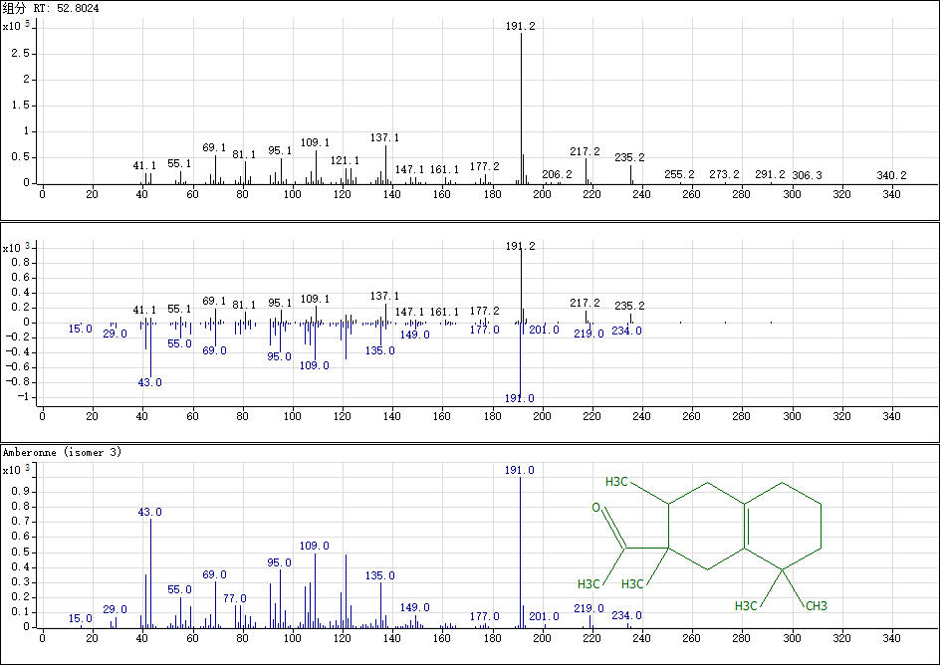

Compound 4：Sclareol analog
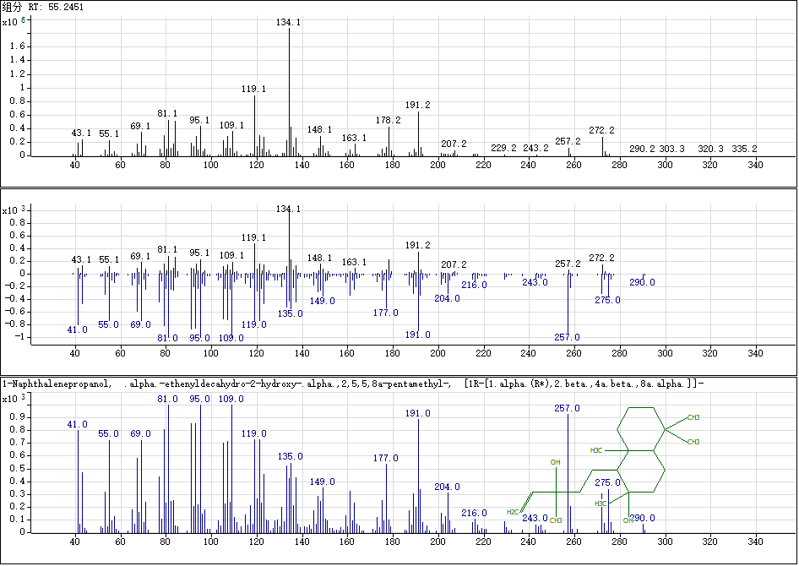

Compound 5：15-Isobutyl-(13.alpha.H)-isocopalane
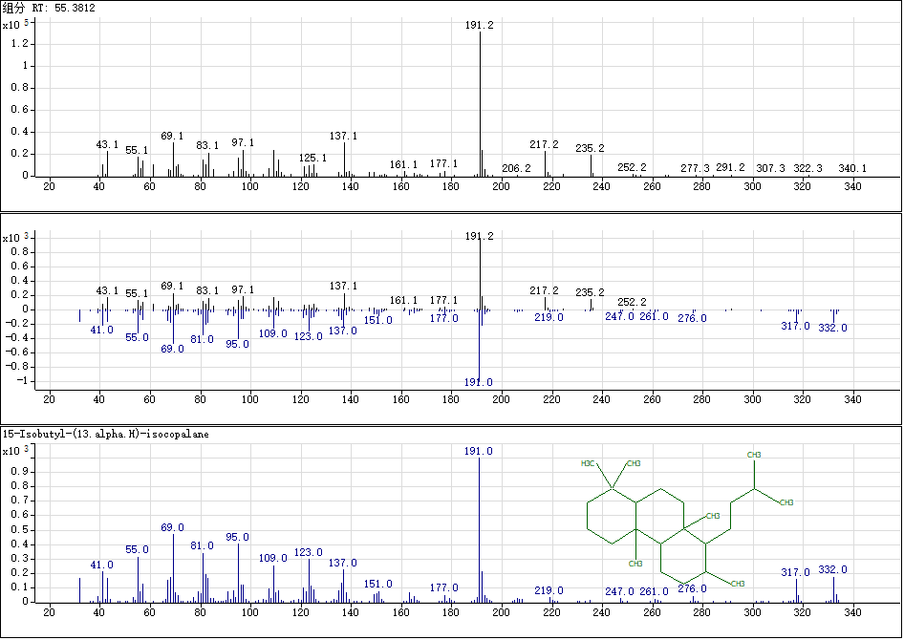
Compound 6：(3R)-3,7-Dihydroxy-9,11-eremophiladien-8-one, 3-acetate
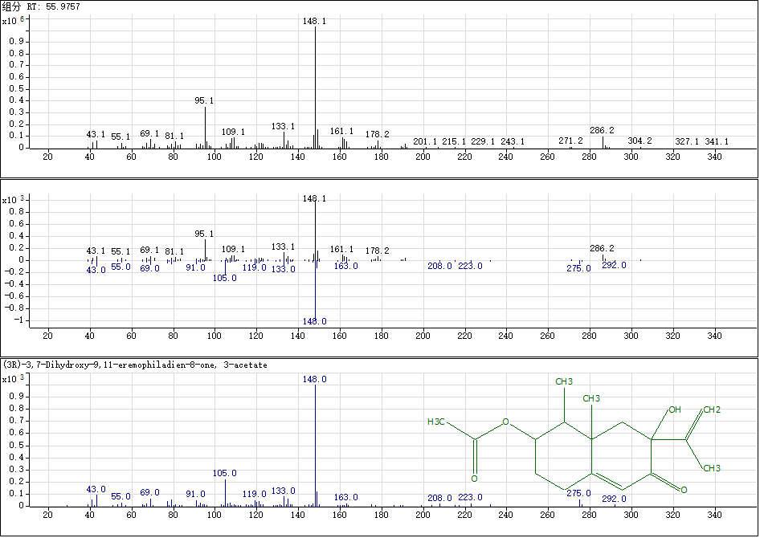

Compound 7：2,5,5,8a-Tetramethyl-4-methylene-4a,5,6,7,8,8a-hexahydro-4H -chromene
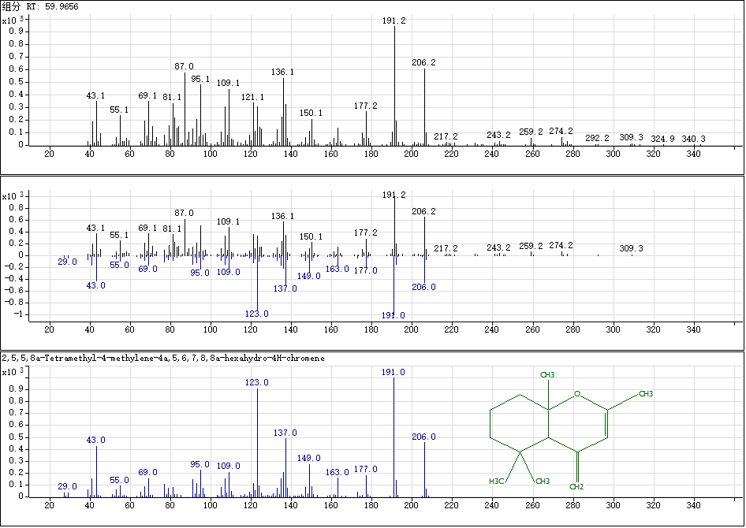

Compound 8：Ambreinolide
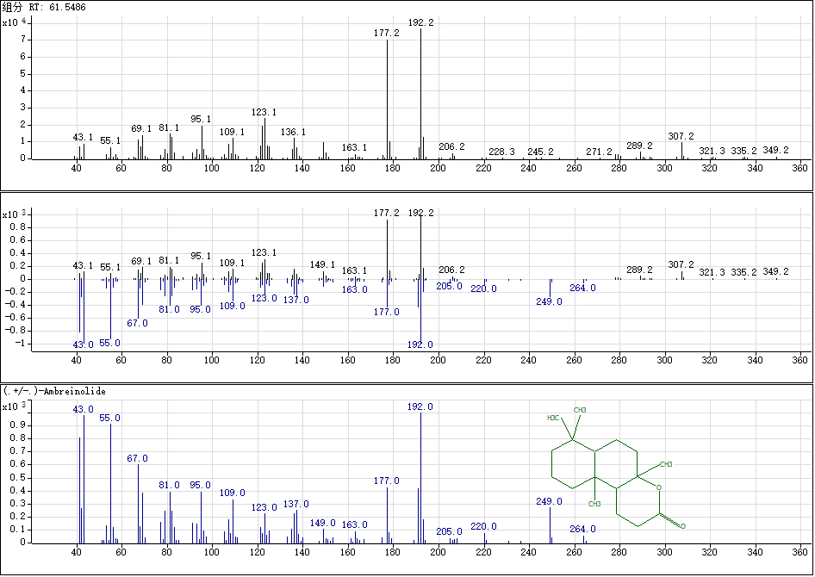
Figure S4. Peak ion spectra profile of the cis-abienol degraded products by GC-MS.

