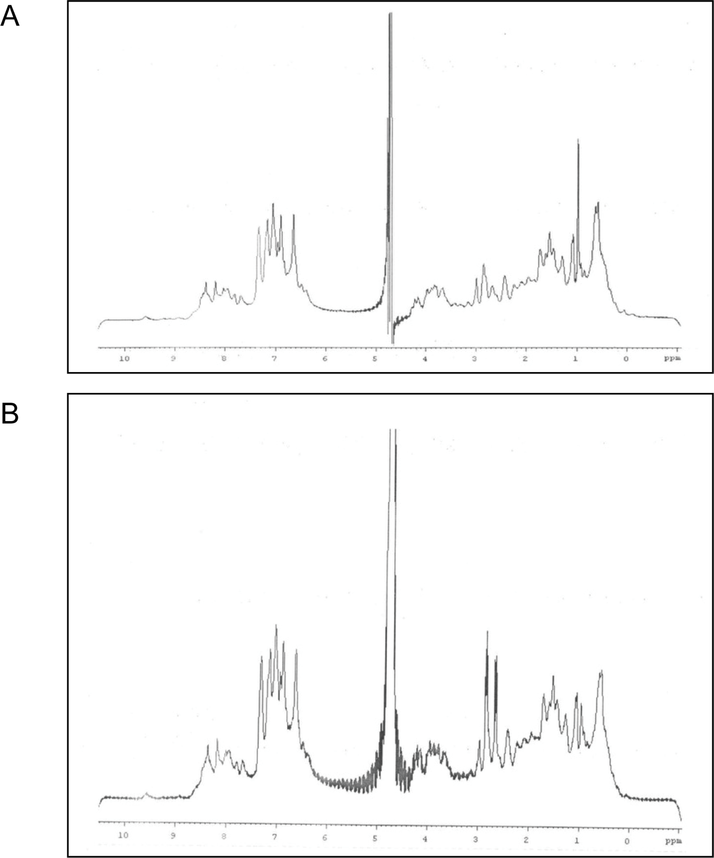 Figure S1. Comparison of 1H-NMR Spectra for Insulin Lisargine and Standard Human Insulin. (A) 1H-NMR spectrum of standard human insulin. (B) 1H-NMR spectrum of Insulin Lisargine.

