Discovery and Molecular Characterization of a Potent Thiazolyl-Pyrazole Hybrid Targeting EGFR for Breast Cancer Therapy
Samar E. Mahmoud, Ahmed A. Fadda, Ehab Abdel-Latif & Mohamed R. Elmorsy
Department of Chemistry, Faculty of Science, Mansoura University, 35516 Mansoura, Egypt.
Correspondence: m.r.elmorsy@gmail.com & m.r.elmorsy@mans.edu.eg

- Spectral analysis:
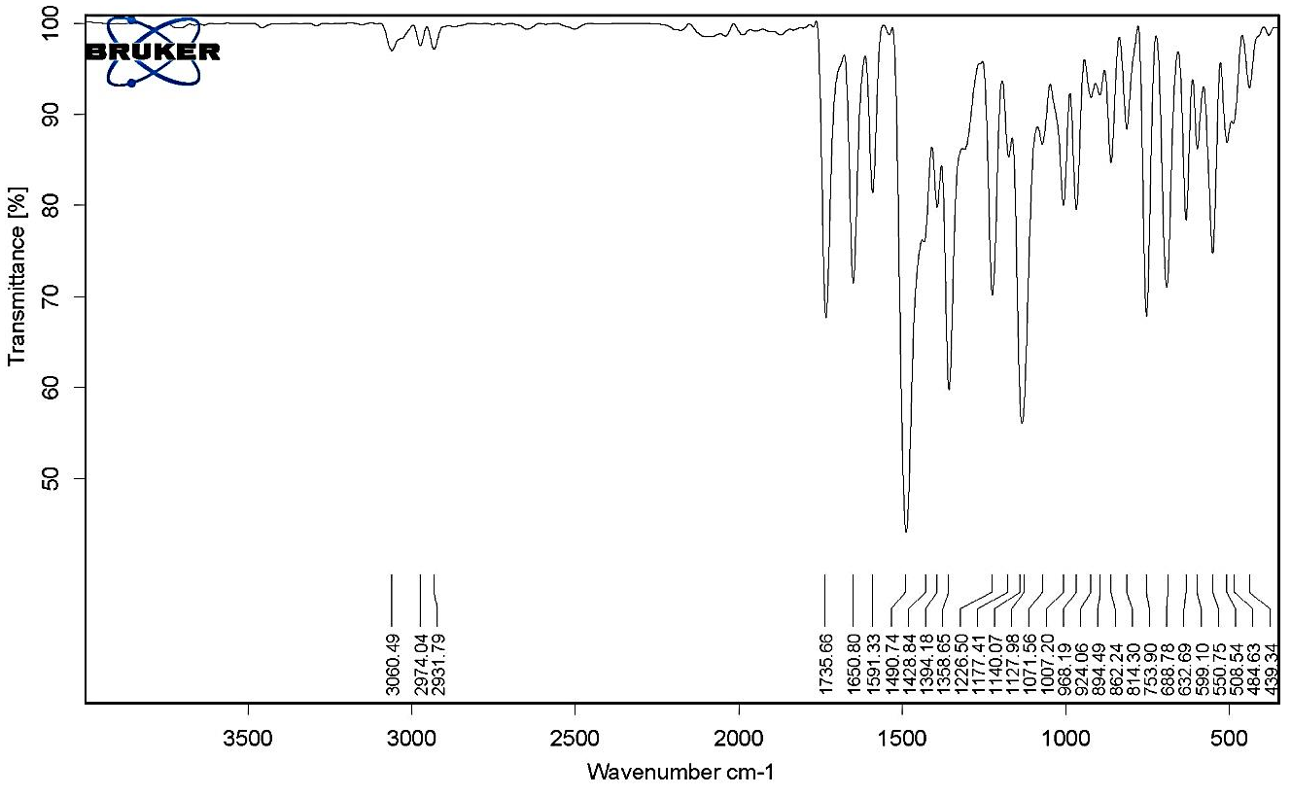
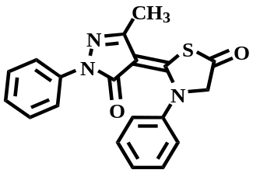
Figure (S1): IR spectrum of compound 2.

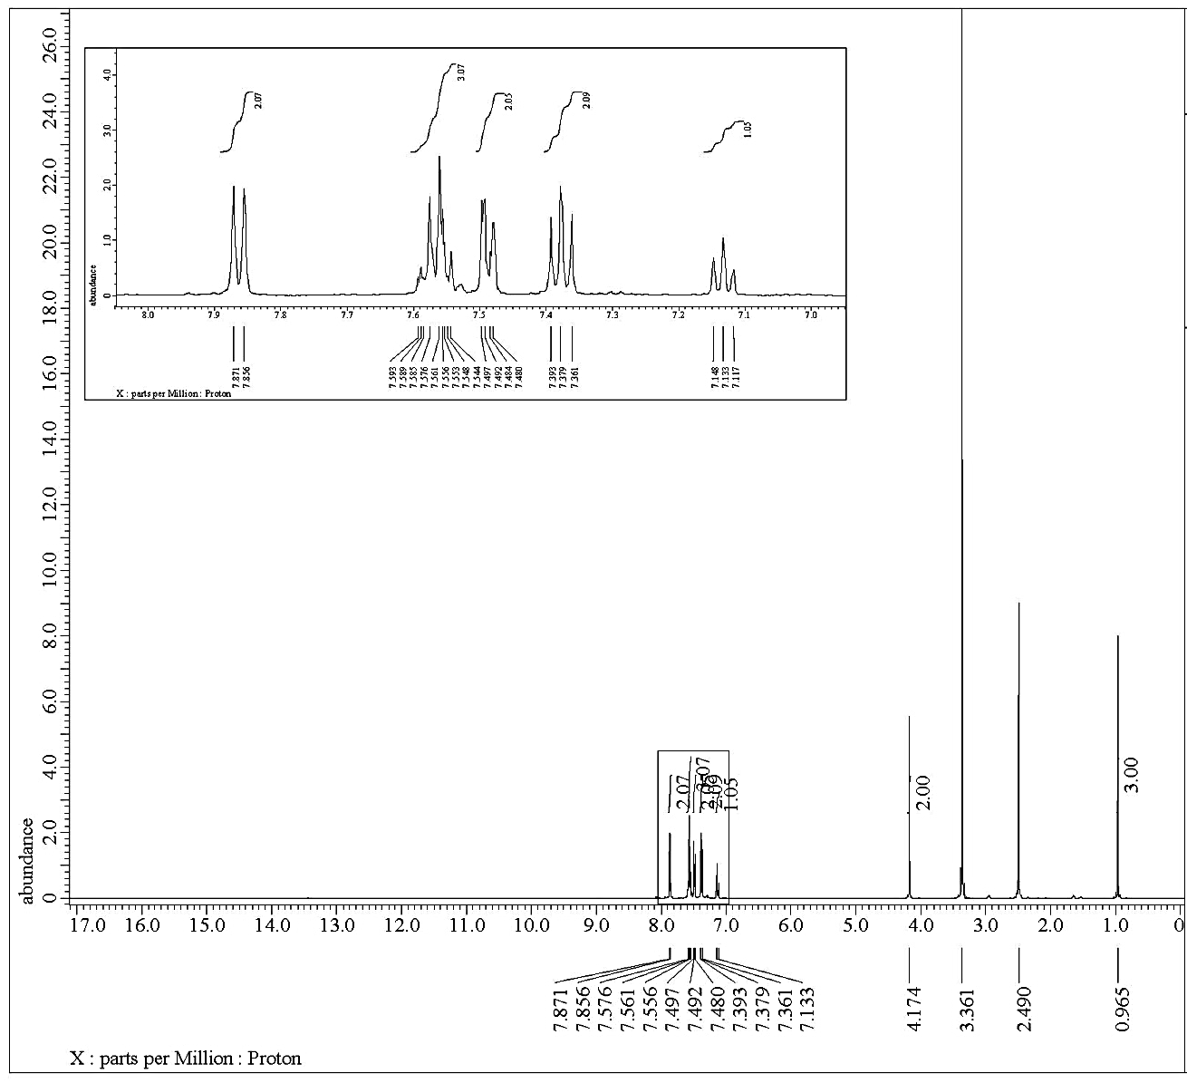
Figure (S2): ¹H NMR spectrum of compound 2.

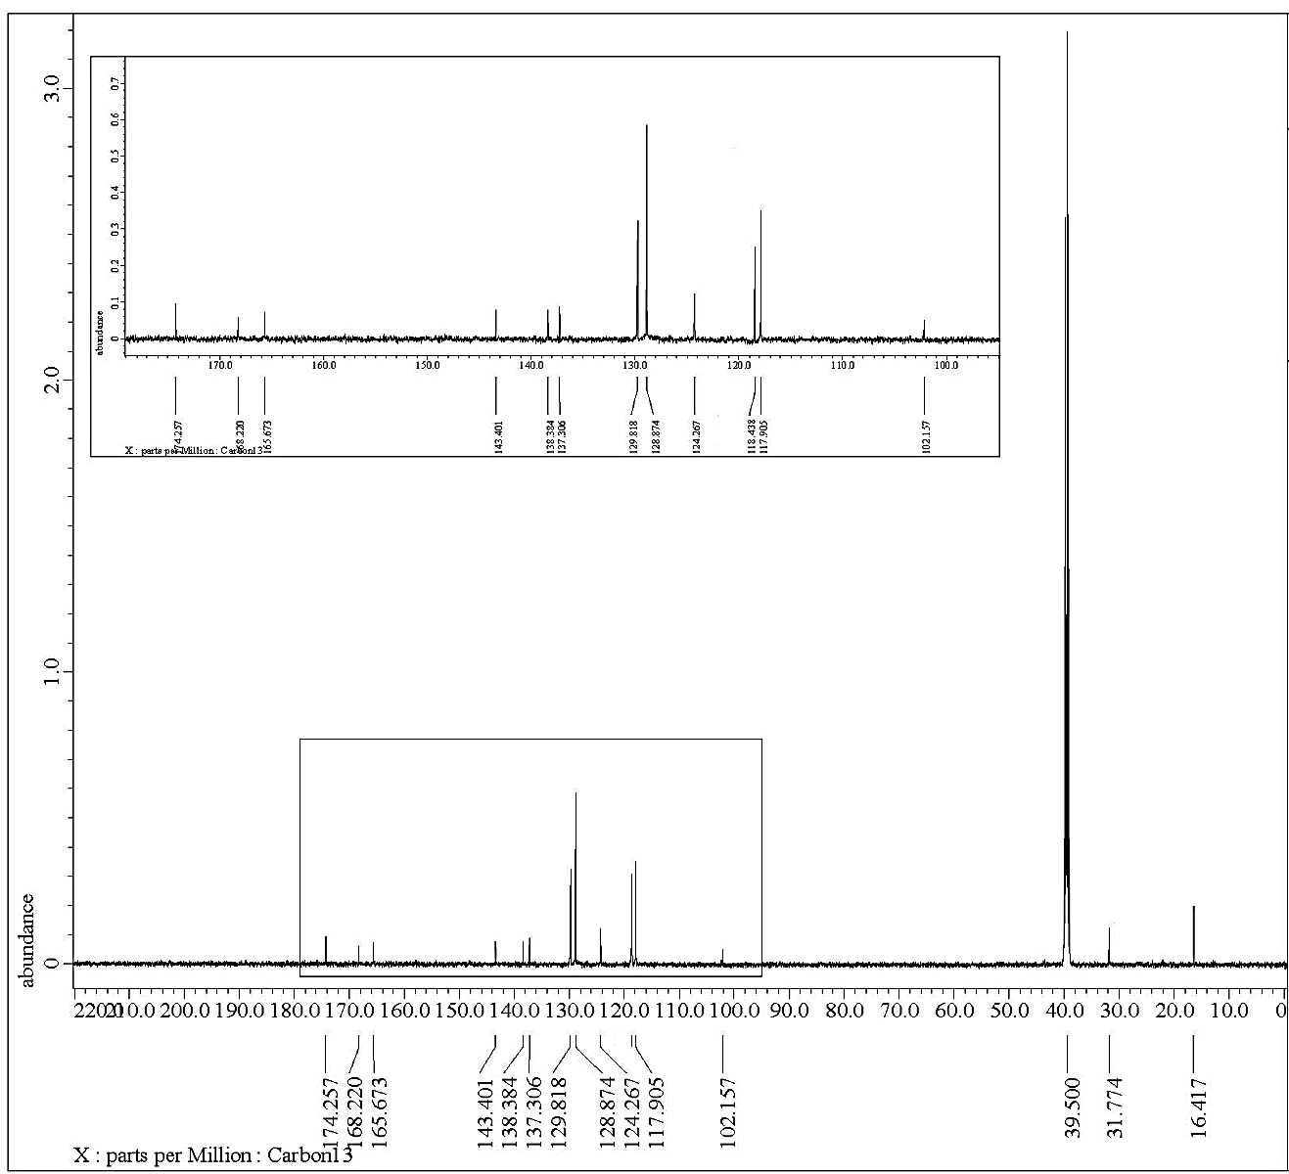

Figure (S3): ¹³C NMR spectrum of compound 2.

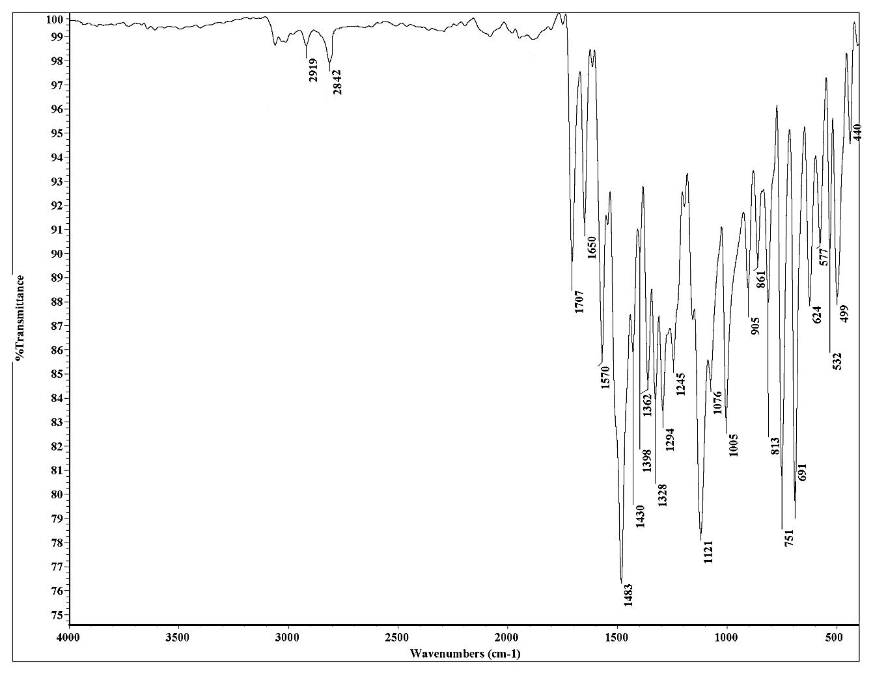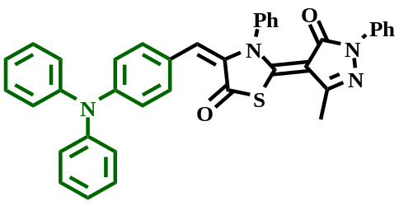
Figure (S4): IR spectrum of compound 4a.

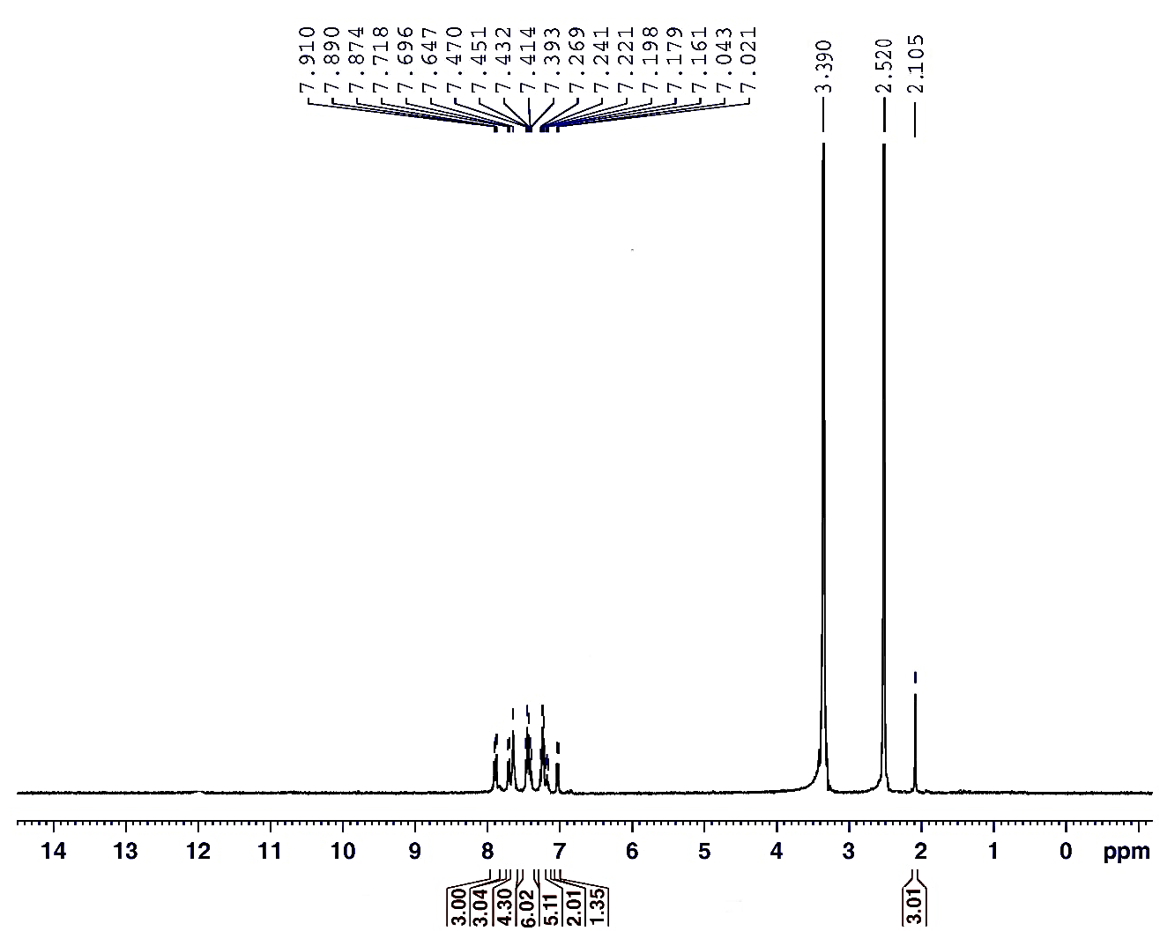
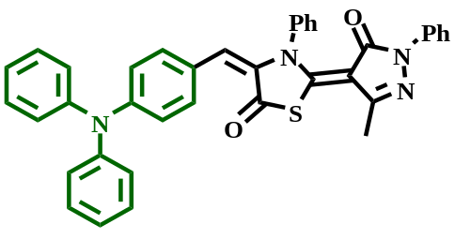
Figure (S5): ¹H NMR spectrum of compound 4a.
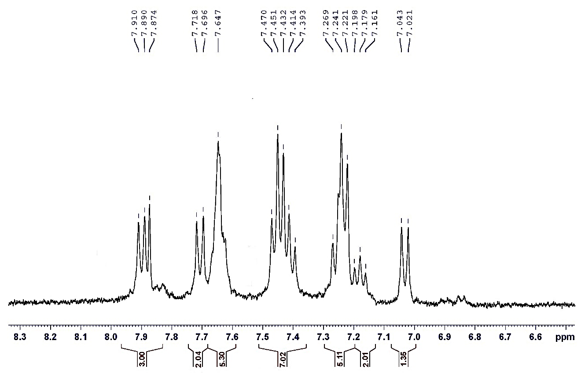
Figure (S6): ¹H NMR spectrum of compound 4a.

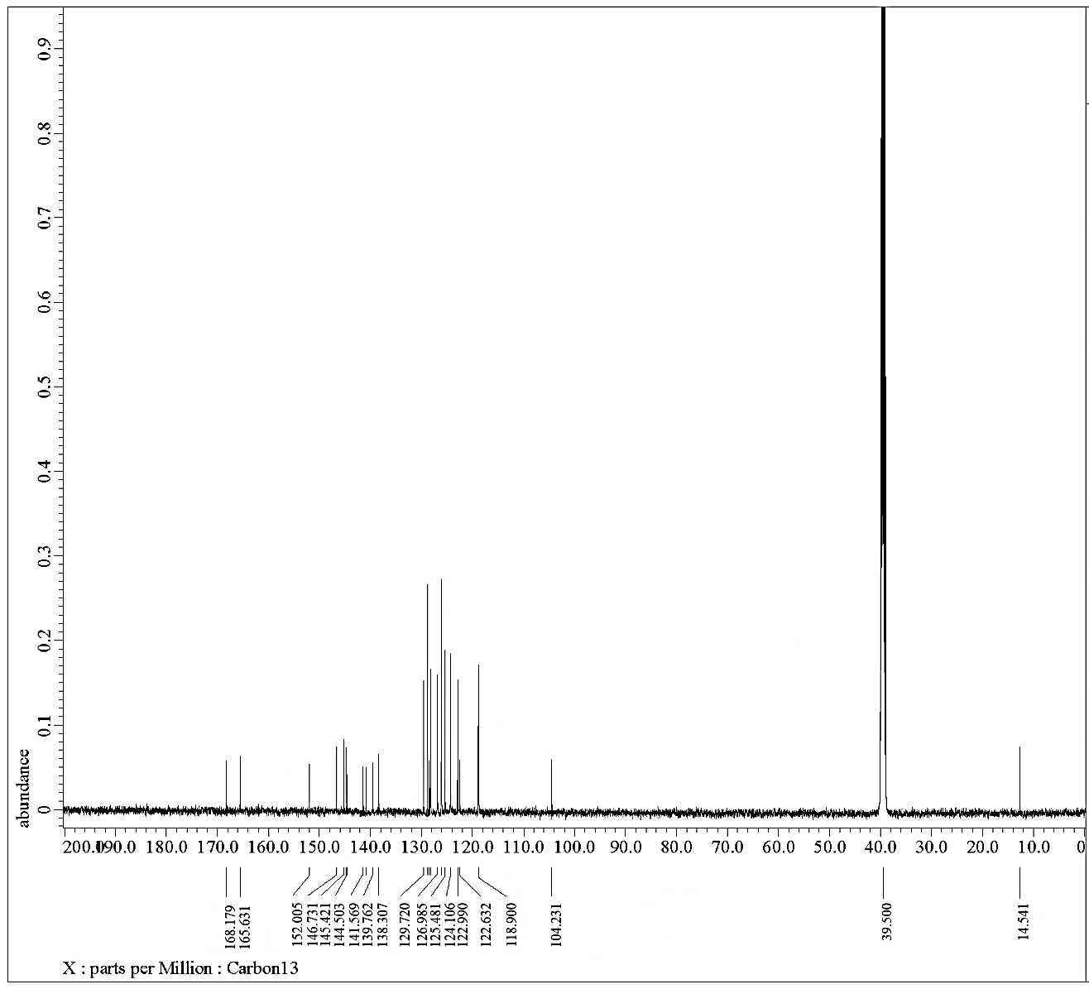

Figure (S7): ¹³C NMR spectrum of compound 4a.

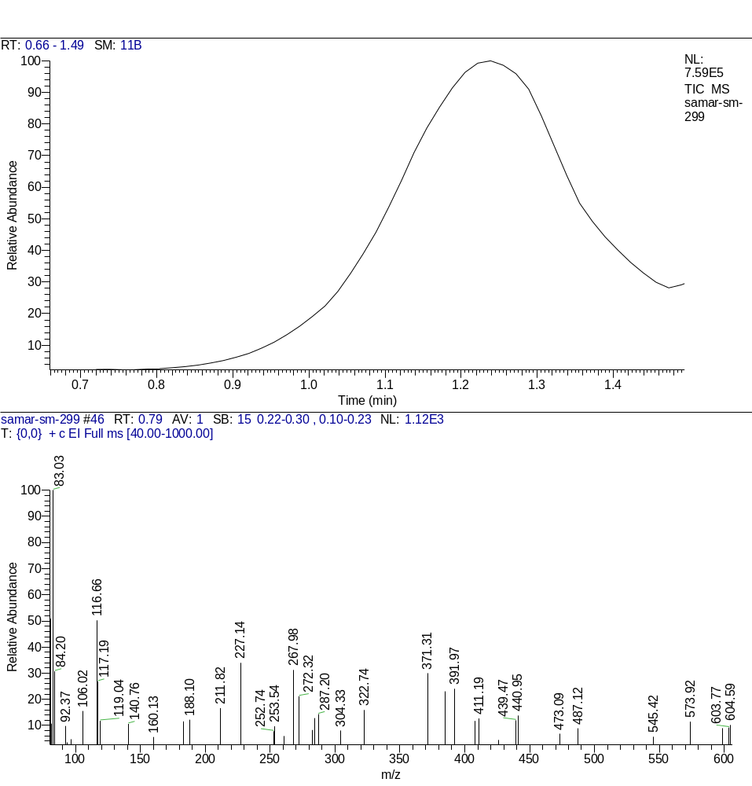
Figure (S8): Mas spectrum of compound 4a.

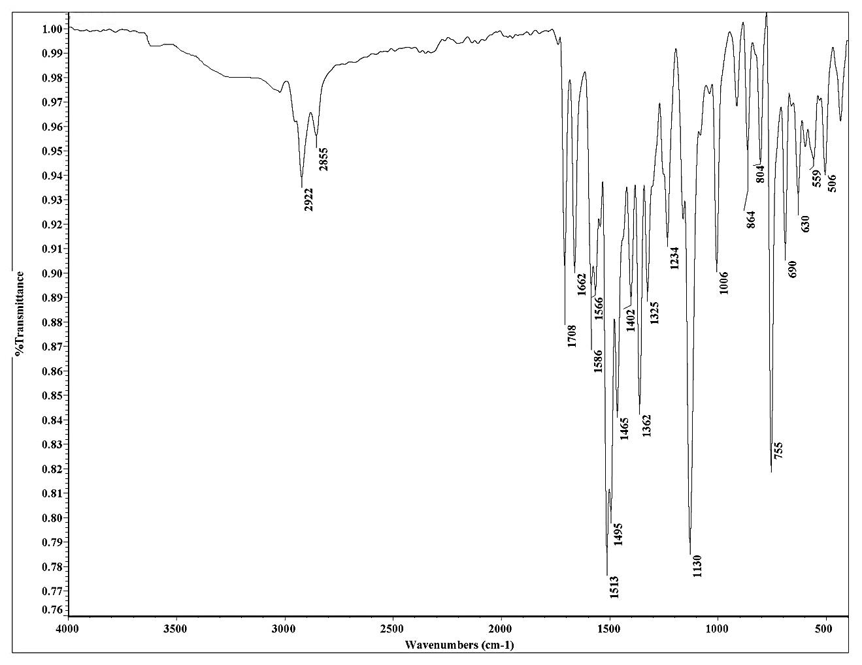
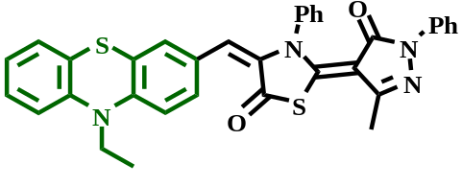
Figure (S9): IR spectrum of compound 4b.
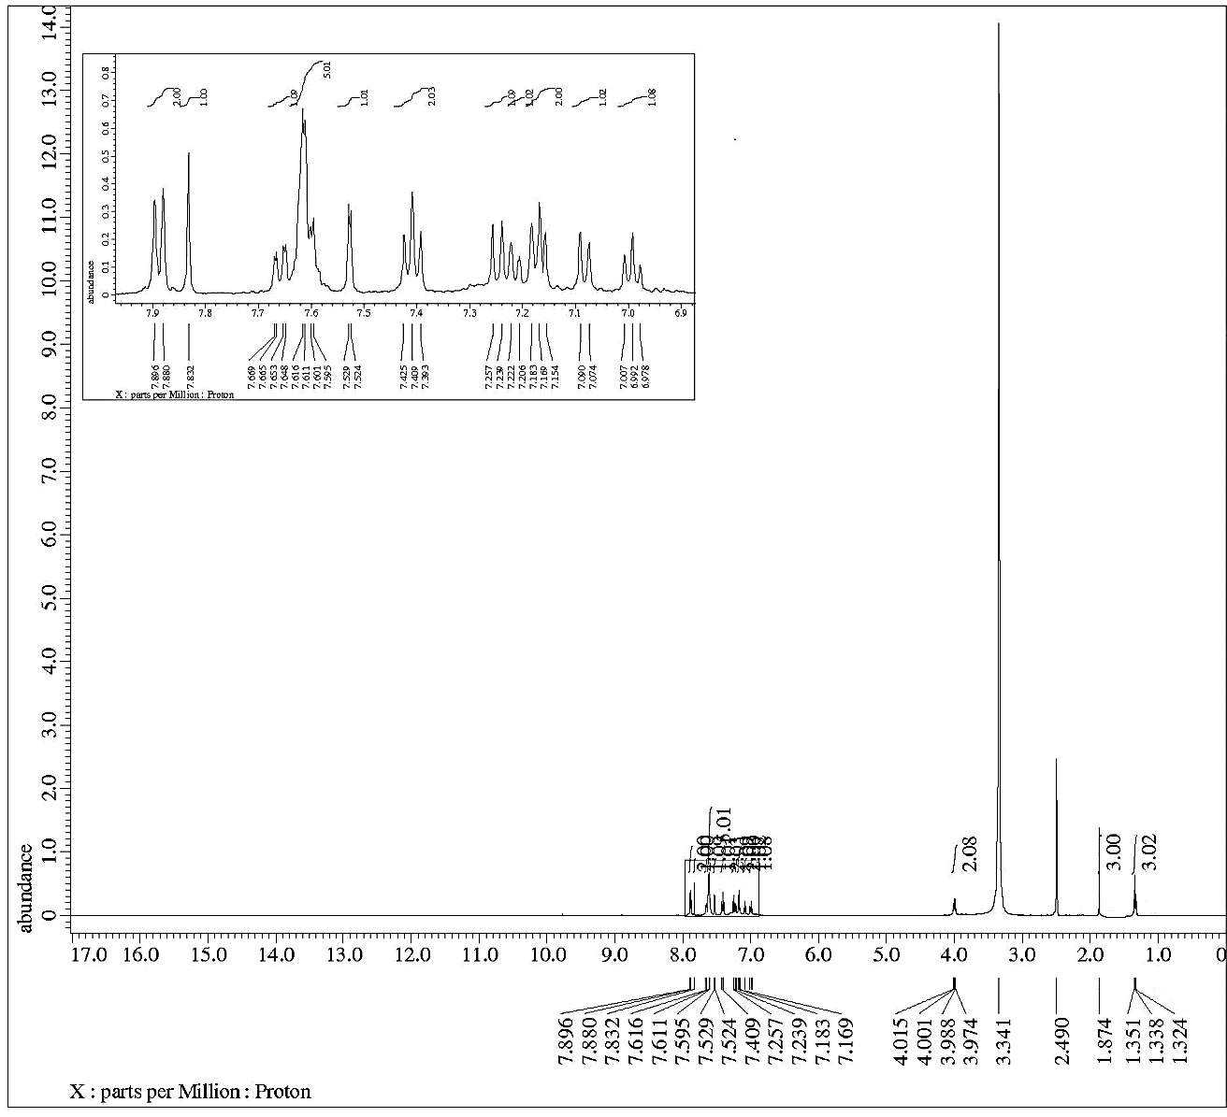
Figure (S10): ¹H NMR spectrum of compound 4b.

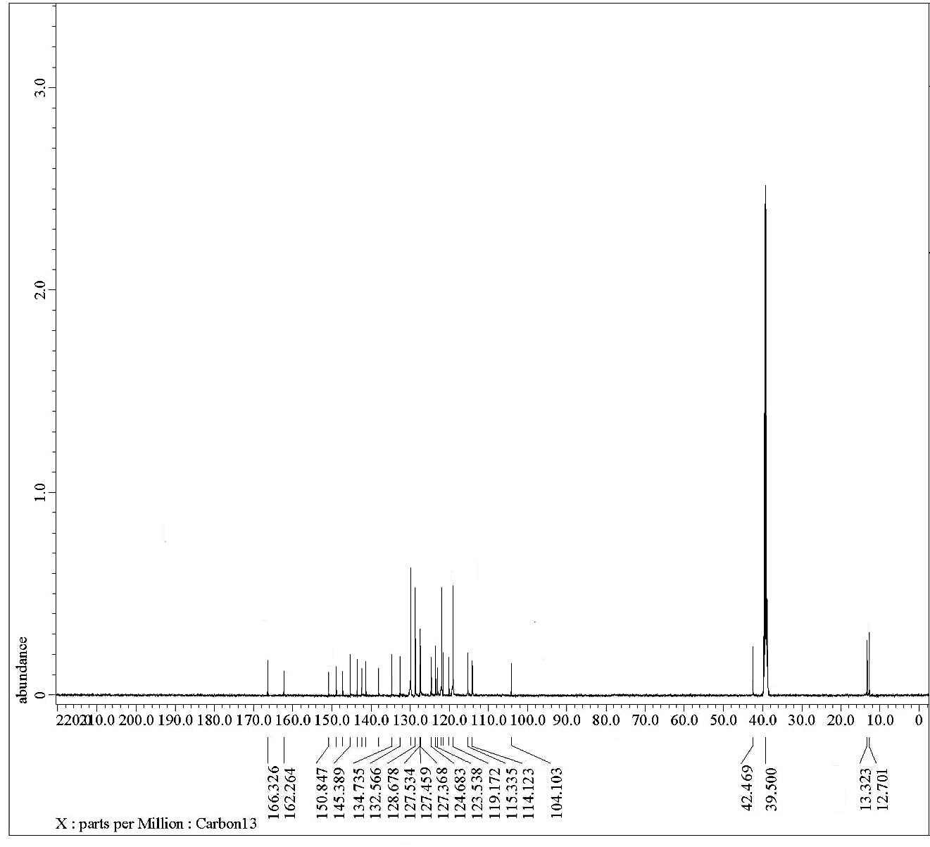
Figure (S11): ¹³C NMR spectrum of compound 4b.

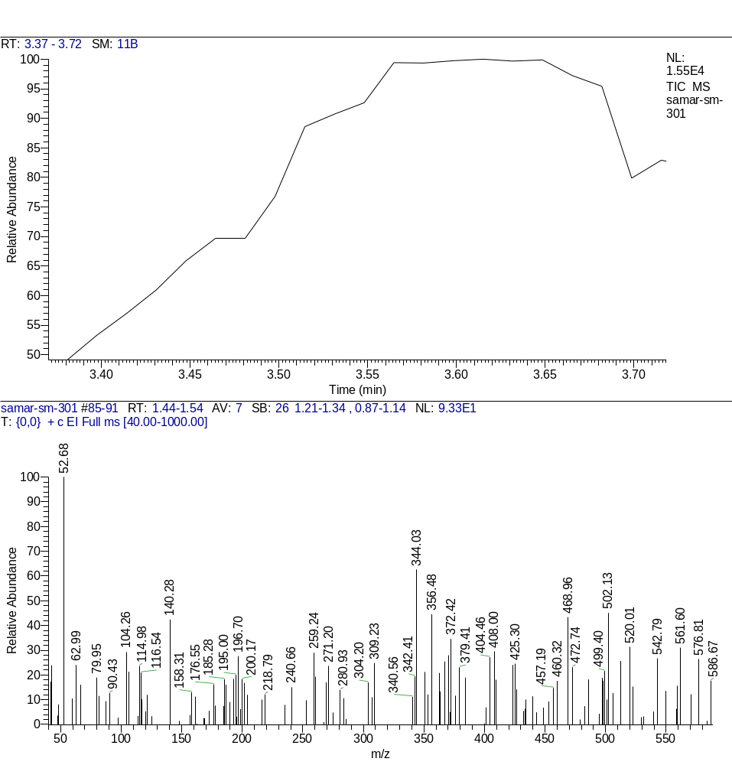
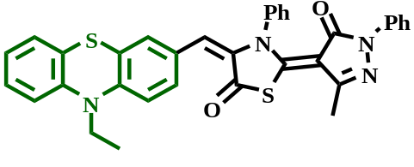
Figure (S12): Mass spectrum of compound 4b.

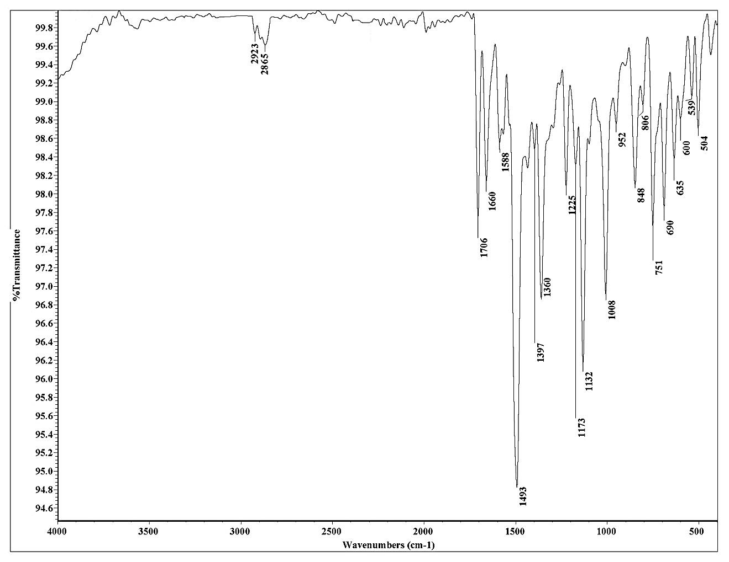
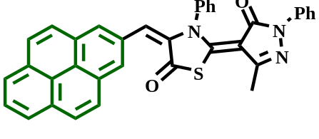
Figure (S13): IR spectrum of compound 4c.
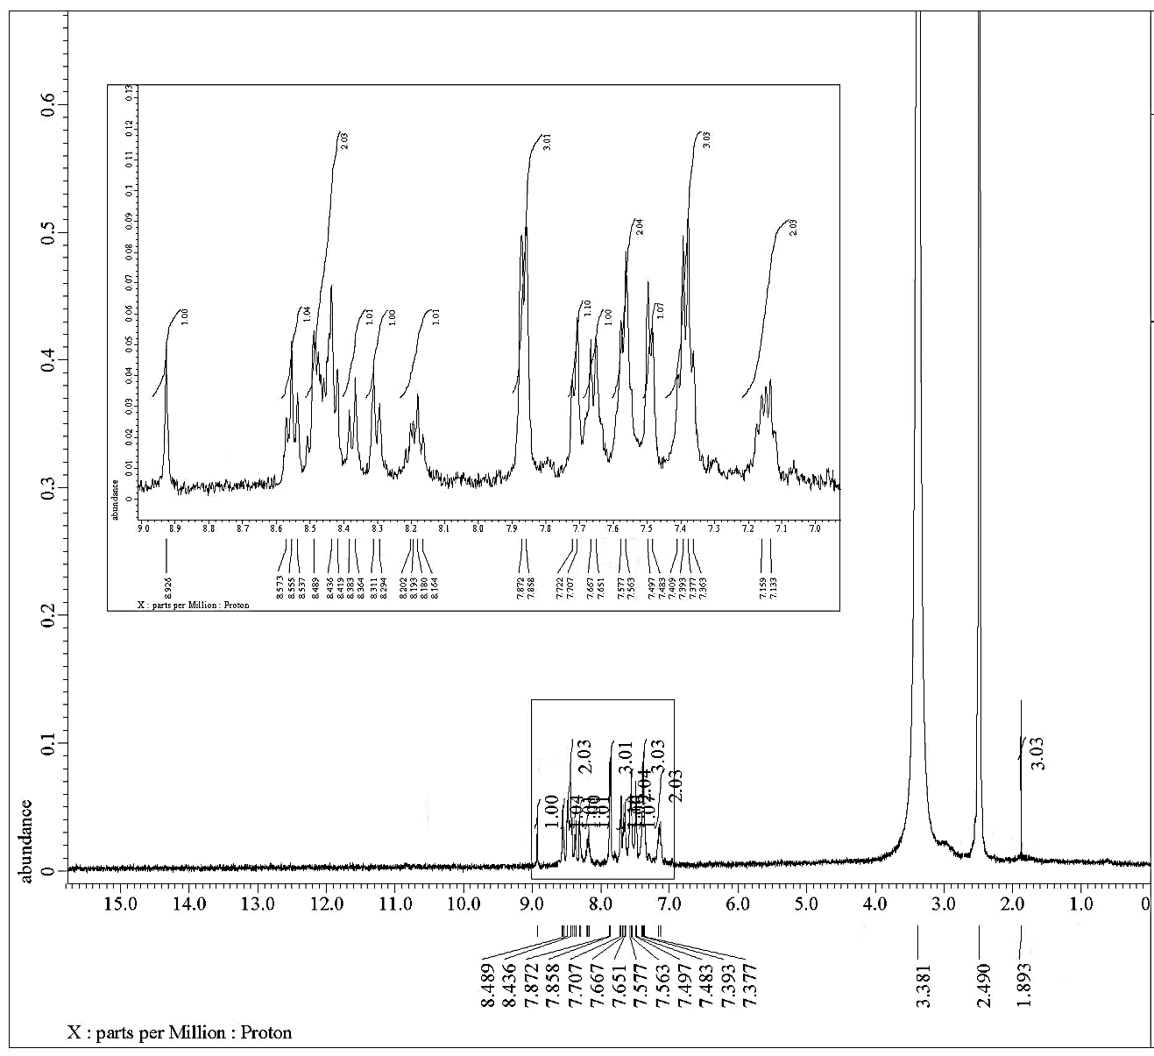
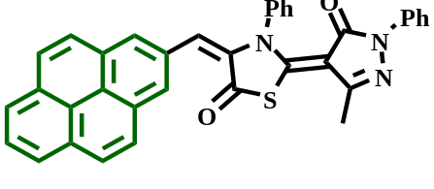
Figure (S14): ¹H NMR spectrum of compound 4c.

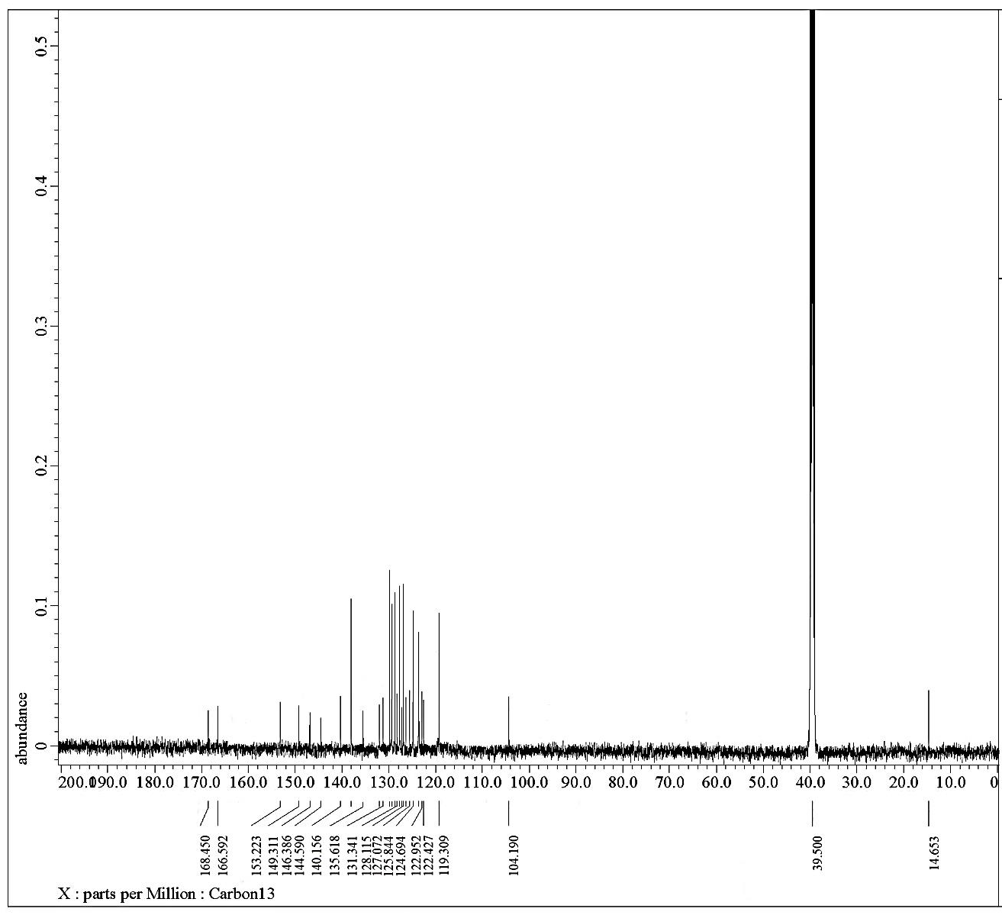

Figure (S15): ¹³C NMR spectrum of compound 4c.

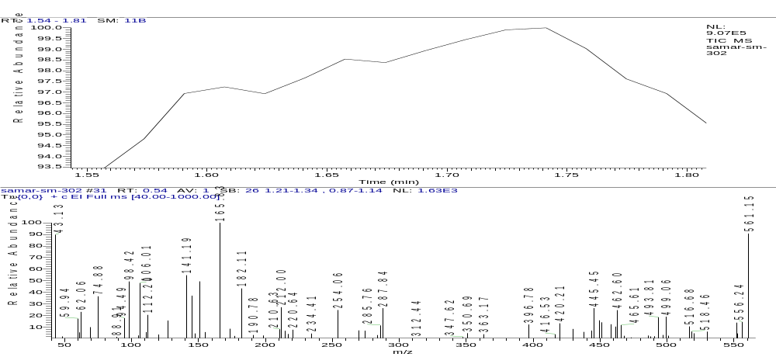
Figure (S16): Mass spectrum of compound 4c.

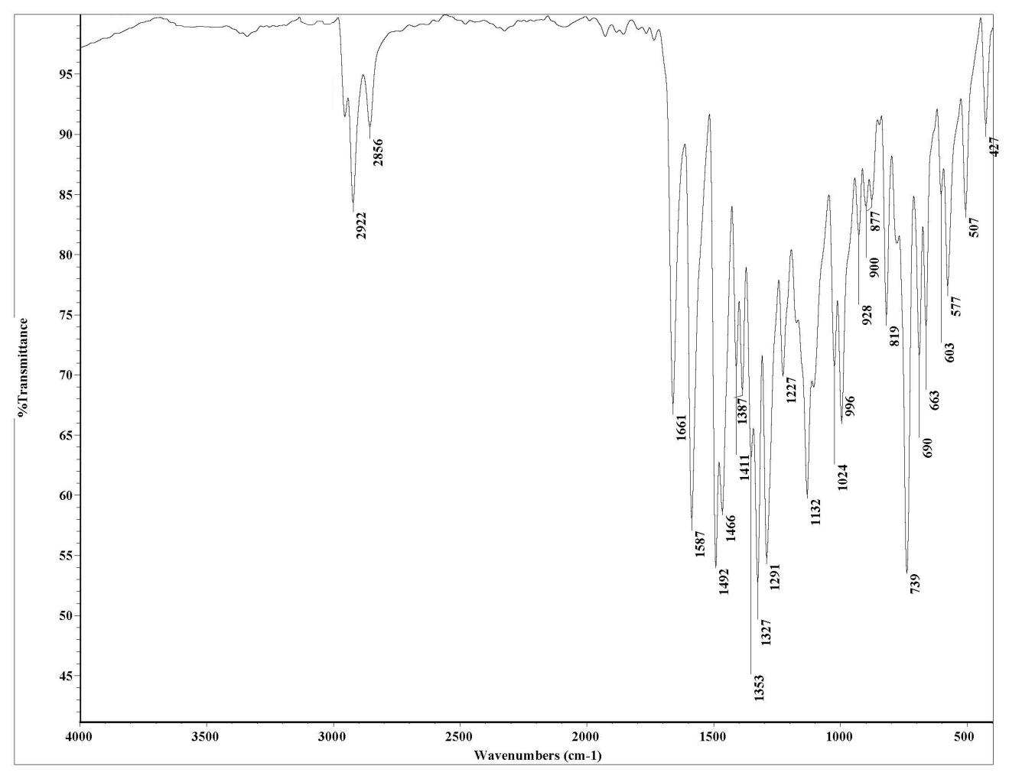
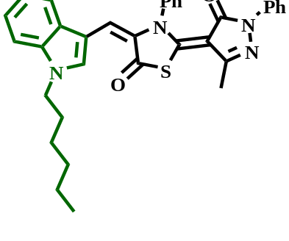
Figure (S17): IR spectrum of compound 4d.

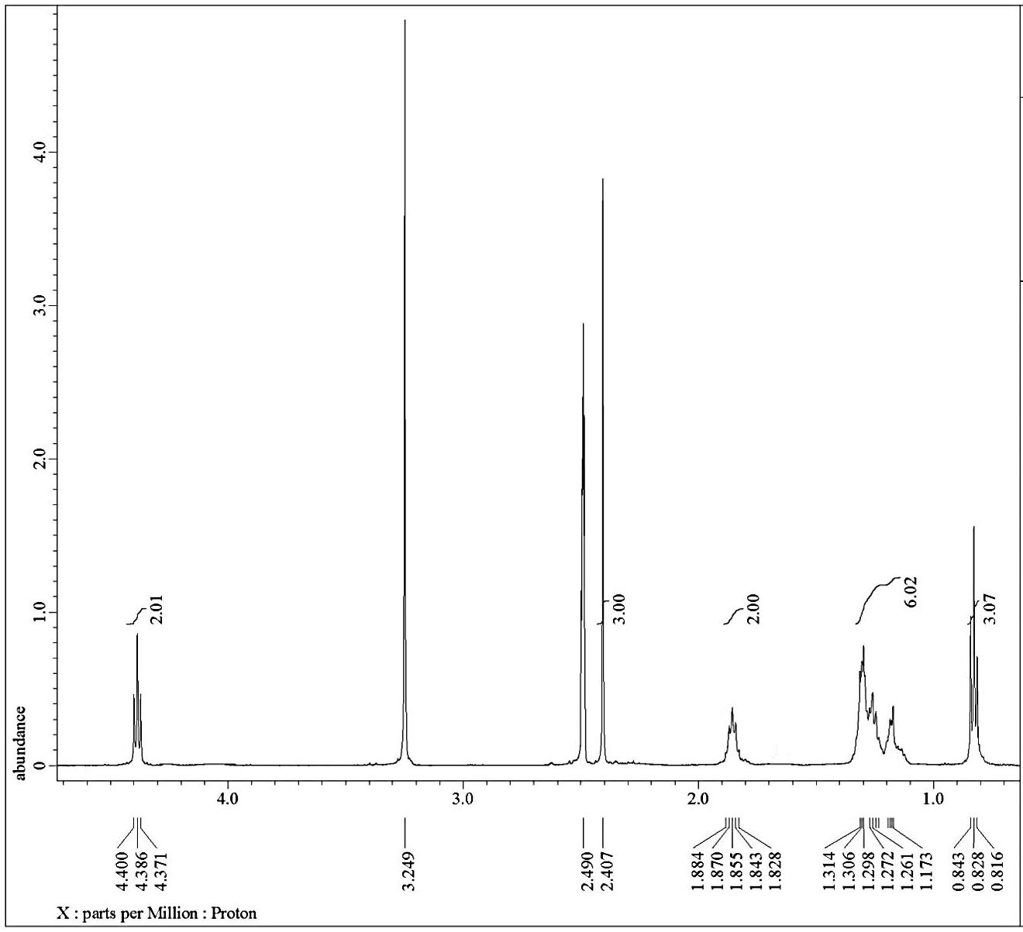
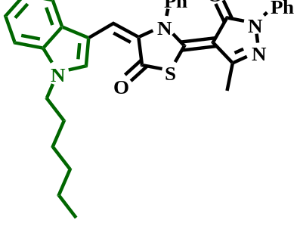
Figure (S18): ¹H NMR spectrum of compound 4d.

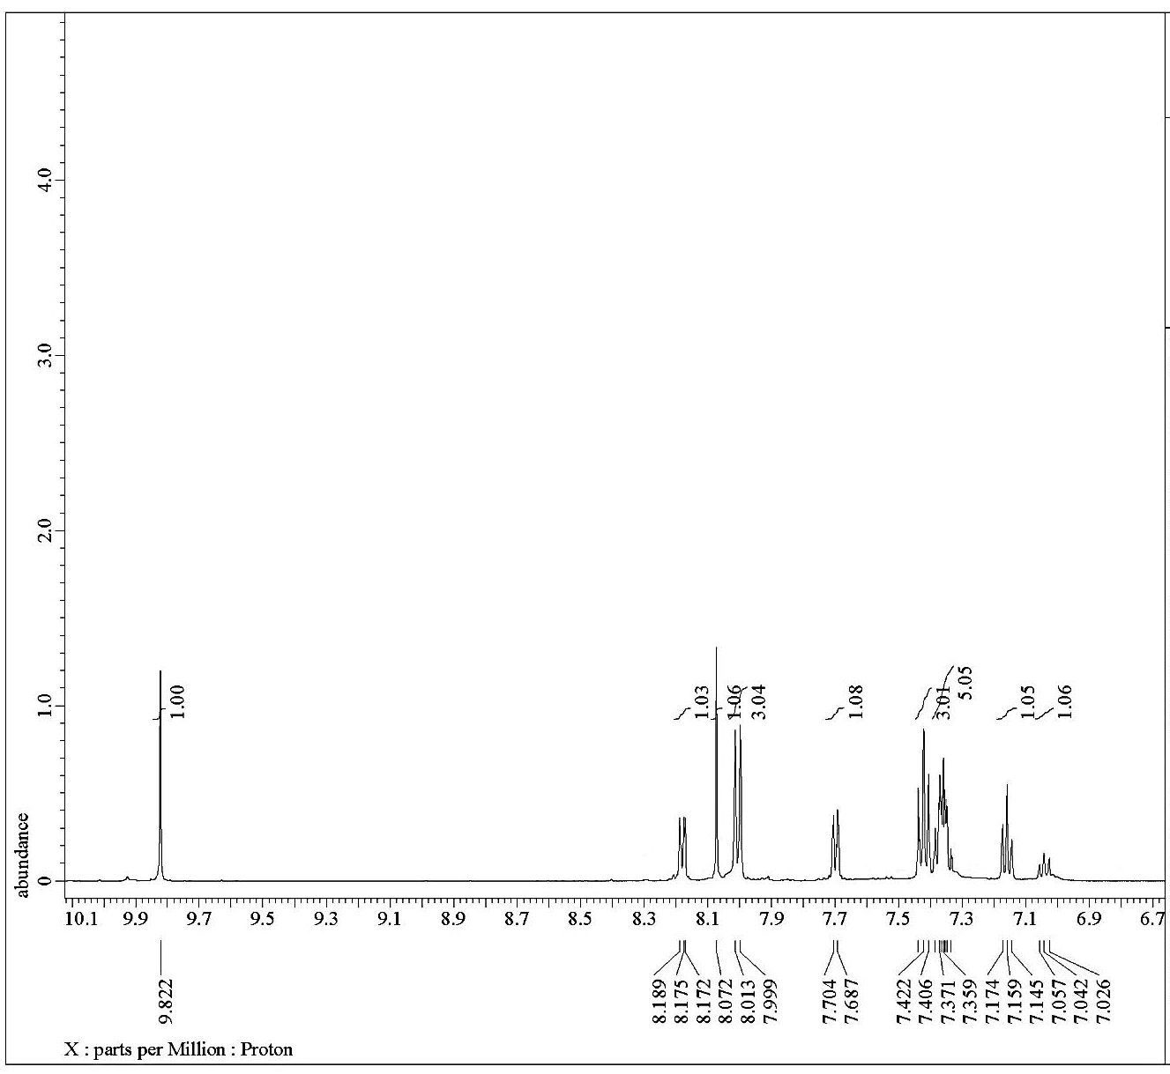
Figure (S19): ¹H NMR spectrum of compound 4d.

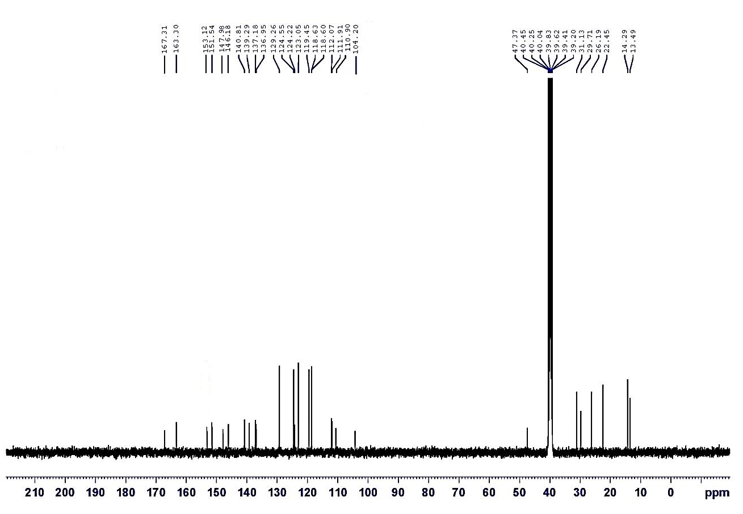

Figure (S20): ¹³C NMR spectrum of compound 4d.

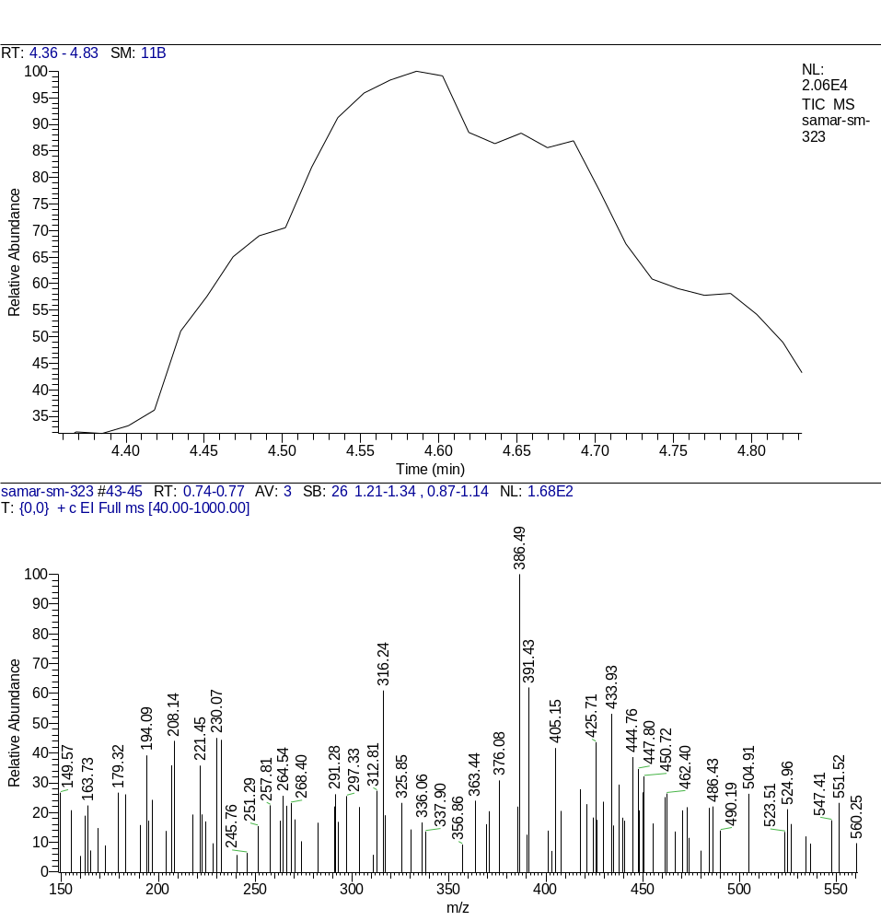
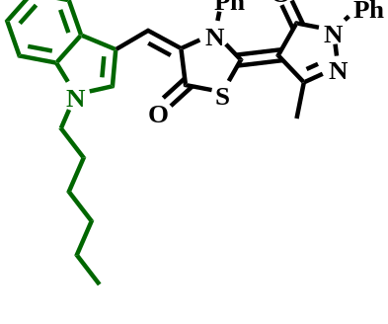
Figure (S21): Mass spectrum of compound 4d.

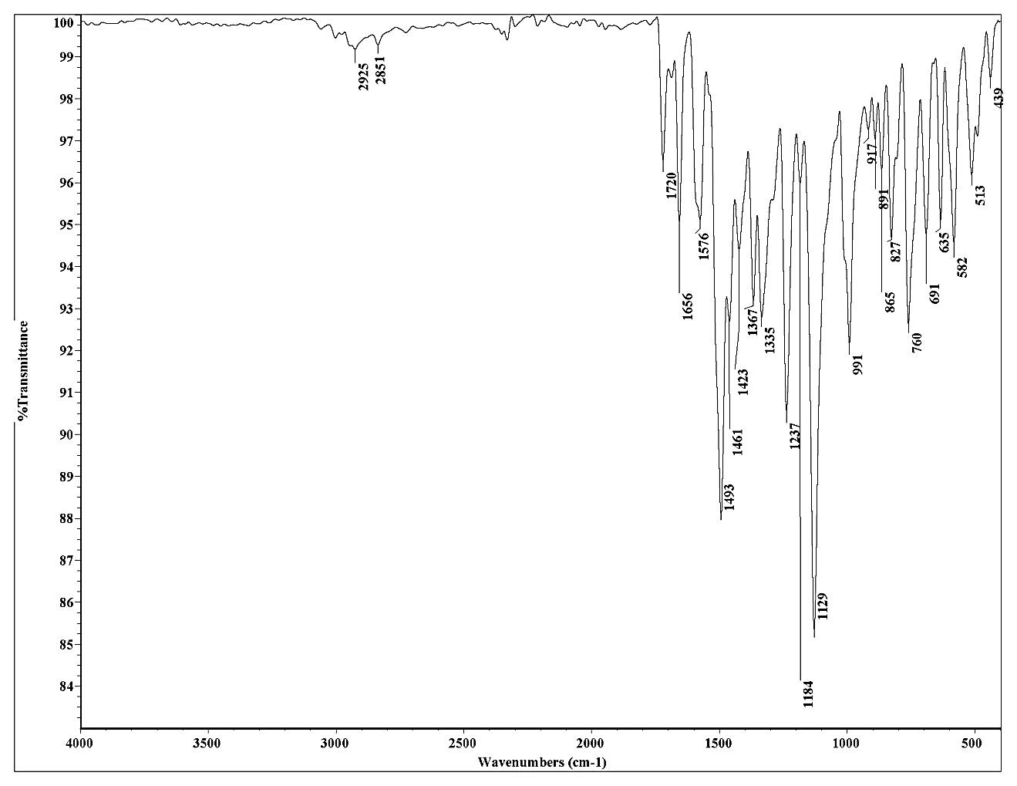
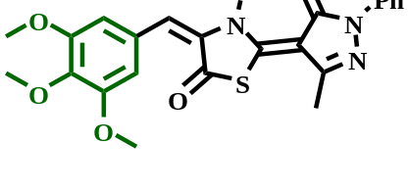
Figure (S22): IR spectrum of compound 4e.

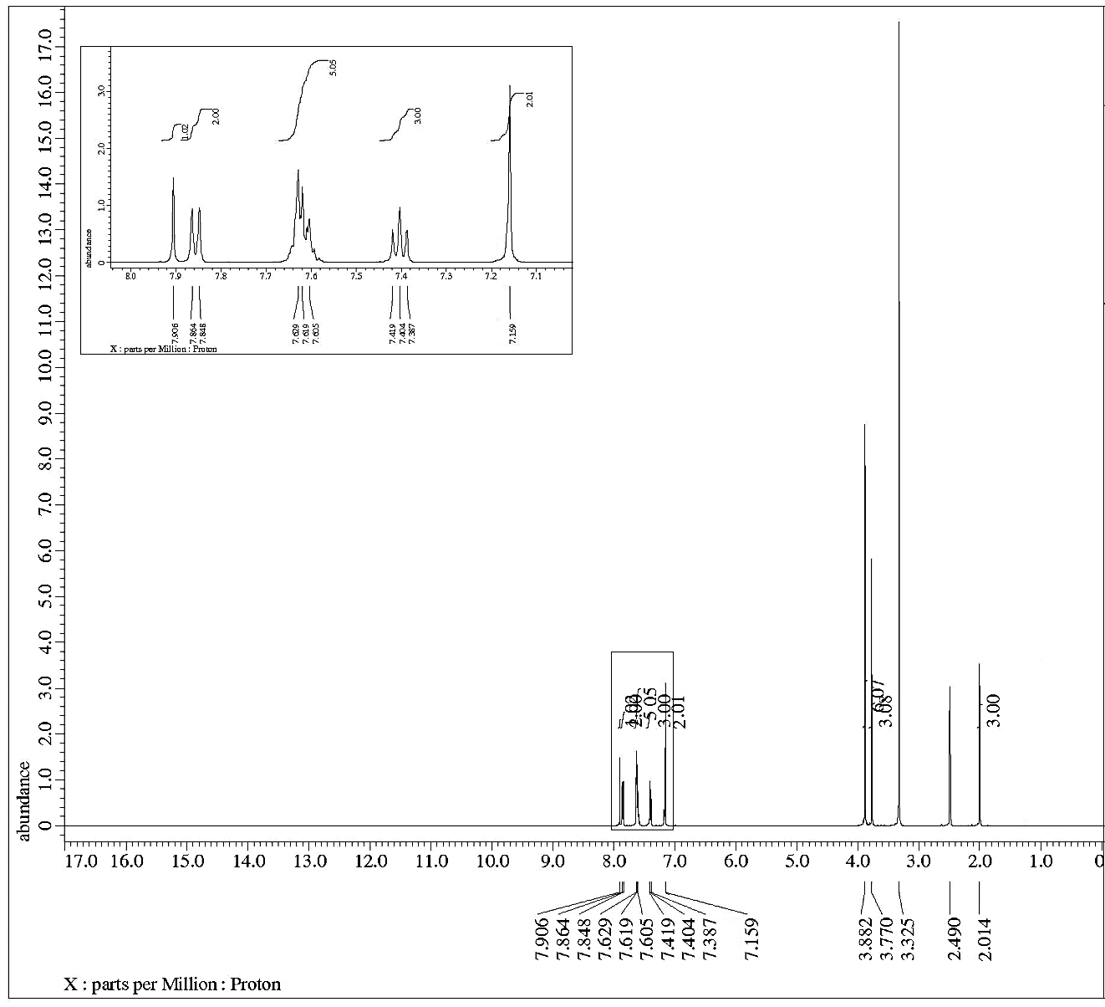
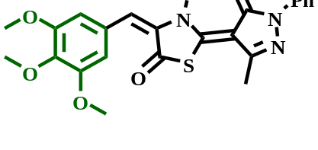
Figure (S23): ¹H NMR spectrum of compound 4e.
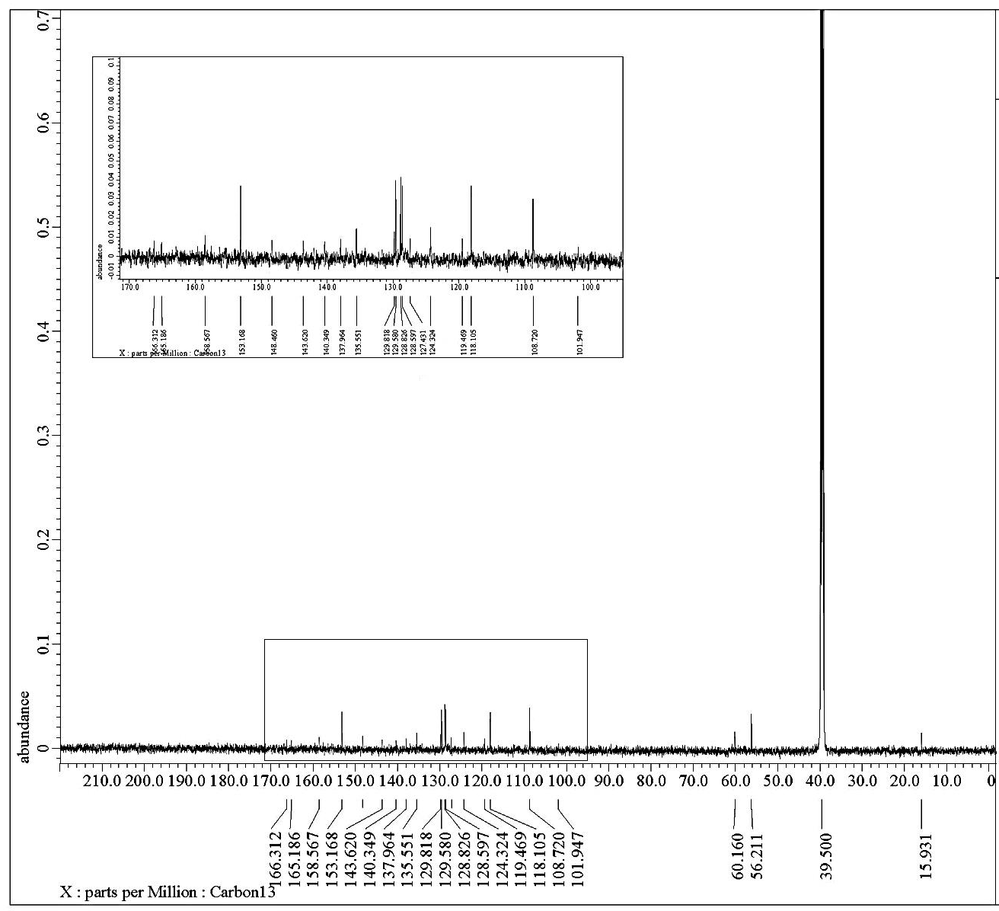
Figure (S24): ¹³CNMR spectrum of compound 4e.

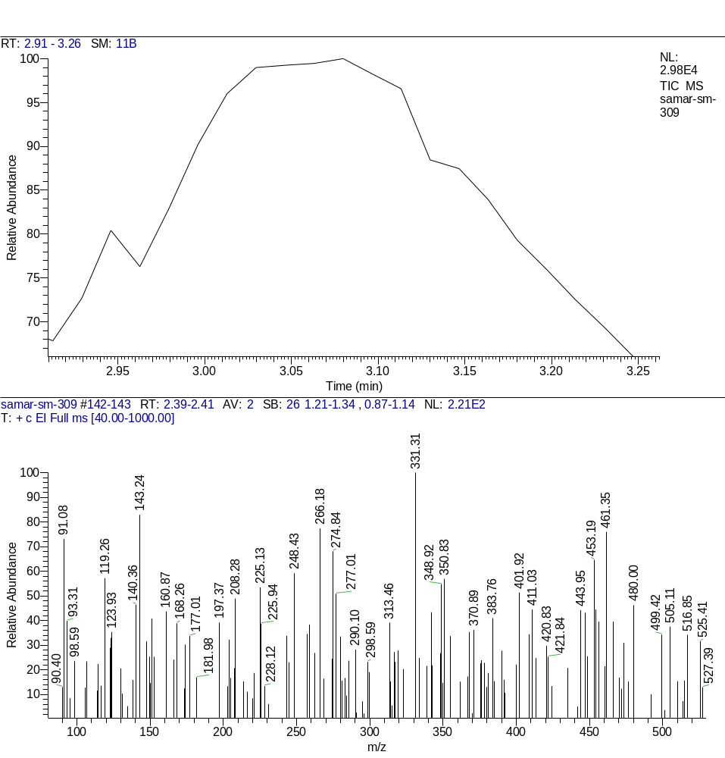
Figure (S25): Mass spectrum of compound 4e.

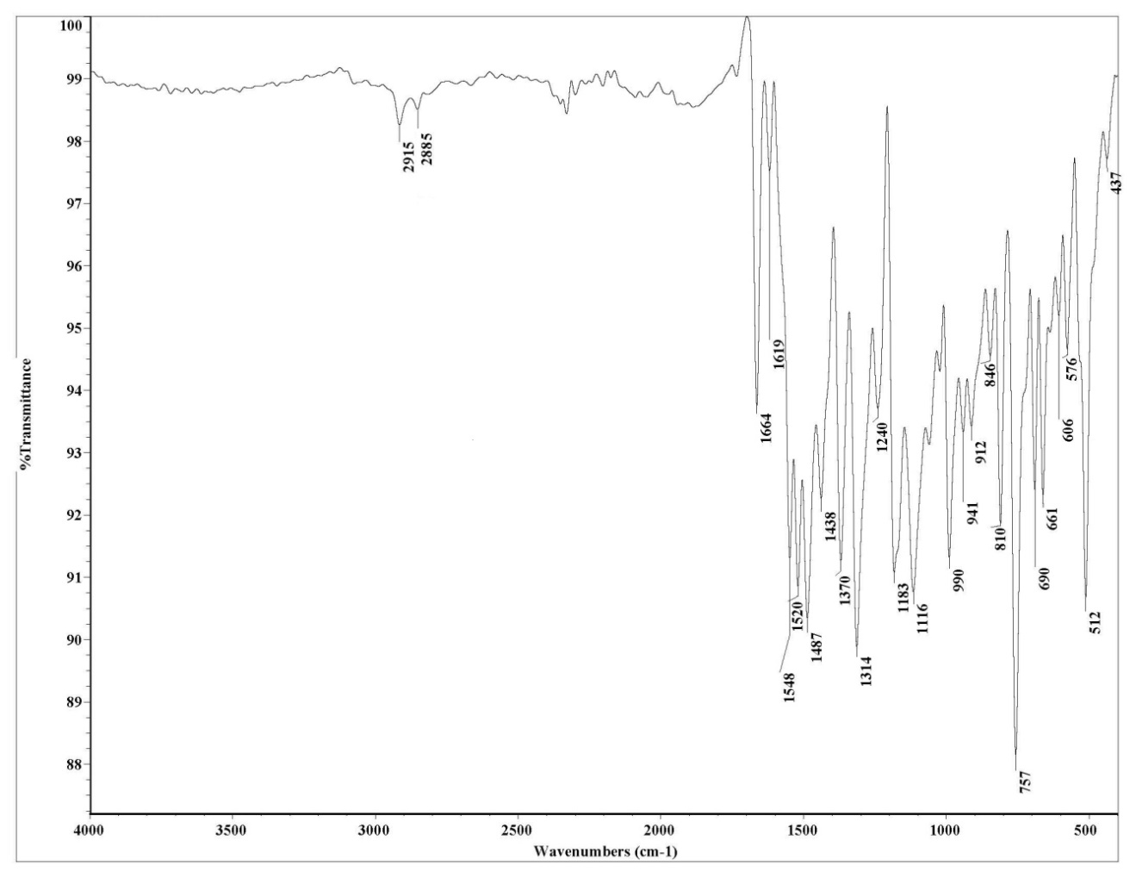
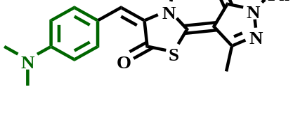
Figure (S26): IR spectrum of compound 4f.

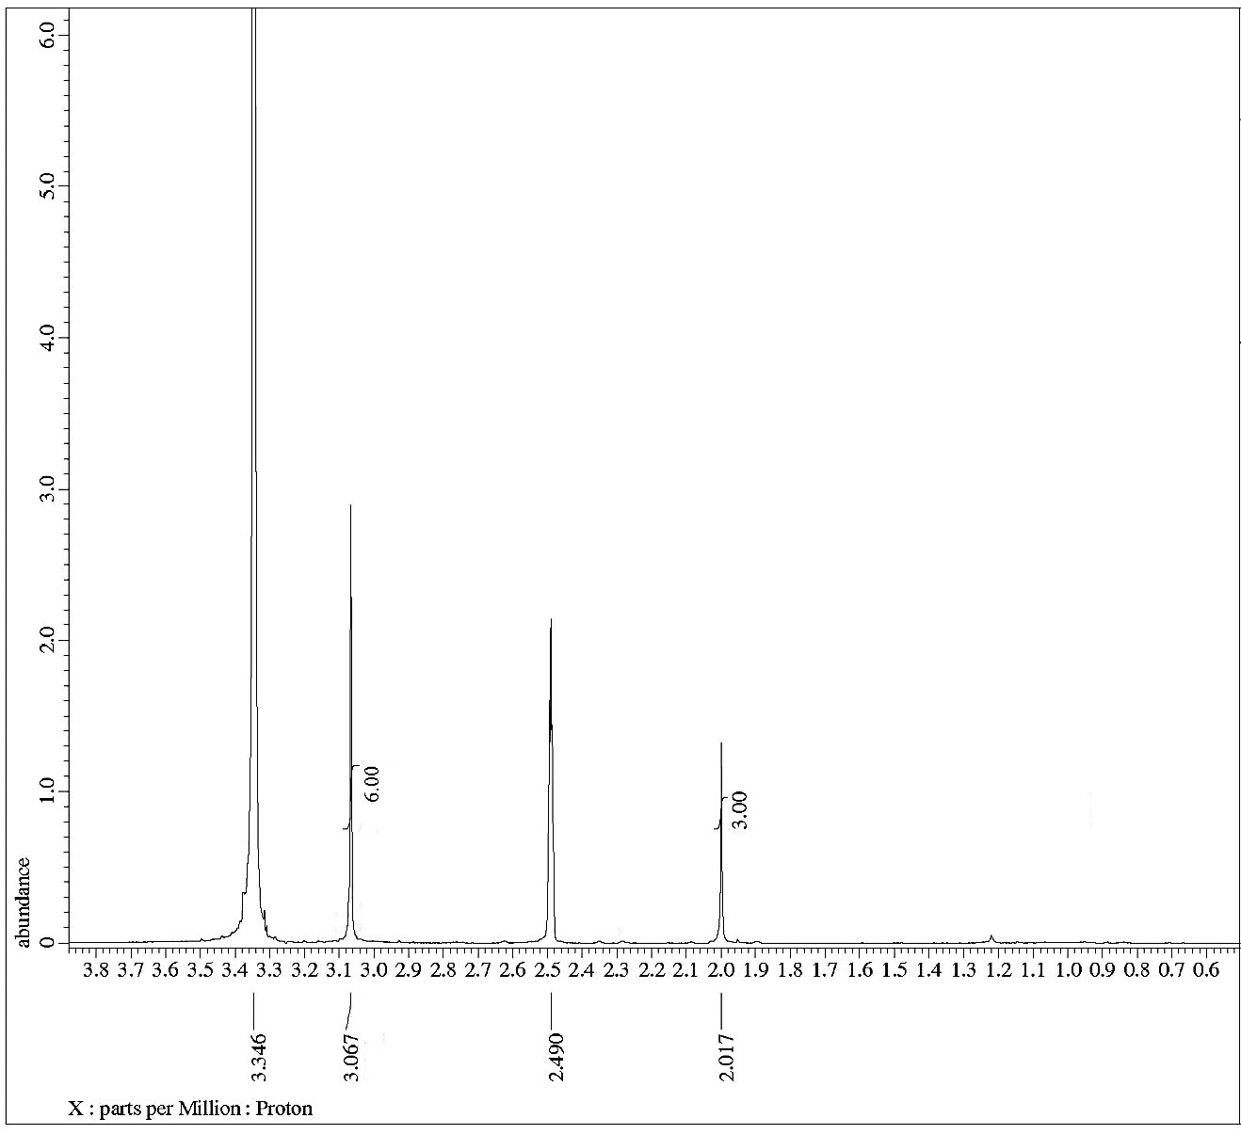
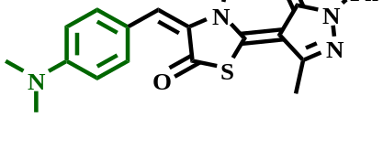
Figure (S27): ¹H NMR spectrum of compound 4f.

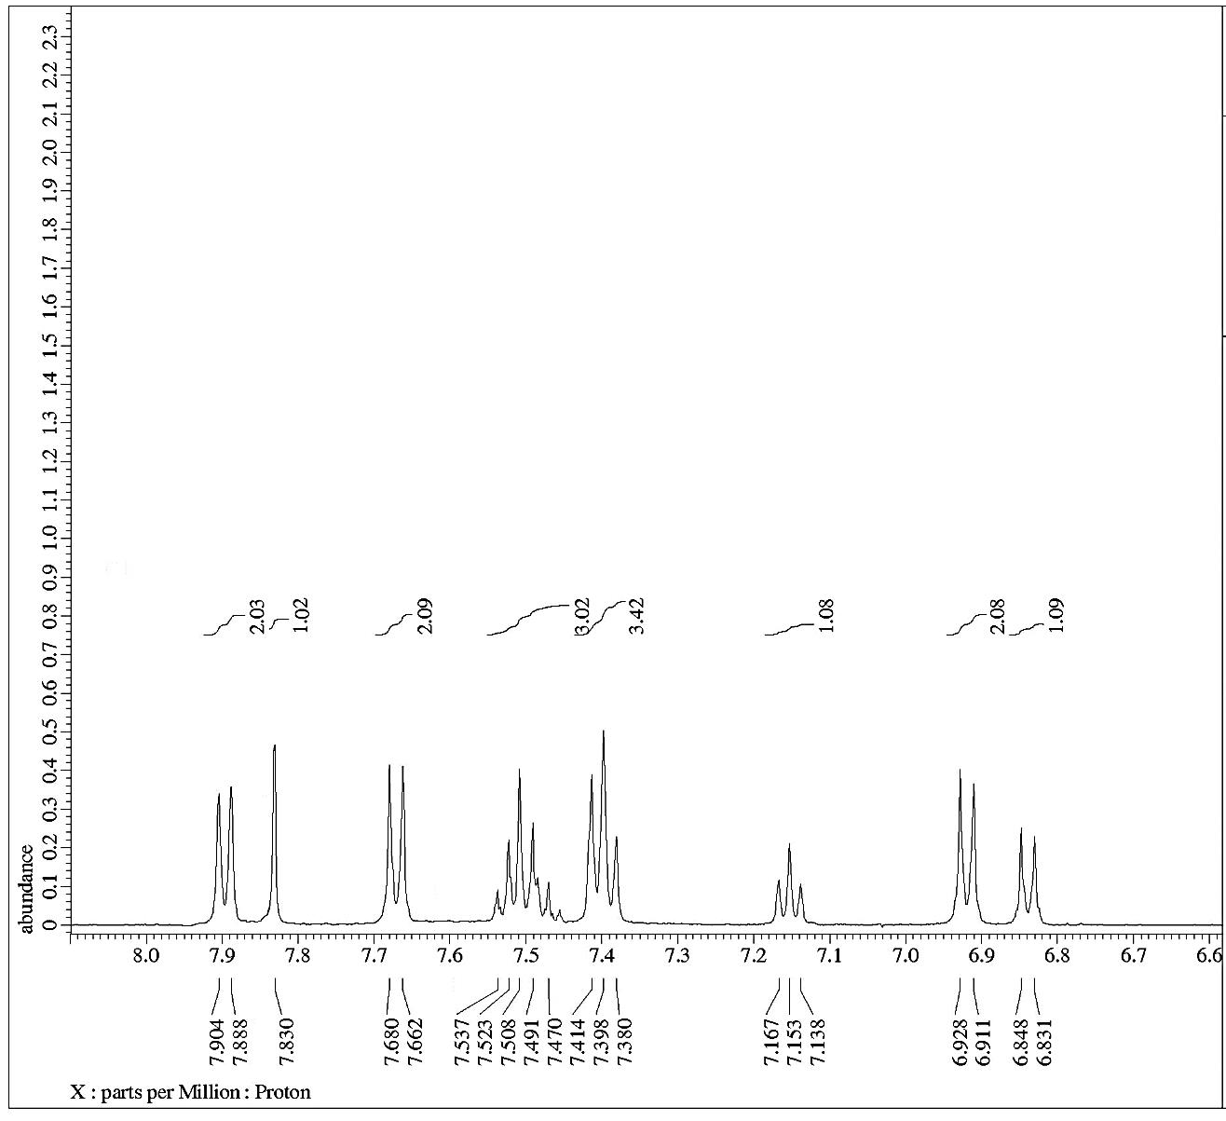
Figure (S28): ¹H NMR spectrum of compound 4f.

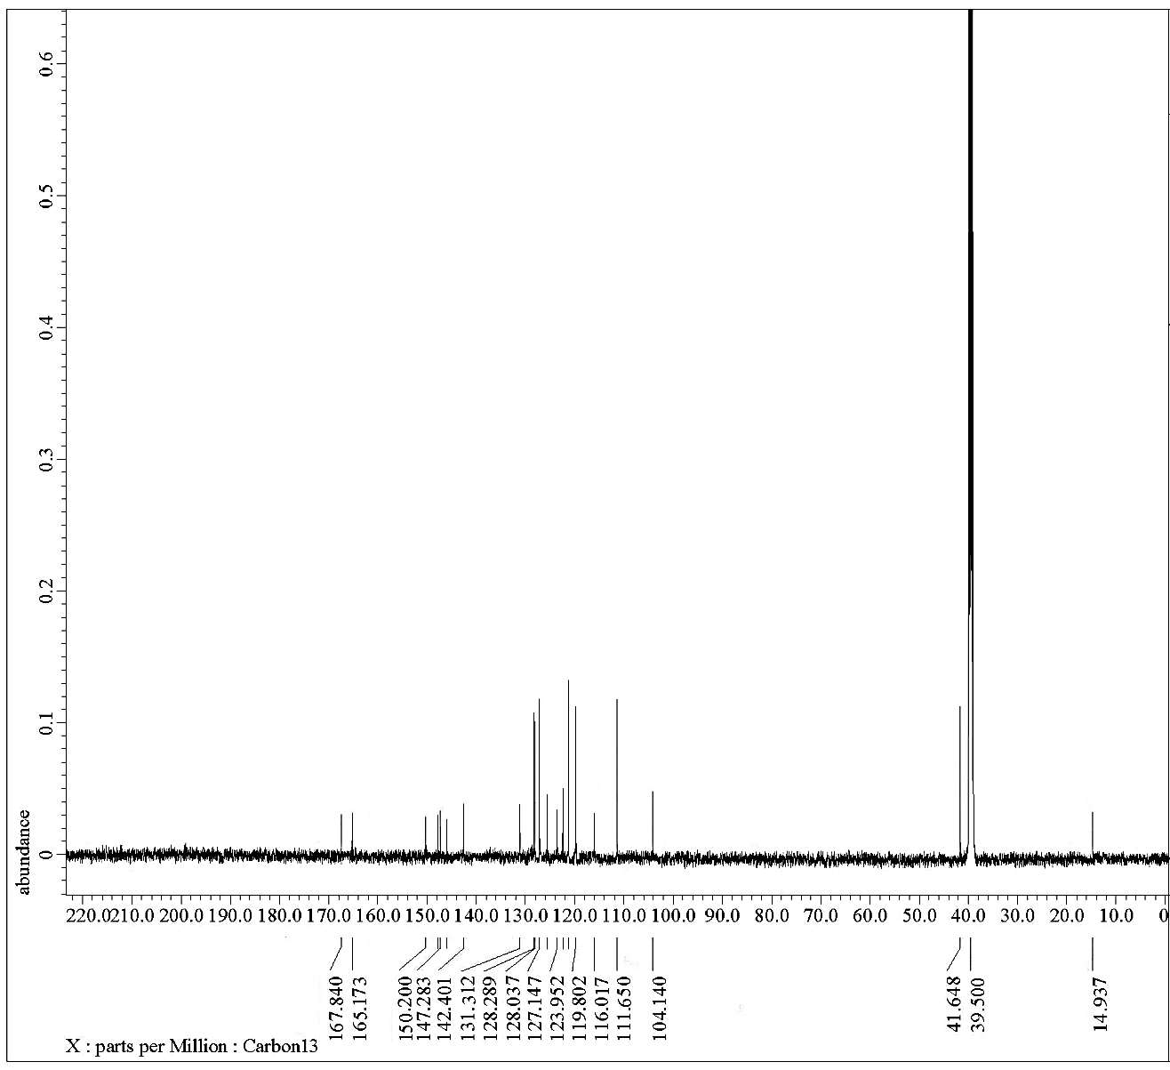
Figure (S29): ¹³C NMR spectrum of compound 4f.

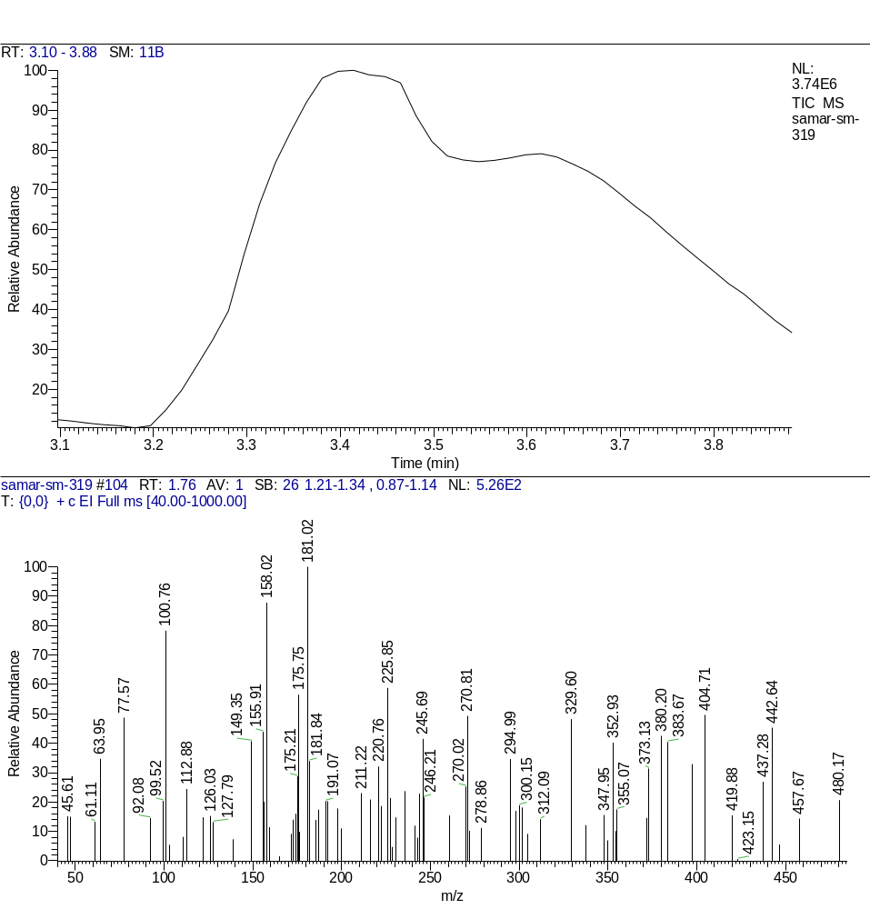
Figure (S30): Mass spectrum of compound 4f.

