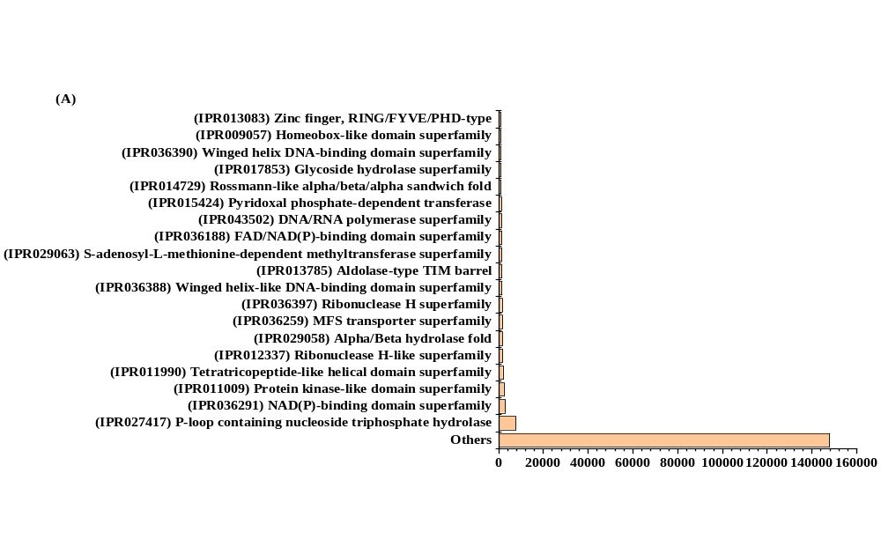
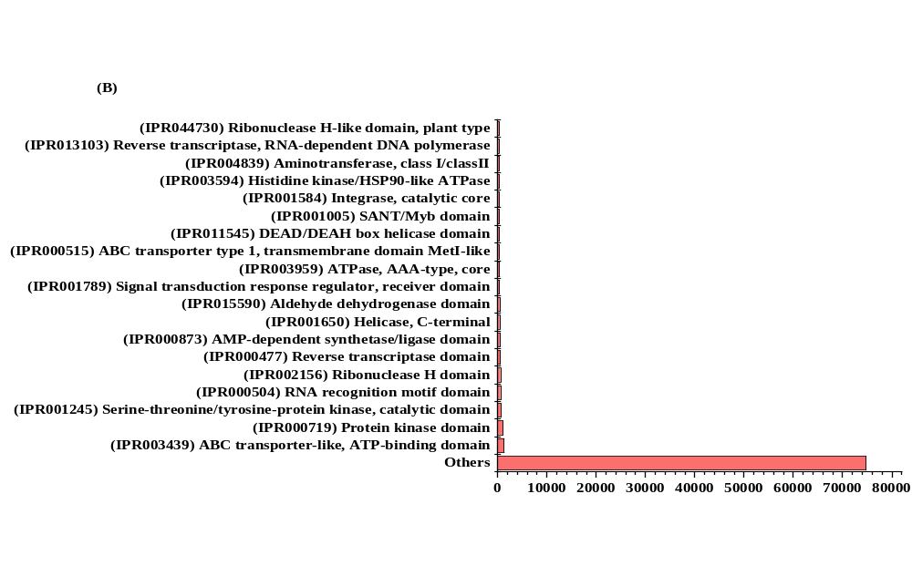
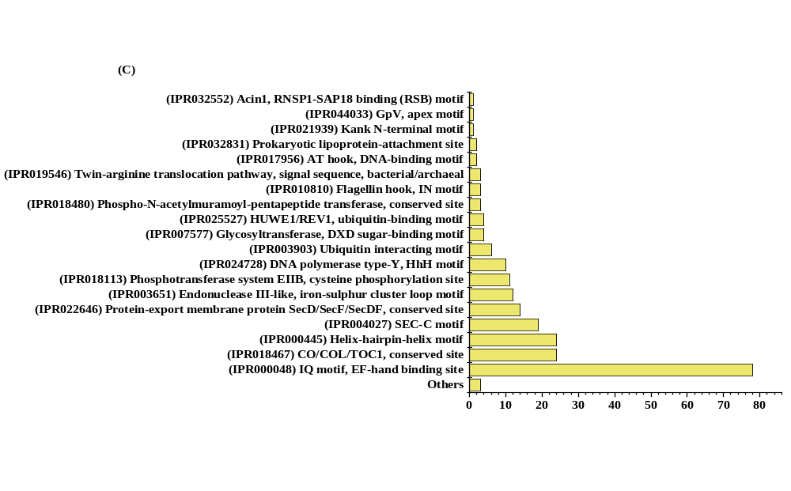
Supplementary Figure_1 Graph depicts the search results for M. cymbalaria transcripts via interpro scan using OmicsBox: A) Distribution of putative transcripts among the protein families. B) Major protein domains and their respective distribution among contigs. C) Repeated regions found in M. cymbalaria transcript sequences.
Supplementary Table1 Some common and individual DEGs of seed vs. leaf and seed vs. mature fruit.
Contig ID | GO Names | Enzyme Description
Common
TRINITY_DN697_c0_g1_i13 | (BP) organic substance metabolic process; cellular metabolic process; nitrogen compound metabolic process; small molecule metabolic process; biosynthetic process; primary metabolic process; (MF) catalytic activity, acting on a protein; heterocyclic compound binding; hydrolase activity; transferase activity; organic cyclic compound binding; ion binding; small molecule binding | Carbon-oxygen lyases; Transferring phosphorus-containing groups; Isomerases; Acting on ester bonds
TRINITY_DN666_c0_g1_i3 | (BP) organic substance metabolic process; cellular component organization or biogenesis; cellular response to stimulus; cellular metabolic process; nitrogen compound metabolic process; small molecule metabolic process; biosynthetic process; establishment of localization; primary metabolic process; (CC) intracellular anatomical structure; cytoplasm; organelle; cytosol; (MF) catalytic activity, acting on a nucleic acid; protein binding; heterocyclic compound binding; hydrolase activity; transferase activity; organic cyclic compound binding; ion binding; small molecule binding | DNA primase DnaG; DNA-directed RNA polymerase; Transferring one-carbon groups; Acting on ester bonds
TRINITY_DN4239_c0_g1_i1 | (MF) hydrolase activity | Hydrolases
TRINITY_DN168_c2_g2_i1 | (BP) establishment of localization; (MF) heterocyclic compound binding; hydrolase activity; carbohydrate derivative binding; organic cyclic compound binding; ion binding; small molecule binding | nucleoside-triphosphate phosphatase
TRINITY_DN267_c0_g1_i12 | (MF) hydrolase activity | Hydrolases
TRINITY_DN389_c0_g1_i11 | (BP) organic substance metabolic process; catabolic process; cellular metabolic process; nitrogen compound metabolic process; biosynthetic process; primary metabolic process; (CC) intracellular anatomical structure; membrane; cytoplasm; organelle; (MF) transferase activity | protein-tyrosine-phosphatase; phosphatidylinositol-3,4,5-trisphosphate 3-phosphatase; Transferring phosphorus-containing groups
TRINITY_DN864_c0_g1_i1 | (BP) biosynthetic process; (MF) heterocyclic compound binding; hydrolase activity; transferase activity; organic cyclic compound binding; ion binding; small molecule binding | Transferring nitrogenous groups; Carbon-carbon lyases; Hydrolases
TRINITY_DN864_c1_g1_i1 | (BP) biosynthetic process; (MF) heterocyclic compound binding; hydrolase activity; transferase activity; organic cyclic compound binding; ion binding; small molecule binding | Transferring nitrogenous groups; Carbon-carbon lyases; Hydrolases
TRINITY_DN97_c1_g1_i8 | (BP) organic substance metabolic process; cellular response to stimulus; cellular metabolic process; nitrogen compound metabolic process; small molecule metabolic process; biosynthetic process; primary metabolic process; (CC) intracellular anatomical structure; cytoplasm; organelle; cytosol; (MF) catalytic activity, acting on a nucleic acid; catalytic activity, acting on a protein; heterocyclic compound binding; hydrolase activity; transferase activity; organic cyclic compound binding; ion binding | Acting on ester bonds; Forming phosphoric ester bonds; Isomerases; Transferring phosphorus-containing groups
TRINITY_DN400_c0_g1_i7 | (BP) organic substance metabolic process; nitrogen compound metabolic process; transmembrane transport; establishment of localization; (CC) intracellular anatomical structure; membrane; cytoplasm; cell periphery; cytosol; (MF) oxidoreductase activity; heterocyclic compound binding; organic cyclic compound binding; ion binding; small molecule binding; transmembrane transport | glutathione synthase; Oxidoreductases
TRINITY_DN10640_c2_g3_i7 | (BP) establishment of localization; (CC) intracellular anatomical structure; cytoplasm; organelle; (MF) hydrolase activity | Hydrolases
TRINITY_DN89164_c1_g1_i1 | (BP) organic substance metabolic process; cellular component organization or biogenesis; nitrogen compound metabolic process; biosynthetic process; primary metabolic process; (CC) intracellular anatomical structure; membrane; cytoplasm; organelle; (MF) catalytic activity, acting on a protein; transferase activity | dolichyl-phosphate-mannose--protein mannosyltransferase
Seed vs. Leaf
TRINITY_DN1374_c0_g1_i2 | (BP) organic substance metabolic process; cellular component organization or biogenesis; cellular metabolic process; nitrogen compound metabolic process; small molecule metabolic process; biosynthetic process; establishment of localization; primary metabolic process; (CC) intracellular anatomical structure; cytoplasm; organelle; (MF) catalytic activity, acting on a nucleic acid; protein binding; heterocyclic compound binding; hydrolase activity; transferase activity; organic cyclic compound binding; ion binding | Transferring phosphorus-containing groups; Transferring one-carbon groups; Acting on ester bonds
TRINITY_DN230_c0_g1_i3 | (BP) organic substance metabolic process; cellular component organization or biogenesis; cellular response to stimulus; catabolic process; cellular metabolic process; nitrogen compound metabolic process; small molecule metabolic process; biosynthetic process; establishment of localization; primary metabolic process; (CC) intracellular anatomical structure; membrane; cytoplasm; organelle; cytosol; (MF) catalytic activity, acting on a nucleic acid; protein binding; catalytic activity, acting on a protein; heterocyclic compound binding; hydrolase activity; ion binding; transferase activity; small molecule binding; organic cyclic compound binding | DNA primase DnaG; DNA-directed RNA polymerase; Transferring one-carbon groups; Acting on ester bonds
TRINITY_DN1078_c0_g1_i21 | (BP) cellular component organization or biogenesis; regulation of cellular process; (CC) intracellular anatomical structure; cytoplasm; organelle; (MF) transferase activity | Transferases
TRINITY_DN2482_c0_g2_i2 | (BP) organic substance metabolic process; cellular metabolic process; nitrogen compound metabolic process; small molecule metabolic process; biosynthetic process; primary metabolic process | diaminopimelate decarboxylase
TRINITY_DN322_c0_g3_i1 | (BP) organic substance metabolic process; primary metabolic process; (MF) oxidoreductase activity; heterocyclic compound binding; ion binding; organic cyclic compound binding | Acting on paired donors, with incorporation or reduction of molecular oxygen. The oxygen incorporated need not be derived from O2
TRINITY_DN11352_c0_g1_i6 | (BP) transmembrane transport; establishment of localization; (CC) membrane; cell periphery; (MF) transmembrane transport; transferase activity | NAD(+) ADP-ribosyltransferase
Seed vs. Mature Fruit
TRINITY_DN4092_c0_g1_i1 | (BP) cellular component organization or biogenesis; regulation of metabolic process; cellular metabolic process; regulation of cellular process; establishment of localization; (CC) intracellular anatomical structure; membrane; cytoplasm; organelle; catalytic complex; (MF) oxidoreductase activity; heterocyclic compound binding; hydrolase activity; carbohydrate derivative binding; ion binding; small molecule binding; organic cyclic compound binding | photosystem II; nucleoside-triphosphate phosphatase
TRINITY_DN5285_c0_g1_i2 | (CC) membrane; (MF) catalytic activity, acting on a protein; oxidoreductase activity; heterocyclic compound binding; hydrolase activity | Carbon-oxygen lyases; Acting on peptide bonds (peptidases); Oxidoreductases
TRINITY_DN2694_c0_g2_i1 | (BP) organic substance metabolic process; regulation of metabolic process; catabolic process; cellular metabolic process; nitrogen compound metabolic process; small molecule metabolic process; biosynthetic process; regulation of cellular process; primary metabolic process; (CC) intracellular anatomical structure; organelle; (MF) catalytic activity, acting on a protein; oxidoreductase activity; heterocyclic compound binding; hydrolase activity; catalytic activity, acting on a protein; oxidoreductase activity; heterocyclic compound binding; ion binding; transferase activity; organic cyclic compound binding | Transferring phosphorus-containing groups; Acting on ester bonds; Acting on a peroxide as acceptor
TRINITY_DN1136_c0_g1_i9 | (BP) organic substance metabolic process; cellular metabolic process; primary metabolic process; (MF) protein binding; oxidoreductase activity; heterocyclic compound binding; ion binding | Acting on single donors with incorporation of molecular oxygen (oxygenases). The oxygen incorporated need not be derived from O2
TRINITY_DN7172_c0_g1_i1 | (BP) cellular component organization or biogenesis; (MF) protein binding | Oxidoreductases
TRINITY_DN876_c0_g1_i1 | (BP) organic substance metabolic process; cellular component organization or biogenesis; regulation of metabolic process; cellular metabolic process; nitrogen compound metabolic process; small molecule metabolic process; biosynthetic process; regulation of cellular process; primary metabolic process; (CC) intracellular anatomical structure; membrane; cytoplasm; organelle; (MF) catalytic activity, acting on a nucleic acid; heterocyclic compound binding; hydrolase activity; ion binding; transferase activity; small molecule binding; organic cyclic compound binding | Acting on ester bonds; Transferring one-carbon groups
TRINITY_DN18_c0_g1_i2 | (BP) organic substance metabolic process; cellular metabolic process; nitrogen compound metabolic process; biosynthetic process; (MF) transferase activity | Transferring alkyl or aryl groups, other than methyl groups

Supplementary Table 2 Number of transcripts encoding for transcription factor families in M. cymbalaria.
Transcription Factor | Leaf | Mature Fruit | Seed
bHLH | 179 | 119 | 132
MYB_related | 125 | 106 | 131
ERF | 124 | 66 | 102
C2H2 | 121 | 102 | 145
bZIP | 113 | 65 | 103
NAC | 98 | 69 | 133
C3H | 92 | 76 | 88
GRAS | 81 | 44 | 55
WRKY | 75 | 61 | 55
G2-like | 59 | 46 | 35
B3 | 55 | 25 | 57
MYB | 53 | 41 | 65
Trihelix | 51 | 39 | 50
HD-ZIP | 42 | 40 | 35
Dof | 37 | 32 | 28
MIKC_MADS | 36 | 26 | 29
FAR1 | 35 | 28 | 42
GATA | 35 | 25 | 32
LBD | 35 | 13 | 32
HB-other | 33 | 34 | 47
SBP | 30 | 12 | 18
AP2 | 29 | 24 | 42
TCP | 26 | 27 | 28
TALE | 24 | 18 | 13
HSF | 23 | 29 | 31
NF-YB | 22 | 11 | 20
ARF | 21 | 12 | 18
LSD | 18 | 16 | 11
GeBP | 15 | 9 | 12
M-type_MADS | 15 | 14 | 20
NF-YA | 14 | 12 | 33
BES1 | 12 | 9 | 8
NF-YC | 12 | 10 | 9
BBR-BPC | 11 | 6 | 11
CO-like | 9 | 11 | 3
ARR-B | 8 | 5 | 7
DBB | 8 | 8 | 11
EIL | 8 | 7 | 5
VOZ | 8 | 7 | 7
ZF-HD | 8 | 6 | 15
CAMTA | 7 | 10 | 9
YABBY | 7 | 12 | 11
E2F/DP | 6 | 8 | 5
WOX | 6 | 6 | 7
Nin-like | 5 | 8 | 8
CPP | 4 | 0 | 4
NF-X1 | 4 | 3 | 5
SRS | 4 | 3 | 7
HB-PHD | 3 | 1 | 0
S1Fa-like | 3 | 2 | 7
RAV | 2 | 5 | 5
STAT | 2 | 0 | 1
Whirly | 2 | 4 | 4
HRT-like | 1 | 1 | 1
GRF | 0 | 0 | 3
SAP | 0 | 0 | 1

Supplementary Table 3 Primers for qRT-PCR to verify above three genes involved in various secondary metabolites biosynthesis in M. cymbalaria plant
Target CDSs | Primer | Sequence (5′ to 3′)
TRINITY_DN13056_c0_g1_i1 (r3l) | F | TATCCGCCGTTTGCCATTCT
TRINITY_DN13056_c0_g1_i1 (r3l) | R | GTGAGTTGGGTCGAAAACGC
TRINITY_DN4072_c0_g1_i5 (ALA1l) | F | TCTAGCTTCGATTGGCCGTC
TRINITY_DN4072_c0_g1_i5 (ALA1l) | R | GATGGGTTCCGCGTCAAAAC
TRINITY_DN1170_c0_g1_i1 (ufm1) | F | ACTCTCACCTCAGACCCCAA
TRINITY_DN1170_c0_g1_i1 (ufm1) | R | TGCCAGCACTTTGTTGAGGA
Actin (Act-internal control gene) | F | AGGAGGACATTCTGAATCCCG
Actin (Act-internal control gene) | R | TCCTTTTGGCCCATACCGAC

