Supplementary Material Online

Table S1. Lifestyle risk components and scoring standards
Table S2. Dietary evaluation index and scoring standards
Table S3. Validating dietary score using estimated nutrients data
Table S4. Lifestyle characteristics of study subjects according to metabolic syndrome
Table S5. Metabolic syndrome prevalence according to lifestyle in low PRS_{MetS}
Table S6. Metabolic syndrome prevalence according to lifestyle in high PRS_{MetS}
Table S7. Odds ratios (ORs) and 95% confidence intervals (CIs) for the risk of metabolic syndrome according to lifestyle in low PRS_{MetS}
Table S8. Odds ratios (ORs) and 95% confidence intervals (CIs) for the risk of metabolic syndrome according to lifestyle in high PRS_{MetS}
Figure S1. Bar plot of odds ratios (ORs) and 95% confidence intervals (CIs) for the risk of metabolic syndrome according to lifestyle in low and high PRSMetS

Table S1. Lifestyle risk components and scoring standards
 | Lifestyle risk component | Score
1 | Obesity
 | Obese (BMI≥25 kg/m²) | 0
 | Overweight (23≤BMI<25 kg/m²) | 1
 | Normal (BMI<23 kg/m²) | 2
2 | Physical activity
 | Inactive | 0
 | Minimally active | 1
 | Health-enhancing physical activity | 2
3 | Smoking
 | Current smoker | 0
 | Ex-smoker | 1
 | Non-smoker | 2
4 | Diet*
 | Poor diet | 0
 | Intermediate diet | 1
 | Ideal diet | 2
5 | Alcohol consumption
 | >14 drinks per week | 0
 | ≤14 drinks per week | 1

Notes: Higher scores mean better lifestyle habits. Healthy lifestyle score representing sum of these five risk scores was categorized as 6–9 points for ideal lifestyle, 3–5 points for intermediate lifestyle, and 0–2 points for poor lifestyle.
* Diet was classified by diet quality score (Table S2).

Table S2. Dietary evaluation index and scoring standards
Dietary habits questionnaire | Diet quality score
Dietary habits questionnaire | Ideal (5 points) | Intermediate (3 points) | Poor (1 point)
How often do you eat grains (rice, noodle, bread, rice cake, bread, cereal, and (sweet) potatoes)? | 3 times/day | 1–2 time(s)/day | Less than 6 times/week
How often do you eat one of dishes like meat, fish, tofu, or eggs? | More than 2 times/day | Once a day | 3–6 times/week  Less than 2 times/ week or hardly
How often do you eat vegetables (raw vegetables, cooked potherb, and salad)? | More than 2 times/day | Once a day | 3–6 times/week  Less than 2 times/ week or hardly
How often do you eat fruits? | Everyday | 3–6 times/week | Less than 2 times/week or hardly
How often do you drink milk and dairy products? (1 time: milk 200mL or yogurt drink 150mL or yogurt 100g) | 1–2 time(s)/day | More than 3 times/day  3–6 times/week | Less than 2 times/ week or hardly
Do you usually eat sweets (ice cream, cake, and cookies)? | Never | Sometimes (less than 2/week) | Often (more than 3/week)
How often do you eat fried food? | Less than 1–2/week or hardly | 3–6 times/week | More than 2 times/day  Once a day
How often do you eat fat rich meat (pork fatback, rib, and eel)? | Less than 1–2/week or hardly | 3–6 times/week | More than 2 times/day  Once a day
How often do you eat instant and processed food (instant noodle, ham, and canned food)? | Less than 1–2/week or hardly | 3–6 times/week | More than 2 times/day  Once a day
Do you usually eat salty food like fermented fish, pickled vegetable or soup? | NO | Sometimes | YES
How often do you drink juice, soft, or instant drinks? (1 glass: 200mL) | Less than 1–2 glass(es)/week or hardly | 3–6 glasses/week | More than 2 glasses/day  1 glass/day
Do you usually add more salt or soy sauce to your food? | Never | Sometimes | Often

Table S3. Validating dietary score using estimated nutrients data
Nutrients | Diet group |  |  | p-value
Nutrients | Diet score≤40  (n=173) | 40<Diet score<50 (n=1220) | Diet score≥50  (n=231) | p-value
Energy (kcal/d) | 2149.53±505.72 | 2053.02±515.18 | 2062.39±472.85 | 0.065
Carbohydrate (g/d) | 49.89±8.84 | 50.60±8.51 | 50.47±8.40 | 0.591
Fiber (g/d) | 19.68±3.92 | 20.06±3.87 | 20.13±3.33 | 0.440
Protein (g/d) | 30.31±7.50 | 29.61±7.15 | 29.36±7.36 | 0.394
Vegetable protein (g/d) | 312.95±216.35ª | 358.65±214.11^{b} | 457.68±206.90^{c} | <0.0001
Animal protein (g/d) | 583.99±130.15 | 560.07±144.48 | 555.72±147.11 | 0.094
Fat (g/d) | 598.40±275.16 | 580.18±260.36 | 585.77±223.55 | 0.673
Vegetable fat (g/d) | 212.60±179.19^{ab} | 191.45±156.26ª | 227.42±161.35^{b} | 0.004
Animal fat (g/d) | 245.24±323.04 | 197.59±291.06 | 180.54±278.00 | 0.073
n-3 fatty acids (g/d) | 14.92±10.70ª | 17.61±10.43^{b} | 22.29±9.46^{c} | <0.0001
n-6 fatty acids (g/d) | 26.05±9.27 | 26.87±8.93 | 26.45±7.85 | 0.450
Cholesterol (mg/d) | 30.27±8.32^{ab} | 31.14±8.36^{b} | 29.49±7.76ª | 0.014
Total fatty acids (g/d) | 12.94±10.23 | 11.42±8.65 | 12.07±8.42 | 0.081
Saturated fatty acids (g/d) | 11.84±13.47^{b} | 10.11±12.55^{b} | 7.68±10.64ª | 0.003
Monounsaturated fatty acids (g/d) | 235.53±59.37^{ab} | 232.47±58.37ª | 245.04±56.56^{b} | 0.011
Polyunsaturated fatty acids (g/d) | 92.09±26.10^{ab} | 89.97±27.43ª | 94.83±26.31^{b} | 0.037
Vitamin A (μg RAE/d) | 37.03±11.60ª | 38.28±11.22ª | 40.53±10.77^{b} | 0.004
Retinol (µg/d) | 57.52±26.57 | 54.90±24.60 | 57.17±24.00 | 0.232
β-carotene (µg/d) | 63.28±21.72 | 61.20±20.09 | 63.08±22.28 | 0.252
Vitamin D (µg/d) | 22.59±12.61ª | 23.64±12.17ª | 27.24±10.99^{b} | <0.0001
Vitamin E (mg α-TE/d) | 33.02±16.94 | 32.81±17.19 | 32.54±16.85 | 0.959
Vitamin K (µg/d) | 639.80±253.01ª | 676.52±245.30ª | 741.17±236.45^{b} | <0.0001
Vitamin B₁ (mg/d) | 1265.78±317.55ª | 1284.58±311.94ª | 1360.81±307.23^{b} | 0.002
Vitamin B₂ (mg/d) | 16.16±4.22ª | 16.60±4.19ª | 17.50±4.07^{b} | 0.003
Niacin (mg NE/d) | 4521.90±2063.83ª | 4539.02±2121.98ª | 5128.74±1845.91^{b} | 0.0003
Vitamin B₆ (mg/d) | 3473.44±885.75ª | 3567.28±836.88ª | 3826.81±898.63^{b} | <0.0001
Folate (μg DFE/d) | 9.91±2.69 | 9.85±2.60 | 10.06±2.52 | 0.530
Vitamin B₁₂ (µg/d) | 915.09±521.49ª | 976.89±552.84ª | 1092.75±507.53^{b} | 0.002
Pantothenic acid (mg/d) | 100.82±80.72 | 98.76±73.96 | 106.00±68.95 | 0.390
Biotin (µg/d) | 4438.37±2698.88ª | 4860.19±2989.80ª | 5523.35±2891.88^{b} | 0.001
Vitamin C (mg/d) | 1.26±0.43ª | 1.27±0.42ª | 1.35±0.41^{b} | 0.038
Calcium (mg/d) | 1.49±0.44 | 1.53±0.45 | 1.60±0.46 | 0.030
Phosphorus (mg/d) | 2.62±0.80ª | 2.68±0.78ª | 2.87±0.82^{b} | 0.002
Sodium (mg/d) | 21.93±6.77 | 21.62±7.19 | 22.22±7.29 | 0.473
Chlorine (mg/d) | 116.65±55.55ª | 129.78±58.59^{b} | 143.44±60.13^{c} | <0.0001
Potassium (mg/d) | 313.12±111.13ª | 339.00±115.43^{b} | 355.81±116.71^{b} | 0.001
Magnesium (mg/d) | 15.02±5.78ª | 16.76±6.68^{b} | 18.35±6.52^{c} | <0.0001
Iron (mg/d) | 19.83±8.29ª | 20.86±8.60ª | 23.82±9.34^{b} | <0.0001
Zinc (mg/d) | 317.69±203.92 | 308.75±195.90 | 335.55±185.22 | 0.154
Copper (mg/d) | 29.57±18.14 | 31.38±16.47 | 32.32±17.10 | 0.256
Manganese (mg/d) | 6.81±4.81 | 7.33±4.71 | 7.56±4.56 | 0.268
Iodine (µg/d) | 11.83±7.60 | 12.48±7.48 | 12.87±7.47 | 0.379
Selenium (µg/d) | 8.86±4.36ª | 9.76±4.51^{b} | 10.71±4.79^{c} | 0.0002
Energy distribution
Carbohydrate (%) | 45.78±13.93 | 45.98±11.80 | 46.03±15.23 | 0.998
Protein (%) | 16.49±3.54 | 16.87±3.09 | 17.39±1.81 | 0.796
Fat (%) | 35.36±13.04 | 37.18±11.77 | 35.45±14.56 | 0.806
Data is presented as mean ± SD.
Table S4. Lifestyle characteristics of study subjects according to metabolic syndrome
Variables | Metabolic syndrome |  |  | p-value
Variables | Total  (n=4987) | No  (n=3367) | Yes  (n=1620) | p-value
Lifestyle risk component
Obesity |  |  |  | <0.0001
Obese (BMI≥25 kg/m²) | 1755 (35.2) | 725 (21.5) | 1030 (63.6)
Overweight (23≤BMI<25 kg/m²) | 1538 (30.8) | 1115 (33.1) | 423 (26.1)
Normal (BMI<23 kg/m²) | 1694 (34.0) | 1527 (45.4) | 167 (10.3)
Physical activity |  |  |  | 0.542
Inactive | 2920 (58.6) | 1964 (58.3) | 956 (59.0)
Minimally active | 1699 (34.1) | 1145 (34.0) | 554 (34.2)
Health-enhancing physical activity | 368 (7.4) | 258 (7.7) | 110 (6.8)
Smoking |  |  |  | <0.0001
Current smoker | 953 (19.1) | 653 (19.4) | 300 (18.5)
Ex-smoker | 2611 (52.4) | 1673 (49.7) | 938 (57.9)
Non-smoker | 1423 (28.5) | 1041 (30.9) | 382 (23.6)
Diet |  |  |  | <0.0001
Poor diet | 831 (16.7) | 524 (15.6) | 307 (19.0)
Intermediate diet | 3321 (66.6) | 2234 (66.4) | 1087 (67.1)
Ideal diet | 835 (16.7) | 609 (18.1) | 226 (14.0)
Alcohol consumption |  |  |  | <0.0001
>14 drinks per week | 1370 (27.5) | 811 (24.1) | 559 (34.5)
Healthy lifestyle score (points) | 4.30±1.69 | 4.63±1.65 | 3.60±1.53 | <0.0001
Healthy lifestyle score |  |  |  | <0.0001
0 | 25 (0.5) | 14 (0.4) | 11 (0.7)
1 | 184 (3.7) | 75 (2.2) | 109 (6.7)
2 | 526 (10.6) | 252 (7.5) | 274 (16.9)
3 | 934 (18.7) | 505 (15.0) | 429 (26.5)
4 | 1052 (21.1) | 707 (21.0) | 345 (21.3)
5 | 1072 (21.5) | 799 (23.7) | 273 (16.9)
6 | 704 (14.1) | 584 (17.3) | 120 (7.4)
7 | 347 (7.0) | 299 (8.9) | 48 (3.0)
8 | 120 (2.4) | 109 (3.2) | 11 (0.7)
9 | 23 (0.5) | 23 (0.7) | 0 (0.0)
Lifestyle status |  |  |  | <0.0001
Poor lifestyle | 735 (14.7) | 341 (10.1) | 394 (24.3)
Intermediate lifestyle | 3058 (61.3) | 2011 (59.7) | 1047 (64.6)
Ideal lifestyle | 1194 (23.9) | 1015 (30.2) | 179 (11.1)

Notes: Data is presented as number (%). Higher lifestyle scores indicate better lifestyle habits. BMI, body mass index.

Table S5. Metabolic syndrome prevalence according to lifestyle in low PRS_{MetS}
 | Lifestyle |  |  | p-value
 | Ideal lifestyle  (n=1120) | Intermediate lifestyle  (n=2847) | Poor lifestyle  (n=704) | p-value
Metabolic syndrome |  |  |  | <0.0001
Yes | 161 (14.4) | 965 (33.9) | 376 (53.4)
No | 959 (85.6) | 1882 (66.1) | 328 (46.6)

Notes: Healthy lifestyle score was categorized as 6–9 points for ideal lifestyle, 3–5 points for intermediate lifestyle, and 0–2 points for poor lifestyle. PRS_{MetS}, metabolic disease PRS; PRS, polygenic risk score.

Table S6. Metabolic syndrome prevalence according to lifestyle in high PRS_{MetS}
 | Lifestyle |  |  | p-value
 | Ideal lifestyle  (n=74) | Intermediate lifestyle  (n=211) | Poor lifestyle  (n=31) | p-value
Metabolic syndrome |  |  |  | 0.004
Yes | 18 (24.3) | 82 (38.9) | 18 (58.1)
No | 56 (75.7) | 129 (61.1) | 13 (41.9)

Notes: Healthy lifestyle score was categorized as 6–9 points for ideal lifestyle, 3–5 points for intermediate lifestyle, and 0–2 points for poor lifestyle. PRS_{MetS}, metabolic disease PRS; PRS, polygenic risk score.

Table S7. Odds ratios (ORs) and 95% confidence intervals (CIs) for the risk of metabolic syndrome according to lifestyle in low PRS_{MetS}
 | Lifestyle |  |  | p-value
 | Ideal lifestyle  (n=1120) | Intermediate lifestyle  (n=2847) | Poor lifestyle  (n=704) | p-value
Metabolic syndrome
Unadjusted | 1.00 (reference) | 3.05 (2.54, 3.67) | 6.83 (5.46, 8.53) | <0.0001
Model 1 | 1.00 (reference) | 3.01 (2.48, 3.64) | 7.26 (5.70, 9.25) | <0.0001
Model 2 | 1.00 (reference) | 3.10 (2.56, 3.76) | 7.52 (5.89, 9.61) | <0.0001

Notes: Healthy lifestyle score was categorized as 6–9 points for ideal lifestyle, 3–5 points for intermediate lifestyle, and 0–2 points for poor lifestyle. OR and 95% CI were obtained using multiple logistic regression analysis. Model 1 was adjusted for sex and age. Model 2 was adjusted for sex, age, and low-density lipoprotein cholesterol. PRS_{MetS}, metabolic disease PRS; PRS, polygenic risk score.

Table S8. Odds ratios (ORs) and 95% confidence intervals (CIs) for the risk of metabolic syndrome according to lifestyle in high PRS_{MetS}
 | Lifestyle |  |  | p-value
 | Ideal lifestyle  (n=74) | Intermediate lifestyle  (n=211) | Poor lifestyle  (n=31) | p-value
Metabolic syndrome
Unadjusted | 1.00 (reference) | 1.98 (1.09, 3.60) | 4.31 (1.77, 10.48) | 0.005
Model 1 | 1.00 (reference) | 1.85 (0.98, 3.51) | 4.18 (1.60, 10.94) | 0.014
Model 2 | 1.00 (reference) | 2.20 (1.13, 4.31) | 4.52 (1.66, 12.29) | 0.010

Notes: Healthy lifestyle score was categorized as 6–9 points for ideal lifestyle, 3–5 points for intermediate lifestyle, and 0–2 points for poor lifestyle. OR and 95% CI were obtained using multiple logistic regression analysis. Model 1 was adjusted for sex and age. Model 2 was adjusted for sex, age, and low-density lipoprotein cholesterol. PRS_{MetS}, metabolic disease PRS; PRS, polygenic risk score.

Figure S1. Bar plot of odds ratios (ORs) and 95% confidence intervals (CIs) for the risk of metabolic syndrome according to lifestyle in low and high PRS_{MetS}
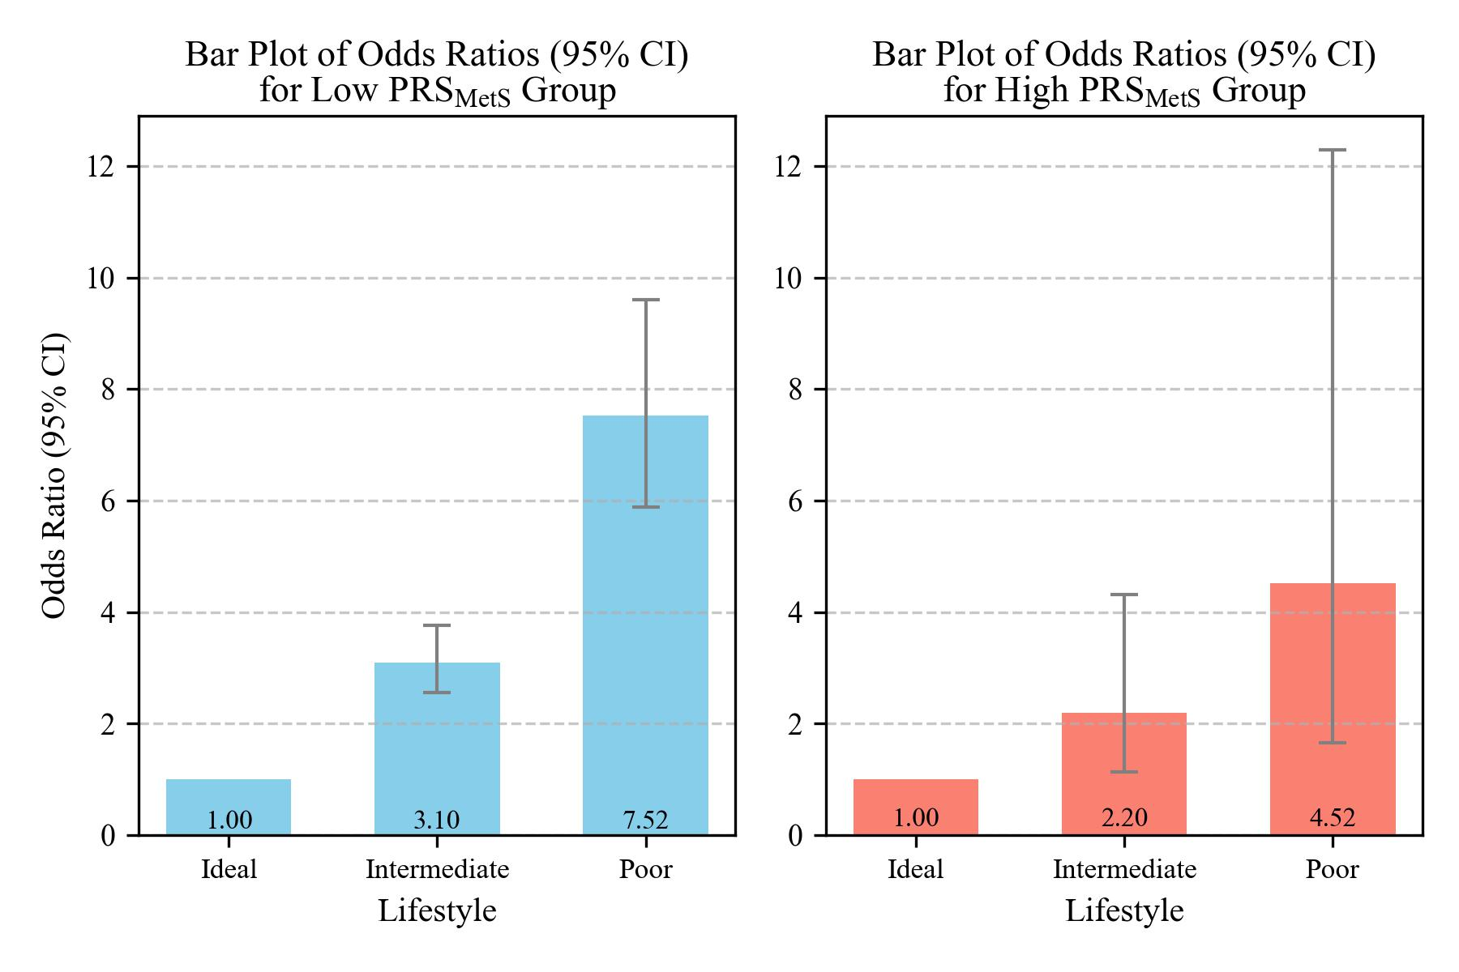
Notes: Healthy lifestyle score was categorized as 6–9 points for ideal lifestyle, 3–5 points for intermediate lifestyle, and 0–2 points for poor lifestyle. OR and 95% CI were obtained using multiple logistic regression analysis. Adjusted for sex, age, and low-density lipoprotein cholesterol. PRSMetS, metabolic disease PRS; PRS, polygenic risk score.

