Data-Driven Analysis of the Relationship Between the HbA1c/HDL-C Ratio and Coronary Artery Calcification: A Cross-Sectional Study
Supplementary File

Chen Chen ¹, Mingkang Li ^{2, 3}, Gaoliang Yan ^{2, 3}, Wenkang Zhang ^{2, 3} *, Chengchun Tang ^{2, 3} *
¹ School of Cyber Science and Engineering, Southeast University, Nanjing, Jiangsu, China
² School of Medicine, Southeast University, Nanjing, Jiangsu, China
³ Department of Cardiology, Zhongda Hospital, Southeast University, Nanjing, Jiangsu, China

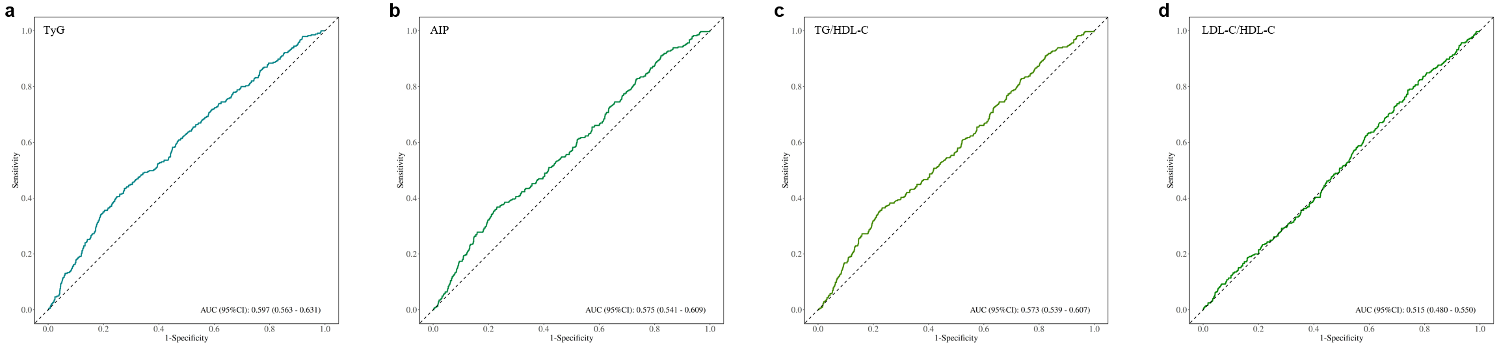
Supplementary Fig. 1 ROC curves of the TyG index (a), AIP index (b), TG/HDL-C ratio (c), and LDL-C/HDL-C ratio (d) on identifying CAC
AUC, the area under the curve; CI, confidence interval; TyG, triglyceride-glucose; AIP, atherogenic index of plasma; TG, triglycerides; HDL-C, high-density lipoprotein cholesterol; LDL-C, low-density lipoprotein cholesterol; ROC, receiver operating characteristic; CAC, coronary artery calcification.

