Concomitant effects of fatigue and potentiation in rat medial gastrocnemius fast motor units
Angelos Angelidis^{1*}, Hanna Drzymała-Celichowska^{2,3}, Katarzyna Kryściak², Rene Vandenboom¹, Jan Celichowski^{2*}
¹ Department of Kinesiology, Centre for Bone and Muscle Health, Brock University, 1812 Sir Isaac Brock Way, St. Catharines, ON, L2S 3A1, Canada
² Department of Neurobiology, Poznan University of Physical Education, Poznan, Poland
³ Department of Physiology and Biochemistry, Poznan University of Physical Education, Poznan, Poland
*Correspondence: Jan Celichowski (celichowski@awf.poznan.pl); Angelos Angelidis (aa18lu@brocku.ca)

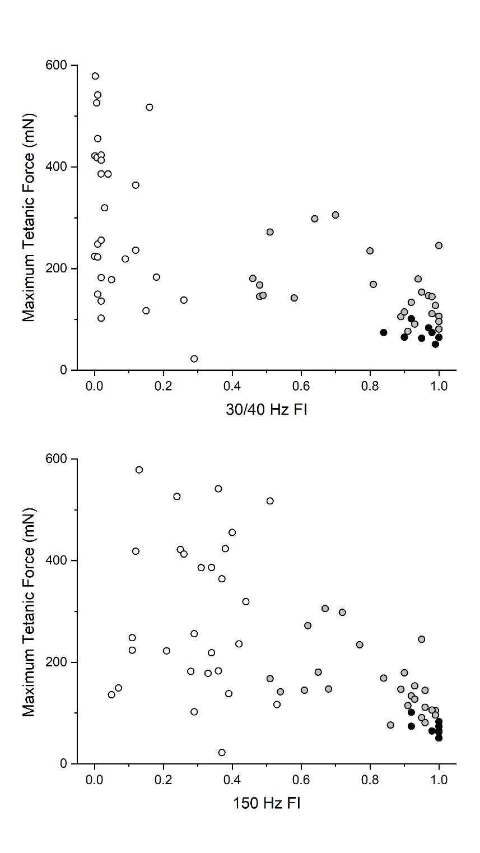

Fig. S1. Scatterplots of maximum tetanic force (y axis) relative to force-based fatigue index (x axis) for 40 Hz (30 Hz for S-type motor units) (top) and 150 Hz (bottom) tetani. Within each scatterplot, motor unit types are color-classified (FF: white, FR: grey, S: black). Units were classified as slow (n = 8) or fast (n = 53) based on the presence of sag in unfused tetanic contractions during the first stimulation cycle. Fast units were further classified as FF or FR based on 40 Hz fatigue index: units with values greater than 0.4 were categorized as FR (n = 25), whereas units with values lower than 0.4 were considered FF (n = 28).
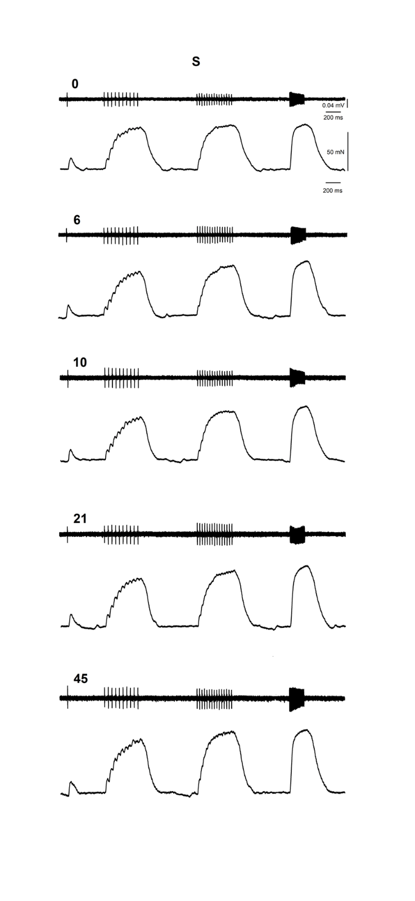
Fig. S2. Representative force (bottom part within each trial) and EMG (upper part within each trial) traces from an S rat medial gastrocnemius motor unit. Traces are presented for different stimulation cycles (numbers indicate cycle number within an experiment). Reference bars include time (200 ms for both force and EMG), force (50 mN) and voltage (0.04 mV).
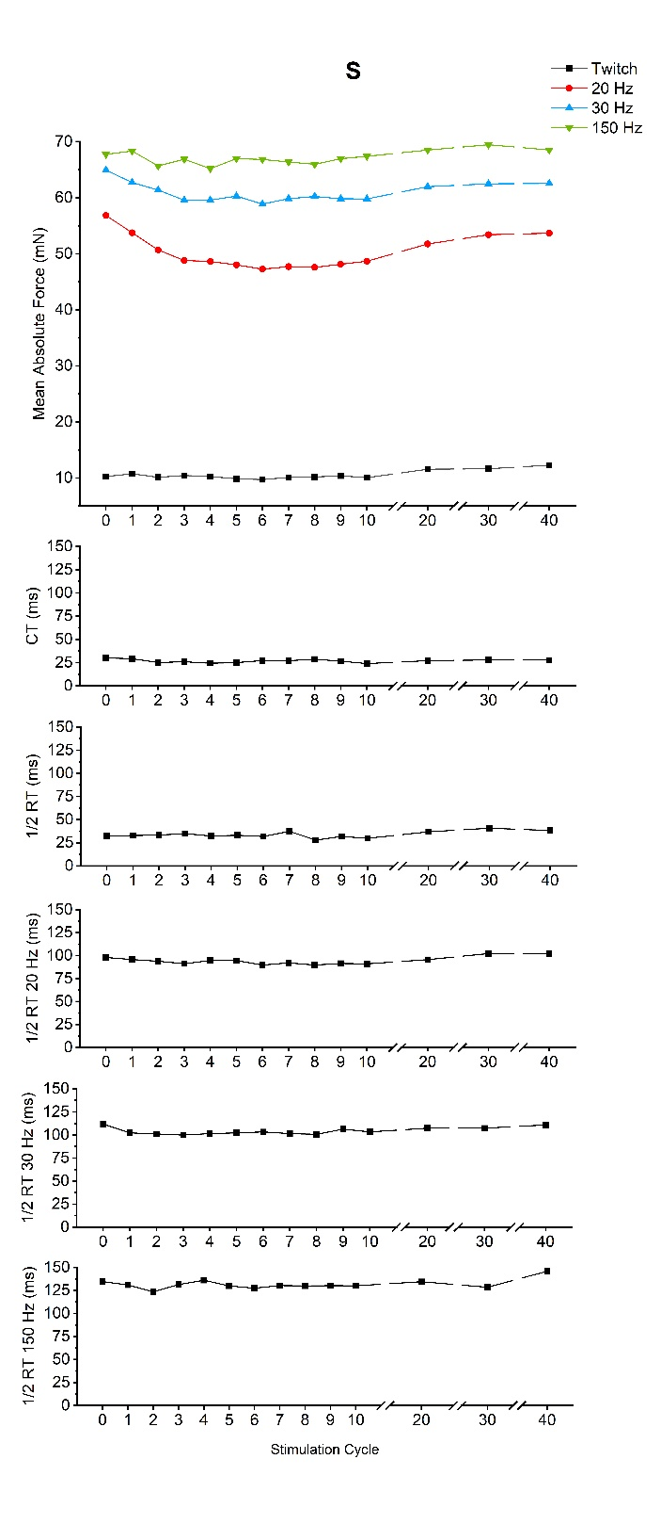
Fig. S3. Contractile property graphs for S (n=8) rat medial gastrocnemius motor units. Mean values are presented for absolute force (top, in mN), twitch contraction and half-relaxation times (following two graphs, in ms), as well as half-relaxation times for 20, 30 and 150 Hz tetani (following three graphs, in ms) on the y-axis, across stimulation cycles (x-axis). For absolute force, stimulation frequencies are color and shape-coded (twitch: black squares, 20 Hz: red circles, 30 Hz: blue triangles, 150 Hz: upside-down green triangles).

