Supplementary

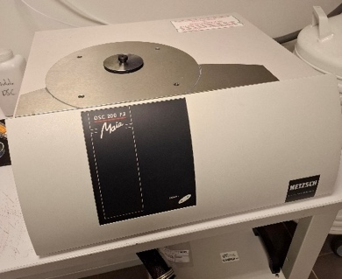
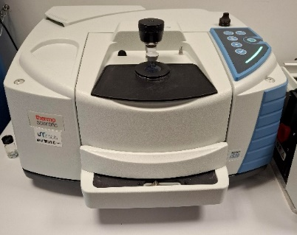
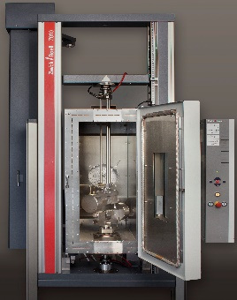
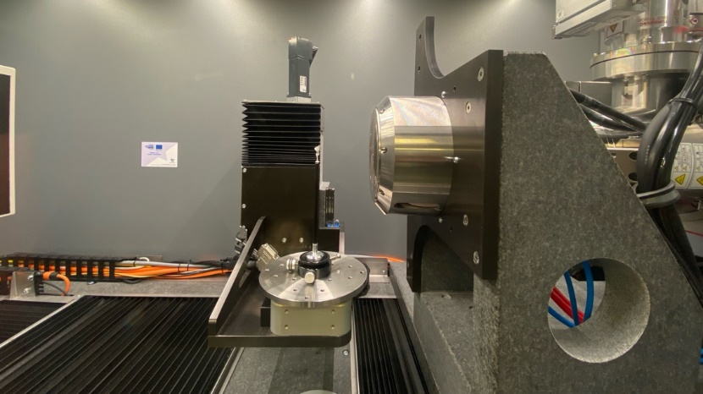
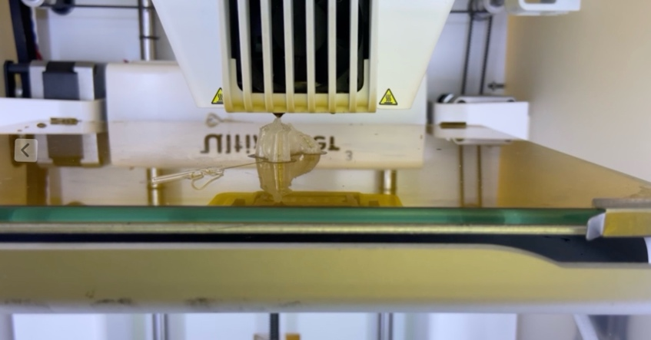
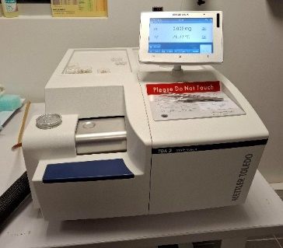
A
B
C
D
E
F
Supplementary Figure S1: Photograph of the machines for the manufacturing and testing of the surgical plates. (A) shows the frontotemporal plate in the Ultimaker S3printer at the end of printing. (B) shows the thermogravimetric analysis (TGA 2, Mettler Toledo, USA). (C) represents the differential scanning calorimetry (DSC 200 F3 Maia, Netzsch, Germany). (D) shows the attenuated total reflection-Fourier transform infrared (ATR-FTIR) spectrometer (Thermo Fisher IS20). (E) displays the Easytom 160 (Rx Solution) with the frontotemporal plate ready for scanning. (F) shows the Z010 universal testing machine with a heated control chamber.

 | Orientation | PLGA_{p} | PLGA_{ps} | p value (t-test)
Young’s modulus, MPa | Flat | 1918 ± 209 | 1263 ± 292 | 0,034
Young’s modulus, MPa | Trench | 2094 ± 188 | 1243 ± 149 | 0,004
Young’s modulus, MPa | Vertical | 1691 ± 305 | 1046 ± 48 | 0,094
Yield stress, MPa | Flat | 27.3 ± 3.4 | 24.6 ± 9.2 | 0,640
Yield stress, MPa | Trench | 31.2 ± 2.3 | 27.1 ± 9.9 | 0,759
Yield stress, MPa | Vertical | 13.1 ± 3.3 | 22.9 ± 2.8 | 0,008
Values are median ± standard deviation.
PLGAp: printed poly(lactic-co-glycolic acid), PLGAps: printed and sterilized poly(lactic-co-glycolic acid), SD: standard deviation.
Supplementary Table S1: Table of standardized tensile tests using ISO 527-2 Type 5B PLGA specimens before and after sterilization, depending on printing orientation.

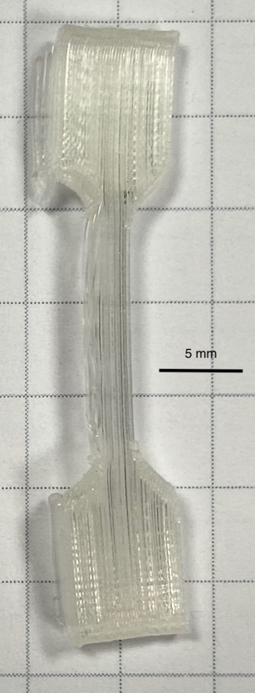
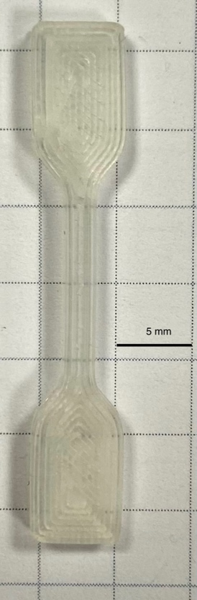
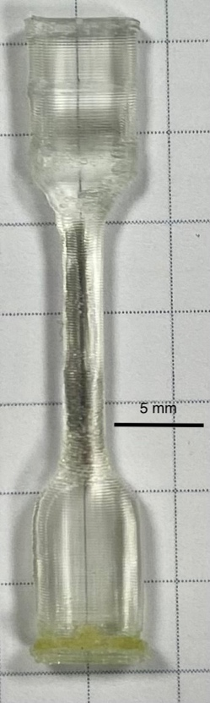
A
B
C
Supplementary Figure S2: Photograph of PLGA samples after sterilization, showing bending occurring in some cases. (A) corresponds to the flat orientation, (B) the trench orientation, and (C) the vertical orientation.

