Physiochemical characterization and biological evaluation of amorphous solid dispersions of erlotinib HCl; better chemotherapeutic efficacy
K.P. Safna Hussan ^{1,2,3*}, Thekkekara D Babu¹, M. Shahin Thayyil⁴, T.S. Sreeshma⁵, A. Archana¹
¹Amala Cancer Research Centre, Amalanagar P O, Thrissur 680 555 Kerala, India.
²Micro/Nano Technology Center, Tokai University, Hiratsuka-shi, Kanagawa 259-1292, Japan
³Ayurgreen Scientifica Research Institute LLP, Ayurgreen Campus, Edappal, Malappuram 679 582, Kerala, India
⁴Department of Physics, University of Calicut, Malappuram-673635, Kerala, India.
⁵Department of Veterinary Biochemistry, College of Veterinary and Animal Sciences, Mannuthy, Thrissur, India

Corresponding Authors
*Safna Hussan K.P, yfm4476@tokai.ac.jp, safnahussain2@gmail.com

X-Ray Diffraction

1.1. Optimum Concentration:
In this study, we developed an amorphous solid dispersion of erlotinib HCl using several polymers of PVP-K30, PEG 4000, and their blend in a 10:90 weight ratio of drug:polymer configuration. In which ERL+PEG exhibits enhanced solubility, bioavailability and anticancer efficacy in invitro and in vivo studies. The ideal drug: polymer concentration is 10:90 because when drug loading in the formulation is increased, ERL's propensity to recrystallize increases. The XRD pattern for different weight ratio of ERL+PEG is emphasizing the crystalline peaks of ERL is hiking upon increasing drug concentration, which is clearly depicted in the Figure below. Such recrystallisation adversely effects their solubility and bioavailability , rendering the effort useless.
Fig 1S. Powder X-ray diffraction patterns of ERL and amorphous solid dispersion of ERL with PEG 4000 at different weight ratios

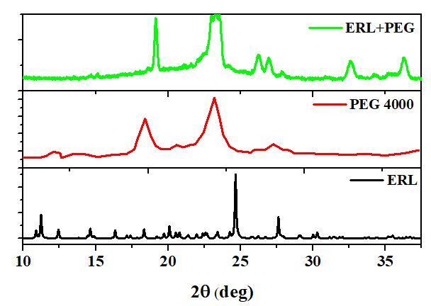
Fig 2S. Powder X-ray diffraction patterns of ERL, PEG 4000 and amorphous solid dispersion of ERL with PEG 4000 (at the weight ratio 10:90).
The excipient PEG-4000 showed two sharp peaks for crystallinity at 19.36˚ and 23.72˚. The characteristic peaks of ERL were found to diminish in the formulations, however the crystalinity peaks of PEG 4000 were retained.

FTIR Spectroscopy

Wavenumber (cm⁻¹) |  |  |  | Functional groups [24][25][7][26][27]
ERL | ERL+PEG | ERL+PVP | ERL+PEG+PVP | Functional groups [24][25][7][26][27]
 | 1721
1666 | 1642 | 1648 | 1658 | C=O- bending
1603 |  |  |  | C=C stretching
1539 |  |  |  | C=N stretching
1479 | 1470 | 1467 | 1464 | CH₂ sym. deformation vibration
1386 | 1346 | 1346 | 1349 | C-H sym. deformation vibration
1301 | 1279 | 1282 | 1288 | NCO stretching vibration
1183 | 1252 | 1237 | 1243 | C-N stretching vibrations
1146 | 1107 | 1110 | 1116 | COCN stretching vibration
1086 |  |  |  | -COCN stretching vibration
1035 |  |  |  | C=O stretching
947 | 949 | 955 | 967 | C-H out-of-plane deformation vibration
893 | 840 | 840 | 840 | C-C skeleton vibration
793 |  |  | 753 | C-O-C stretching vibration
709 |  |  |  | N-H deformation vibrations
679 |  |  | 653 | N-H out-of-plane bending vibrations
588 | 588 | 588 | 577 | C-C skeleton vibration
Tab S1. Prominent FTIR peaks for neat and amorphous binary dispersion of AMB with selected polymers

DPPH Assay
Fig 3S. DPPH radical scavenging activities of various concentrations of polymers PVP K -30 and PEG 4000.
The DPPH scavenging activity of different concentrations of base polymers PVP K -30 and PEG 4000 were evaluated and depicted in Figure 3.S. Both polymers have negligible activity even at higher concentration.

Hydroxyl Radical Assay
Fig 4S. Hydroxyl radical scavenging activities of various polymers PVP K and PEG concentrations.
In addition, the hydroxyl scavenging activity of different concentrations of base polymers PVP K -30 and PEG 4000 were evaluated and depicted in Figure 4.S in supplementary material. Both polymers have negligible activity even at higher concentration.

