SUPPLEMENTARY MATERIAL
Assessment of the effect of pomegranate seed extracts on prostate cancer through cellular and animal models
Miriam Guzmán-Lorite ª, Laura Muñoz-Moreno ^{b}, María Luisa Marina ^{a c}, María José Carmena ^{b}, María Concepción García * ^{a c}
ª Universidad de Alcalá, Departamento de Química Analítica, Química Física e Ingeniería Química, Ctra. Madrid-Barcelona Km. 33.600, 28871 Alcalá de Henares (Madrid), Spain
^{b} Universidad de Alcalá, Departamento de Biología de Sistemas, Ctra. Madrid-Barcelona Km. 33.600, 28871 Alcalá de Henares (Madrid), Spain
^{c} Universidad de Alcalá, Instituto de Investigación Química “Andrés M. del Río”, Ctra. Madrid-Barcelona Km. 33.600, 28871 Alcalá de Henares (Madrid), Spain

*Corresponding author: María Concepción García López, Universidad de Alcalá, Departamento de Química Analítica, Química Física e Ingeniería Química, Ctra. Madrid-Barcelona Km. 33.600, 28805 Alcalá de Henares, Madrid, Spain
Tel.: +34 918839235; E-mail address: concepcion.garcia@uah.es

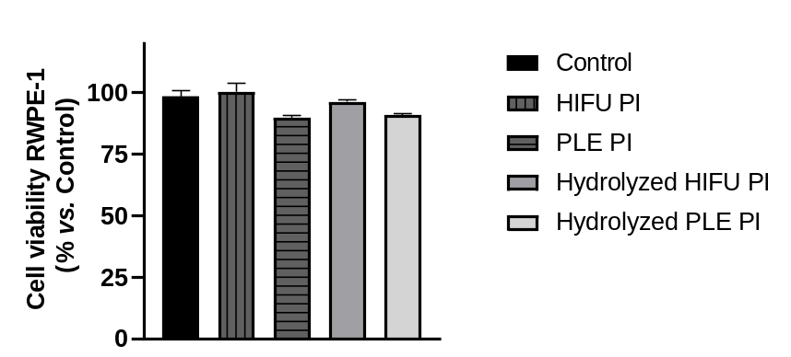
Fig. S1. Viability of normal epithelial prostatic cells before (control) and after the treatment with pomegranate seed HIFU PI (2 mg/mL), PLE PI (4 mg/mL), and hydrolysates (2.4 mg/mL).

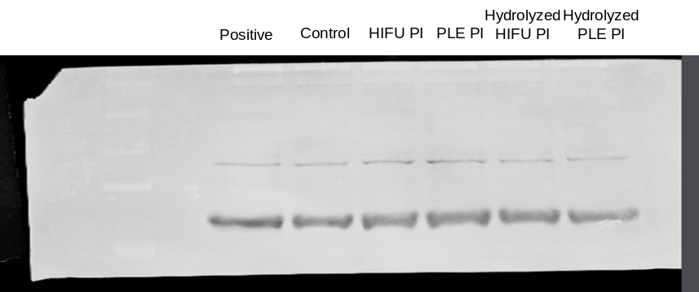
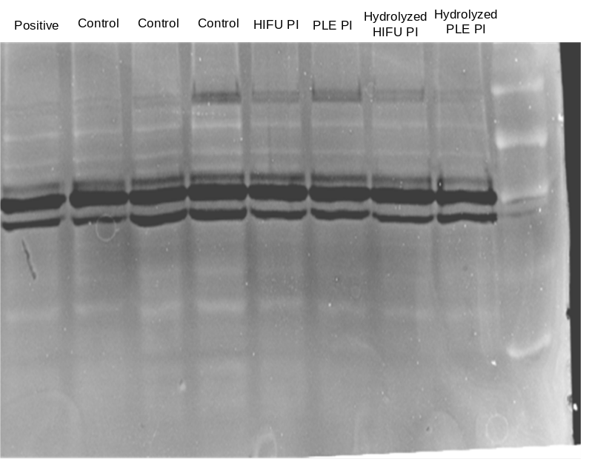
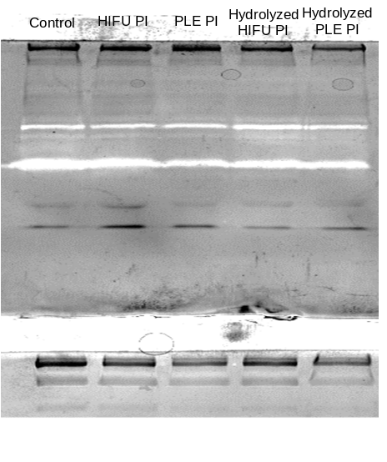
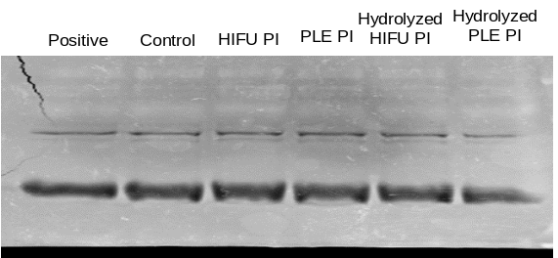
- MMP-2
- MMP-9

Fig. S2. Zymography showing the activity of MMP-9 (a) and MMP-2 (b) in untreated (control) PC-3 cells or cells treated with pomegranate seed protein isolates (2 mg/mL HIFU PI, 4 mg/mL PLE PI) and hydrolysates (2.4 mg/mL).

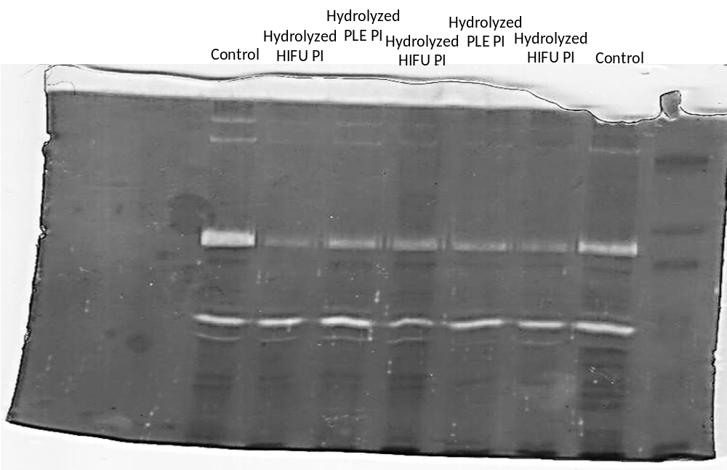
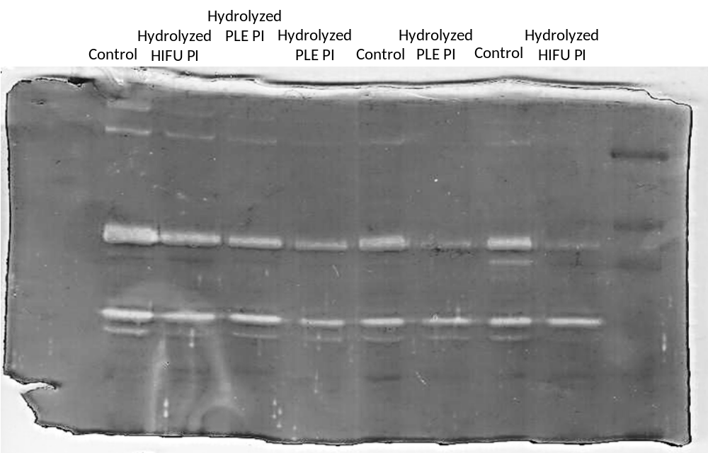
Fig. S3. Complete zymography of MMP activity from tumors in immunodeficient mice, generated using PC-3 cells either untreated (control) or treated with pomegranate seed hydrolysates (2.4 mg/mL). Each column corresponds to a different tumor.

