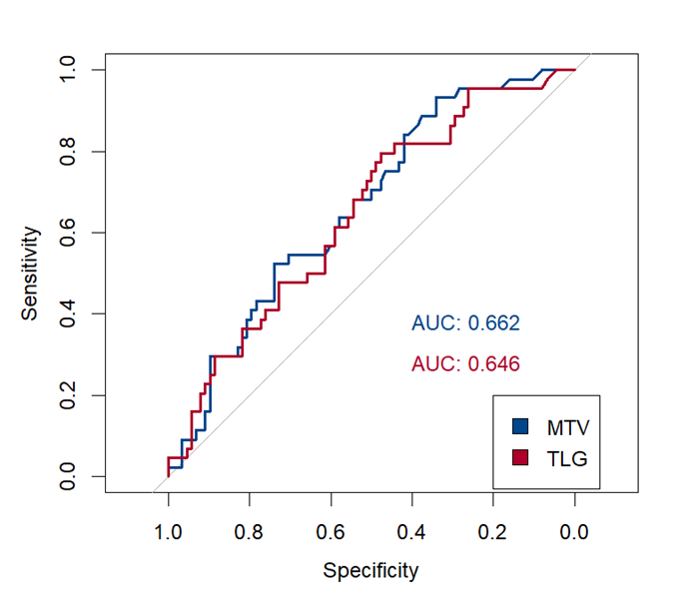
Figure S1 ROC curves for predicting R/R DLBCL using MTV and TLG

Table S1 Selected 8 radiomics features and coefficients

Radiomic Features | Coefficients
PET INTENSITY_HISTOGRAM_MaximumHistogramGradient | -0.22892275
PET GLSZM_LowGrayLevelZoneEmphasis | 0.92336278
CT MORPHOLOGICAL CentreofMassshift | 0.07017484
CT LOCAL_INTENSITY_BASEDIntensityPeakDiscretizedVolumeought. | -0.20462196
CT INTENSITY_HISTOGRAM RootMeanSquare. | -0.64143927
CT LOCAL_INTENSITY_ISTOGRAMIntensityPeakDiscretizedVolumeSought | -0.01993085
CT GLCM_Joint Maximum. | -0.10151023
CT GLSZM_ZoneSizeNonUniformity | 1.06293024

Table S2 Description of prediction models included in this study

Models | Included Variables
Clinical Model | Ann Arbor stage, ECOG PS, IPI, Bulk disease
PET Model | MTV, DmaxVox
Clinical-PET Model | IPI, Bulk disease, MTV, DmaxVox
Combined Model | IPI, Bulk disease, MTV, DmaxVox, Rad-score

Table S3 The performance evaluation of the 64 machine learning models for predicting refractory/relapsed DLBCL using 8 algorithms
Models | Clinical  Model |  | PET  Model |  | Clinical-PET Model |  | Combined  Model
 | AUC | Accuracy | AUC | Accuracy | AUC | Accuracy | AUC | Accuracy
Log Reg | 0.67 | 0.63 | 0.66 | 0.67 | 0.69 | 0.65 | 0.71 | 0.66
LDA | 0.67 | 0.64 | 0.67 | 0.67 | 0.69 | 0.67 | 0.72 | 0.68
QDA | 0.64 | 0.65 | 0.65 | 0.65 | 0.65 | 0.66 | 0.68 | 0.65
Naïve Bayes | 0.68 | 0.65 | 0.65 | 0.67 | 0.67 | 0.67 | 0.73 | 0.67
KNN | 0.59 | 0.38 | 0.67 | 0.61 | 0.60 | 0.60 | 0.63 | 0.65
Rpart | 0.56 | 0.69 | 0.65 | 0.63 | 0.60 | 0.57 | 0.59 | 0.64
RandomForest | 0.65 | 0.66 | 0.66 | 0.66 | 0.63 | 0.60 | 0.66 | 0.65
Xgboost | 0.62 | 0.62 | 0.57 | 0.59 | 0.56 | 0.53 | 0.64 | 0.63
Oversample Log Reg | 0.66 | 0.62 | 0.66 | 0.61 | 0.69 | 0.70 | 0.71 | 0.65
Oversample LDA | 0.66 | 0.62 | 0.67 | 0.60 | 0.69 | 0.68 | 0.73 | 0.65
Oversample QDA | 0.64 | 0.58 | 0.65 | 0.66 | 0.65 | 0.66 | 0.68 | 0.65
Oversample Naïve Bayes | 0.67 | 0.65 | 0.65 | 0.64 | 0.67 | 0.68 | 0.73 | 0.69
Oversample KNN | 0.60 | 0.38 | 0.70 | 0.62 | 0.60 | 0.58 | 0.64 | 0.58
Oversample Rpart | 0.57 | 0.55 | 0.53 | 0.51 | 0.63 | 0.63 | 0.59 | 0.57
Oversample RandomForest | 0.66 | 0.61 | 0.64 | 0.61 | 0.60 | 0.57 | 0.62 | 0.59
Oversample Xgboost | 0.64 | 0.59 | 0.63 | 0.64 | 0.61 | 0.57 | 0.57 | 0.58

Table S4 Clinical Characteristics by Different Cluster
Clinical  Characteristic | Cluster 1  (n = 50) | Cluster 2  (n = 65) | Cluster 3  (n = 17) | P-value
Gender |  |  |  | 0.978
Female | 25(50.0) | 33(50.8) | 9(52.9)
Male | 25(50.0) | 32(49.2) | 8(47.1)
BMI | 22.69 ± 3.06 | 23.46 ± 3.31 | 22.98 ± 2.38 | 0.589
Age (year) |  |  |  | 0.644
< 60 | 24(48.0) | 36(55.4) | 10(58.8)
≥ 60 | 26(52.0) | 29(44.6) | 7(41.2)
Ann Arbor stage |  |  |  | 0.025
I-II | 14(28.0) | 27(41.5) | 11(54.7)
III-IV | 36(72.0) | 38(58.5) | 6(35.3)
Extranodal involvement |  |  |  | 0.973
0-1 | 31(62.0) | 40(61.5) | 10(58.8)
≥ 2 | 19(38.0) | 25(38.5) | 7(41.2)
LDH |  |  |  | 0.813
Normal | 20(40.0) | 25(38.5) | 8(47.1)
Elevated | 30(60.0) | 40(61.5) | 9(52.9)
ECOG PS |  |  |  | 0.933
0-1 | 36(72.0) | 48(73.8) | 13(76.5)
≥ 2 | 14(28.0) | 17(26.2) | 4(23.5)
IPI |  |  |  | 0.026
≤ 2 | 20(40.0) | 40(61.5) | 12(70.6)
> 2 | 30(60.0) | 25(38.5) | 5(29.4)
B Symptoms |  |  |  | 0.677
No | 31(62.0) | 42(64.6) | 9(52.9)
Yes | 19(38.0) | 23(35.4) | 8(47.1)
Bulk disease |  |  |  | <0.001
No | 9(18.0) | 63(96.9) | 16(94.1)
Yes | 41(82.0) | 2(3.1) | 1(5.9)

Table S5 Selection and Parameter Application of Machine Learning Algorithms

Machine learning algorithms | Advantage Scenarios | Key Tuning Parameters
Log Reg | Linear classification, small data | penalty, C, L1_ratio, max_iter
LDA | Strong class separability, multi-dim | method, nu, tol
QDA | Strong class separability, multi-dim | Gamma, Lambda
Naive Bayes | High-dimensional sparse data | Laplace, adjust
KNN | Local pattern recognition, no training | Number of neighbors (k), distance, kernel
Rpart | High interpretability | Minsplit, cp
RandomForest | High-dim data, noise resistance | min.node.size, mtry
Xgboost | Large-scale data, competition scenarios | Eta, max_depth, subsample, min_child_weight, nrounds

