Supplementary Information
Figure SF1: Histogram plot showing the frequency distribution of peptide length of the alternate dataset 1.
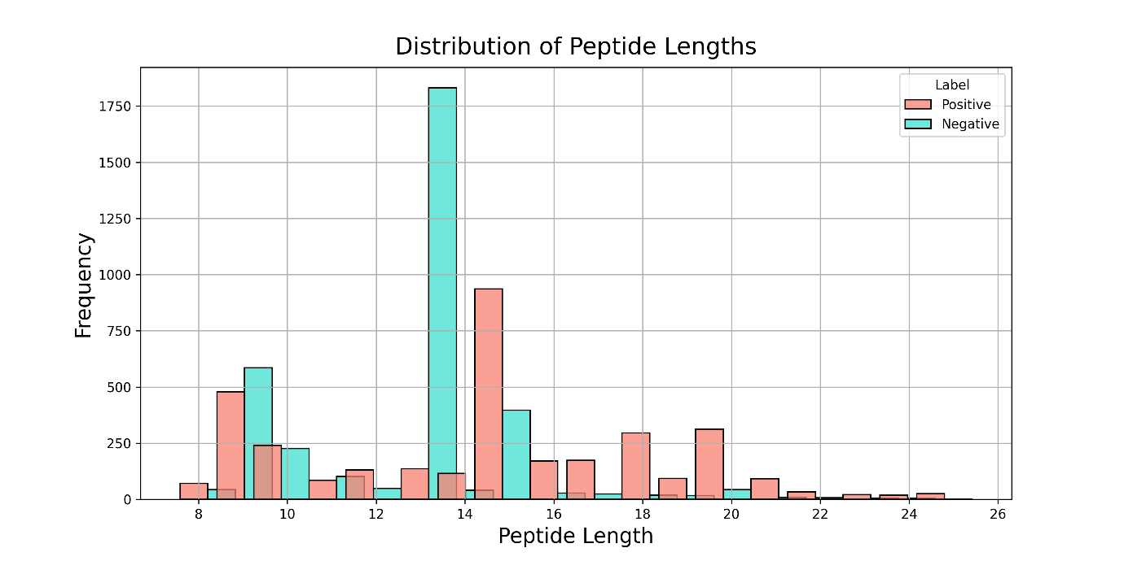

Figure SF2: Histogram plot showing the frequency distribution of peptide length of the alternate dataset 2.

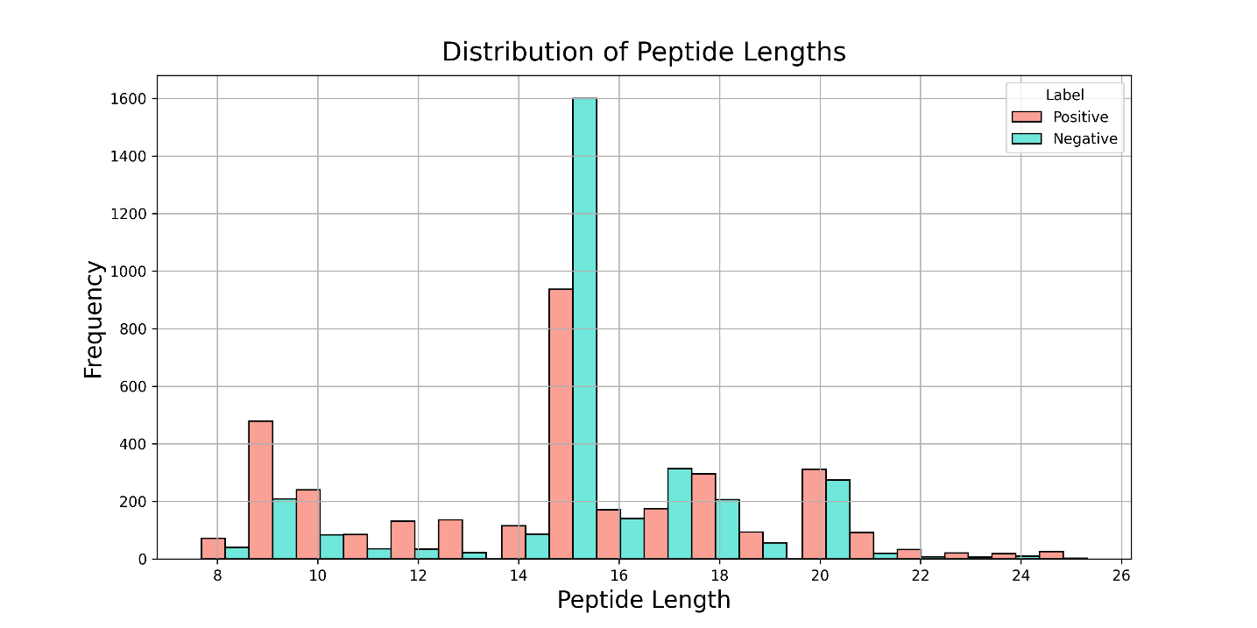

Figure SF3: Bar plot of the peptides' average single amino acid composition in the IL-2 inducers and non-inducers of the alternate dataset 1. The adjusted p-values are shown above the bars.
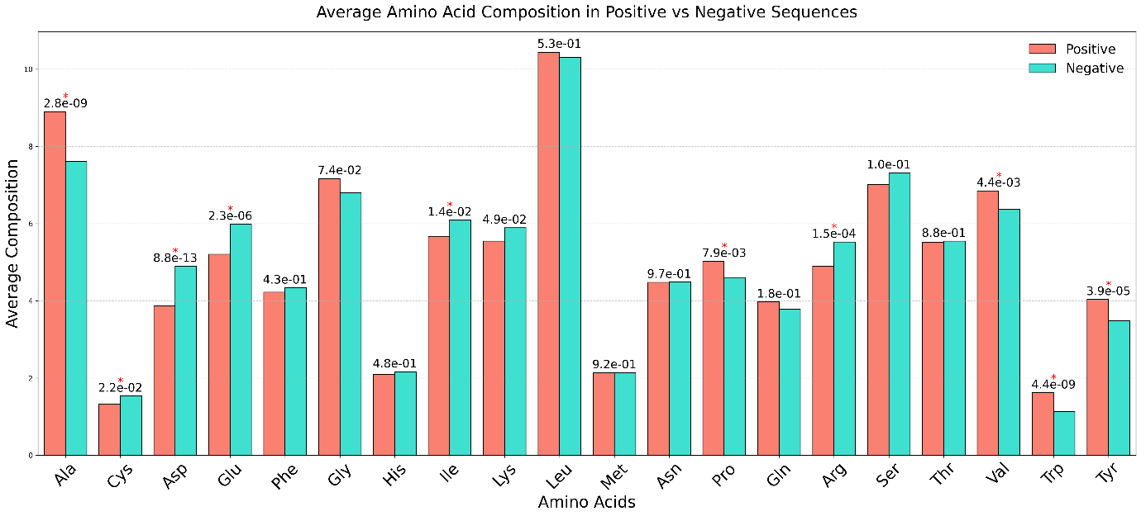
Figure SF4: Bar plot of the peptides' average single amino acid composition in the IL-2 inducers and non-inducers of the alternate dataset 2. The adjusted p-values are shown above the bars.
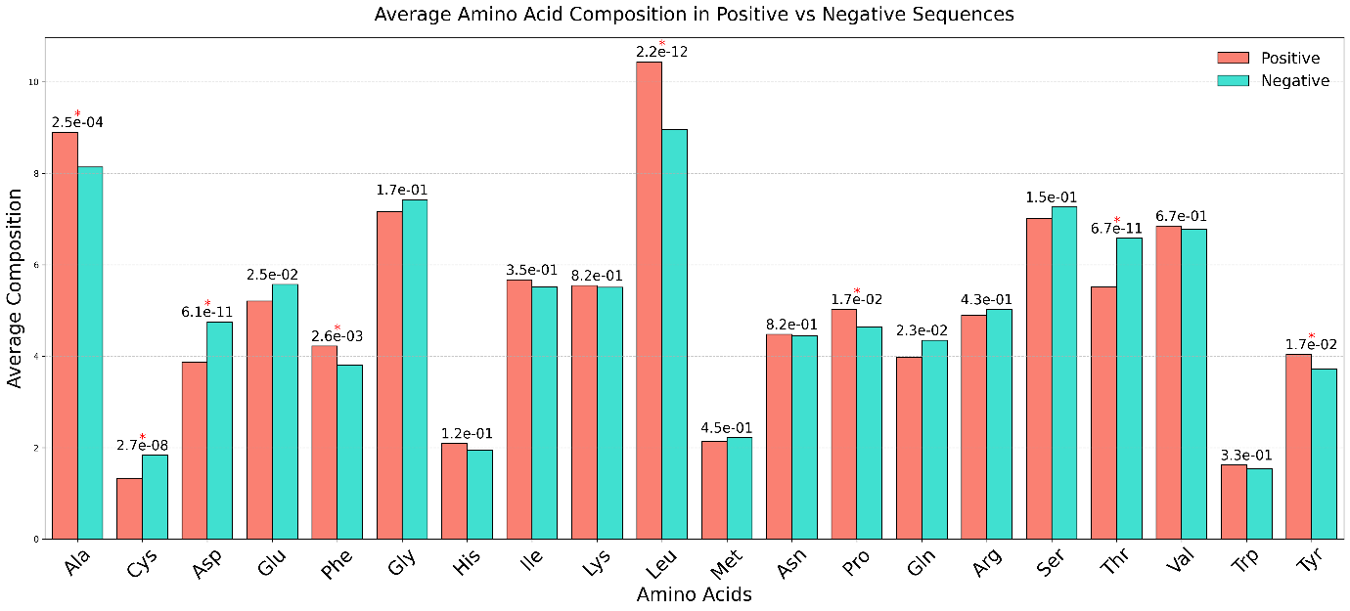

Figure SF5: Two-sample logo displaying the positional conservation of amino acid for the alternate dataset 1.
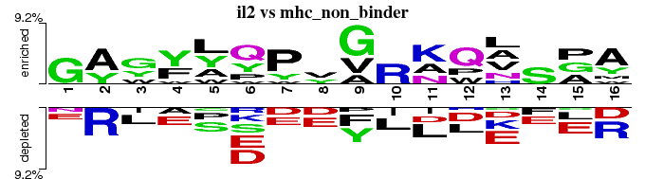
Figure SF6: Two-sample logo displaying the positional conservation of amino acid for the alternate dataset 2.

