Supplementary Information
Prediction of treatment-resistant depression using the 23andMe survey data
Srinivasan Vairavan^{1*}, Chao Tian², 23andMe Research Team², David Hinds², Vaibhav Narayan¹, Qingqin S. Li^{1*}
¹Janssen Research & Development, LLC, Titusville, NJ, USA; ²23andMe, Inc., San Francisco, CA, USA
*Corresponding authors: svairava@ITS.JNJ.com and Qingqin.li@chdifoundation.org

Supplementary Table S1. 101 features used in predictive modeling
Supplementary Table S2. Modeling results with different algorithms
Supplementary Table S3. Top 25 features in the XGBoost TRD model
Supplementary Table S4. Frequency/rank of a feature selected during the model training
Supplementary Table S5. The gain and lift analysis of the XGBoost model
Supplementary Table S6. Summary of TRD predictors from various studies
Supplementary Figure S1. The gain and lift plot for the XGBoost model (a) Gain (b) Lift (c) calibration plot
Supplementary Text 1. Selected questions defining selected top predictors
Supplementary Text 2. The full Antidepressant Efficacy Survey (AES) in HTML format

Supplementary Table S1: 101 features used in the predictive modeling
Coded_feature
trd_age_onset
trd_age_onset_before_24
trd_burden
trd_usual_episode_duration
trd_usual_latency
trd_residual_symptoms
trd_anx1
trd_anx2
trd_anx3
trd_anx4
trd_anx5
anxious_distress_all_2
anxious_distress_all_3
anxious_distress_all_4
anx_distres_all_psyagi
sum_of_5_anx_items
trd_phq9_01
trd_phq9_02
trd_phq9_03
trd_phq9_04
trd_phq9_05
trd_phq9_06
trd_phq9_07
trd_phq9_08
trd_phq9_09
trd_phq9_10
trd_phq9_11
trd_phq9_12
trd_phq9_13
trd_phq9_14
trd_phq9_15
mixture_symptoms_2
mixture_symptoms_3
mixture_symptoms_4
sum_of_5_mixture_items
Sum_of_PHQ_9
PHQ_9_gt_20
PHQ_9_gt_15
PHQ_9_gt_10
melancholic_symptoms_2
melancholic_symptoms_3
melancholic_symptoms_4
melancholic_symptoms_5
Sum_of_6_mela_symptoms
trd_phq9_16ª
trd_psychosis_diag
trd_panic_diag
trd_social_phobia_diag
trd_other_phobia_diag
trd_ocd_diag
trd_ptsd_diag
trd_gad_diag
trd_personality_diag
trd_psychosis_symp
trd_panic_symp
trd_social_phobia_symp
trd_other_phobia_symp
trd_ocd_symp
trd_ptsd_symp
trd_gad_symp
trd_personality_symp
trd_substance_abuseª
trd_triggered
trd_stress_career
trd_stress_financial
trd_stress_health
trd_stress_love
trd_stress_relationships
trd_stress_overall
sum_of_stress_w_overall
sum_of_stress_wo_all
trd_people_activities
trd_people_confide
trd_childhood_trauma_verbal
trd_childhood_trama_corporal
trd_childhood_trama_touched
trd_childhood_trama_neglect1
trd_childhood_trama_neglect2
trd_childhood_trama_emotional
trd_childhood_trama_physical
trd_childhood_trama_sexual
sum_of_8_trauma_items
trd_parental_depressionª
trd_parental_bipolarª
trd_parental_panicª
trd_parental_anxietyª
trd_parental_substancesª
trd_parental_otherª
trd_assault
trd_injury
trd_witness
trd_combat
trd_other_trauma
Age
BMI
Weight
Gender_is_male
Race_is_white
Race_is_black
Race_is_Hispanic
Race_is_asian
ªSensitive question (not shown to everyone)

Supplementary Table S2. Modeling results with different algorithms
Performance metrics | XGB | GBM | LogR
Accuracy | 0.73 | 0.70 | 0.71
Sensitivity | 0.64 | 0.71 | 0.72
Specificity | 0.75 | 0.70 | 0.71
Balanced accuracy | 0.70 | 0.70 | 0.71
AUC | 0.78 | 0.78 | 0.78
AUC_lower | 0.76 | 0.76 | 0.76
AUC_upper | 0.80 | 0.80 | 0.80
Positive predictive Value | 0.32 | 0.30 | 0.31
Negative predictive value | 0.92 | 0.93 | 0.93
DOR | 5.39 | 5.46 | 6.20
F1 measure | 0.42 | 0.42 | 0.43
AUC area under curve, DOR diagnostic odds ratio, GBM gradient boosting machine, XGBoost eXtreme Gradient Boosting.

Supplementary Table S3. Top 25 features in the XGBoost TRD model
 | Feature | Occurrence_Freq | Mean_Rank | SD_Rank
1 | trd_residual_symptoms | 1 | 1 | 0
2 | trd_burden | 1 | 2 | 0
3 | trd_usual_episode_duration | 1 | 3 | 0
4 | trd_stress_health | 1 | 4 | 0
5 | trd_phq9_16 | 1 | 5 | 0
6 | trd_stress_overall | 1 | 6 | 0
7 | Age | 1 | 7 | 0
8 | trd_ptsd_symp | 1 | 8 | 0
9 | Bmi | 1 | 9 | 0
10 | trd_people_activities | 1 | 10 | 0
11 | Weight | 1 | 11 | 0
12 | trd_usual_latency | 1 | 12 | 0
13 | trd_phq9_15 | 1 | 13 | 0
14 | trd_stress_relationships | 1 | 14 | 0
15 | trd_substance_abuse | 1 | 15 | 0
16 | trd_people_confide | 1 | 16 | 0
17 | trd_phq9_08 | 1 | 17 | 0
18 | trd_phq9_06 | 1 | 18 | 0
19 | trd_social_phobia_diag | 1 | 19 | 0
20 | trd_social_phobia_symp | 1 | 20 | 0
21 | trd_age_onset | 1 | 21 | 0
22 | trd_phq9_01 | 1 | 22 | 0
23 | trd_stress_financial | 1 | 23 | 0
24 | trd_phq9_02 | 1 | 24 | 0
25 | trd_phq9_07 | 1 | 25 | 0

Supplementary Table S4. Frequency/rank of a feature selected during the model training
 | Feature | Occurrence_Freq | Mean_Rank | SD_Rank
1 | trd_residual_symptoms | 1.00 | 1.02 | 0.13
2 | trd_burden | 1.00 | 1.98 | 0.13
3 | trd_usual_episode_duration | 1.00 | 3.50 | 0.72
4 | trd_stress_health | 1.00 | 4.01 | 0.79
5 | trd_phq9_16 | 1.00 | 7.43 | 1.51
6 | trd_stress_overall | 1.00 | 8.41 | 1.99
7 | Age | 1.00 | 4.94 | 1.20
8 | trd_ptsd_symp | 1.00 | 8.51 | 2.35
9 | Bmi | 1.00 | 6.82 | 1.23
10 | trd_people_activities | 1.00 | 12.45 | 2.31
11 | Weight | 1.00 | 12.24 | 2.33
12 | trd_usual_latency | 1.00 | 11.89 | 2.54
13 | trd_phq9_15 | 0.99 | 13.85 | 3.18
14 | trd_stress_relationships | 0.99 | 14.72 | 3.08
15 | trd_substance_abuse | 0.96 | 18.70 | 2.84
16 | trd_people_confide | 0.95 | 17.99 | 2.79
17 | trd_phq9_08 | 0.92 | 16.96 | 3.64
18 | trd_phq9_06 | 0.88 | 17.14 | 4.28
19 | trd_social_phobia_diag | 0.79 | 14.90 | 4.60
20 | trd_social_phobia_symp | 0.75 | 16.27 | 4.66
21 | trd_age_onset | 0.68 | 21.76 | 2.31
22 | trd_phq9_01 | 0.59 | 21.69 | 2.52
23 | trd_stress_financial | 0.56 | 21.06 | 2.67
24 | trd_phq9_02 | 0.48 | 22.01 | 2.20
25 | trd_phq9_07 | 0.48 | 21.42 | 2.39
26 | trd_phq9_11 | 0.47 | 20.13 | 3.57
27 | trd_phq9_03 | 0.41 | 21.62 | 2.83
28 | trd_phq9_05 | 0.38 | 22.74 | 1.91
29 | trd_gad_symp | 0.33 | 19.33 | 3.82
30 | trd_phq9_14 | 0.33 | 20.61 | 2.90
31 | trd_gad_diag | 0.25 | 21.15 | 3.07
32 | Gender_is_male | 0.18 | 22.67 | 2.05
33 | trd_phq9_13 | 0.18 | 21.87 | 2.44
34 | trd_witness | 0.12 | 23.24 | 1.61
35 | trd_ptsd_diag | 0.10 | 20.13 | 3.77
36 | trd_panic_symp | 0.04 | 23.46 | 2.22
37 | trd_stress_career | 0.04 | 23.09 | 1.70
38 | trd_phq9_10 | 0.03 | 23.90 | 1.52
39 | trd_stress_love | 0.03 | 23.67 | 0.71
40 | trd_phq9_12 | 0.02 | 21.33 | 3.33
41 | trd_phq9_04 | 0.02 | 24.60 | 0.89
42 | trd_other_trauma | 0.02 | 23.20 | 2.95
43 | trd_childhood_trama_physical | 0.01 | 22.67 | 2.08
44 | trd_childhood_trauma_verbal | 0.003 | 25.00 | 0.00

Supplementary Table S5. The gain and lift analysis of the XGBoost model
bucket | Total | Total response | Cumulative response | Gain | Cumulative lift
1 | 48 | 34 | 34 | 4.66 | 4.66
2 | 48 | 32 | 66 | 9.05 | 4.53
3 | 47 | 30 | 96 | 13.17 | 4.39
4 | 48 | 26 | 122 | 16.74 | 4.18
5 | 47 | 19 | 141 | 19.34 | 3.87
6 | 48 | 28 | 169 | 23.18 | 3.86
7 | 47 | 27 | 196 | 26.89 | 3.84
8 | 48 | 23 | 219 | 30.04 | 3.76
9 | 48 | 22 | 241 | 33.06 | 3.67
10 | 47 | 16 | 257 | 35.25 | 3.53
11 | 48 | 19 | 276 | 37.86 | 3.44
12 | 47 | 11 | 287 | 39.37 | 3.28
13 | 48 | 12 | 299 | 41.02 | 3.16
14 | 47 | 16 | 315 | 43.21 | 3.09
15 | 48 | 15 | 330 | 45.27 | 3.02
16 | 47 | 12 | 342 | 46.91 | 2.93
17 | 48 | 15 | 357 | 48.97 | 2.88
18 | 48 | 8 | 365 | 50.07 | 2.78
19 | 47 | 9 | 374 | 51.30 | 2.70
20 | 48 | 6 | 380 | 52.13 | 2.61
21 | 47 | 5 | 385 | 52.81 | 2.51
22 | 48 | 10 | 395 | 54.18 | 2.46
23 | 47 | 12 | 407 | 55.83 | 2.43
24 | 48 | 8 | 415 | 56.93 | 2.37
25 | 47 | 4 | 419 | 57.48 | 2.30
26 | 48 | 11 | 430 | 58.98 | 2.27
27 | 48 | 12 | 442 | 60.63 | 2.25
28 | 47 | 11 | 453 | 62.14 | 2.22
29 | 48 | 7 | 460 | 63.10 | 2.18
30 | 47 | 2 | 462 | 63.37 | 2.11
31 | 48 | 6 | 468 | 64.20 | 2.07
32 | 47 | 9 | 477 | 65.43 | 2.04
33 | 48 | 10 | 487 | 66.80 | 2.02
34 | 48 | 7 | 494 | 67.76 | 1.99
35 | 47 | 11 | 505 | 69.27 | 1.98
36 | 48 | 8 | 513 | 70.37 | 1.95
37 | 47 | 10 | 523 | 71.74 | 1.94
38 | 48 | 6 | 529 | 72.57 | 1.91
39 | 47 | 7 | 536 | 73.53 | 1.89
40 | 48 | 3 | 539 | 73.94 | 1.85
41 | 47 | 6 | 545 | 74.76 | 1.82
42 | 48 | 6 | 551 | 75.58 | 1.80
43 | 48 | 4 | 555 | 76.13 | 1.77
44 | 47 | 8 | 563 | 77.23 | 1.76
45 | 48 | 9 | 572 | 78.46 | 1.74
46 | 47 | 4 | 576 | 79.01 | 1.72
47 | 48 | 7 | 583 | 79.97 | 1.70
48 | 47 | 4 | 587 | 80.52 | 1.68
49 | 48 | 6 | 593 | 81.34 | 1.66
50 | 47 | 6 | 599 | 82.17 | 1.64
51 | 48 | 4 | 603 | 82.72 | 1.62
52 | 48 | 9 | 612 | 83.95 | 1.61
53 | 47 | 4 | 616 | 84.50 | 1.59
54 | 48 | 4 | 620 | 85.05 | 1.57
55 | 47 | 3 | 623 | 85.46 | 1.55
56 | 48 | 3 | 626 | 85.87 | 1.53
57 | 47 | 4 | 630 | 86.42 | 1.52
58 | 48 | 4 | 634 | 86.97 | 1.50
59 | 48 | 3 | 637 | 87.38 | 1.48
60 | 47 | 4 | 641 | 87.93 | 1.47
61 | 48 | 6 | 647 | 88.75 | 1.45
62 | 47 | 3 | 650 | 89.16 | 1.44
63 | 48 | 2 | 652 | 89.44 | 1.42
64 | 47 | 4 | 656 | 89.99 | 1.41
65 | 48 | 4 | 660 | 90.53 | 1.39
66 | 47 | 0 | 660 | 90.53 | 1.37
67 | 48 | 4 | 664 | 91.08 | 1.36
68 | 48 | 4 | 668 | 91.63 | 1.35
69 | 47 | 4 | 672 | 92.18 | 1.34
70 | 48 | 2 | 674 | 92.46 | 1.32
71 | 47 | 3 | 677 | 92.87 | 1.31
72 | 48 | 2 | 679 | 93.14 | 1.29
73 | 47 | 2 | 681 | 93.42 | 1.28
74 | 48 | 2 | 683 | 93.69 | 1.27
75 | 47 | 0 | 683 | 93.69 | 1.25
76 | 48 | 3 | 686 | 94.10 | 1.24
77 | 48 | 1 | 687 | 94.24 | 1.22
78 | 47 | 4 | 691 | 94.79 | 1.22
79 | 48 | 1 | 692 | 94.92 | 1.20
80 | 47 | 1 | 693 | 95.06 | 1.19
81 | 48 | 1 | 694 | 95.20 | 1.18
82 | 47 | 2 | 696 | 95.47 | 1.16
83 | 48 | 1 | 697 | 95.61 | 1.15
84 | 48 | 3 | 700 | 96.02 | 1.14
85 | 47 | 1 | 701 | 96.16 | 1.13
86 | 48 | 3 | 704 | 96.57 | 1.12
87 | 47 | 4 | 708 | 97.12 | 1.12
88 | 48 | 3 | 711 | 97.53 | 1.11
89 | 47 | 3 | 714 | 97.94 | 1.10
90 | 48 | 2 | 716 | 98.22 | 1.09
91 | 47 | 2 | 718 | 98.49 | 1.08
92 | 48 | 2 | 720 | 98.77 | 1.07
93 | 48 | 2 | 722 | 99.04 | 1.06
94 | 47 | 0 | 722 | 99.04 | 1.05
95 | 48 | 2 | 724 | 99.31 | 1.05
96 | 47 | 3 | 727 | 99.73 | 1.04
97 | 48 | 0 | 727 | 99.73 | 1.03
98 | 47 | 0 | 727 | 99.73 | 1.02
99 | 48 | 1 | 728 | 99.86 | 1.01
100 | 47 | 1 | 729 | 100.00 | 1.00

Supplementary Table S6. Summary of TRD predictors from various studies
Data Source | Clinical cohorts |  |  |  |  | Claim/EHR |  | Self-reports
Study | Perlis 2013²⁵ | Kautzky et al., 2017²⁷ |  | Kautzky et al., 2019²⁶ | Nie et al., 2018¹⁹ | Liberman et al., 2020⁶ | Cepeda et al., 2018³⁹ | This study
Demographic variables
Age |  |  |  |  |  | X |  | X
Education | X | X
Occupation |  | X
Sex | X
Marital Status | X
Race | X
Depression characteristics
Timespan between first and last depressive episode |  | X
Years in life having ≥2 weeks depressive episode |  |  |  |  |  |  |  | X
Age at first antidepressant treatment |  | X
Duration >3 months |  |  |  | X
Average duration of depressive episodes |  |  |  |  |  |  |  | X
Latency |  |  |  |  |  |  |  | X
Symptom severity |  | X |  | X | X
Level 1 QIDS-C16 total score at week 0 |  |  |  |  | X
QIDS-SR16 Total | X
QIDS-SR16 Middle Insomnia | X
QIDS-SR16 Late Insomnia | X
QIDS-SR16 Energy | X
Level 1 QLESQ total score at week 0 |  |  |  |  | X
Level 1 WSAS total score at week 0 |  |  |  |  | X
Level 1 SFHS Physical Health Composite scores at week 0 |  |  |  |  | X
Level 1 HAM-D17 anxiety/somatization factor score at week 0 |  |  |  |  | X
Suicidal risk |  | X |  | X | X | X |  | X
Number of MDE |  | X |  | X
Recurrent Episodes | X
Residual symptoms |  |  |  |  |  |  |  | X
Melancholia |  | X |  |  | X
Level 1 Bech melancholia scale score at week 0 |  |  |  |  | X
Medical comorbidity
Comorbid diabetes |  | X
Comorbid panic disorder |  | X
Comorbid GAD |  |  |  | X
Comorbid PTSD/endorsing PTSD symptoms | X |  |  |  |  |  |  | X
Comorbid thyroid disorder |  | X
Diagnosis of insomnia |  |  |  |  |  | X
Diagnosis of hypertension |  |  |  |  |  | X
Psychosis Screen Positive | X
Healthcare setting
In- or outpatient |  | X |  | X
Psychiatric office visits |  |  |  |  |  | X
Nurse telephonic encounters |  |  |  |  |  | X
Physician specialty associated with index prescription |  |  |  |  |  | X
Vulnerability characteristics
Stress level from life overall before the start of your most recent depressive episode |  |  |  |  |  |  |  | X
Stress level from health before the start of your most recent depressive episode |  |  |  |  |  |  |  | X
Witnessed Trauma | X
Experienced Trauma | X
Family Impact Score | X
Early response to antidepressant treatment / treatment history
Response to first antidepressant treatment |  |  | X
Level 1 QIDS-C16 total score at week 2 |  |  |  |  | X
Level 1 QIDS-C16 suicidal ideation at week 2 |  |  |  |  | X
Level 1 QIDS-SR16 Outlook (self) at week 2 |  |  |  |  | X
Level 1 changing citalopram dose at week 2 |  |  |  |  | X
Duration of untreated illness (the lag between diagnosis and index prescription) |  |  |  |  |  | X
Anticonvulsant medication use |  |  |  |  |  | X
Total prescription drug claims |  |  |  |  |  | X
Number of previous AD |  |  |  | X |  | X | X
Number of previous APS |  |  |  |  |  |  | X
AD antidepressant, APS antidepressant pharmacotherapy strategies, GAD generalized anxiety disorder, HAM-D, Hamilton Depression Rating Scale, MDE major depression episode, PTSD post-traumatic stress disorder, QIDS-C Quick Inventory of Depressive Symptomatology – Clinician Rating, QIDS-SR Quick Inventory of Depressive Symptomatology – Self Report, SFHS Subjective Fluctuating Happiness Scale, WSAS Work and Social Adjustment Scale.

Supplementary Figure S1: The gain and lift plot for the XGBoost model (a) Gain (b) Lift (c) calibration plot
(a)
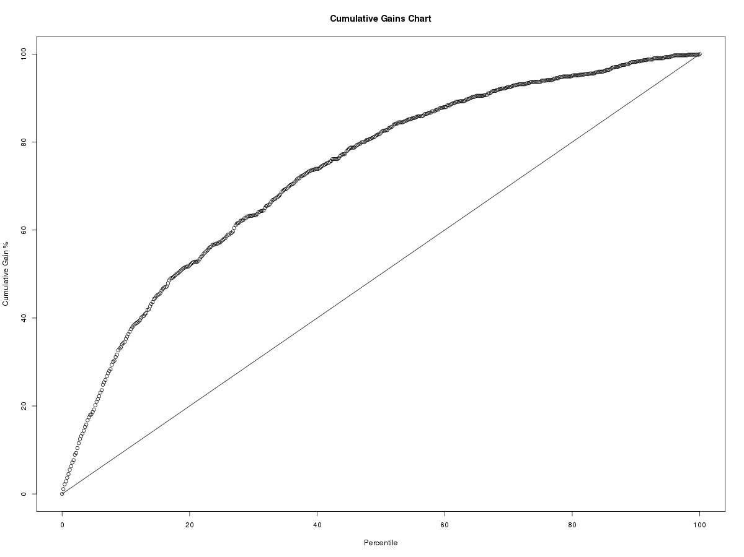
(b)
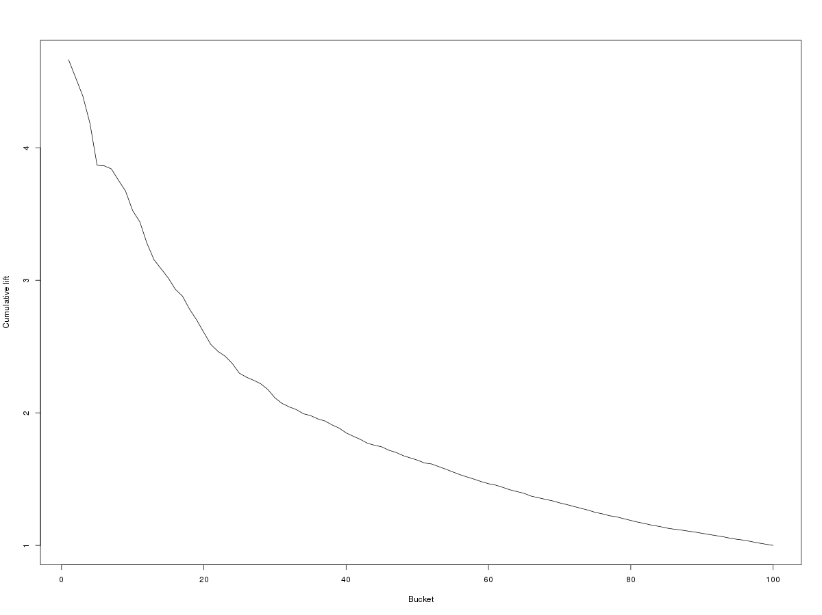

(c)
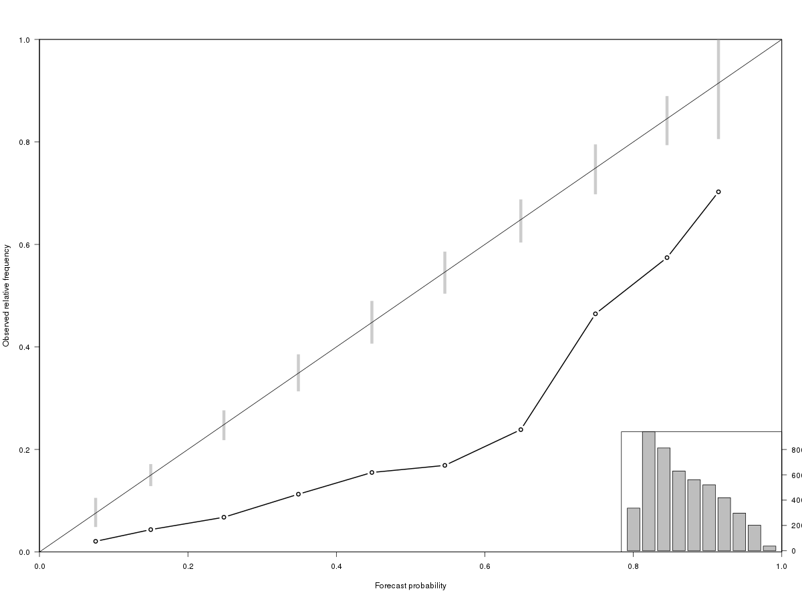

Supplementary Text 1. Select questions defining selected top predictors.
- Which of the following statements best describes how often you had residual depressive symptoms between the end of one episode and the beginning of the next episode?
Option | Count | Percentage | ntrd_count | ntrd_percentage | trd_count | trd_percentage
You usually had no symptoms between episodes. | 5181 | 14.16 | 1997 | 14.11 | 162 | 5.24
You sometimes had symptoms, but with long periods (3 months or longer) of no symptoms. | 8648 | 23.64 | 3585 | 25.33 | 369 | 11.93
You had at least some symptoms most of the time, but with long periods (3 months or longer) of no symptoms. | 5046 | 13.79 | 2074 | 14.65 | 343 | 11.09
You usually had symptoms, but with short periods (less than 3 months) of no symptoms. | 4953 | 13.54 | 1906 | 13.47 | 455 | 14.72
You almost always had at least some symptoms. | 12753 | 34.86 | 4591 | 32.44 | 1763 | 57.02
[CONCEPT: trd_residual_symptoms]

P-value
7.442165E-172
{IF ((hh_depression = yes OR hp_depression = yes OR #3 = Yes) AND (#4 = No) AND (hh_bipolar_disorder != yes) AND (hp_bipolar_disorder != yes))}
- About how many years in your life did you have a depressive episode lasting two weeks or longer?
[CONCEPT: trd_burden]
Option | Count | Percentage | ntrd_Count | ntrd_percentage | trd_Count | trd_ percentage
1 or less | 10157 | 21.17 | 3396 | 18.98 | 189 | 5.65
2 | 5991 | 12.49 | 2148 | 12.01 | 187 | 5.59
3 – 4 | 8238 | 17.17 | 3250 | 18.16 | 388 | 11.60
5 – 6 | 5653 | 11.78 | 2216 | 12.39 | 360 | 10.76
7 - 10 | 5552 | 11.57 | 2107 | 11.78 | 515 | 15.39
11 - 15 | 3369 | 7.02 | 1291 | 7.22 | 398 | 11.89
16 - 20 | 3047 | 6.35 | 1164 | 6.51 | 394 | 11.78
21 or more | 5978 | 12.46 | 2320 | 12.97 | 915 | 27.35

P-value
3.870484E-228
{IF ((hh_depression = yes OR hp_depression = yes OR #3 = Yes) AND (#4 = No) AND (hh_bipolar_disorder != yes) AND (hp_bipolar_disorder != yes) AND (#7 = 2 OR #7 = 3 - 4 OR #7 = 5 - 6 OR #7 = 7 - 10 OR #7 = 11 - 15 OR #7 = 16 - 20 OR #7 = 21 or more))}
- About how long did these episodes usually last? (If it varied, estimate the average duration.)
[CONCEPT: trd_usual_episode_duration]
Option | Count | Percentage | ntrd_count | ntrd_percentage | trd_count | trd_ percentage
1 - 3 months | 18495 | 49.57 | 7427 | 51.81 | 1033 | 33.24
4 - 6 months | 7168 | 19.21 | 2831 | 19.75 | 563 | 18.11
7 - 9 months | 2377 | 6.37 | 887 | 6.19 | 215 | 6.92
10 - 12 months | 1728 | 4.63 | 644 | 4.49 | 166 | 5.34
1 - 2 years | 2691 | 7.21 | 937 | 6.54 | 252 | 8.11
More than 2 years | 4850 | 13.00 | 1609 | 11.22 | 879 | 28.28

P-value
1.058325E-153
How much stress did you have in each of the following areas of your life in the weeks and months before the start of your most recent depressive episode in which you used medication?
- Your health [CONCEPT: trd_stress_health]
Option | Count | Percentage | ntrd_count | ntrd_ percentage | trd_count | trd_ percentage
None | 9711 | 29.66 | 6212 | 33.90 | 622 | 18.39
Mild | 8460 | 25.84 | 4914 | 26.82 | 787 | 23.26
Moderate | 8342 | 25.48 | 4409 | 24.06 | 961 | 28.41
Severe | 4051 | 12.37 | 1875 | 10.23 | 595 | 17.59
Very severe | 2175 | 6.64 | 912 | 4.98 | 418 | 12.36

P-value
6.310655E-138
- Your life overall [CONCEPT: trd_stress_overall]
Option | Count | Percentage | ntrd_count | ntrd_percentage | trd_count | trd_ percentage
None | 1883 | 5.76 | 1282 | 7.00 | 70 | 2.07
Mild | 6972 | 21.31 | 4480 | 24.48 | 446 | 13.20
Moderate | 14398 | 44.01 | 8178 | 44.68 | 1359 | 40.21
Severe | 7275 | 22.24 | 3485 | 19.04 | 1074 | 31.78
Very severe | 2190 | 6.69 | 878 | 4.80 | 431 | 12.75

P-value
1.496720E-172
Please think about the two weeks during the episode when your depressive symptoms were most severe and persistent. How much were you bothered by each of the following problems during those two weeks?
- Being so fidgety or restless that you were moving around a lot more than usual? [CONCEPT: trd_phq9_15]
Option | Count | Percentage | ntrd_count | ntrd_ percentage | trd_count | trd_ percentage
Not at all | 22128 | 67.71 | 13138 | 71.89 | 1911 | 56.52
Several days | 6846 | 20.95 | 3451 | 18.88 | 875 | 25.88
More than half the days | 2414 | 7.39 | 1118 | 6.12 | 381 | 11.27
Nearly every day | 1291 | 3.95 | 568 | 3.11 | 214 | 6.33

P-value
2.427677E-77

- Thoughts that you would be better off dead or of hurting yourself? [CONCEPT: trd_phq9_16]
Option | Count | Percentage | ntrd_count | ntrd_ percentage | trd_count | trd_percentage
Not at all | 15553 | 48.84 | 9641 | 54.15 | 1071 | 32.35
Several days | 9239 | 29.02 | 4970 | 27.91 | 1054 | 31.83
More than half the days | 3550 | 11.15 | 1637 | 9.19 | 585 | 17.67
Nearly every day | 3500 | 10.99 | 1557 | 8.74 | 601 | 18.15

P-value
2.502842E-153

The next questions are about some other emotional problems people with depression often have. Did a doctor or other health professional ever say you had these problems?

- Post-traumatic stress disorder (PTSD) [CONCEPT: trd_ptsd_diag]
Option | Count | Percentage | ntrd_count | ntrd_ percentage | trd_count | trd_ percentage
Yes | 7804 | 23.73 | 3490 | 18.97 | 1205 | 35.57
No | 25077 | 76.27 | 14903 | 81.03 | 2183 | 64.43

P-value
4.294947E-103

For each problem you just reported, did you have symptoms of the problem during the most recent depressive episode in which you used medication?
{IF ((#116 = Yes))}
- Post-traumatic stress disorder (PTSD) [CONCEPT: trd_ptsd_symp]
Option | Count | Percentage | ntrd_count | ntrd_ percentage | trd_count | trd_ percentage
Yes | 5640 | 72.47 | 2356 | 67.64 | 984 | 82.00
No | 2142 | 27.53 | 1127 | 32.36 | 216 | 18.00

P-value
3.490446E-21
- If I had asked you at the very beginning of your most recent depressive episode in which you used medication how many people you had in your personal life to do things with, like watch TV together or go out socially together, how would you have answered?
[CONCEPT: trd_people_activities]
Option | Count | Percentage | ntrd_count | ntrd_ percentage | trd_count | trd_ percentage
0 | 2583 | 7.90 | 1200 | 6.56 | 420 | 12.42
1 | 6238 | 19.08 | 3204 | 17.52 | 802 | 23.72
2 | 6177 | 18.90 | 3353 | 18.33 | 692 | 20.47
3 | 4619 | 14.13 | 2620 | 14.33 | 437 | 12.93
4 | 3456 | 10.57 | 2034 | 11.12 | 302 | 8.93
5 | 3134 | 9.59 | 1895 | 10.36 | 249 | 7.36
6-10 | 4488 | 13.73 | 2789 | 15.25 | 345 | 10.20
11+ | 1996 | 6.11 | 1193 | 6.52 | 134 | 3.96

P-value
2.222280E-65
- How much time usually went on between the end of one episode and the beginning of the next episode? (If it varied, estimate the average amount of time.)
[CONCEPT: trd_usual_latency]
Option | Count | Percentage | ntrd_count | ntrd_percentage | trd_count | trd_percentage
1 - 6 months | 16877 | 47.00 | 5995 | 43.27 | 1790 | 58.96
7 - 12 months | 6392 | 17.80 | 2590 | 18.69 | 462 | 15.22
13 - 18 months | 2574 | 7.17 | 1095 | 7.90 | 175 | 5.76
19 - 24 months | 1871 | 5.21 | 782 | 5.64 | 135 | 4.45
2 - 3 years | 3279 | 9.13 | 1426 | 10.29 | 194 | 6.39
4 - 5 years | 1773 | 4.94 | 772 | 5.57 | 73 | 2.40
More than 5 years | 3143 | 8.75 | 1194 | 8.62 | 207 | 6.82

P-value
1.620894E-55

Supplementary Text 2. The full Antidepressant Efficacy Survey (AES)

SURVEY TITLE. Antidepressant Efficacy
1. Consent Form
( ) Yes, I'd like to participate in this research. I am this person, I am at least 18 years old, I have read this document, and I CONSENT to be shown the questions in this survey.
( ) Yes, I'd like to participate in this research. I am legally authorized to give consent for this person, this person is at least 18 years old, I have read this document, and I CONSENT to be shown the questions in this survey.
( ) No, I do not want to take part in sensitive research. Please show me the survey with the sensitive questions removed.
2. Have you ever been diagnosed with major depressive disorder by a doctor or other health professional?
( ) Yes
( ) No
3. Have you ever been diagnosed with bipolar or manic-depressive disorder by a doctor or other health professional?
( ) Yes
( ) No
4. About how old were you the very first time you had a depressive episode lasting two weeks or longer?
( ) 0 - 12 years old
( ) 13 - 17 years old
( ) 18 - 24 years old
( ) 25 - 34 years old
( ) 35 - 49 years old
( ) 50+ years old
5. In an earlier survey you mentioned having times in your life when you were diagnosed with depression. About how old were you the very first time you had a depressive episode lasting two weeks or longer?
( ) 0 - 12 years old
( ) 13 - 17 years old
( ) 18 - 24 years old
( ) 25 - 34 years old
( ) 35 - 49 years old
( ) 50+ years old
6. About how many years in your life did you have a depressive episode lasting two weeks or longer?
( ) 1
( ) 2
( ) 3 - 4
( ) 5 - 6
( ) 7 - 10
( ) 11 - 15
( ) 16 - 20
( ) 21+
7. About how long did these episodes usually last? (If it varied, estimate the average duration.)
( ) 1 - 3 months
( ) 4 - 6 months
( ) 7 - 9 months
( ) 10 - 12 months
( ) 1 - 2 years
( ) More than 2 years
8. How much time usually went on between the end of one episode and the beginning of the next episode? (If it varied, estimate the average amount of time.)
( ) 1 - 6 months
( ) 7 - 12 months
( ) 13 - 18 months
( ) 19 - 24 months
( ) 2 - 3 years
( ) 4 - 5 years
( ) More than 5 years
9. Which of the following statements best describes how often you had residual depressive symptoms between the end of one episode and the beginning of the next episode?
( ) You usually had no symptoms between episodes.
( ) You sometimes had symptoms, but with long period (3 months or longer) of no symptoms.
( ) You had at least some symptoms most of the time, but with long periods (3 months or longer) of no symptoms.
( ) You usually had symptoms, but with short periods (less than 3 months) of no symptoms?
( ) You almost always had at least some symptoms.
10. Was there ever a time in the past five years (60 months) when you took medication for a depressive episode?
( ) Yes - currently
( ) Yes - in the past 2 years
( ) Yes - between 2 and 5 years ago
( ) No
11. Did you also receive any of the following other types of treatment at any time during your current depressive episode when you were also taking medication? Please select all that apply.
[ ] Psychotherapy
[ ] Deep brain stimulation
[ ] Electroconvulsive therapy (ECT)
[ ] Repetitive Transcranial Magnetic Stimulation (rTMS)
[ ] Self-help support group
[ ] Vagus nerve stimulation (VNS)
[ ] Any other type of treatment
[ ] None of these
12. Think of the most recent depressive episode in which you took medication. Did you also receive any of the following other types of treatment at the same time you were taking medication? Please select all that apply.
[ ] Psychotherapy
[ ] Deep brain stimulation
[ ] Electroconvulsive therapy (ECT)
[ ] Repetitive Transcranial Magnetic Stimulation (rTMS)
[ ] Self-help support group
[ ] Vagus nerve stimulation (VNS)
[ ] Any other type of treatment
[ ] None of these
13. How helpful would you say the treatment of your current episode has been overall?
( ) Very helpful (completely back to normal, not at all depressed after treatment)
( ) Helpful (not completely back to normal, but only minimally depressed after treatment)
( ) Not very helpful (still moderately depressed after treatment)
( ) No change
( ) Symptoms worsened with treatment compared to before treatment began
14. How helpful would you say the treatment of that episode was overall?
( ) Very helpful (completely back to normal, not at all depressed after treatment)
( ) Helpful (not completely back to normal, but only minimally depressed after treatment)
( ) Not very helpful (still moderately depressed after treatment)
( ) No change
( ) Symptoms worsened with treatment compared to before treatment began
15. You had multiple components to your treatment. What part do you think medication played in your treatment being helpful?
( ) Medication helped
( ) Medication did not help
( ) You are not sure whether medication helped or not
16. You had multiple components to your treatment. What part do you think medication played in your treatment being very helpful?
( ) Medication helped
( ) Medication did not help
( ) You are not sure whether medication helped or not
17. How important would you say medication was in making your treatment helpful?
( ) Medication was the main reason the treatment was helpful.
( ) Medication was important but not the main reason the treatment was helpful.
( ) Medication played a part but not an important part in the treatment being helpful.
Which of the following kinds of medication have you taken and for how many weeks during your current episode?
- 18. Abilify® or aripiprazole
( )Less than 3 weeks or not at all ( )3-4 ( )5-6 ( )7+ weeks
- 19. Brintellix® or vortioxetine
( )Less than 3 weeks or not at all ( )3-4 ( )5-6 ( )7+ weeks
- 20. Celexa® or citalopram
( )Less than 3 weeks or not at all ( )3-4 ( )5-6 ( )7+ weeks
- 21. Cymbalta® or duloxetine
( )Less than 3 weeks or not at all ( )3-4 ( )5-6 ( )7+ weeks
- 22. Desyrel®, Oleptro®, Trazorel®, or trazodone
( )Less than 3 weeks or not at all ( )3-4 ( )5-6 ( )7+ weeks
- 23. Effexor® or venlafaxine
( )Less than 3 weeks or not at all ( )3-4 ( )5-6 ( )7+ weeks
- 24. Fetzima® or levomilnacipran
( )Less than 3 weeks or not at all ( )3-4 ( )5-6 ( )7+ weeks
- 25. Lexapro® or escitalopram
( )Less than 3 weeks or not at all ( )3-4 ( )5-6 ( )7+ weeks
- 26. Paxil® or paroxetine
( )Less than 3 weeks or not at all ( )3-4 ( )5-6 ( )7+ weeks
- 27. Pristiq® or desvenlafaxine
( )Less than 3 weeks or not at all ( )3-4 ( )5-6 ( )7+ weeks
- 28. Prozac® or fluoxetine
( )Less than 3 weeks or not at all ( )3-4 ( )5-6 ( )7+ weeks
- 29. Seroquel® or quetiapine
( )Less than 3 weeks or not at all ( )3-4 ( )5-6 ( )7+ weeks
- 30. Symbyax®
( )Less than 3 weeks or not at all ( )3-4 ( )5-6 ( )7+ weeks
- 31. Viibryd® or vilazodone
( )Less than 3 weeks or not at all ( )3-4 ( )5-6 ( )7+ weeks
- 32. Wellbutrin®, Zyban®, or bupropion
( )Less than 3 weeks or not at all ( )3-4 ( )5-6 ( )7+ weeks
- 33. Zoloft® or sertraline
( )Less than 3 weeks or not at all ( )3-4 ( )5-6 ( )7+ weeks
- 34. Another antidepressant
( )Less than 3 weeks or not at all ( )3-4 ( )5-6 ( )7+ weeks
- 35. A 2nd other antidepressant
( )Less than 3 weeks or not at all ( )3-4 ( )5-6 ( )7+ weeks
Which of the following kinds of medication did you take and for how many weeks during your most recent episode?
- 36. Abilify® or aripiprazole
( )Less than 3 weeks or not at all ( )3-4 ( )5-6 ( )7+ weeks
- 37. Brintellix® or vortioxetine
( )Less than 3 weeks or not at all ( )3-4 ( )5-6 ( )7+ weeks
- 38. Celexa® or citalopram
( )Less than 3 weeks or not at all ( )3-4 ( )5-6 ( )7+ weeks
- 39. Cymbalta® or duloxetine
( )Less than 3 weeks or not at all ( )3-4 ( )5-6 ( )7+ weeks
- 40. Desyrel®, Oleptro®, Trazorel®, or trazodone
( )Less than 3 weeks or not at all ( )3-4 ( )5-6 ( )7+ weeks
- 41. Effexor® or venlafaxine
( )Less than 3 weeks or not at all ( )3-4 ( )5-6 ( )7+ weeks
- 42. Fetzima® or levomilnacipran
( )Less than 3 weeks or not at all ( )3-4 ( )5-6 ( )7+ weeks
- 43. Lexapro® or escitalopram
( )Less than 3 weeks or not at all ( )3-4 ( )5-6 ( )7+ weeks
- 44. Paxil® or paroxetine
( )Less than 3 weeks or not at all ( )3-4 ( )5-6 ( )7+ weeks
- 45. Pristiq® or desvenlafaxine
( )Less than 3 weeks or not at all ( )3-4 ( )5-6 ( )7+ weeks
- 46. Prozac® or fluoxetine
( )Less than 3 weeks or not at all ( )3-4 ( )5-6 ( )7+ weeks
- 47. Seroquel® or quetiapine
( )Less than 3 weeks or not at all ( )3-4 ( )5-6 ( )7+ weeks
- 48. Symbyax®
( )Less than 3 weeks or not at all ( )3-4 ( )5-6 ( )7+ weeks
- 49. Viibryd® or vilazodone
( )Less than 3 weeks or not at all ( )3-4 ( )5-6 ( )7+ weeks
- 50. Wellbutrin®, Zyban®, or bupropion
( )Less than 3 weeks or not at all ( )3-4 ( )5-6 ( )7+ weeks
- 51. Zoloft® or sertraline
( )Less than 3 weeks or not at all ( )3-4 ( )5-6 ( )7+ weeks
- 52. Another antidepressant
( )Less than 3 weeks or not at all ( )3-4 ( )5-6 ( )7+ weeks
- 53. A 2nd other antidepressant
( )Less than 3 weeks or not at all ( )3-4 ( )5-6 ( )7+ weeks
54. You used more than one type of medication during the episode. How many different types of medication did you have to use before you found one that was helpful? (Count the first helpful medication. For example, if the 3rd medication was the first one that helped, check "3" rather than "2".)
( ) 1
( ) 2
( ) 3
( ) 4+
Which one was the first helpful medication or combination of medicines?
- 55. Abilify® or aripiprazole
( )First to help ( )Helped, but not the first to help ( )Did not help
- 56. Brintellix® or vortioxetine
( )First to help ( )Helped, but not the first to help ( )Did not help
- 57. Celexa® or citalopram
( )First to help ( )Helped, but not the first to help ( )Did not help
- 58. Cymbalta® or duloxetine
( )First to help ( )Helped, but not the first to help ( )Did not help
- 59. Desyrel®, Oleptro®, Trazorel®, or trazodone
( )First to help ( )Helped, but not the first to help ( )Did not help
- 60. Effexor® or venlafaxine
( )First to help ( )Helped, but not the first to help ( )Did not help
- 61. Fetzima® or levomilnacipran
( )First to help ( )Helped, but not the first to help ( )Did not help
- 62. Lexapro® or escitalopram
( )First to help ( )Helped, but not the first to help ( )Did not help
- 63. Paxil® or paroxetine
( )First to help ( )Helped, but not the first to help ( )Did not help
- 64. Pristiq® or desvenlafaxine
( )First to help ( )Helped, but not the first to help ( )Did not help
- 65. Prozac® or fluoxetine
( )First to help ( )Helped, but not the first to help ( )Did not help
- 66. Seroquel® or quetiapine
( )First to help ( )Helped, but not the first to help ( )Did not help
- 67. Symbyax®
( )First to help ( )Helped, but not the first to help ( )Did not help
- 68. Viibryd® or vilazodone
( )First to help ( )Helped, but not the first to help ( )Did not help
- 69. Wellbutrin®, Zyban®, or bupropion
( )First to help ( )Helped, but not the first to help ( )Did not help
- 70. Zoloft® or sertraline
( )First to help ( )Helped, but not the first to help ( )Did not help
- 71. Another antidepressant
( )First to help ( )Helped, but not the first to help ( )Did not help
- 72. A 2nd other antidepressant
( )First to help ( )Helped, but not the first to help ( )Did not help
73. You mentioned earlier that you got completely back to normal with treatment. How long did it take after treatment began for you to get back to normal?
( ) 1 - 3 months
( ) 4 - 6 months
( ) 7 - 9 months
( ) 10 - 12 months
( ) 13 - 18 months
( ) 19 - 24 months
( ) 25+ months
74. You mentioned earlier that treatment did not resolve your depressive symptoms. Did you eventually get back to normal? Or are you still having symptoms?
( ) Eventually got back to normal
( ) Still having symptoms
75. How long did the episode last between the time treatment began and the time you got back to normal?
( ) 1 - 3 months
( ) 4 - 6 months
( ) 7 - 9 months
( ) 10 - 12 months
( ) 13 - 18 months
( ) 19 - 24 months
( ) 25+ months
How much of the time during the episode did you have each of the following feelings?
- 76. Feeling keyed up or tense?
( )Nearly all ( )Most ( )Less than half ( )None
- 77. Feeling unusually restless?
( )Nearly all ( )Most ( )Less than half ( )None
- 78. Feeling so worried that you had difficulty concentrating
( )Nearly all ( )Most ( )Less than half ( )None
- 79. Feeling fearful that something awful might happen
( )Nearly all ( )Most ( )Less than half ( )None
- 80. Feeling like you might lose control
( )Nearly all ( )Most ( )Less than half ( )None
81. Think of the one month when your symptoms were least severe since treatment began. How severe were your symptoms during that month?
( ) Mild
( ) Moderate
( ) Severe
( ) Very severe
82. How long has this episode of depression been going on so far since treatment started?
( ) 1 - 3 months
( ) 4 - 6 months
( ) 7 - 9 months
( ) 10 - 12 months
( ) 13 - 18 months
( ) 19 - 24 months
( ) 25+ months
How much of the time since the episode began have you had each of the following feelings?
- 83. Feeling keyed up or tense?
( )Nearly all ( )Most ( )Less than half ( )None
- 84. Feeling unusually restless?
( )Nearly all ( )Most ( )Less than half ( )None
- 85. Feeling so worried that you had difficulty concentrating
( )Nearly all ( )Most ( )Less than half ( )None
- 86. Feeling fearful that something awful might happen
( )Nearly all ( )Most ( )Less than half ( )None
- 87. Feeling like you might lose control
( )Nearly all ( )Most ( )Less than half ( )None
88. How long did the episode last until the symptoms became mild?
( ) 1 - 3 months
( ) 4 - 6 months
( ) 7 - 9 months
( ) 10 - 12 months
( ) 13 - 18 months
( ) 19 - 24 months
( ) 25+ months
How much of the time since the episode began have you had each of the following feelings?
- 89. Feeling keyed up or tense?
( )Nearly all ( )Most ( )Less than half ( )None
- 90. Feeling unusually restless?
( )Nearly all ( )Most ( )Less than half ( )None
- 91. Feeling so worried that you had difficulty concentrating
( )Nearly all ( )Most ( )Less than half ( )None
- 92. Feeling fearful that something awful might happen
( )Nearly all ( )Most ( )Less than half ( )None
- 93. Feeling like you might lose control
( )Nearly all ( )Most ( )Less than half ( )None
Please think about the two weeks during the episode when your depressive symptoms were most severe and persistent. How much were you bothered by each of the following problems during those two weeks?
- 94. Feeling down, depressed, or hopeless?
( )Not at all ( )Several days ( )More than half the days ( )Nearly every day
- 95. Feeling happy or excited?
( )Not at all ( )Several days ( )More than half the days ( )Nearly every day
- 96. Little interest or pleasure in doing things?
( )Not at all ( )Several days ( )More than half the days ( )Nearly every day
- 97. A lot more interest than usual in pleasurable things (e.g., sex, gambling)?
( )Not at all ( )Several days ( )More than half the days ( )Nearly every day
- 98. Feeling anxious or tense?
( )Not at all ( )Several days ( )More than half the days ( )Nearly every day
- 99. Trouble falling or staying asleep, or sleeping too much?
( )Not at all ( )Several days ( )More than half the days ( )Nearly every day
- 100. Decreased need for sleep without feeling tired?
( )Not at all ( )Several days ( )More than half the days ( )Nearly every day
- 101. Feeling tired or having little energy?
( )Not at all ( )Several days ( )More than half the days ( )Nearly every day
- 102. Having an increase in energy?
( )Not at all ( )Several days ( )More than half the days ( )Nearly every day
- 103. Poor appetite or overeating?
( )Not at all ( )Several days ( )More than half the days ( )Nearly every day
- 104. Feeling bad about yourself - or that you are a failure or have let yourself or your family down?
( )Not at all ( )Several days ( )More than half the days ( )Nearly every day
- 105. Feeling especially good about yourself or optimistic about your abilities?
( )Not at all ( )Several days ( )More than half the days ( )Nearly every day
- 106. Trouble concentrating on things, such as reading the newspaper or watching television?
( )Not at all ( )Several days ( )More than half the days ( )Nearly every day
- 107. Moving or speaking so slowly that other people could have noticed?
( )Not at all ( )Several days ( )More than half the days ( )Nearly every day
- 108. Being so fidgety or restless that you were moving around a lot more than usual?
( )Not at all ( )Several days ( )More than half the days ( )Nearly every day
- 109. Thoughts that you would be better off dead or of hurting yourself?
( )Not at all ( )Several days ( )More than half the days ( )Nearly every day
The next questions are about some other emotional problems people with depression often have. Did a doctor or other health professional ever say you had these problems?
- 110. Psychotic disorder or schizophrenia
( )Yes ( )No
- 111. Panic disorder
( )Yes ( )No
- 112. Social phobia (a.k.a. social anxiety disorder)
( )Yes ( )No
- 113. Other phobias (e.g., of heights, closed spaces, animals)
( )Yes ( )No
- 114. Obsessive compulsive disorder (OCD)
( )Yes ( )No
- 115. Post-traumatic stress disorder (PTSD)
( )Yes ( )No
- 116. General anxiety disorder (GAD)
( )Yes ( )No
- 117. Personality disorder
( )Yes ( )No
For each problem you just reported, did you have symptoms of the problem during the most recent depressive episode in which you used medication?
- 118. Psychotic disorder or schizophrenia
( )Yes ( )No
- 119. Panic disorder
( )Yes ( )No
- 120. Social phobia (a.k.a. social anxiety disorder)
( )Yes ( )No
- 121. Other phobias (e.g., of heights, closed spaces, animals)
( )Yes ( )No
- 122. Obsessive compulsive disorder (OCD)
( )Yes ( )No
- 123. Post-traumatic stress disorder (PTSD)
( )Yes ( )No
- 124. General anxiety disorder (GAD)
( )Yes ( )No
- 125. Personality disorder
( )Yes ( )No
126. How often during the most recent depressive episode in which you used medication did you have problems with alcohol or drug abuse?
( ) Nearly all of the time
( ) Most of the time
( ) Sometimes
( ) Rarely
( ) Never
127. Sometimes depressive episodes occur "out of the blue" and at other times they occur in reaction to a stressful experience like the death of a loved one, a romantic break-up, or a job loss. Which one of these situations applied to the start of your most recent depressive episode in which you used medication?
( ) The episode occurred "out of the blue"
( ) The episode was triggered by a stressful experience
How much stress did you have in each of the following areas of your life in the weeks and months before the start of your most recent depressive episode in which you used medication?
- 128. Your career?
( )None ( )Mild ( )Moderate ( )Severe ( )Very severe
- 129. Your financial situation?
( )None ( )Mild ( )Moderate ( )Severe ( )Very severe
- 130. Your health?
( )None ( )Mild ( )Moderate ( )Severe ( )Very severe
- 131. Your love life?
( )None ( )Mild ( )Moderate ( )Severe ( )Very severe
- 132. Relationships with friends and family?
( )None ( )Mild ( )Moderate ( )Severe ( )Very severe
- 133. Your life overall?
( )None ( )Mild ( )Moderate ( )Severe ( )Very severe
134. If I had asked you at the very beginning of your most recent depressive episode in which you used medication how many people you had in your personal life to do things with, like watch TV together or go out socially together, how would you have answered?
( ) 0
( ) 1
( ) 2
( ) 3
( ) 4
( ) 5
( ) 6-10
( ) 11+
135. If I had asked you at the very beginning of your most recent depressive episode in which you used medication how many people you had in your personal life to open up with about personal problems, how would you have answered?
( ) 0
( ) 1
( ) 2
( ) 3
( ) 4
( ) 5
( ) 6-10
( ) 11+
People who have depressive episodes sometimes have histories of exposure to very stressful experiences in their childhoods. How often during your childhood did you have each of the following experiences?
- 136. People in your family said hurtful or insulting things to you?
( )Never ( )Rarely ( )Sometimes ( )Often ( )Very
- 137. Someone in your family hit you hard enough to leave a bruise?
( )Never ( )Rarely ( )Sometimes ( )Often ( )Very
- 138. Someone touched you or made you touch them in a sexual way against your will?
( )Never ( )Rarely ( )Sometimes ( )Often ( )Very
- 139. Nobody worried about making sure you had adequate food, clothing, or medical care?
( )Never ( )Rarely ( )Sometimes ( )Often ( )Very
- 140. You didn't have anyone to take care of you or protect you?
( )Never ( )Rarely ( )Sometimes ( )Often ( )Very
- 141. You were emotionally abused at home?
( )Never ( )Rarely ( )Sometimes ( )Often ( )Very
- 142. You were physically abused at home?
( )Never ( )Rarely ( )Sometimes ( )Often ( )Very
- 143. You were sexually abused at home?
( )Never ( )Rarely ( )Sometimes ( )Often ( )Very
How often did either of your parents have each of the following problems during your childhood?
- 144. Episodes of depression?
( )Never ( )Rarely ( )Sometimes ( )Often ( )Very
- 145. Manic-depression or bipolar disorder
( )Never ( )Rarely ( )Sometimes ( )Often ( )Very
- 146. Panic attacks?
( )Never ( )Rarely ( )Sometimes ( )Often ( )Very
- 147. Problems with nerves or anxiety?
( )Never ( )Rarely ( )Sometimes ( )Often ( )Very
- 148. Problems with alcohol or drugs?
( )Never ( )Rarely ( )Sometimes ( )Often ( )Very
- 149. Any other serious behavioral or emotional problem?
( )Never ( )Rarely ( )Sometimes ( )Often ( )Very
How often in your entire life up until the time of the most recent depressive episode in which you used medication did you have each of the following traumatic experiences?
- 150. Physical or sexual assault?
( )Never ( )1 - 2 times ( )3 - 5 times ( )6 - 10 times ( )More than 10 times
- 151. A life-threatening accident or injury?
( )Never ( )1 - 2 times ( )3 - 5 times ( )6 - 10 times ( )More than 10 times
- 152. Witnessing a death or other traumatic event?
( )Never ( )1 - 2 times ( )3 - 5 times ( )6 - 10 times ( )More than 10 times
- 153. Combat experience in the military?
( )Never ( )1 - 2 times ( )3 - 5 times ( )6 - 10 times ( )More than 10 times
- 154. Any other experience that put you at risk of death or serious injury?
( )Never ( )1 - 2 times ( )3 - 5 times ( )6 - 10 times ( )More than 10 times
155. An external industry partner will be conducting a clinical study of depression treatment. Are you willing to be contacted about this research?
( ) Yes
( ) No
156. How far are you willing to travel to participate in a clinical study?
( ) Within my local area only (less than 20 miles)
( ) Within my region only (less than 40 miles)
( ) Within my region only (less than 60 miles)
( ) Greater than 60 miles
157. In what country and postal code do you currently live?

