Supplementary Materials
Radiation suppresses liver metastases via exosome secretion in pancreatic cancer cells
Running title: Radiation Suppresses Liver Metastasis via Exosomes
Ai Nakaoka ^{1#}, Mohammed Salah ^{1,2#*}, Zhangzhu Ruixian ¹, Makiko Nakahana ¹, Yasuyuki Shimizu ¹, Qin Qin ^{1, 3}, Qu Zhang ^{1, 4}, Naritoshi Mukumoto ¹, Kana Kobayashi ^{1, 5}, Yukihiro Ikegaki ¹, Hiroaki Akasaka ¹, Sachiko Inubushi ⁶, Yu-ichiro Koma ⁷, Takeaki Ishihara ¹, Daisuke Miyawaki ¹, Takashi Sasayama ⁸, and Ryohei Sasaki ^{1*}

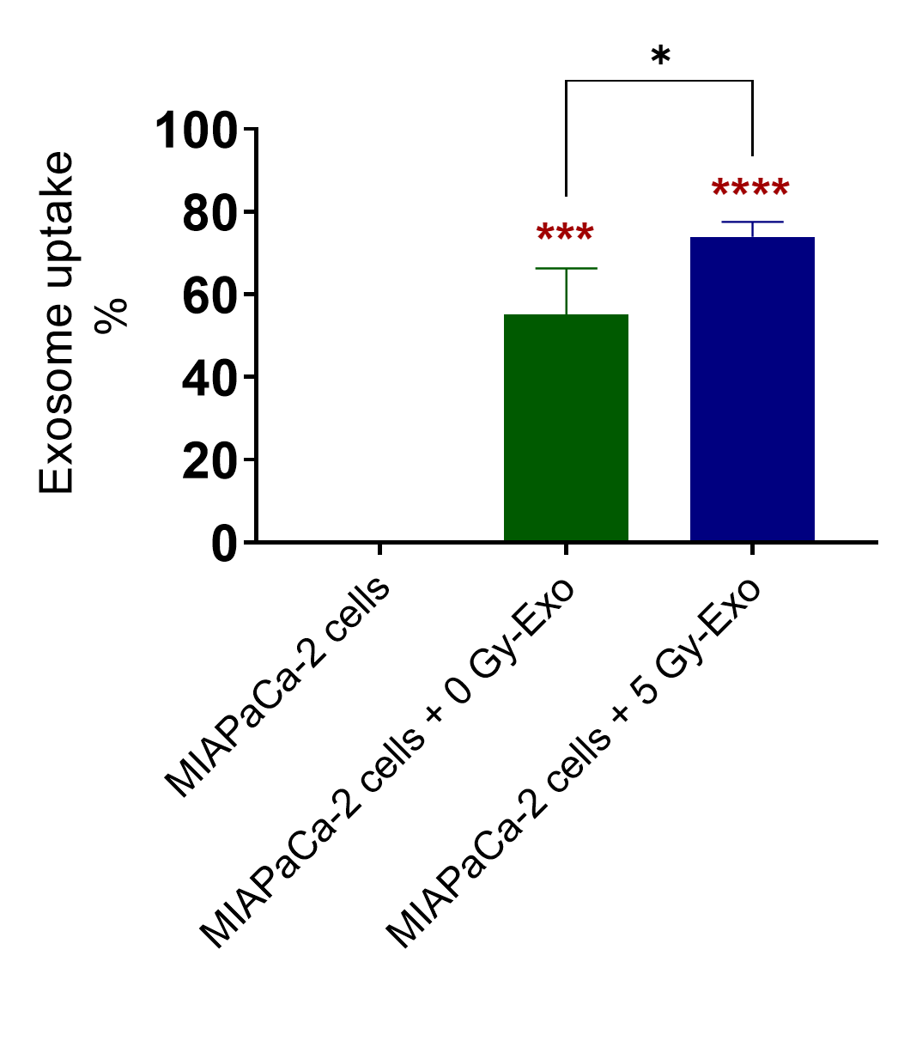

Figure S1. Representative images showing the uptake of 0 and 5 Gy-Exo by MIAPaCa-2 cells under a confocal microscope. The uptake (green) of 5 Gy-Exo was higher compared to 0 Gy-Exo. Blue represents Hoechst counterstaining. Data are presented as the mean ± standard error of the mean (n = 3). P-values were calculated using one-way analysis of variance, followed by a post-hoc Tukey's test. *p < 0.05, ***p < 0.001, and ****p < 0.0001. Scale bar, 20 µm.

Figure S2. Schematic representation for migration and invasion study.

Figure S3. Exosome suppressed liver metastasis. Representative images displaying the expression of S100A4 in the spleen and liver of mice injected with MIAPaCa-2 cells, with or without exosome treatment.

