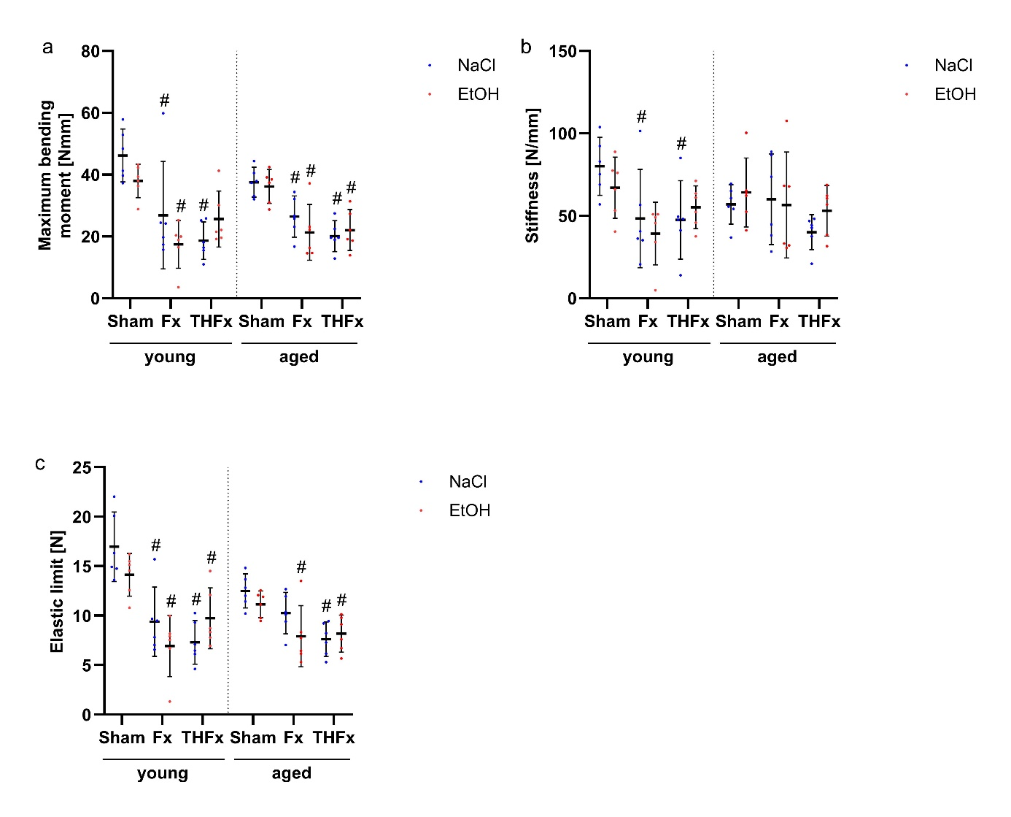
Supplementary Figure 1: Analysis of biomechanical parameters. No effects of single binge alcohol consumption or an additional blood loss was detectable in the biomechanical three-point bending test for the parameters maximum bending moment (A), stiffness (B) or elastic limit (C). Only differences against the representative Sham groups occurred. # p < 0.05 vs. respective Sham. n = 6 per group.

