Supplementary Information

Optimizing Extracellular Matrix for Endothelial Differentiation
Using a Design of Experiments Approach
Mikayla L. Hall^{1, 2}, Wei-Han Lin^{1, 2}, and Brenda M. Ogle^{1,2,3,4,5,6}*

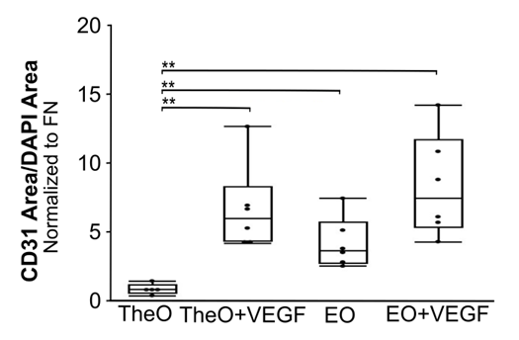
Figure S1: Effect of VEGF addition to cell culture media on endothelial differentiation
Abbreviations used: Collagen I (C), Collagen IV (CIV), Laminin 411 (LN411), Fibronectin (FN), Theoretical Optimized ECM (TheO), Endothelial Optimized ECM (EO)
Graphical representation of CD31 area per DAPI area normalized to the FN control for TheO and EO with and without the addition of VEGF to cell culture media beginning day 0 of differentiation. **p<0.01

Figure S2: Collagen IV distribution in the dual ECM construct prior to differentiation
Abbreviations used: Endothelial Optimized ECM (EO)
Bioprinted dual component constructs fixed on day 0 of endothelial differentiation were stained for collagen IV (red) and DAPI (blue) to show the exogenous ECM distribution in the EO side (left) and the no ECM control side (right) of the construct.

Figure S3: Profound CD31 expression in the no ECM control side with collagen IV expression of the dual ECM construct after endothelial differentiation
Abbreviations used: Endothelial Optimized ECM (EO), No ECM control area with collagen IV expression (Ctrl_COL4+; No ECM control – CIV+)
Graphical representation of CD31 area ratio for the EO side and the no ECM control side with collagen IV expression of the dual component constructs (left, n = 4), as well as an immunofluorescence image of the no ECM control side with collagen IV expression stained for CD31 (red), collagen IV (green) and DAPI (blue). *p<0.05

