In-silico characterization and expression study of eIF genes associated with abiotic stresses in potato (Solanum tuberosum L.)
Maninder Kaur¹, Pooja Manchanda¹*, Sat Pal Sharma²
¹ School of Agricultural Biotechnology, Punjab Agricultural University, Ludhiana, Punjab, India, 141004
² Department of Vegetable Science, PAU, Ludhiana, Punjab

*Corresponding author- poojamanchanda5@pau.edu
Supplementary Figures
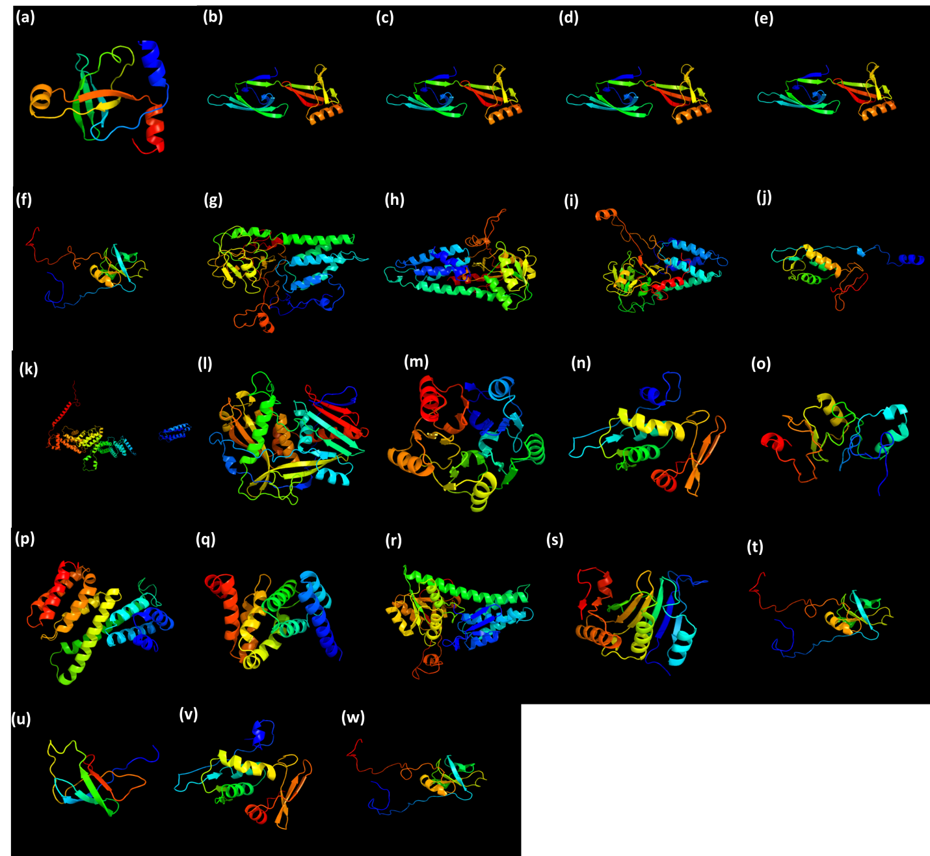

Fig. S1. Predicted structures of proteins (a) SteIF-5, (b) SteIF5A3, (c) SteIF5A-4, (d) SteIF-5A5, (e) SteIF5A-1/2, (f) SteIf-1a, (g) SteIF2b, delta, (h) SteIF-2balpha-2, (i) SteIF2Bbeta, (j) SteIF2beta, (k) SteIF3, (l) SteIF-3, (m) SeeIF-4.1, (n) SteIF5, (o) StEMB1624 (p) St4FeiF-4F-1, (q) St4Feif-4F-2, (r) StCIG2, (s) SteIF(ISO)4E-2, (t) SteIF, (u) SteIF-1, chloroplastic, (v) SteIF-1.1, (w) SteIF-1a.1

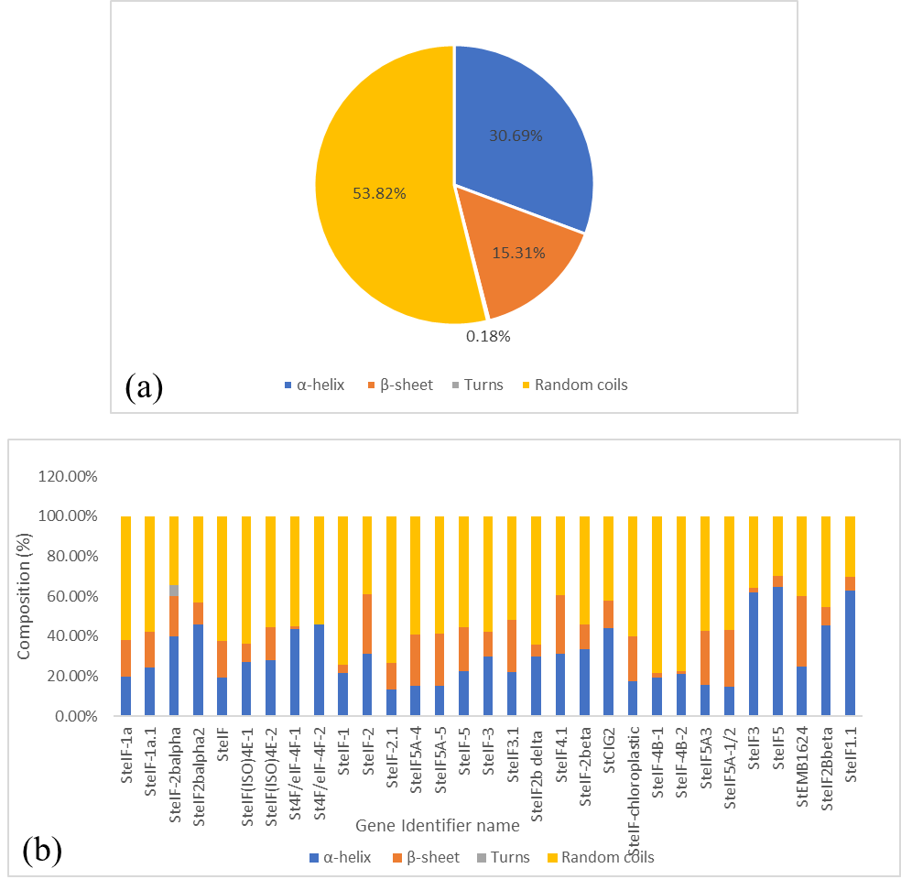
Fig. S2. (a) Pie-chart represents different conformational stages of all proteins (b) Distribution of different conformational stages in the secondary structure of all proteins

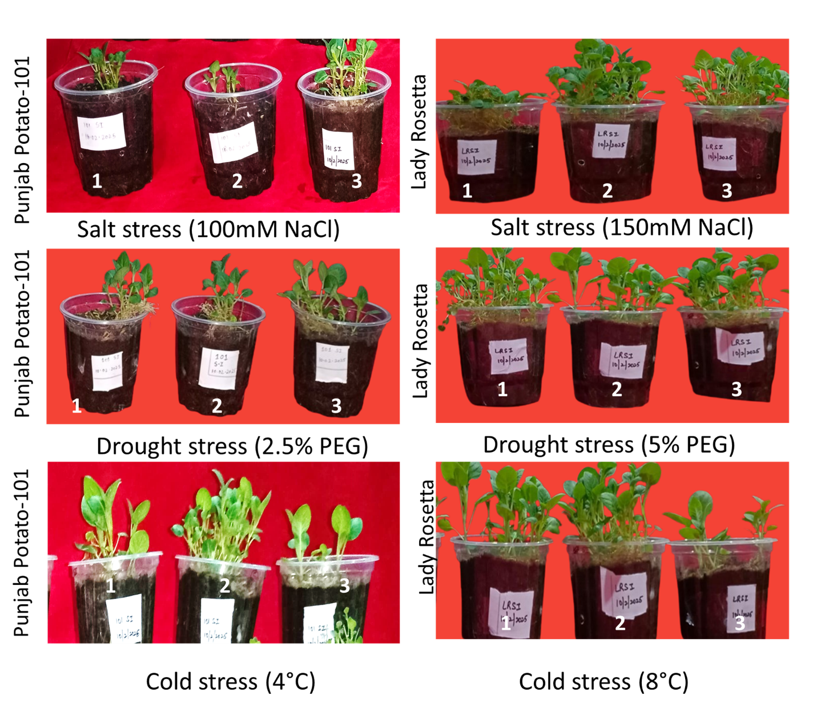
Fig S3 Morphological observations under salt, drought and cold stress in Punjab Potato-101 and Lady Rosetta; 1, 2 and 3 represent three biological replicates

