Supporting Information
Computational Repurposing of Drugs against Dengue Virus Targeting NS5 and Methyltransferase Proteins
Murthaeti Yaswanth^{1#}, Amit Dubey^{2#}, Aisha Tufail^{$3}, Subrata Nath^{$4}, Saravanan Janardhan¹, Michele Maffia⁵, Andrea Ragusa^{6,7}* and Vipin Kumar Mishra⁴*
¹ Department of Pharmaceutical Chemistry, PESU Institute of Pharmacy, PES University, Bangalore-560100, Karnataka, India.
² Center for Global Health Research, Saveetha Medical College and Hospital, Saveetha Institute of Medical and Technical Sciences, Chennai-600077, Tamil Nadu, India
³ Computational Chemistry and Drug Discovery Division, Quanta Calculus, Greater Noida-201310, Uttar Pradesh, India
⁴ Chemistry Division, School of Advanced Science and Languages, VIT Bhopal University Bhopal, India
⁵ Department of Experimental Medicine, University of Salento, Via Lecce-Monteroni, 73100 Lecce, Italy
⁶ Department of Life Sciences, Health and Health Professions, Link Campus University, Via del Casale di San Pio V 44, 00165, Rome, Italy
⁷ CNR-Nanotec, Institute of Nanotechnology, Via Monteroni, 73100, Lecce, Italy
Corresponding authors: Vipin Kumar Mishra, Chemistry Division, School of Advanced Science and Languages, VIT Bhopal University Bhopal, India; Andrea Ragusa, Department of Life Sciences, Health and Health Professions, Link Campus University, Via del Casale di San Pio V 44, 00165, Rome, Italy
Contact email: vipinkumarmishra@vitbhopal.ac.in; a.ragusa@unilink.it
* Corresponding Authors
# Equal Contributions
$ Equal Contributions

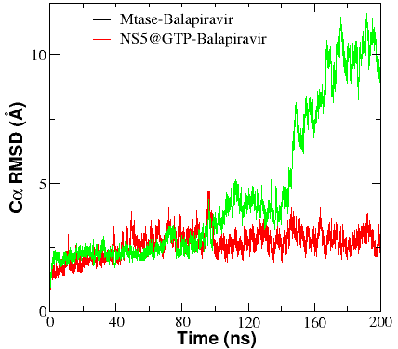
Figure S1: RMSD of reference drug (Balapiravir) with Mtase and NS5 protein as target.

Figure S2: The number of Hydrogen bonds between Balapiravi and Targets protein (Mtase and NS5).

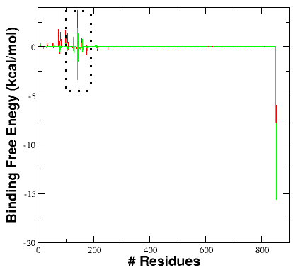
(A)
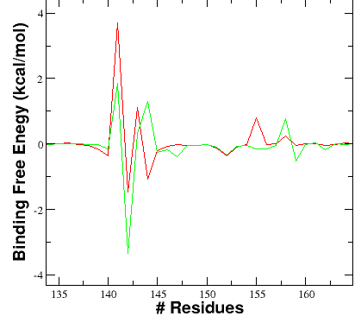
(B)
Figure S3: (A) Residue wise decompositions of binding free energy NS5 protein with Avermectin (red) and Doramectin (green) (B) A zoom picture of residues 135 to 160.

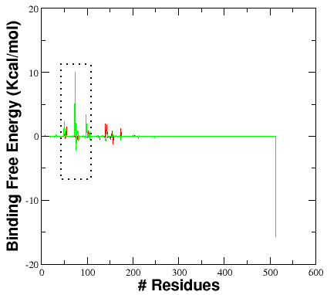
(A)
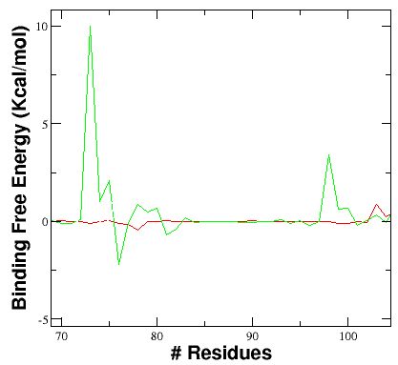
(B)
Figure S4: (A) Residue wise decompositions of binding free energy Mtaseprotein with Avermectin (red) andDoramectin (green) (B) A zoom picture of residues 70 to 105.

(A)  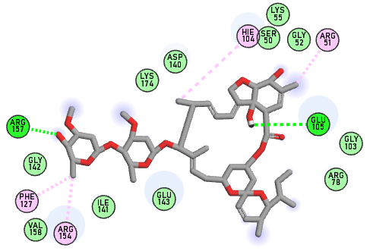 | 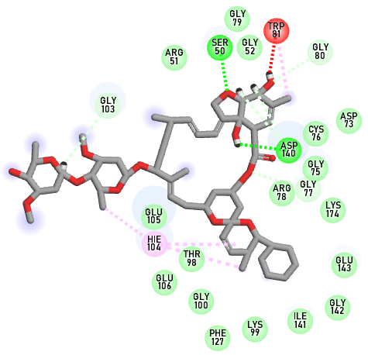  (B)
(C)  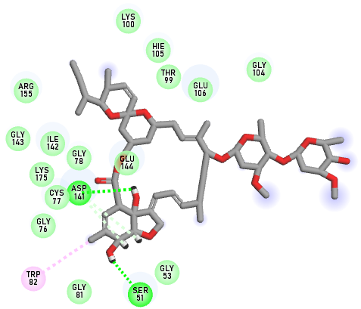 | (D)  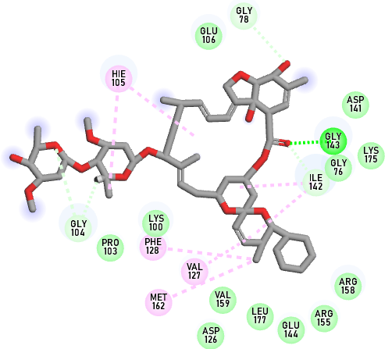
Figure S5: The representation structure of the most populated cluster of MTase and NS5 with bound inhibitors during 200 ns molecular dynamics simulation (A) Binding site of Avermactive in Mtase (B) interaction of Doramectine with Mtase (C) Binding site of and (D) interaction of 1d ligand with E.Coil .The ligand (green) with stick and protein complex shown as cartoon.

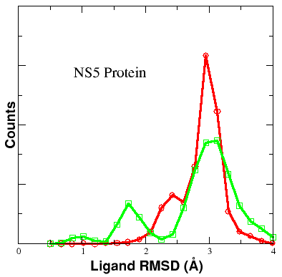  (A) | 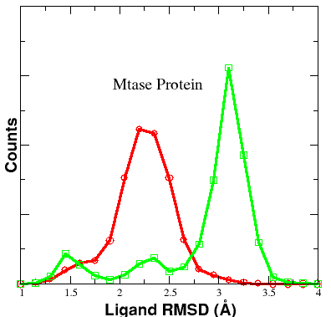  (B)
Figure S6: (A) Ligand RMSD of Avermectin and Doramectin in the NS5 protein-bound complex. (B) Ligand RMSD of Avermectin and Doramectin in the Mtase protein-bound complex. The red plot represents Avermectin, while the green plot represents Doramectin.

Table S1. Binding free energy components of Mtase protein and Balapiravi
∆E_{ELEC} | -5.9
∆E_{VDW} | -8.3
∆EPB | 10.2
∆EPB_{np} | -1.02
∆E_{Disper} | 0.0
∆G(∆H_{PB}-T∆S) | -4.1±0.5
Binding free energy (∆G) ofMtase protein and ligand complex was calculated from the 200 ns simulation. The molecular-mechanical energy calculations were performed using MM/PBSA, and entropy calculations using nmode analysis. ∆E_{EELEC}, ∆E_{VDW}, ∆EPB_{np} and ∆EPB_{solv} are referred to the electrostatic, Vander Waals, polar, the non-polar contribution to the solvation energy and the electrostatic contribution to the solvation energy, respectively.

Table S2. Binding free energy components of NS5 protein and Balapiravi
∆E_{ELEC} | -36
∆E_{VDW} | -59
∆EPB | 77
∆EPB_{np} | -5.0
∆E_{Disper} | 0.0
∆G(∆H_{PB}-T∆S) | -23.0±4.2
Binding free energy (∆G) ofNS5 protein and ligand complex was calculated from the 200 ns simulation. The molecular-mechanical energy calculations were performed using MM/PBSA, and entropy calculations using nmode analysis. ∆E_{EELEC}, ∆E_{VDW}, ∆EPB_{np} and ∆EPB_{solv} are referred to the electrostatic, Vander Waals, polar, the non-polar contribution to the solvation energy and the electrostatic contribution to the solvation energy, respectively.

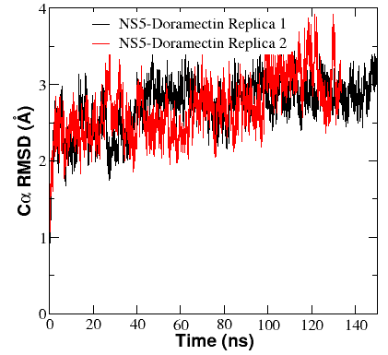  (A) | 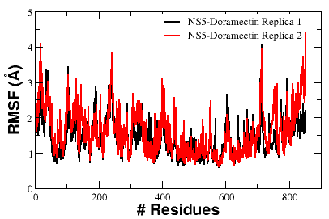  (B)
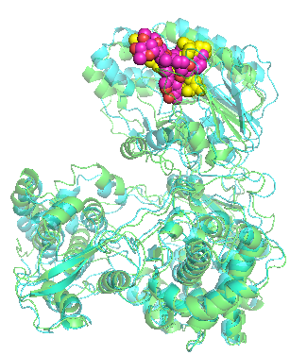
(C)
Yellow Ligand (replica 2)
Magenta Ligand (replica 1)
Figure S7: (A) RMSD comparison of NS5–Doramectin complexes from Replica 1 and Replica 2,
(B) RMSF profiles of NS5–Doramectin from Replica 1 and Replica 2,
(C) Representative structural snapshots at 140 ns for both Replica 1 and Replica 2

System | ∆G (kcal/mol) | RMSD (average) | RMSF (average)
NS5 and Doramectin Replica1 | -23.8±0.82 | 2.77 Å | 1.43 Å
NS5 and Doramectin Replica2 | -22.2±2.1 | 2.68 Å | 1.50 Å
Table S3: A comparative analysis of two 150 ns MD simulation replicas of the NS5–Doramectin complex.

