Supplementary Materials

Comprehensive Experimental Study of Multivariable Oil–Brine–Rock Interactions: Impact of Brine–Rock Chemistry and Crude Oil Polarity on Enhanced Oil Recovery in Carbonate Reservoirs

Azadeh Amrollahi Biyouki^{1,2}* , Nosrat Izadi², Samaneh Bovard³, Yasaman Tahernezhad⁴, Nashaat Nassar⁵, Ebrahim Ghafar-Zadeh⁴

¹School of Chemical Engineering, College of Engineering, University of Tehran, P.O. Box: 11155/4563, Tehran, Iran
²Nanotechnology Research Center, Research Institute of Petroleum Industry (RIPI), P.O. Box: 14665-1998, Tehran, Iran
³Petroleum Engineering Research Division, Research Institute of Petroleum Industry (RIPI), P.O. Box: 14665-1998, Tehran, Iran
⁴Biologically Inspired Sensors and Actuators (BioSA), Lassonde School of Engineering, York University, Toronto, ON M3J1P3, Canada
⁵Department of Chemical and Petroleum Engineering, University of Calgary, 2500 University Dr NW, Calgary, T2N 1N4, Alberta, Canada

*Corresponding authors: Azadeh Amrollahi Biyouki (Azadeh.Amrollahi@gmail.com), (aab@yorku.ca)

LAS 1012D, 4700 Keele Street, ON M3J 1P3, Toronto, Canada
Phone: (416) 736-2100 X44646
Fax: (416) 736-5872

Table of Contents: | Page
Section S1. Extract method of asphaltenes from an Iranian oil sample | 2
Section S2. FTIR spectra of asphaltenes | 2
Section S3. P-values of zeta potential data for both n-heptane/toluene 1:5 and n-heptane/toluene 1:40 | 3
Section S4. Box plot of zeta potential data for both n-heptane/toluene 1:5 and n-heptane/toluene 1:40 | 3
Section S5. Statistical analysis: zeta-potentials of water/oil interface | 4
Section S6. Box plot with p-values of zeta potential values measured at different brine and Box plot of zeta potential values measured at various concentration | 5
Section S7. Statistical analysis: zeta-potentials of water/rock interface | 7
Section S8. Shapiro-Wilk and Levene's test for Zeta Potential data of rock in different Brines and Box-plot of zeta potential between two rock types for different brine solutions | 8
Section S9. Statistical analysis: wettability alteration (contact angle change) In water rock interface | 10
Section S10. Result of asphaltene size distribution | 11

S1. Extract method of asphaltenes from an Iranian oil sample- modified ASTM 2007-03.
To extract asphaltenes from an Iranian heavy oil sample, a modified ASTM 2007-03 standard procedure involving precipitation in excess n-heptane was employed. Before the extraction, the field's dead oil sample underwent centrifugation at 7000 rpm for one hour to eliminate water and particulate matter found in typical field samples. A specified quantity of heavy oil was mixed with n-heptane at a ratio of 1:40 g/mL in a sealed glass container. The mixture was then subjected to ultrasonic irradiation using an Ultrasonic Cleaner Elmasonic PH350EL for 30 min followed by stirring at 650 rpm for 24 h at room temperature. The mixture separated into two phases, with black precipitates forming in the container. After decanting the supernatant liquid, the precipitates were mixed with fresh n-heptane at a ratio of 1:4 (g/mL) and shaken for 10 min to remove any accompanying maltenes. The resultant mixture was centrifuged at 3500 rpm for 45 min. The washing with fresh n-heptane and subsequent centrifugation were repeated several times until the asphaltenes' color became shiny black. The obtained solid asphaltenes were dried at 60°C, refined, and stored in a dessicator. The elemental composition, functional groups, and size of the asphaltenes nanoaggregates in heptol were determined as previously described in our research.

S2. FTIR spectra of asphaltene.
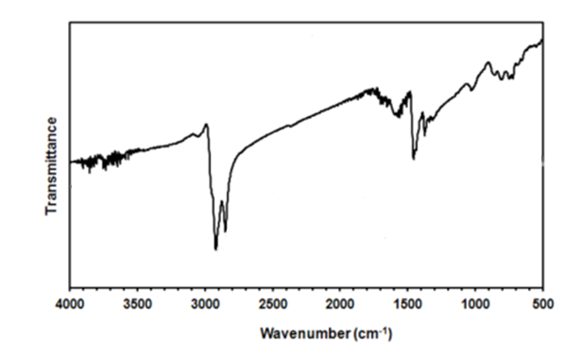
Fig.S1. FTIR spectra of asphaltenes.

In the following, statistical analyses were conducted to evaluate the distribution and variability of zeta potential measurements across different brine conditions. The Shapiro-Wilk test [1] was employed to assess the normality of the data within each group. This test is highly sensitive to deviations from normality and is particularly effective for small sample sizes. Results indicated significant departures from normality (p<0.05) in most groups, necessitating the use of non-parametric methods. To examine the equality of variances among groups, Levene’s test [2] was applied, revealing heterogeneity in variances (p<0.001), which further supported the use of non-parametric approaches. The degrees of freedom (Df) reported with Levene's test represent the number of independent values that can vary in the analysis. For pairwise comparisons, Wilcoxon rank-sum tests (also known as the Mann-Whitney U test) were conducted, as these tests do not assume normality or equal variances [3]. Additionally, the Kruskal-Wallis test [4] was used for multi-group comparisons to evaluate whether distributions differed significantly across brine conditions. The Kruskal-Wallis test is a rank-based non-parametric method, appropriate for datasets that violate parametric assumptions. Statistical outputs, including W-values for Shapiro-Wilk test, Levene's test and Wilcoxon tests, along with corresponding p-values, were reported to highlight significant group differences. These methods ensured robust analysis of the data, accounting for its non-normal distribution and heteroscedasticity.

S3. P-values of zeta potential data for both n-heptane/toluene 1:5 and n-heptane/toluene 1:40.

Table S1. P-values of zeta potential data for both n-heptane/toluene 1:5 and n-heptane/toluene 1:40
Method | W-value | P-value
Shapiro-Wilk test for n-heptane/toluene 1:5 | 0.90874 | 0.005966
Shapiro-Wilk test for n-heptane/toluene 1:40 | 0.81965 | 1.194e-05
Wilcoxon rank-sum test for Zeta Potential between n-heptane/toluene 1:5 and 1:40 | 373 | 0.0001259

Since the p-value is much less than 0.05, we reject the null hypothesis that the two groups have the same distribution. This suggests that there is a statistically significant difference in the zeta potential values between the n-heptane/toluene 1:5 and n-heptane/toluene 1:40 groups.

S4. Box plot of zeta potential data for both n-heptane/toluene 1:5 and n-heptane/toluene 1:40
The boxplot analysis presented in the figure provides a detailed comparison of the zeta potentials for two different mixtures of n-heptane and toluene at ratios of 1:40 and 1:5. The median zeta potential for the n-heptane/toluene 1:40 mixture is approximately -22 mV, whereas the median for the n-heptane/toluene 1:5 mixture is around -10 mV. This indicates a more negative surface charge for the 1:40 mixture. Additionally, the mean values, indicated by the red crosses, corroborate this observation, showing a similar trend in both groups. The p-value of 0.034, derived from the Wilcoxon test, confirms that this difference is statistically significant at the 5% significance level, suggesting that the variations in zeta potential between the two mixtures are not due to random chance. Furthermore, the spread of data points and the error bars indicate a greater variability in the zeta potential values for the 1:40 mixture compared to the 1:5 mixture. The min and max values, highlighted by the triangles and circles respectively, emphasize the range of zeta potential values within each group. This detailed analysis demonstrates that the proportion of toluene in the mixture significantly impacts the zeta potential, with higher toluene content (1:40 ratio) resulting in a less negative zeta potential. These findings are critical for understanding the electrokinetic properties of these mixtures, which can influence various applications in fields such as oil recovery and colloidal stability.
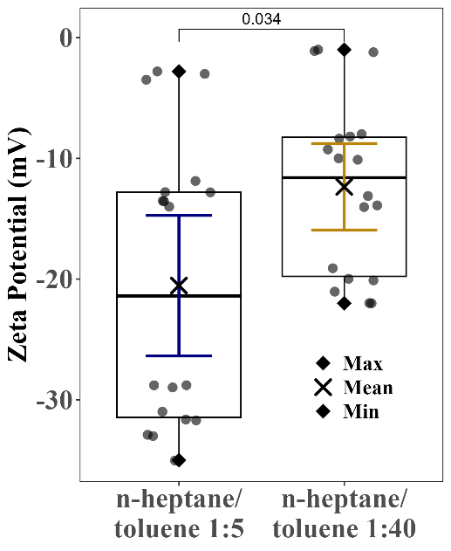
Fig.S2. Box plot of zeta potential data for both n-heptane/toluene 1:5 and n-heptane/toluene 1:40.

S5. Statistical analysis: zeta-potentials of water/oil interface
From a statistical point of view, figure 2(a) shows results for two heptane/toluene mixtures (1:5 and 1:40). The R² values of 1.00 and 0.98 confirm the reliability of the Locally Estimated Scatterplot Smoothing (LOESS) regression models. It is a non-parametric regression method that fits multiple linear regressions to localized subsets of the data, enabling it to capture complex, nonlinear relationships [5]. By weighing nearby points more heavily, LOESS provides a smooth curve that closely follows the underlying data patterns, making it particularly useful for modeling trends in experimental studies. The 1:5 mixture becomes more negative with higher pH, reaching -25 mV, while the 1:40 mixture stabilizes around -15 mV. Smaller error bars indicate consistent data, and stronger negative values at higher pH suggest better emulsion stability. Zeta potential measurements for oil droplets in brines (A=FW, B=SW, C=SW2Ca, D=SW2Mg, E=SW0SO4, F=SW2SO4, G=SW4SO4, H=SW25d and I=SW50d) show trends influenced by pH and ionic strength. Increasing pH leads to more negative zeta potential values, reflecting stronger electrostatic repulsion. Figure 2(b) highlights variations across brines with R2 values between 0.917 and 1.000, indicating strong fits. Brine A reaches -25 mV at pH 7–8, suggesting effective stabilization against coalescence. Brines H and D show moderate decreases, while A remains stable and less negative, indicating weaker repulsion. Highly negative values in G highlight its role in stabilizing emulsions. Figure 2(c) investigates the impact of brine concentration at neutral pH with 1:5 heptol and 0.2% asphaltene. Brines show varied responses, with A remaining around -10.8 mV and B fluctuating between -16.1 mV and less negative values. D initially dips to -25 mV at low concentrations and increases, while G peaks at -28 mV at 20,000 ppm before stabilizing. The R2 values, including 0.971 for G and 0.989 for B, confirm reliable trends. Results show that zeta potential becomes less negative with rising concentrations, indicating weaker electrostatic repulsion and reduced stability. G maintains higher negative values, promoting stable emulsions and preventing droplet coalescence. Figure 2(d) explores how IFT changes with brine type and asphaltene concentration (0.2%, 4%, and 9%). Higher asphaltene levels lead to increased IFT. Brines A and B have lower IFT (~5–8 mN/m), while G and I show higher values (~12–14 mN/m). The error bars are small, supporting measurement consistency. Trends emphasize the importance of balancing asphaltene content and ionic strength to control interfacial stability and optimize oil recovery. Figure 2(f) compares IFT and coalescence times. Brine G shows the highest IFT (~25 mN/m) and longest coalescence time, while brine A has lower IFT (~10 mN/m) and shorter coalescence time. Higher IFT correlates with longer coalescence times, suggesting better stability. Error bars are small, confirming data reliability. Small error bars confirm reliability, and the dual-axis visualization highlights the link between IFT and coalescence behavior [4-7].
These results confirm that pH, brine type, concentration, and asphaltene levels affect zeta potential and interfacial stability. Stronger negative zeta potentials and higher IFT values prevent droplet merging, stabilizing emulsions. High values validate the data, emphasizing the importance of selecting brine compositions to optimize oil recovery. Lower concentrations and sulfate-rich brines like G enhance stability due to stronger electrostatic repulsion. These findings provide practical strategies for improving oil recovery through controlled chemical interactions.

S6. Box plot with p-values from Wilcox test for zeta potential of oil droplets in different brine and Box plot of zeta potential values measured at various concentrations.
Wilcox test for zeta potential of oil droplets in different brine plot provides a detailed analysis of the zeta potential differences across various brine types, with a particular focus on the statistical significance of these differences as indicated by the p-values. The extremely low p-values observed in many pairwise comparisons (e.g., 4.2e-08, 3.1e-07) suggest highly significant differences in zeta potential between the corresponding brine types. For instance, the zeta potential values for FW and SW0SO₄ are significantly different from those of all other brine types, emphasizing their unique electrochemical properties. On the other hand, brine types like SW2Mg and SW4SO₄ exhibit p-values around 0.65, indicating no significant difference in their zeta potential values. These findings are crucial for practical applications, such as oil recovery, where understanding the surface charge interactions can optimize the selection of brine types. The plot highlights the importance of statistical analysis in distinguishing the electrochemical behaviors of different brines, providing a clear indication of which brine types have significantly different properties and thus, should be chosen carefully based on their specific electrochemical characteristics.
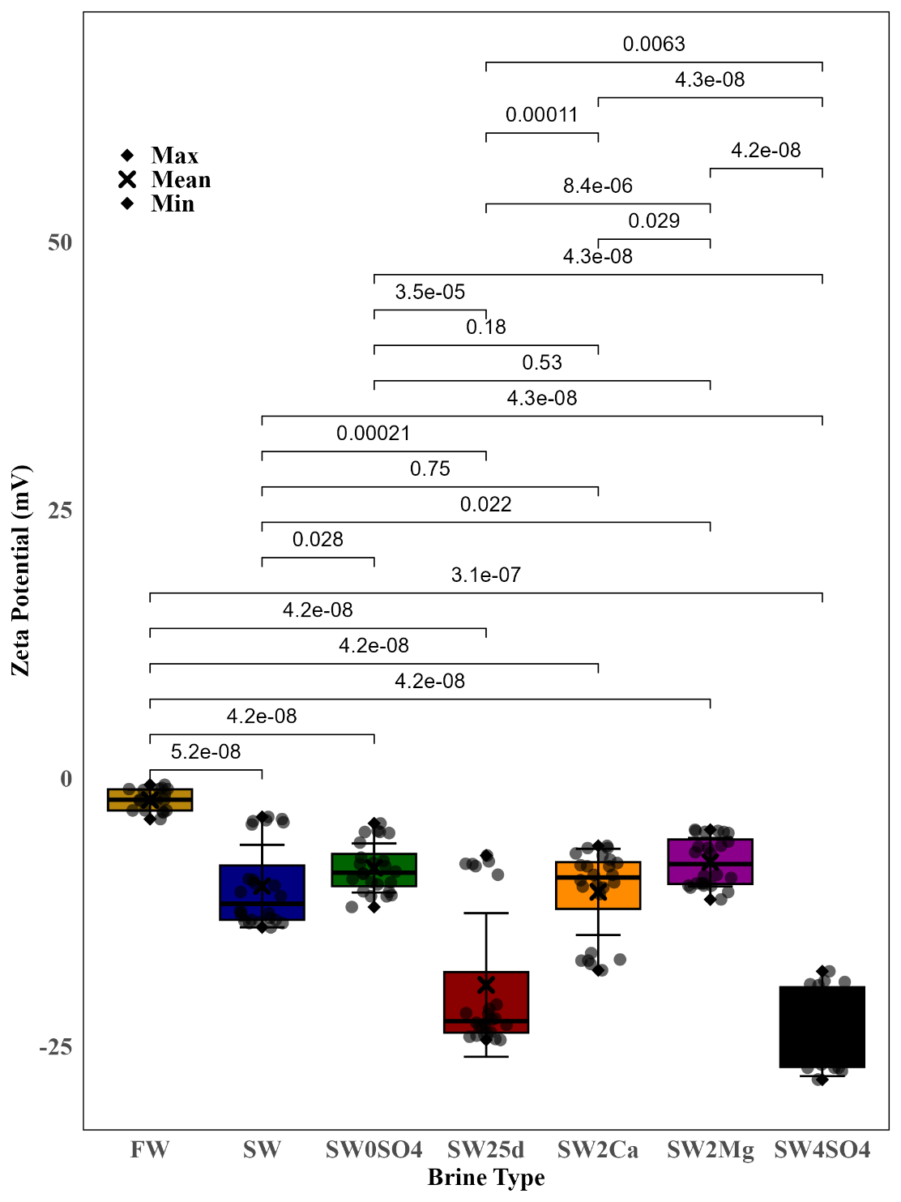
Fig.S3. Box plot of zeta potential of oil droplets in FW, SW, SW4SO₄ and 25dSW brines in variety of PH (1:5 heptol, Asph0.2%).

Box plot of zeta potential values measured at various concentrations compares the zeta potential values for four different brine types: FW, SW, SW25d, and SW4SO₄, providing a detailed view of the data points, summary statistics, and error bars. The individual data points are displayed as dots, showing the distribution and variability within each brine type. The summary statistics, including the mean, median, maximum, and minimum values, are indicated by different symbols: the mean is marked with a cross, the maximum with a circle, and the minimum with a triangle. The error bars represent the standard error of the mean, giving insight into the reliability of the measurements. The p-values shown in the plot highlight the statistical significance of the differences in zeta potential between the brine types, with all values being less than 0.05. For instance, the p-value of 0.00025 between FW and SW indicates a highly significant difference, while the p-values of 9.7e-07 and 2.8e-07 between SW and SW25d, and SW and SW4SO4, respectively, and also show substantial differences. The p-value of 0.0081 between SW25d and SW4SO4, although significant, indicates a relatively smaller difference. These findings underscore the importance of understanding the distinct electrochemical properties of each brine type for applications such as oil recovery and surface chemistry. The plot provides a clear depiction of the variability and central tendencies, emphasizing the need to select the appropriate brine type based on its zeta potential characteristics to optimize processes [8-10].

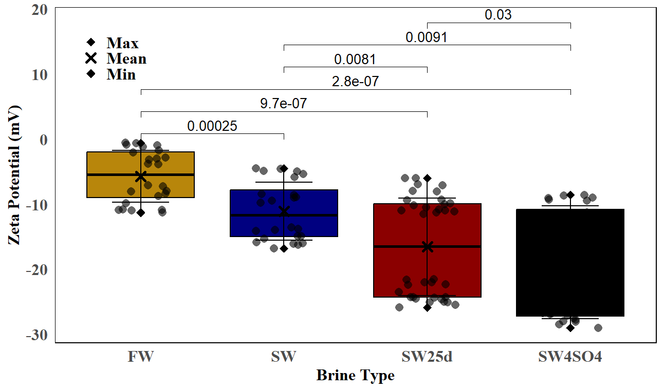
Fig.S4. Box plot of zeta potential of oil droplets in different brines concentrations and in neutral pH (1:5 heptol, Asph0.2%).

S7. Statistical analysis: zeta-potentials of water/rock interface
From a Statistical Point of View, the zeta potential instrument was used to measure the charge of the rock/brine interface for calcite and dolomite in various brines. Figures 3(a) and 3(b) show the variation of zeta potential with pH for calcite and dolomite, respectively. The results indicate that the isoelectric point (IEP) is not fixed but varies with brine salinity, reflecting dynamic electrostatic and ionic interactions. Calcite particles exhibit no IEP in A but show an IEP of 9.5 in B. Above this IEP, the charge is positive, turning negative below it. Dolomite, in contrast, shows a lower IEP around pH 5, reflecting a higher affinity for potential-determining ions (PDIs) due to its more defective surface structure compared to calcite. The LOESS model provides high R2 values (0.994–1.000), indicating reliable fits. Figure 3(d) compares zeta potential values across brines and asphaltene concentrations (0.2%, 4%, 9%). Calcite shows more variation in surface charge, with zeta potential shifting to more negative values at higher sulfate concentrations (G), emphasizing the influence of sulfate ions in stabilizing emulsions. Dolomite maintains a higher, less variable positive charge due to its stronger interactions with divalent cations. These trends demonstrate that calcite is more sensitive to pH and ionic changes, whereas dolomite is influenced more by cation composition. Figures 3(e) and 3(f) examine zeta potential of calcite and dolomite in brines, showing that calcite tends to have more negative values, especially in sulfate-rich solutions. Dolomite remains closer to neutral, indicating higher stability at different pH levels. The results highlight calcite’s steeper slope in B compared to A, shifting IEP to higher pH values (9.3–11.1) with increasing sulfate concentration. Dolomite retains positive charges at higher pH due to excess divalent cations, aligning with previous studies. These trends show that calcite responds strongly to brine modifications, while dolomite’s charge stability reduces sensitivity to pH changes. Total Zeta Potential of Oil/Brine for Calcite and Dolomite. Figures 3(g) and 3(h) combine oil/brine zeta potential for calcite and dolomite. Higher asphaltene concentrations result in less negative potentials, reducing electrostatic repulsion. Calcite shows larger variations (-40 mV to -5 mV) compared to dolomite (-15 mV to -5 mV), indicating calcite’s greater responsiveness to ionic strength and pH changes. The total zeta potential aligns with oil production rates, suggesting that higher repulsion improves oil recovery by stabilizing emulsions. Figure 3(i) provides a summary of zeta potential distributions for calcite and dolomite. Calcite has a wider range (-40 mV to 5 mV), reflecting higher sensitivity to pH and brine composition. Dolomite shows a narrower range (-25 mV to 10 mV), indicating more stable behavior. Statistical markers highlight mean, maximum, and minimum values, reinforcing calcite’s higher variability and dolomite’s consistency. These results support the conclusion that calcite can be fine-tuned for electrostatic interactions, while dolomite offers baseline stability.
From a statistical perspective, Figures 3(a)–(i) highlight how pH, brine composition, and asphaltene concentrations influence zeta potential and surface stability for calcite and dolomite. High R2 values confirm reliable data, showing that calcite is more responsive to pH and brine changes, while dolomite maintains stability with divalent cations. Trends indicate that sulfate-rich brines, like G, produce more negative zeta potentials, enhancing emulsion stability and oil recovery. These findings emphasize the importance of tailoring pH and brine composition to control surface charges, optimizing oil recovery processes through chemical adjustments. Additionally, variations in electrostatic behavior align with oil recovery rates, further demonstrating the role of zeta potential in enhancing production efficiency.

S8. Shapiro-Wilk and Levene's test for zeta potential data of rock in different brines and Box-plot of zeta potential between two rock types for different brine.
Table S2 indicate significant deviations from normality across all brine groups for both Calcite and Dolomite stones, as shown by the Shapiro-Wilk test (p<0.05). Additionally, the Levene's test for equality of variances revealed significant differences in variance among groups (p<0.001), suggesting heterogeneity in variances. Given these violations of normality and homogeneity assumptions, non-parametric methods are recommended. Specifically, the Wilcoxon rank-sum test (Mann-Whitney U test) is suitable for pairwise comparisons, while the Kruskal-Wallis test is appropriate for multi-group comparisons, followed by p-value adjustments for multiple testing.

Table S2: Shapiro-Wilk and Levene's test for zeta potential rock/brain.
Brine | p_value | Test | Stone | Df | W-value | P-value
FW | 9.22E-06 | Shapiro-Wilk | Calcite
SW | 5.76E-07 | Shapiro-Wilk | Calcite
SW25d | 7.57E-05 | Shapiro-Wilk | Calcite
SW4SO4 | 0.000503 | Shapiro-Wilk | Calcite
 |  | Levene's Test | Calcite | 3 | 8.5347 | 2.28E-05
FW | 6.88E-06 | Shapiro-Wilk | Dolomite
SW | 9.2E-06 | Shapiro-Wilk | Dolomite
SW25d | 5.3E-07 | Shapiro-Wilk | Dolomite
SW4SO4 | 0.0161 | Shapiro-Wilk | Dolomite
 |  | Levene's Test | Dolomite | 3 | 8.3898 | 2.75E-05

Figure S5(a) and S5(b) illustrate the zeta potential distributions for Calcite and Dolomite samples, respectively, under different brine conditions (FW, SW, SW25d, and SW4SO4). The boxplot for Calcite shows significant differences in zeta potential across the brine types. The freshwater (FW) condition exhibits the highest mean zeta potential, with values decreasing progressively for SW, SW25d, and SW4SO4. Pairwise comparisons, assessed using the Wilcoxon rank-sum test, reveal highly significant differences (p-values ranging from 8.9×10−11 to 4.6×10−5) between all brine pairs. The observed trends suggest that changes in brine composition strongly influence surface charge, with SW4SO4 producing the most negative zeta potential values. Statistical markers for maximum, mean, and minimum values provide further insights into the variability within each condition, confirming non-overlapping distributions. In contrast, Dolomite demonstrates a more gradual decrease in zeta potential across brine conditions, with FW maintaining higher values and SW4SO4 exhibiting the lowest. Pairwise comparisons indicate significant differences between FW and SW (p=1.7×10−6), FW and SW25d (p=0.012), and FW and SW4SO4 (p=0.027). However, comparisons involving SW25d and SW4SO4 yield non-significant results (p=0.65), suggesting that Dolomite is less sensitive to changes in brine composition than Calcite. Despite this, variations in mean, maximum, and minimum values indicate distinct group separations, especially between FW and SW. Both figures highlight the pronounced effect of brine composition on zeta potential, with Calcite displaying greater sensitivity to compositional changes compared to Dolomite. These findings emphasize the role of mineral type in surface charge behavior and the potential implications for wettability and reactivity in different brine environments. The significant differences detected in most pairwise comparisons further validate the use of non-parametric methods due to deviations from normality and equality of variances, as previously discussed.

a
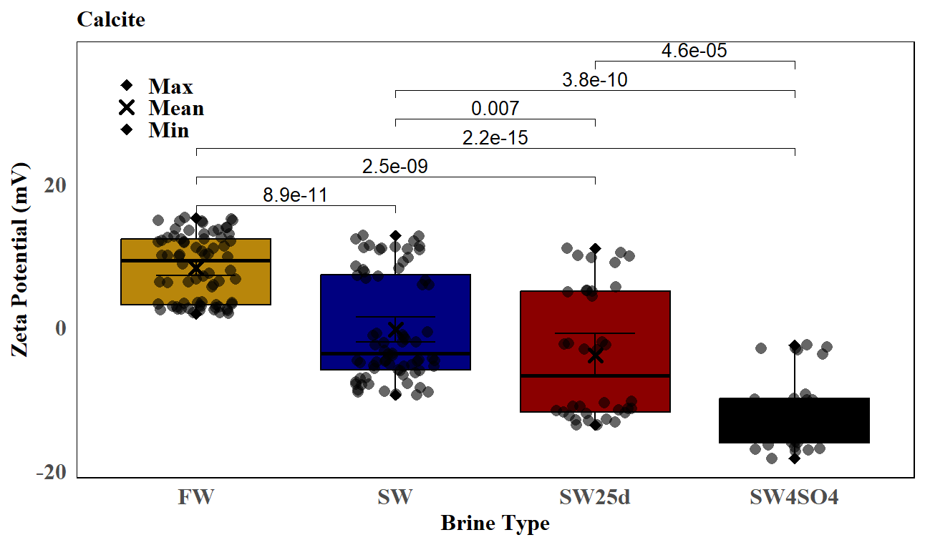
b
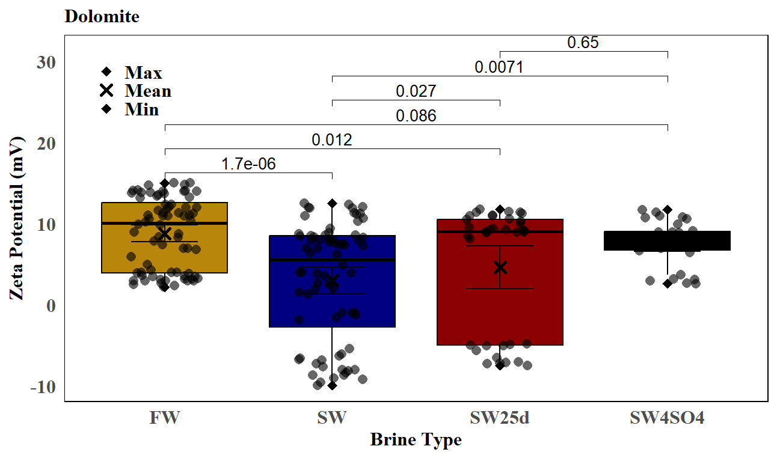
Fig S5. Box plot of zeta-potential of a) calcite and b) dolomite particles in FW, SW, SW4SO₄ and 25dSW.

S9. Statistical analysis: wettability alteration (contact angle change) In water rock Interface
The contact angle measurements for oil/rock (calcite and dolomite) in various brines and at different asphaltene concentrations, aligning with the interfacial tension of oil/brine, are presented in Figure 4a and 4b. As expected, the contact angle decreases with a reduction in asphaltene content, while higher asphaltene concentrations correspond to an increase in the contact angle, indicative of increased oil wetting. Notably, the contact angle in G and low-salinity brines experiences a more pronounced decrease compared to other brines. The dynamic contact angle measurements in different brines for calcite and dolomite rocks show that the contact angle continues to decrease over time (Figure 4c, 4d, 4e, 4f).
Statistical modeling was applied to analyze the trends in the contact angle data, using both linear regression and LOESS smoothing techniques. For calcite (Figure 4c), the linear model showed an R² value of 0.895, while the LOESS model had a slightly better fit with an R² value of 0.957. Similarly, for dolomite (Figure 4d), the linear model yielded an R² value of 0.604, whereas the LOESS model provided a higher R² value of 0.947, indicating that the LOESS approach better captures the non-linear behavior of contact angle reduction over time.
Figures 4e and 4f present boxplots summarizing the contact angle measurements for both rock types based on brine type and time, respectively. The boxplots reveal a wider spread in contact angles for calcite compared to dolomite, particularly at higher asphaltene concentrations, suggesting greater sensitivity of calcite to brine composition. Statistical tests confirmed significant differences (p < 0.05) in contact angles between brines, as well as between calcite and dolomite. For calcite particles, the contact angle is highest in A and decreases progressively in the other brines, with the lowest values observed in E and G. Specifically, in A at an asphaltene content of 0.2%, the contact angle for calcite is 155°, while for dolomite it is 159°, indicating that calcite surfaces are more hydrophilic in this brine. At asphaltene concentrations of 4% and 9%, the contact angles for calcite in A are 162° and 173°, respectively, compared to 161° and 169° for dolomite, showing a slight increase in oil-wettability for calcite at higher concentrations. The experimental observations and statistical analyses highlight that brine composition and asphaltene content significantly influence rock wettability. Low-salinity brines, particularly those enriched with sulfate ions, demonstrate a greater reduction in contact angle, enhancing water wetting. These results emphasize the potential of brine modification as a strategy for improving wettability and enhancing oil recovery efficiency.

S10. Result of asphaltene size distribution

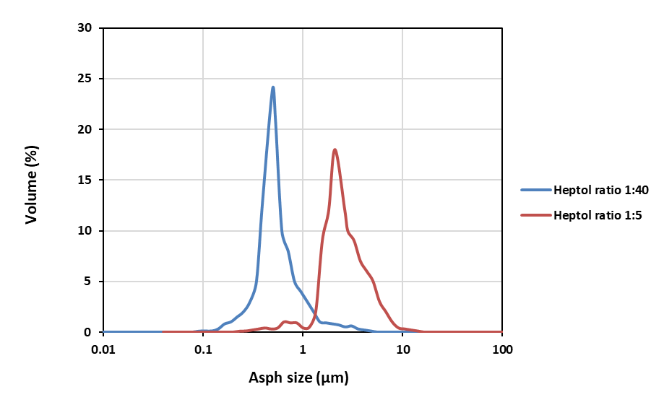
Fig S6. Effect of n-heptane/toluene (heptol) (vol%) ratio on Asphaltene Particle Size Distribution.

This graph illustrates the volume-based particle size distribution of asphaltenes at two different heptol dilution ratios: 1:40 (blue curve) and 1:5 (red curve). The x-axis represents the asphaltene particle size in micrometers (log scale), while the y-axis shows the corresponding volume percentage. At the higher dilution ratio (1:40), the asphaltenes exhibit a narrower distribution with a peak around 0.5 µm, indicating smaller and more stable colloidal particles. In contrast, at the lower dilution ratio (1:5), the peak shifts toward larger sizes (around 2.7 µm), and the distribution becomes broader, suggesting increased aggregation. This shift reflects the influence of heptol ratio on asphaltene behavior—higher ratio leads to enhanced particle coalescence and growth.

References

[1] | N. M. a. W. Y. B. a. o. Razali, "Power comparisons of shapiro-wilk, kolmogorov-smirnov, lilliefors and anderson-darling tests," Journal of statistical modeling and analytics, pp. 21--33, 2011.
[2] | H. Levene, "Robust tests for equality of variances. In Contributions to Probability and Statistics: Essays in Honor of Harold Hotelling," pp. 278-292, 1960.
[3] | P. E. a. N. J. McKnight, "Mann-Whitney U Test," Wiley Online Library, pp. 1--1, 2010.
[4] | W. H. a. W. W. A. Kruskal, "Use of ranks in one-criterion variance analysis," Journal of the American statistical Association, pp. 583--621, 1952.
[5] | W. S. Cleveland, "Robust locally weighted regression and smoothing scatterplots," Journal of the American statistical association, pp. 829--836, 1979.
[6] | P. a. C. W. a. T. B. Newbold, Statistics for Business and Economics, Pearson Education, 2012.
[7] | M. a. B. F. a. Q. D. a. D. F. a. v. d. B. D. a. M. M. a. L. A. a. W. E.-J. Maier, "Model-averaged Bayesian T-tests," PsyArXiv, 2022.
[8] | M. H. a. N. C. J. a. N. J. a. L. W. Kutner, Applied linear statistical models, McGraw-hill, 2005.
[9] | W. a. Q. Y. Zhang, "ANOVA-nSTAT: ANOVA methodology and computational tools in the paradigm of new statistics," Computational Ecology and Software, pp. 48--67, 2024.
[10] | M. E. a. M. K. L. O'Neill, "A comparison of five bootstrap and non-bootstrap levene-type tests of homogeneity of variances," Iranian Journal of Science and Technology, Transactions A: Science, pp. 979--989, 2019.

