Online supporting information for the following article submitted to Scientific Reports

Exposure to elevated relative humidity in laboratory chambers alters fungal gene expression in dust from the International Space Station (ISS)
Neeraja Balasubrahmaniam^{1,2,3}, Nicholas Nastasi^{1,2,3}, Bridget Hegarty⁴, John M. Horack⁵, Marit E. Meyer⁶, Sarah R Haines⁷, Karen C. Dannemiller^{2,3,8*}
¹Environmental Science Graduate Program, Ohio State University, Columbus, OH 43210
²Department of Civil, Environmental & Geodetic Engineering, College of Engineering, Ohio State University, Columbus, OH 43210
³Division of Environmental Health Sciences, College of Public Health, Ohio State University, Columbus, OH 43210
⁴Department of Civil & Environmental Engineering, College of Engineering, Case Western Reserve University, Cleveland, OH 44106
⁵Department of Mechanical and Aerospace Engineering, College of Engineering and John Glenn College of Public Affairs, Ohio State University, Columbus, OH 43210
⁶NASA Glenn Research Center, Cleveland, OH 44135
⁷Department of Civil & Mineral Engineering, University of Toronto, Toronto, Ontario M5S 1A4, Canada
⁸Sustainability Institute, Ohio State University, Columbus, OH 43210
*Corresponding Author Karen C. Dannemiller, Dannemiller.70@osu.edu, Civil, Environmental, and Geodetic Engineering; Environmental Health Sciences, The Ohio State University. 470 Hitchcock Hall, 2070 Neil Ave, Columbus, OH 43210. 614-292-4031.

Table of Contents

Figures
Figure S1 | 2
Figure S2 | 3

Tables
Table S1 | 4
Table S2 | 5
Table S3 | 6
Table S4 | 7
Table S5 | (See .xlsx file for Table S5)
Table S6 | 7
Table S7 | 8
Table S8 | 9

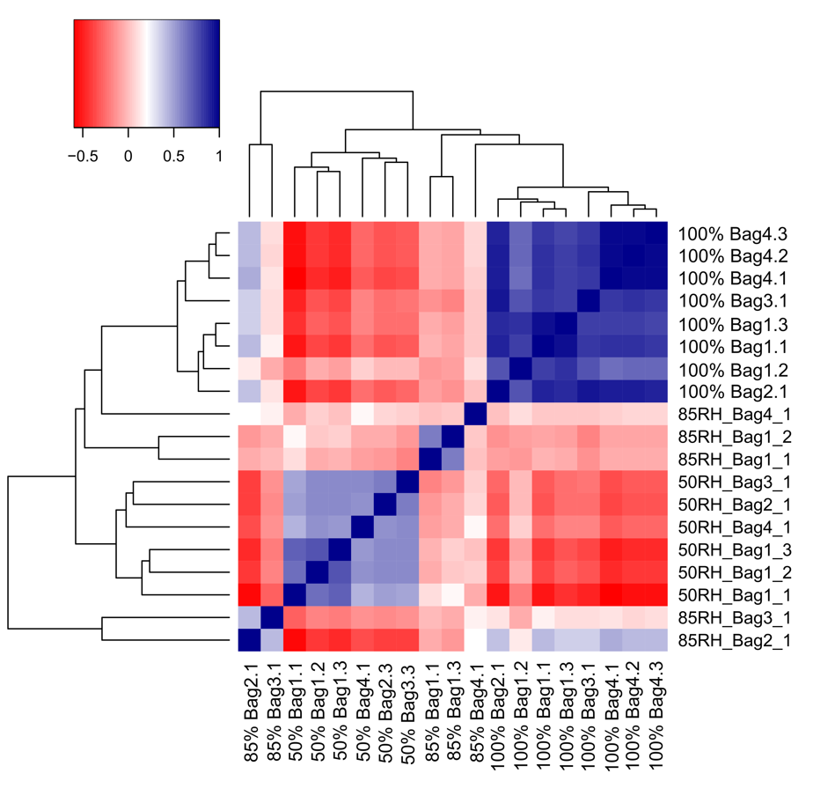
Fig. S1. Spearman correlation heatmap of differentially expressed genes in all pairwise comparisons having log2FC ≥ 2 and p ≤ 0.001. Log2 transformed and TMM-normalized Counts Per Million values are used. Rows and columns are ordered based on hierarchical clustering based on the Euclidean distances and the complete linkage method.

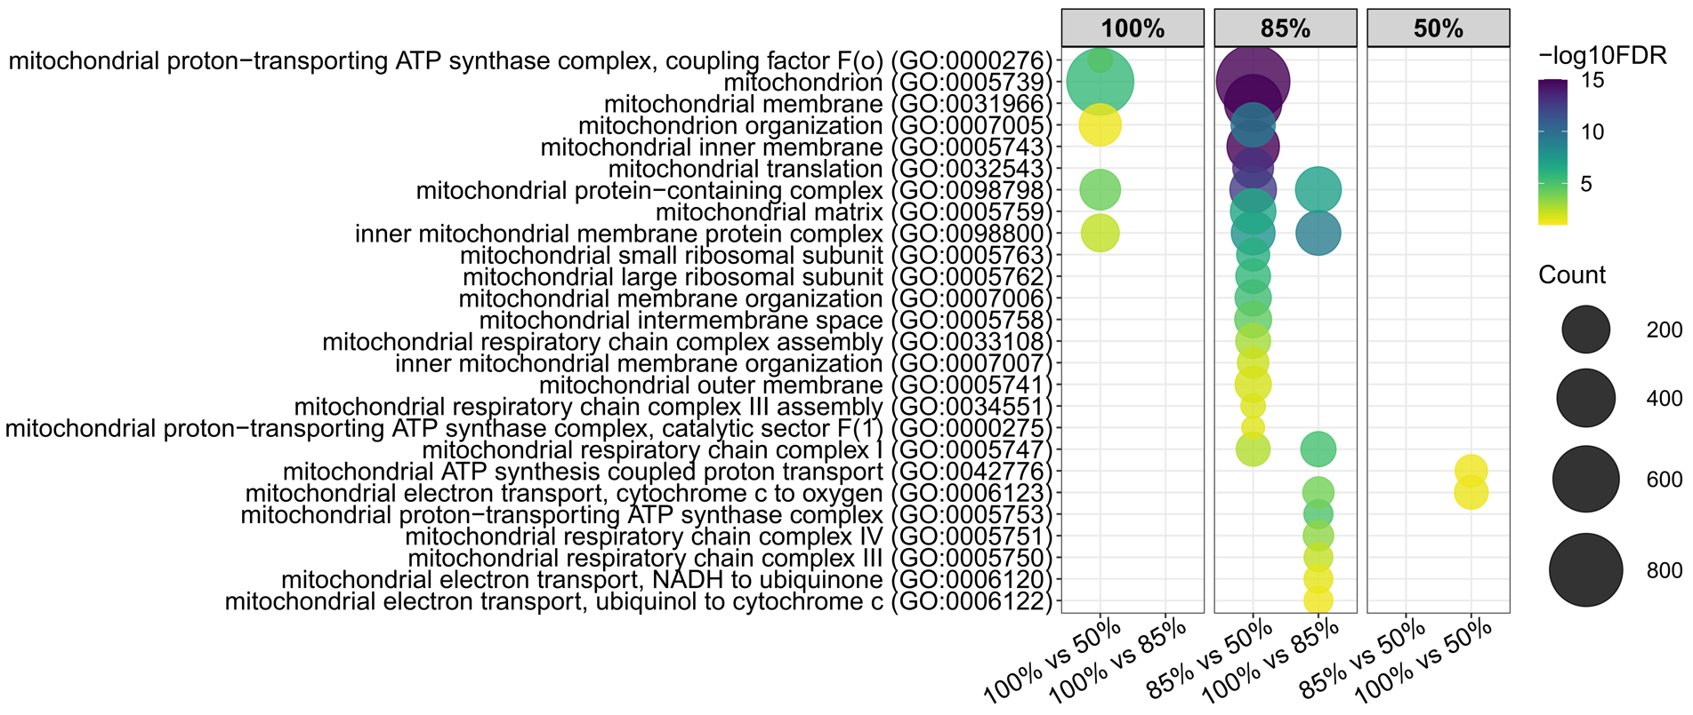
Fig. S2. Bubble plot of representative GO terms (n=26) associated with mitochondrial function enriched at each ERH condition. Bubble sizes represent the number of upregulated genes in that GO category for a specific ERH comparison. Bubble color values are based on the significance (-log10(FDR)) of the GO term enrichment. Darker colors of bubbles represent higher significance of the GO term. All enriched GO terms for pairwise ERH comparisons are provided in Supplementary Table S4.

Table S1. Description of samples sequenced from each vacuum bag and incubated moisture condition. One bag from Bag 1 incubated at 85% ERH marked with ‘*’ (85% Bag1.2) was excluded due to low quality of library indexed cDNA.
Sample name | Vacuum bag | Incubated condition (ERH) | Number of samples
50% Bag1.1 | Bag1 | 50% | 3
50% Bag1.2 | Bag1 | 50% | 3
50% Bag1.3 | Bag1 | 50% | 3
85% Bag1.1 | Bag1 | 85% | 3
85% Bag1.2* | Bag1 | 85% | 3
85% Bag1.3 | Bag1 | 85% | 3
100% Bag1.1 | Bag1 | 100% | 3
100% Bag1.2 | Bag1 | 100% | 3
100% Bag1.3 | Bag1 | 100% | 3
50% Bag2.3 | Bag2 | 50% | 1
85% Bag2.1 | Bag2 | 85% | 1
100% Bag2.1 | Bag2 | 100% | 1
50% Bag3.3 | Bag3 | 50% | 1
85% Bag3.1 | Bag3 | 85% | 1
100% Bag3.1 | Bag3 | 100% | 1
50% Bag4.1 | Bag4 | 50% | 1
85% Bag4.1 | Bag4 | 85% | 1
100% Bag4.1 | Bag4 | 100% | 3
100% Bag4.2 | Bag4 | 100% | 3
100% Bag4.3 | Bag4 | 100% | 3

Table S2. Tools and programs used in the RNA processing pipeline with descriptions and settings used in each. Order of tools listed represents the order in which it was utilized within the pipeline.
Tool | Purpose |  | Program | Settings
FastQC | Initial quality assessment |  | - - | Default
rCorrector | Correct erroneous  k-mers |  | perl run_rcorrector.pl | -t 12
TranscriptomeAssemblyTools | Remove unfixable reads determined from rcorrector |  | Python FilterUncorrectabledPEfastq.py | Default
Trinity | Metatranscriptome assembly and trimming reads |  | Trinity | --seqType fq --left –right  --trimmomatic  --max_memory 150G  --CPU 8  --min_contig_length 300  --output
Trinity | Check statistics of trinity output |  | TrinityStats.pl | Default
CD-HIT-EST | Cluster contigs with a threshold similarity of 80% | cd-hit-est |  | -n 4 -T 20 -M 0 -c 0.8
Bowtie2 | Build index |  | bowtie2-build | Default
Bowtie2 and Samtools | Assessing read content of transcriptome assembly |  | bowtie2 | -p 10 -q --no-unal -k 20 samtools view -@10 -Sbq 2
Trinity | Alignment based abundance estimations |  | align_estimate.adbundace.pl | --seqType fq  --samples_file  --est_method RSEM  --aln_method bowtie2.bam  --debug  --trinity_mode  --prep_reference  --include_rsem_bam  --output_dir
Trinity | Build transcript and gene expression matrices |  | abundance_estimates_to_matrix.pl | --est_method RSEM  --gene_trans_map trinity.fasta.gene_trans_map  --name_sample_by_basedir
Trinity | Quality check samples and biological replicates |  | PtR | --samples  --min_rowSums 10  --comapre_replicates  --log2 --CPM --sample_cor_matrix  --center_rows  --prin_comp 3
TransDecoder | extract the long open reading frames |  | TransDecoder.LongOrfs | -t target_transcripts.fasta
TransDecoder | Scan all ORFs for homology to known proteins |  | Blast+ | blastp -query transdecoder_dir/longest_orfs.pep  -db uniprot_sprot.fasta  -max_target_seqs 1  -outfmt 6 -evalue 1e-5  -num_threads 10 > blastp.outfmt6
TransDecoder | Search the peptides for protein domains |  | Hmmer  Pfam | hmmscan --cpu 8 --domtblout pfam.domtblout Pfam-A.hmm transdecoder_dir/longest_orfs.pep
TransDecoder | Predict the likely coding regions |  | TransDecoder.Predict | -t target_transcripts.fasta  --retain_pfam_hits pfam.domtblout  --retain_blastp_hits blastp.outfmt6
Trinotate | Search Trinity transcripts |  | Blast+ | blastx -query Trinity.fasta -db uniprot_sprot.pep -num_threads 8 -max_target_seqs 1 -outfmt 6 -evalue 1e-3 > blastx.outfmt6
Trinotate | Search Transdecoder-predicted proteins |  | Blast+ | blastp -query transdecoder.pep -db uniprot_sprot.pep -num_threads 8 -max_target_seqs 1 -outfmt 6 -evalue 1e-3 > blastp.outfmt6
Trinotate | Run hmmscan |  | Hmmer  Pfam | hmmscan --domtblout TrinotatePFAM.out Pfam-A.hmm transdecoder.pep > pfam.log
Trinotate | Generating annotation report |  | SQLite | init --gene_trans_map  --transcript_fasta  --transdecoder_pep  LOAD_swissprot_blastp  LOAD_pfam  LOAD_swissprot_blastx  LOAD_rnammer  report
Trinity | Differential expression analysis |  | run_DE_analysis.pl  DESeq2 | --matrix --method DESeq2  --samples_file
Trinity | Clustering differentially expressed transcripts |  | analyze_diff_expr.pl | --matrix -P 1e-6 -C 6  --examine_GO_enrichment  --GO_annots  --gene_lengths
Trinity | Partitioning Genes into Expression Clusters |  | define_clusters_by_cutting_tree.pl | --Ptree 60

Table S3. FDR-adjusted p values for pairwise adonis2 (PERMANOVA) tests to compare gene expression between ERH conditions. Gene expression is statistically different based on ERH condition. Significant p-values (p < 0.05) are bolded.
ERH comparison | FDR-adjusted p value
85% vs 50% | 0.003
100% vs 50% | 0.003
100% vs 85% | 0.003

Table S4. Number of KEGG annotations of upregulated fungal genes.
Pairwise ERH Comparison | Upregulated ERH | Number of KEGG annotations of upregulated genes
100% vs 50% | 100% | 2907
100% vs 50% | 50% | 1690
85% vs 50% | 85% | 3051
85% vs 50% | 50% | 16
100% vs 85% | 100% | 1308
100% vs 85% | 85% | 694

Table S5. All enriched GO terms significantly upregulated genes at each ERH condition. The number of genes significantly upregulated within each term is reported along with the list of genes. (See attached excel file: Supplementary Table S5.xlsx)
Table S6. Genes associated with melanin present within the secondary metabolic process GO terms (GO:0044550 and GO:0019748) upregulated at 100% ERH compared to 85%.
Trinity gene | Swissprot annotation | Gene name | log2FC | p-adj
TRINITY_DN6162_c0_g2 | ABR1_ASPFU | abr1 | 5.109746 | 0.000158
TRINITY_DN29296_c0_g4 | ABR2_ASPFU | abr2 | 4.990706 | 0.000127
TRINITY_DN55460_c0_g1 | ABR2_ASPFU | abr2 | 4.653168 | 0.00554
TRINITY_DN24967_c0_g2 | ARP1_ASPFU | arp1 | 8.438169 | 3.21E-08
TRINITY_DN1616_c0_g2 | ARP1_ASPFU | arp1 | 7.490036 | 5.57E-06
TRINITY_DN9837_c0_g1 | ARP2_ASPFU | arp2 | 13.21749 | 8.71E-25
TRINITY_DN17774_c0_g2 | ARP2_ASPFU | arp2 | 6.902372 | 0.00929
TRINITY_DN2020_c0_g1 | AYG1_ASPFU | ayg1 | 8.052902 | 5.81E-10
TRINITY_DN9666_c0_g1 | HPPD1_ASPFU | hppD | 10.96332 | 2.32E-14
TRINITY_DN9666_c0_g2 | HPPD1_ASPFU | hppD | 9.546598 | 4.07E-07
TRINITY_DN14516_c0_g1 | TYRO_ASPFU | tyr1 | 6.594821 | 0.00542

Table S7. Log2FC and FDR-adjusted p values of differentially expressed genes with a fungal allergen annotation.
Upregulated at 100% RH (100% vs 85%)
Trinity gene | Allergen | log2FC | p-adj
TRINITY_DN34777_c0_g6 | Asp f 15 | 4.93 | 9.73E-05
TRINITY_DN92805_c0_g2 | Asp f 4 | 5.24 | 0.000651
Upregulated at 100% RH (100% vs 50%)
Trinity gene | Allergen | log2FC | p-adj
TRINITY_DN34777_c0_g6 | Asp f 15 | 8.13 | 2.31E-12
TRINITY_DN5636_c0_g1 | Asp f 7 | 6.05 | 1.23E-07
TRINITY_DN15339_c0_g3 | Asp f 15 | 6.07 | 2.78E-06
TRINITY_DN21903_c0_g2 | Asp f 4 | 5.2 | 2.88E-05
TRINITY_DN2762_c0_g1 | Alt a 7 | 2.66 | 0.000167
TRINITY_DN4312_c0_g1 | Asp f 4 | 4.8 | 0.000186
TRINITY_DN2376_c0_g1 | Alt a 7 | 2.98 | 0.001301
Upregulated at 85% RH (85% vs 50%)
Trinity gene | Allergen | log2FC | p-adj
TRINITY_DN907_c0_g1 | Asp f 7 | 27.67 | 3.98E-20
TRINITY_DN39498_c0_g1 | Cla h 7 | 25.51 | 2.38E-17
TRINITY_DN1525_c0_g1 | Asp f 4 | 26.43 | 1.3E-16
TRINITY_DN15339_c0_g3 | Asp f 15 | 24.79 | 6.11E-15
TRINITY_DN21903_c0_g2 | Asp f 4 | 15.61 | 8.35E-12
TRINITY_DN5636_c0_g1 | Asp f 7 | 12.63 | 1.57E-08
TRINITY_DN66023_c0_g1 | Asp f 15 | 9.25 | 0.009779
Upregulated at 50% RH (100% vs 50%)
Trinity gene | Allergen | log2FC | p-adj
TRINITY_DN5911_c0_g1 | Mal f 1 | 14.33 | 1.05E-34
TRINITY_DN3847_c0_g1 | Mal f 1 | 12.25 | 5.85E-16
TRINITY_DN40822_c0_g2 | Mal f 1 | 10.99 | 7.9E-10
TRINITY_DN28676_c0_g2 | Mal f 1 | 10.83 | 6.28E-09
Upregulated at 85% RH (100% vs 85%)
Trinity gene | Allergen | log2FC | p-adj
TRINITY_DN21903_c0_g2 | Asp f 4 | 4.16 | 3.85E-07
TRINITY_DN5911_c0_g1 | Mal f 1 | 10.41 | 2.54E-05
TRINITY_DN3847_c0_g1 | Mal f 1 | 8.81 | 0.003
TRINITY_DN907_c0_g1 | Asp f 7 | 7.48 | 0.0065

Table S8. Log2FC and FDR-adjusted p values of differentially expressed genes associated with aflatoxin related processes: “regulation of aflatoxin biosynthetic process” (GO:1900177) and “positive regulation of aflatoxin biosynthetic process” (GO:1900179). All reported genes were associated with both GO:1900177 and GO:1900179.
Trinity gene | Gene name  (BLASTX) | Gene name  (BLASTP) | log2FC | p-adj
TRINITY_DN434_c0_g1 | HOG1 | HOG1 | 6.87 | 0.0096
TRINITY_DN2057_c0_g2 | - | atfB | 7.12 | 2.22E-14
TRINITY_DN47_c0_g2 | - | atfB | 7.83 | 8.96E-08
TRINITY_DN497_c0_g1 | - | atfB | 9.21 | 1.68E-07
TRINITY_DN5135_c0_g2 | - | atfB | 11.09 | 5.08E-06
TRINITY_DN47_c0_g1 | - | atfB | 8.86 | 8.01E-06
TRINITY_DN2057_c0_g3 | - | atfB | 5.21 | 0.000783
TRINITY_DN46250_c1_g1 | - | atfB | 5.16 | 0.006556

