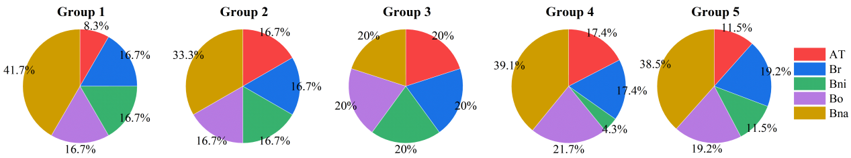
Fig. S1. Distribution of EPFL proteins from three Brassica species and A. thaliana. At, Arabidopsis thaliana; Br, Brassica rapa; Bni, Brassica nigra; Bo, Brassica oleracea; Bna, Brassica napus.

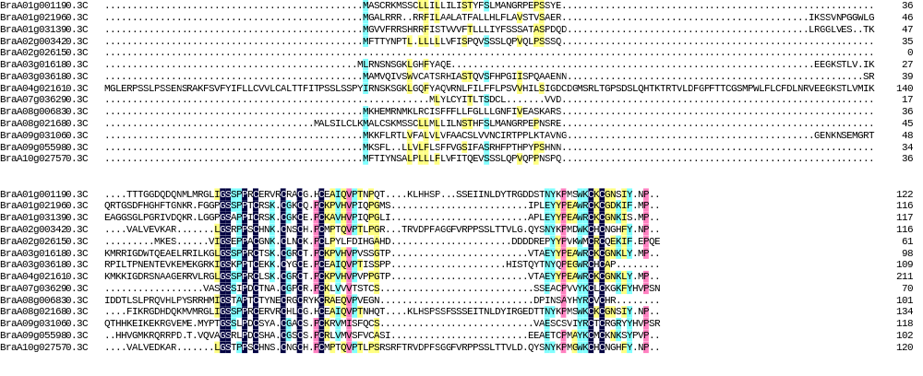
Fig. S2 Multiple alignment of the amino acid sequences of BcEPFLs
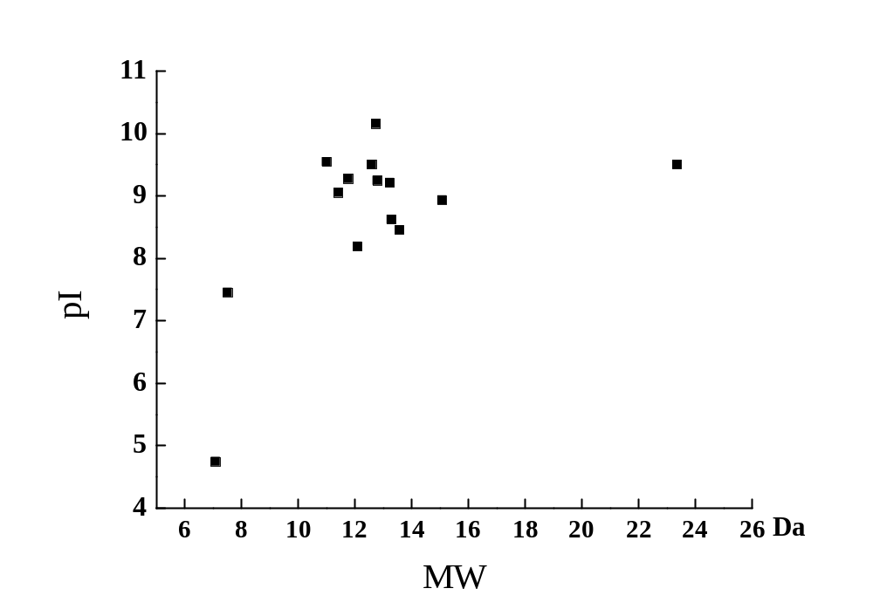
Acidic
Alkalin
Fig. S3 Putative isoelectric points (pI) and molecular weights (MW) of BrEPFL proteins

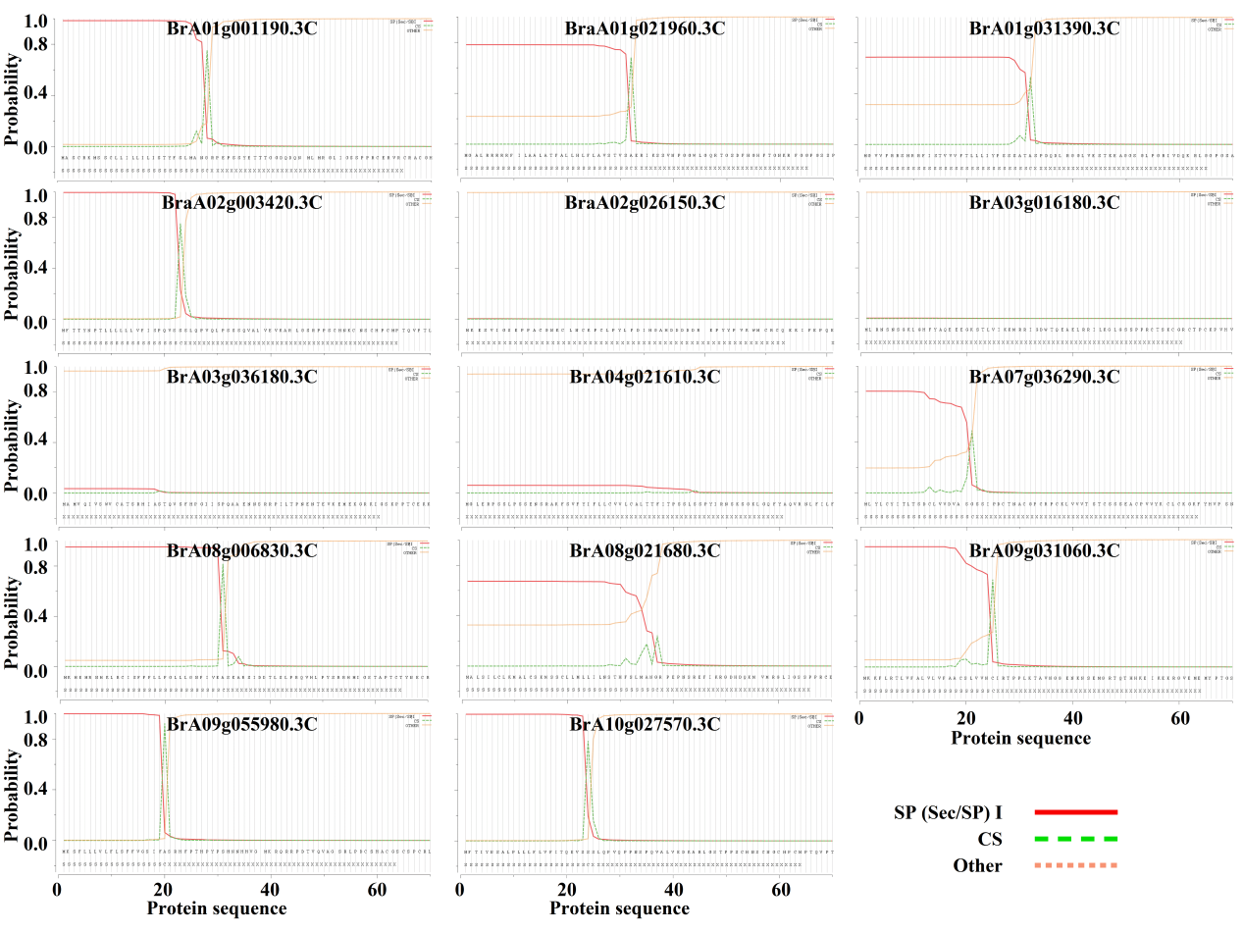
Fig. S4 Signal peptide prediction of BrEPFL proteins

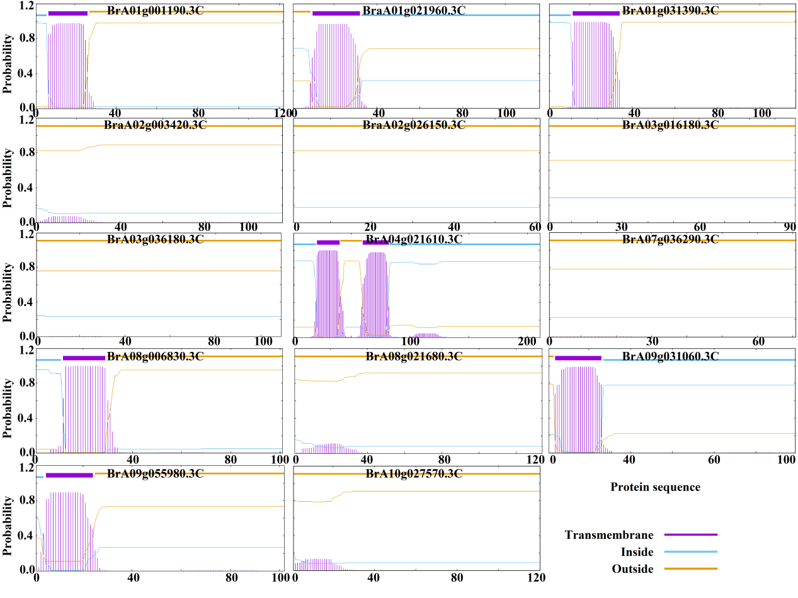
Fig S5 Transmembrane domain prediction of BrEPFL proteins
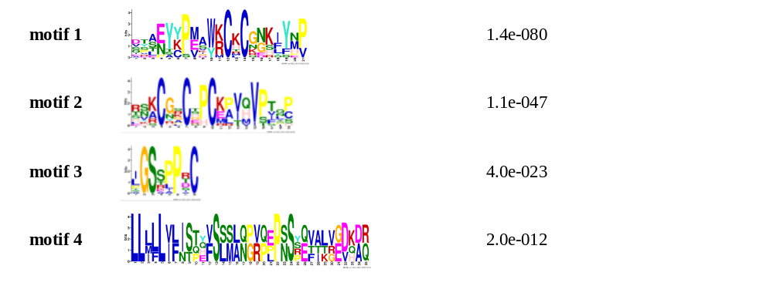Fig. S6 Sequence logos of motifs in BrEPFLs

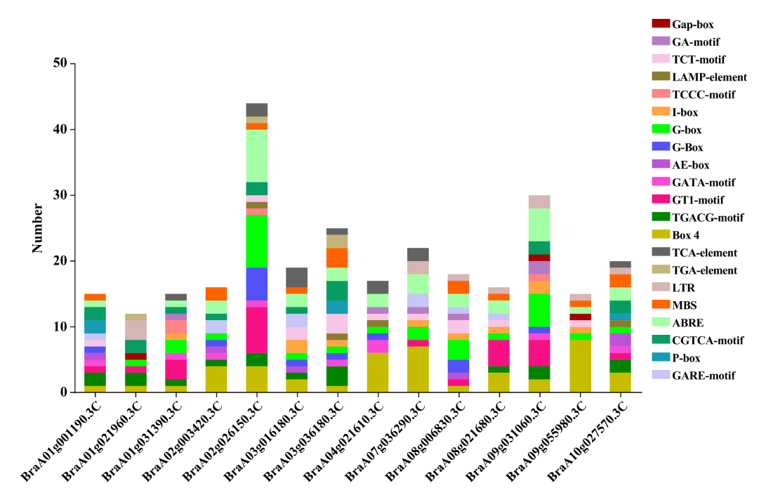
Fig. S7. Number of cis-acting elements in the promoter regions of BrEPFL genes
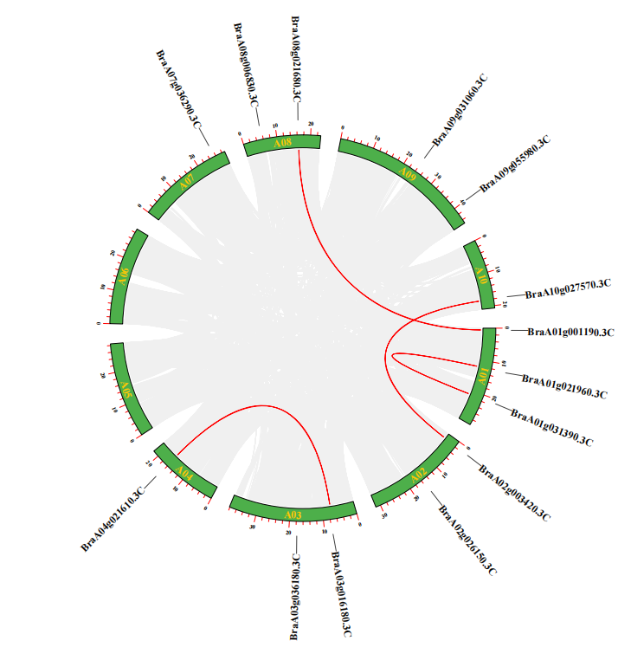
Fig. S8 Chromosomal mapping of BrEPFL family genes
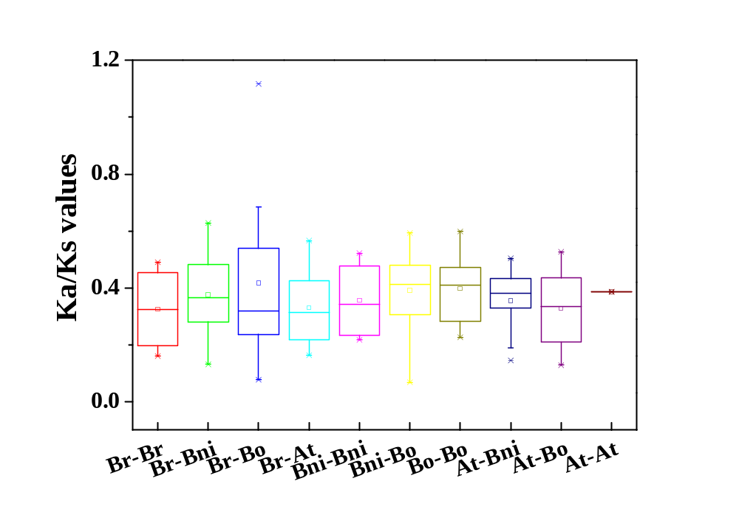
Fig. S9 Ka/Ks values of orthologous / paralogous gene pairs.
Br, B. rapa; Bni, B. nigra; Bo, B. oleracea; At, A.thaliana

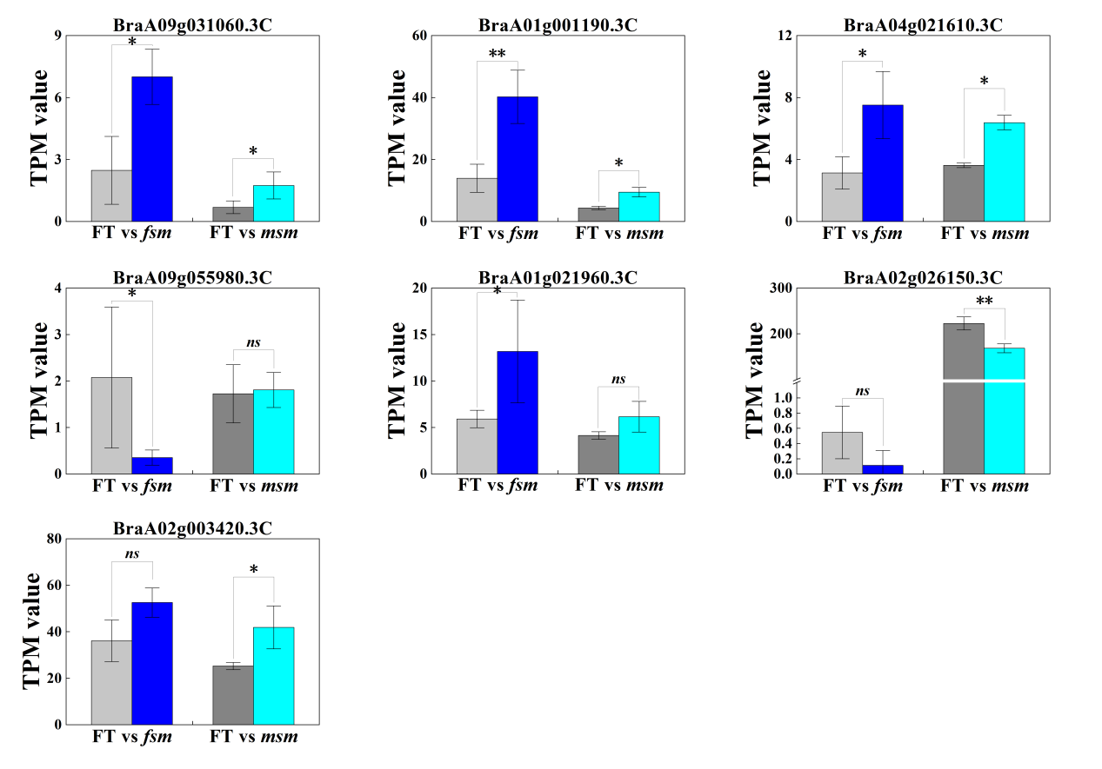
Fig. S10 TPM values of sever BrEPFL genes between male sterile lines msm / fsm and their fertile line ‘FT’. Error bars indicate the means ± SEs; the asterisks indicate significant differences at p < 0.05 (*) or p < 0.01 (**) by Student’s test.

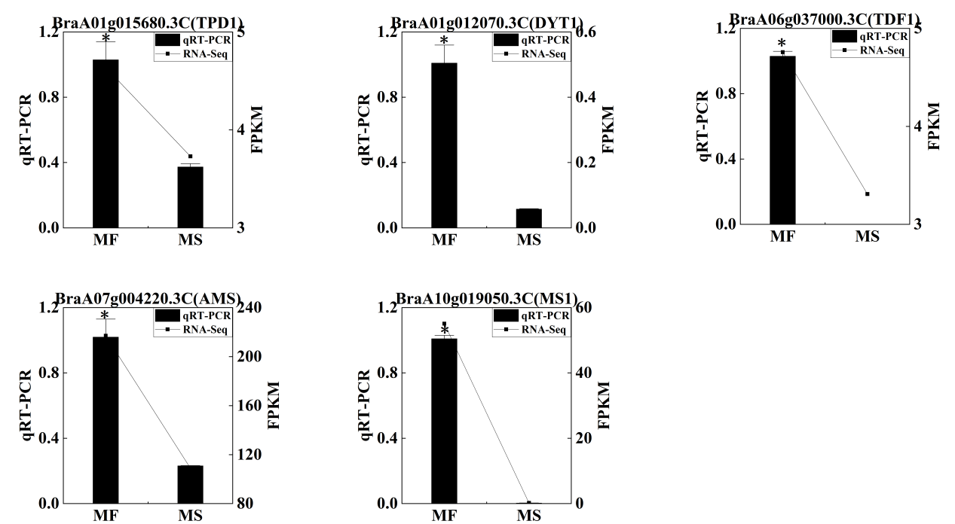
Fig. S11. Expression levels of genes in the anther development regulatory network. Error bars indicate the means ± SEs; the asterisks indicate significant differences at p < 0.05 (*) by Student’s test.

