SUPPLEMENTARY INFORMATION

Insights into the epitaxial formation of dendritic Pt on Au nanoprism with the aid of ultrasonication

Hu-Jun LEE¹, Daisuke HANYU¹, Anh Thi Ngoc DAO^{2, *}, Kenji KANEKO^{1, *}

¹Department of Materials, Kyushu University, 744, Motooka, Nishi, Fukuoka, 819-0395, Japan
²Graduate School of Integrated Science and Technology, Nagasaki University, 1-14 Bunkyo-machi, Nagasaki, Nagasaki, 852-8521, Japan
* Corresponding authors: kaneko.kenji.513@m.kyushu-u.ac.jp: anh.dao@nagasaki-u.ac.jp

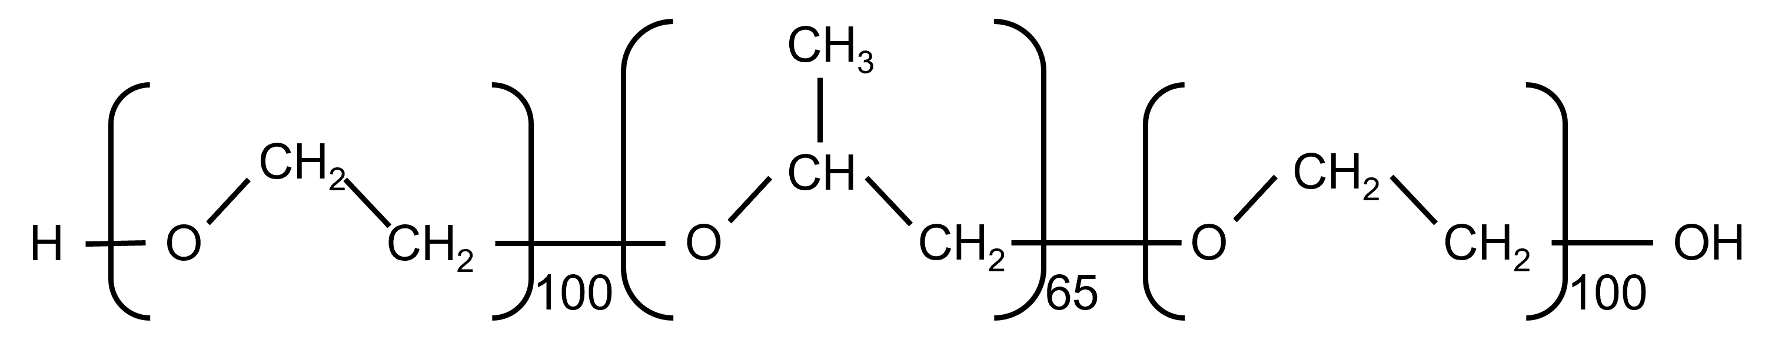
Figure S1. The molecular structure of Pluronic F127: poly (ethylene oxide)-poly (propylene oxide)-poly (ethylene oxide).

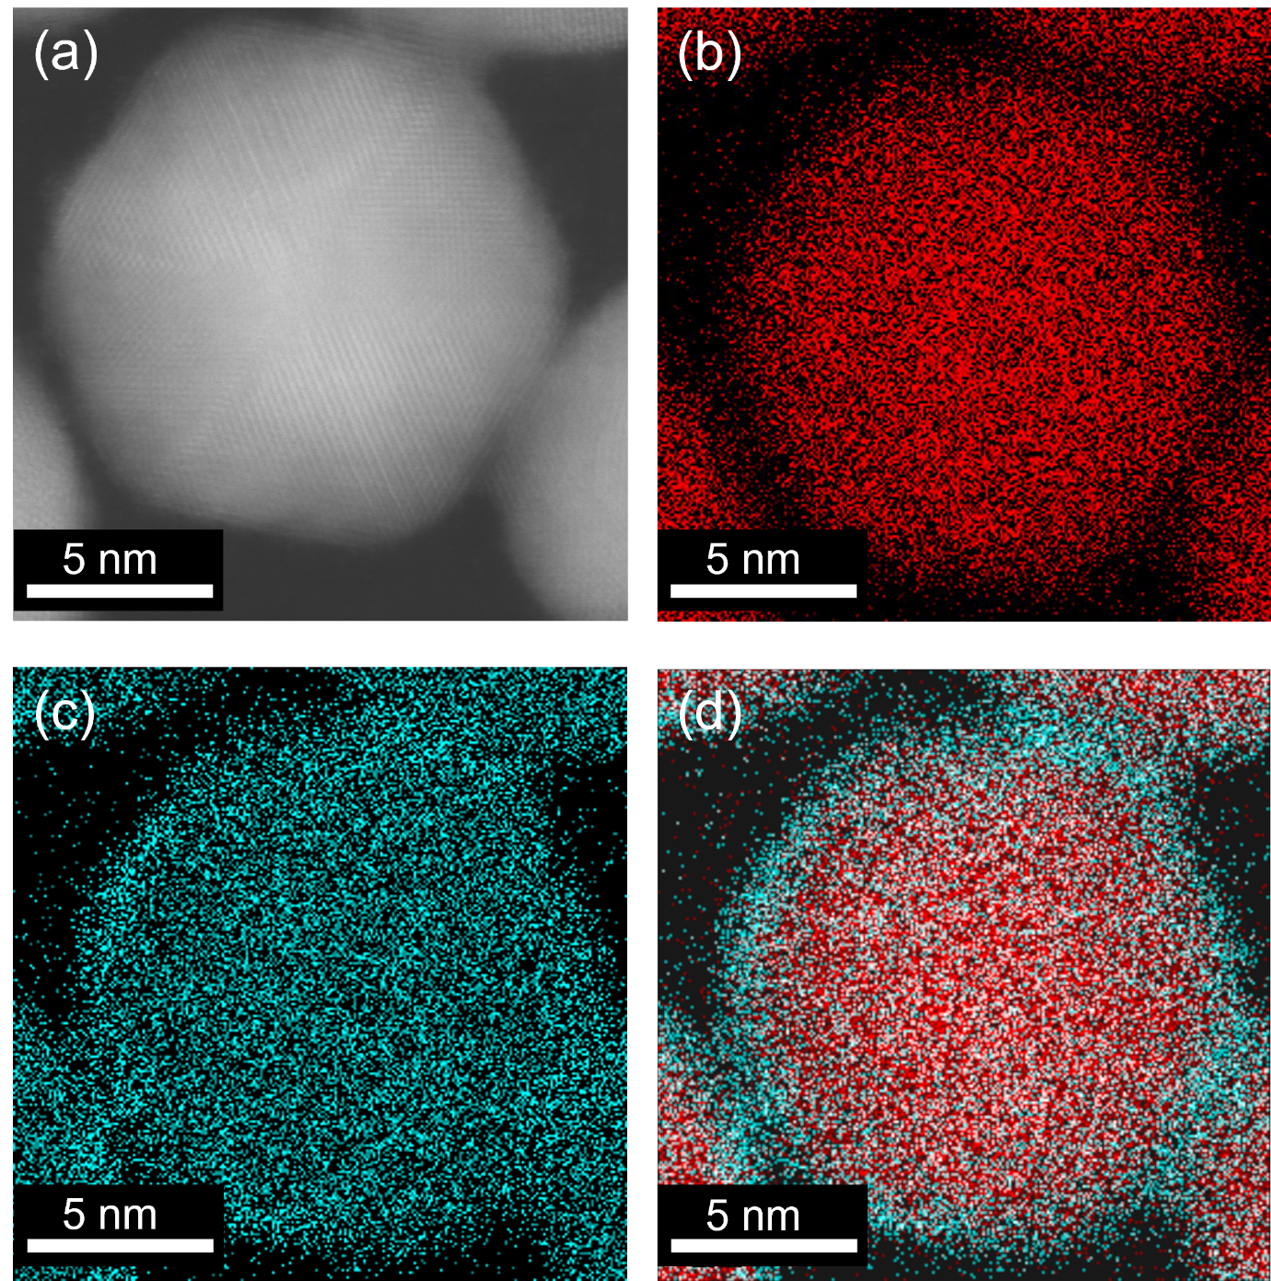
Figure S2. (a) HAADF-STEM image, (b) Au-L elemental distribution map, (c) Pt-L elemental distribution map, and (d) overlay image of Au@Pt NPs synthesized without ultrasonication for 4 hours.

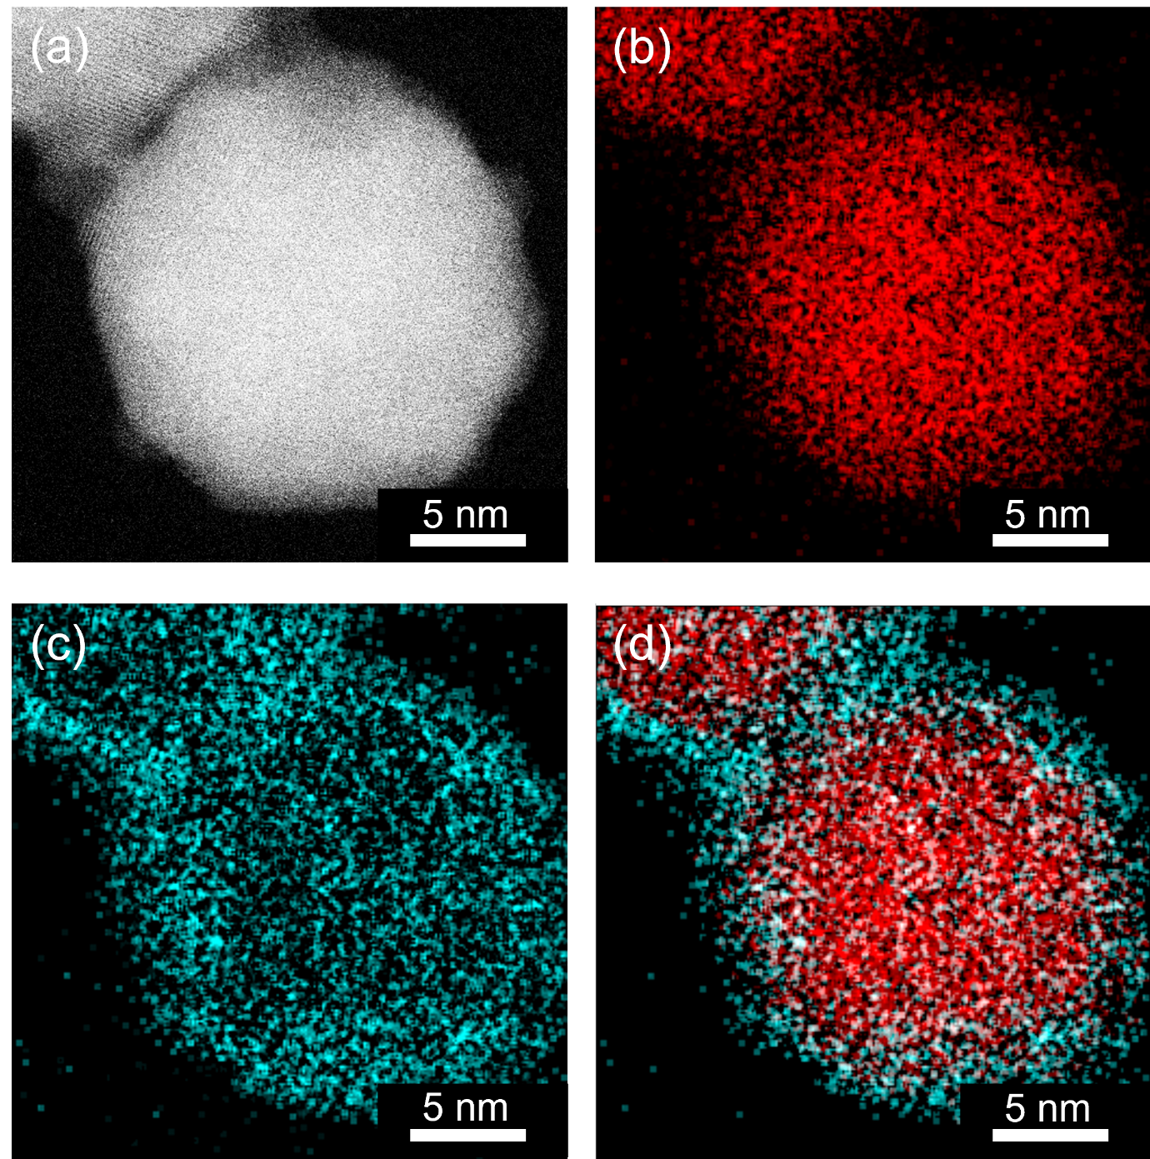Figure S3. (a) HAADF-STEM image, (b) Au-L elemental distribution map, (c) Pt-L elemental distribution map, and (d) overlay image of Au@Pt NPs synthesized without ultrasonication for 24 hours.

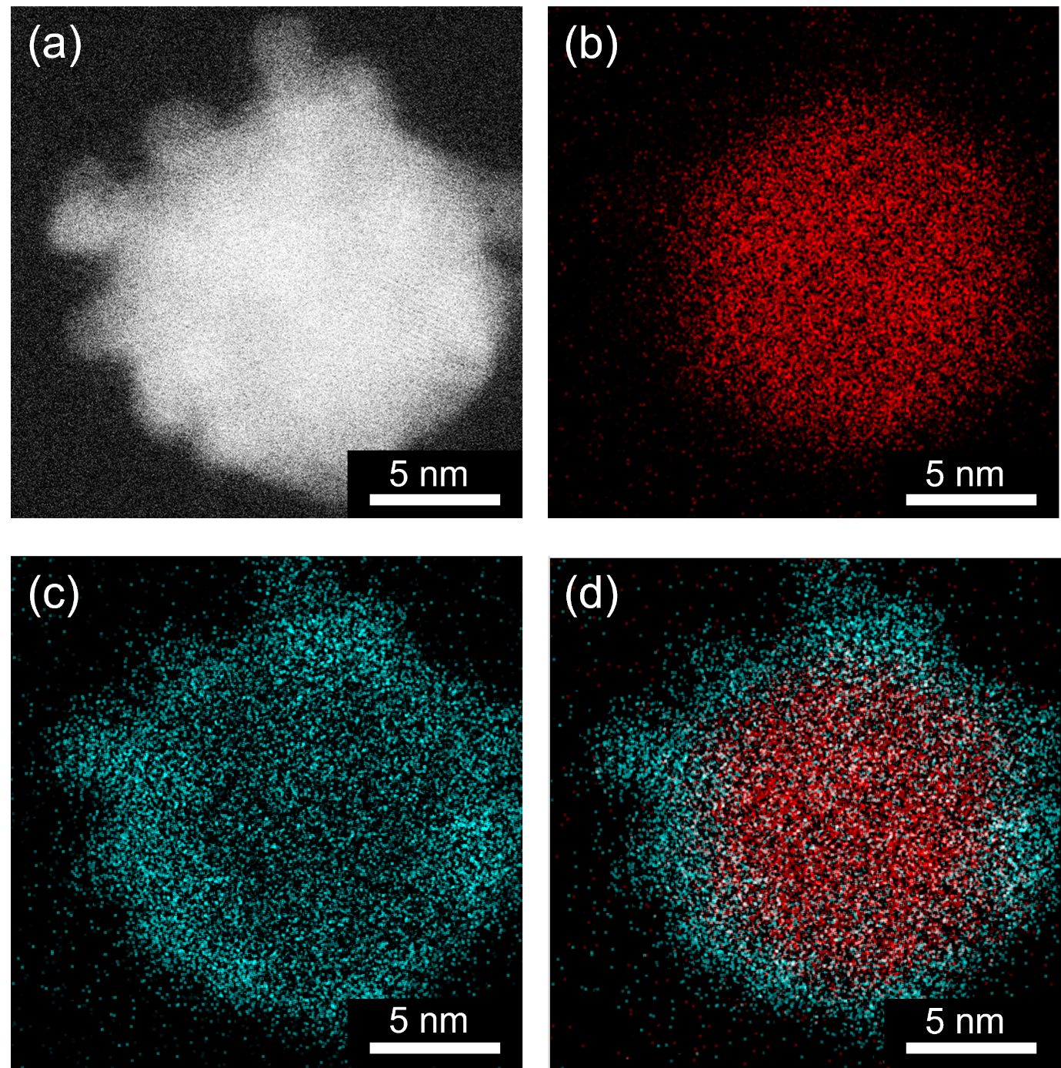
Figure S4. (a) HAADF-STEM image, (b) Au-L elemental distribution map, (c) Pt-L elemental distribution map, and (d) overlay image of Au@Pt NPs synthesized with ultrasonication for 4 hours.

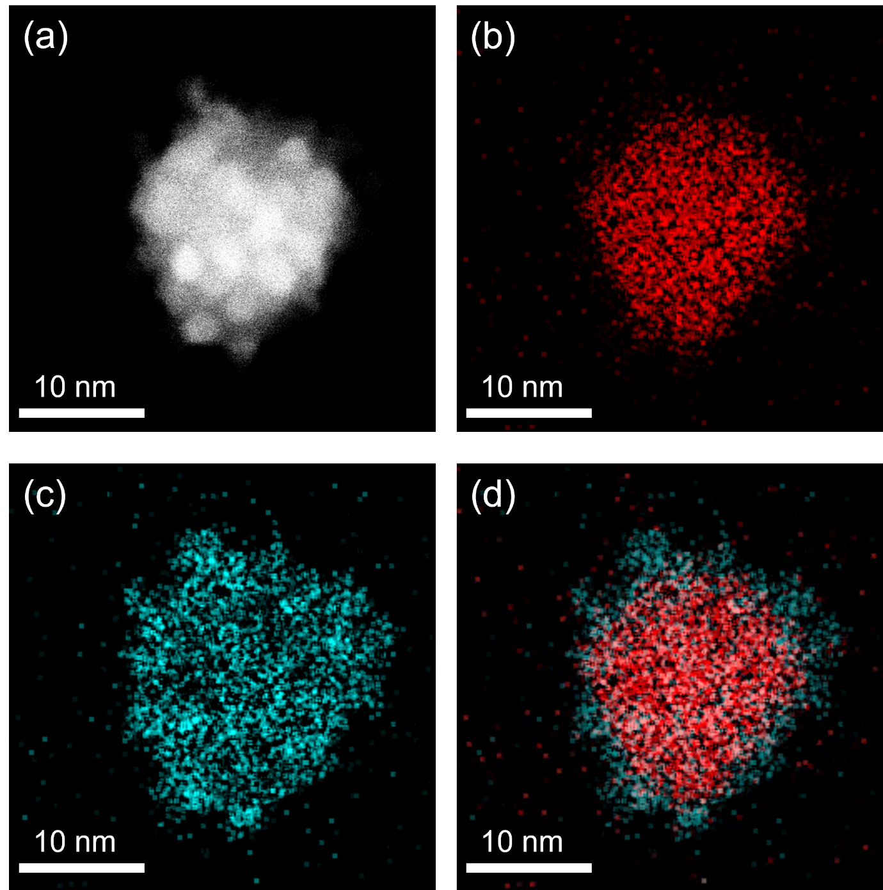Figure S5. (a) HAADF-STEM image, (b) Au-L elemental distribution map, (c) Pt-L elemental distribution map, and (d) overlay image of Au@Pt NPs synthesized with ultrasonication for 24 hours.

