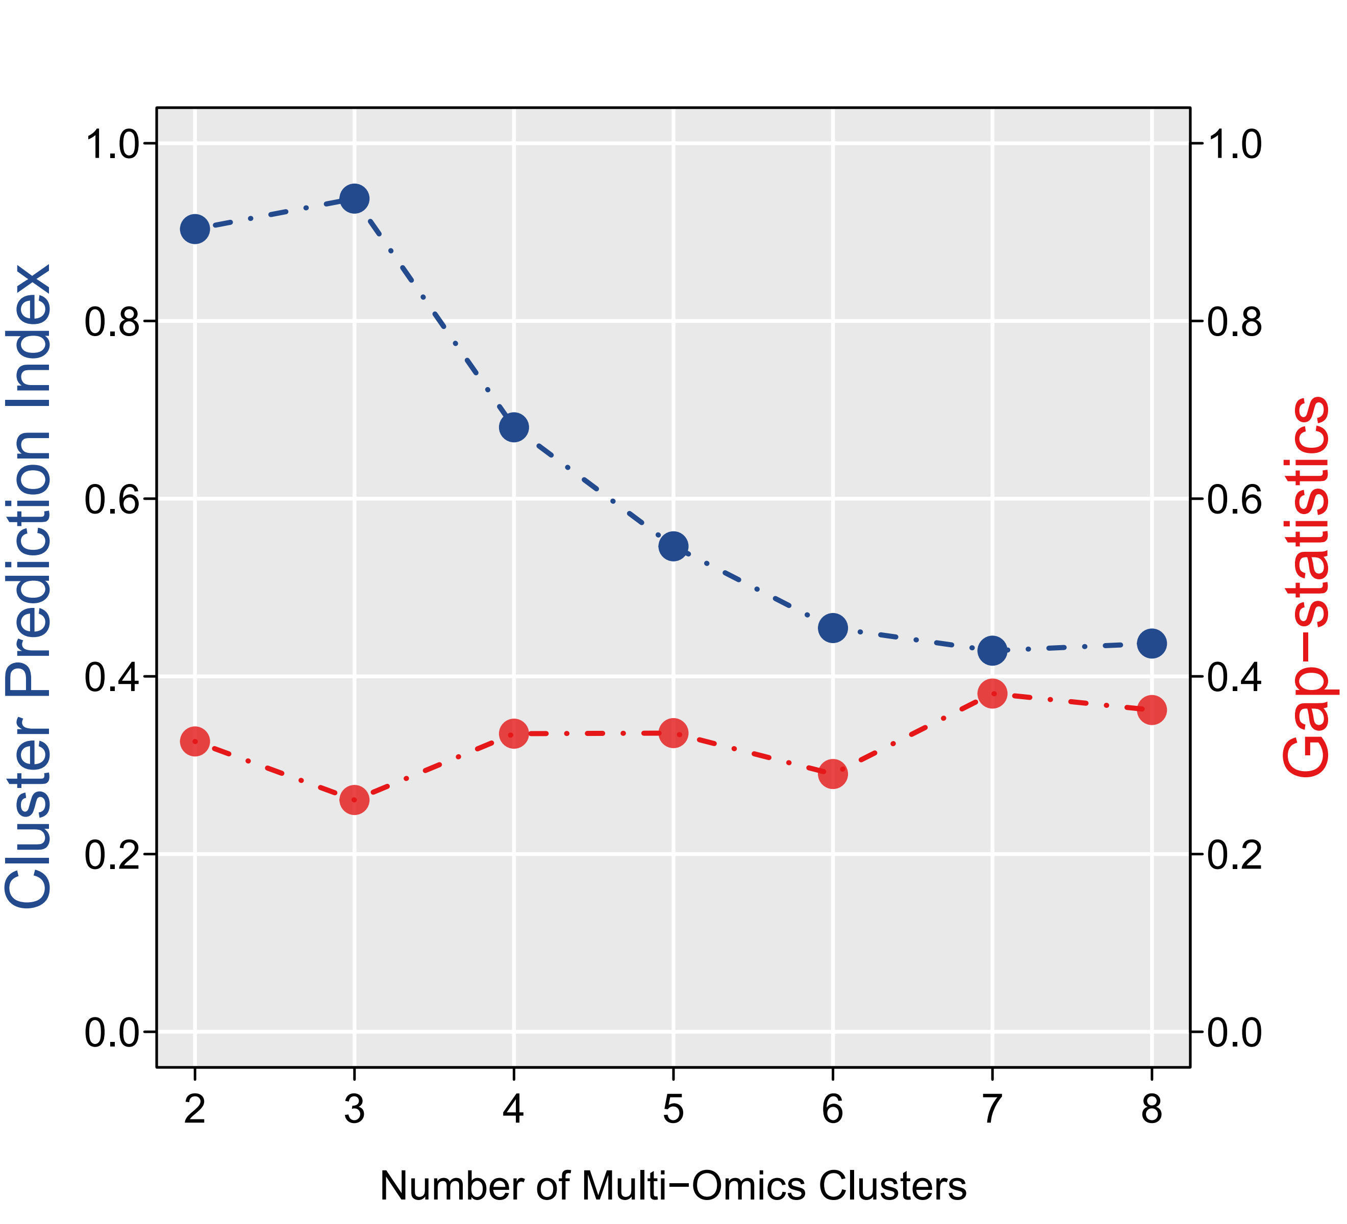

Supplementary Figure S1A. The Cluster Prediction Index and Gap Statistical Analysis of the multiomics clusters.

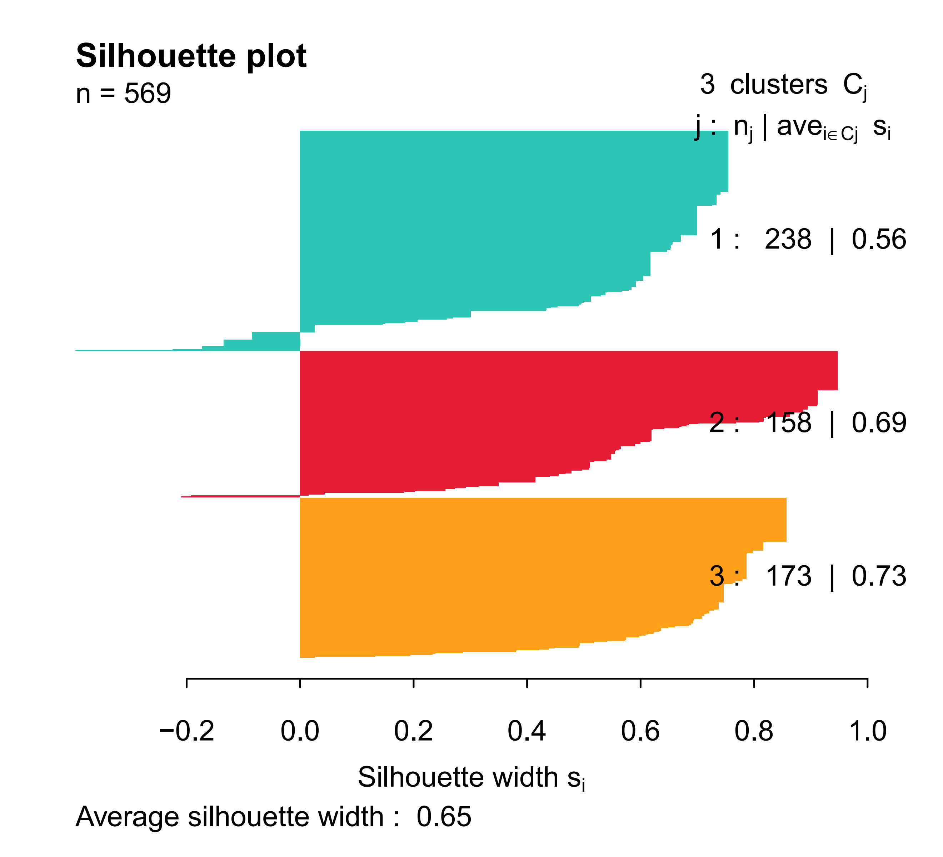
Supplementary Figure S1B. The sample similarity of each subgroup was assessed by calculating the Silhoutte score.

